Pack 1 Audit Financier

Date : 2025-08-05

Résumé Exécutif

None

Key Performance Indicators

- total_revenue : 65999999.99999999

- gross_margin_pct : 0.55

- ebitda_margin_pct : 0.4227272727272728

- avg_operating_cf : 1162500.0

- avg_net_cashflow : 1116714.0

Graphiques

Waterfall EBITDA:

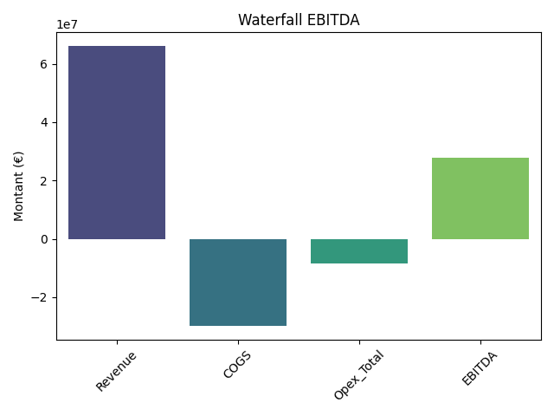

Évolution dans le temps :

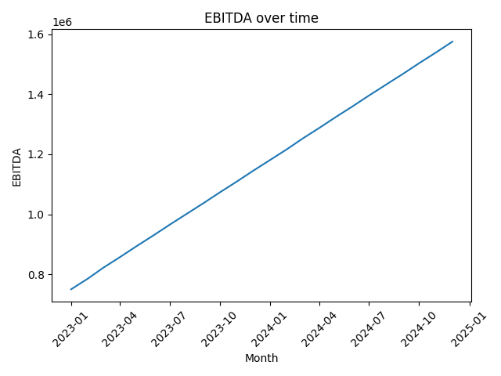

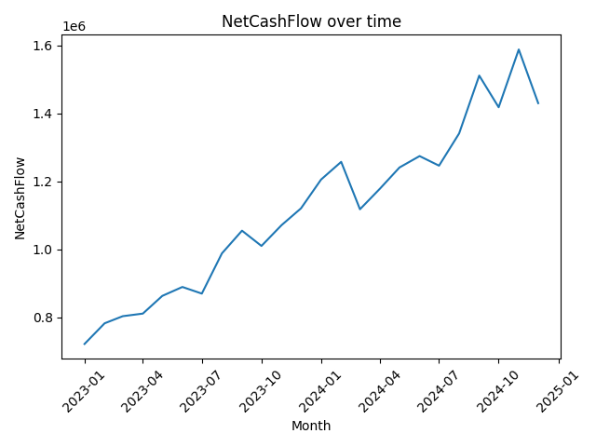

Données détaillées

=== P ===

Month Revenue COGS ... Opex_GA Opex_Total EBITDA  
0 2023-01-01 2000000.00 900000.00 ... 80000 350000 750000.00  
1 2023-02-01 2065217.39 929347.83 ... 80000 350000 785869.56  
2 2023-03-01 2130434.78 958695.65 ... 80000 350000 821739.13  
3 2023-04-01 2195652.17 988043.48 ... 80000 350000 857608.69  
4 2023-05-01 2260869.57 1017391.31 ... 80000 350000 893478.26  
5 2023-06-01 2326086.96 1046739.13 ... 80000 350000 929347.83  
6 2023-07-01 2391304.35 1076086.96 ... 80000 350000 965217.39  
7 2023-08-01 2456521.74 1105434.78 ... 80000 350000 1001086.96  
8 2023-09-01 2521739.13 1134782.61 ... 80000 350000 1036956.52  
9 2023-10-01 2586956.52 1164130.43 ... 80000 350000 1072826.09  
10 2023-11-01 2652173.91 1193478.26 ... 80000 350000 1108695.65  
11 2023-12-01 2717391.30 1222826.08 ... 80000 350000 1144565.22  
12 2024-01-01 2782608.70 1252173.92 ... 80000 350000 1180434.78  
13 2024-02-01 2847826.09 1281521.74 ... 80000 350000 1216304.35  
14 2024-03-01 2913043.48 1310869.57 ... 80000 350000 1252173.91  
15 2024-04-01 2978260.87 1340217.39 ... 80000 350000 1288043.48  
16 2024-05-01 3043478.26 1369565.22 ... 80000 350000 1323913.04  
17 2024-06-01 3108695.65 1398913.04 ... 80000 350000 1359782.61  
18 2024-07-01 3173913.04 1428260.87 ... 80000 350000 1395652.17  
19 2024-08-01 3239130.43 1457608.69 ... 80000 350000 1431521.74  
20 2024-09-01 3304347.83 1486956.52 ... 80000 350000 1467391.31  
21 2024-10-01 3369565.22 1516304.35 ... 80000 350000 1503260.87  
22 2024-11-01 3434782.61 1545652.17 ... 80000 350000 1539130.44  
23 2024-12-01 3500000.00 1575000.00 ... 80000 350000 1575000.00  
  
[24 rows x 9 columns]

=== Cashflow ===

Month OperatingCF CAPEX Delta_BFR NetCashFlow  
0 2023-01-01 750000.00 -50000 21958 721958.00  
1 2023-02-01 785869.56 -50000 46867 782736.56  
2 2023-03-01 821739.13 -50000 31932 803671.13  
3 2023-04-01 857608.69 -50000 3694 811302.69  
4 2023-05-01 893478.26 -50000 19879 863357.26  
5 2023-06-01 929347.83 -50000 10268 889615.83  
6 2023-07-01 965217.39 -50000 -45114 870103.39  
7 2023-08-01 1001086.96 -50000 37337 988423.96  
8 2023-09-01 1036956.52 -50000 68266 1055222.52  
9 2023-10-01 1072826.09 -50000 -12502 1010324.09  
10 2023-11-01 1108695.65 -50000 12727 1071422.65  
11 2023-12-01 1144565.22 -50000 26324 1120889.22  
12 2024-01-01 1180434.78 -50000 75203 1205637.78  
13 2024-02-01 1216304.35 -50000 91335 1257639.35  
14 2024-03-01 1252173.91 -50000 -83977 1118196.91  
15 2024-04-01 1288043.48 -50000 -58910 1179133.48  
16 2024-05-01 1323913.04 -50000 -32779 1241134.04  
17 2024-06-01 1359782.61 -50000 -35180 1274602.61  
18 2024-07-01 1395652.17 -50000 -99231 1246421.17  
19 2024-08-01 1431521.74 -50000 -40265 1341256.74  
20 2024-09-01 1467391.31 -50000 94027 1511418.31  
21 2024-10-01 1503260.87 -50000 -35075 1418185.87  
22 2024-11-01 1539130.44 -50000 99041 1588171.44  
23 2024-12-01 1575000.00 -50000 -94689 1430311.00

Conclusion

Merci pour votre confiance. Voici nos recommandations.

P&L

P&L

|  |  |  |  |  |  |  |  |  |
| --- | --- | --- | --- | --- | --- | --- | --- | --- |
| Month | Revenue | COGS | GrossProfit | Opex_RnD | Opex_SalesMarketing | Opex_GA | Opex_Total | EBITDA |
| 2023-01-01 00:00:00 | 2000000.0 | 900000.0 | 1100000.0 | 150000 | 120000 | 80000 | 350000 | 750000.0 |
| 2023-02-01 00:00:00 | 2065217.39 | 929347.83 | 1135869.56 | 150000 | 120000 | 80000 | 350000 | 785869.56 |
| 2023-03-01 00:00:00 | 2130434.78 | 958695.65 | 1171739.13 | 150000 | 120000 | 80000 | 350000 | 821739.13 |
| 2023-04-01 00:00:00 | 2195652.17 | 988043.48 | 1207608.69 | 150000 | 120000 | 80000 | 350000 | 857608.69 |
| 2023-05-01 00:00:00 | 2260869.57 | 1017391.31 | 1243478.26 | 150000 | 120000 | 80000 | 350000 | 893478.26 |
| 2023-06-01 00:00:00 | 2326086.96 | 1046739.13 | 1279347.83 | 150000 | 120000 | 80000 | 350000 | 929347.83 |
| 2023-07-01 00:00:00 | 2391304.35 | 1076086.96 | 1315217.39 | 150000 | 120000 | 80000 | 350000 | 965217.39 |
| 2023-08-01 00:00:00 | 2456521.74 | 1105434.78 | 1351086.96 | 150000 | 120000 | 80000 | 350000 | 1001086.96 |
| 2023-09-01 00:00:00 | 2521739.13 | 1134782.61 | 1386956.52 | 150000 | 120000 | 80000 | 350000 | 1036956.52 |
| 2023-10-01 00:00:00 | 2586956.52 | 1164130.43 | 1422826.09 | 150000 | 120000 | 80000 | 350000 | 1072826.09 |
| 2023-11-01 00:00:00 | 2652173.91 | 1193478.26 | 1458695.65 | 150000 | 120000 | 80000 | 350000 | 1108695.65 |
| 2023-12-01 00:00:00 | 2717391.3 | 1222826.08 | 1494565.22 | 150000 | 120000 | 80000 | 350000 | 1144565.22 |
| 2024-01-01 00:00:00 | 2782608.7 | 1252173.92 | 1530434.78 | 150000 | 120000 | 80000 | 350000 | 1180434.78 |
| 2024-02-01 00:00:00 | 2847826.09 | 1281521.74 | 1566304.35 | 150000 | 120000 | 80000 | 350000 | 1216304.35 |
| 2024-03-01 00:00:00 | 2913043.48 | 1310869.57 | 1602173.91 | 150000 | 120000 | 80000 | 350000 | 1252173.91 |
| 2024-04-01 00:00:00 | 2978260.87 | 1340217.39 | 1638043.48 | 150000 | 120000 | 80000 | 350000 | 1288043.48 |
| 2024-05-01 00:00:00 | 3043478.26 | 1369565.22 | 1673913.04 | 150000 | 120000 | 80000 | 350000 | 1323913.04 |
| 2024-06-01 00:00:00 | 3108695.65 | 1398913.04 | 1709782.61 | 150000 | 120000 | 80000 | 350000 | 1359782.61 |
| 2024-07-01 00:00:00 | 3173913.04 | 1428260.87 | 1745652.17 | 150000 | 120000 | 80000 | 350000 | 1395652.17 |
| 2024-08-01 00:00:00 | 3239130.43 | 1457608.69 | 1781521.74 | 150000 | 120000 | 80000 | 350000 | 1431521.74 |
| 2024-09-01 00:00:00 | 3304347.83 | 1486956.52 | 1817391.31 | 150000 | 120000 | 80000 | 350000 | 1467391.31 |
| 2024-10-01 00:00:00 | 3369565.22 | 1516304.35 | 1853260.87 | 150000 | 120000 | 80000 | 350000 | 1503260.87 |
| 2024-11-01 00:00:00 | 3434782.61 | 1545652.17 | 1889130.44 | 150000 | 120000 | 80000 | 350000 | 1539130.44 |
| 2024-12-01 00:00:00 | 3500000.0 | 1575000.0 | 1925000.0 | 150000 | 120000 | 80000 | 350000 | 1575000.0 |

Cashflow

Cashflow

|  |  |  |  |  |
| --- | --- | --- | --- | --- |
| Month | OperatingCF | CAPEX | Delta_BFR | NetCashFlow |
| 2023-01-01 00:00:00 | 750000.0 | -50000 | 21958 | 721958.0 |
| 2023-02-01 00:00:00 | 785869.56 | -50000 | 46867 | 782736.56 |
| 2023-03-01 00:00:00 | 821739.13 | -50000 | 31932 | 803671.13 |
| 2023-04-01 00:00:00 | 857608.69 | -50000 | 3694 | 811302.69 |
| 2023-05-01 00:00:00 | 893478.26 | -50000 | 19879 | 863357.26 |
| 2023-06-01 00:00:00 | 929347.83 | -50000 | 10268 | 889615.83 |
| 2023-07-01 00:00:00 | 965217.39 | -50000 | -45114 | 870103.39 |
| 2023-08-01 00:00:00 | 1001086.96 | -50000 | 37337 | 988423.96 |
| 2023-09-01 00:00:00 | 1036956.52 | -50000 | 68266 | 1055222.52 |
| 2023-10-01 00:00:00 | 1072826.09 | -50000 | -12502 | 1010324.09 |
| 2023-11-01 00:00:00 | 1108695.65 | -50000 | 12727 | 1071422.65 |
| 2023-12-01 00:00:00 | 1144565.22 | -50000 | 26324 | 1120889.22 |
| 2024-01-01 00:00:00 | 1180434.78 | -50000 | 75203 | 1205637.78 |
| 2024-02-01 00:00:00 | 1216304.35 | -50000 | 91335 | 1257639.35 |
| 2024-03-01 00:00:00 | 1252173.91 | -50000 | -83977 | 1118196.91 |
| 2024-04-01 00:00:00 | 1288043.48 | -50000 | -58910 | 1179133.48 |
| 2024-05-01 00:00:00 | 1323913.04 | -50000 | -32779 | 1241134.04 |
| 2024-06-01 00:00:00 | 1359782.61 | -50000 | -35180 | 1274602.61 |
| 2024-07-01 00:00:00 | 1395652.17 | -50000 | -99231 | 1246421.17 |
| 2024-08-01 00:00:00 | 1431521.74 | -50000 | -40265 | 1341256.74 |
| 2024-09-01 00:00:00 | 1467391.31 | -50000 | 94027 | 1511418.31 |
| 2024-10-01 00:00:00 | 1503260.87 | -50000 | -35075 | 1418185.87 |
| 2024-11-01 00:00:00 | 1539130.44 | -50000 | 99041 | 1588171.44 |
| 2024-12-01 00:00:00 | 1575000.0 | -50000 | -94689 | 1430311.0 |