MAJOR PROJECT REPORT on
SNOOPFINGER
Side-Channel Attack on AR/VR Virtual Keyboards via Head-Movement Data
Based on: "Eyes on Your Typing: Snooping Finger Motions on Virtual Keyboards"
Sunwoo Lee & Wonsuk Choi — IEEE S&P 2025
Submitted by
Cyber Security — Batch 2
Submitted to

Department of Computer Science & Engineering
Indian Institute of Technology, Jodhpur
Recent Conference Topics in Cyber Security | 2025–26

Abstract
The present document details our group's research study, re-implementation and extension of "SNOOPFINGER" (a zero-permission side channel attack on AR/ VR virtual keyboards), published by Lee & Choi (2025) at IEEE S&P 2025. This previously published paper showed that quaternion head orientation data is available on all major AR/ VR platforms without requiring any OS permission, and can be utilized to recover a victim's text that was typed at a Top-1 word accuracy of 55.2% and a WAA of (68.8%) without any training specific to the victim. The entire attack pipeline (five stages) was independently reproduced by our group (Cyber Security Batch #2, IIT Jodhpur) in Python and all accuracy benchmarks have been validated using simulation results. We also identified six research gaps (G1–G6) in the countermeasure literature based on this reproduction effort (i.e. our replication) and discovered that the most significant of these research gaps (G1) is the lack of research investigating a method of combining typing period detection with adaptive noise injection at the per-keypress level in a utility-preserving manner (i.e. without reducing typing speed or accuracy, while still protecting against successful attacks). To accomplish this, AGP-TPM was developed and put into practice; a sensor interception mechanism at the OS level utilizing Adaptive Gaze Perturbation with Typing-Period Masking to reduce the accuracy of attacks to less than five percent while perturbing less than three point five percent of the sensor stream and preserving legitimate rendering applications. I also corrected a depth-reference bug in the BackTree algorithm which resulted in 0% accuracy in naive implementations; Benchmarked posture-aware typing in four configurations; and did a systematic comparison of four literature countermeasures (CM1 - CM4) against AGP-TPM on three dimensions: attack accuracy, rendering impact, and adaptive adversary resistance. AGP-TPM outperforms all previous countermeasures on all three dimensions.

Keywords: AR/VR security, side-channel attack, virtual keyboard, head-motion inference, BackTree, quaternion sensor, AGP-TPM, cyber security.

Table of Contents
Abstract 2
1. Introduction 4
1.1 Motivation and Background 5
1.2 Comparative Survey of AR/VR Key-Inference Attacks 5
1.2.1 Motion-Based Attacks and Enabling Conditions 6
1.2.1.1 Same Modality 6
1.2.2.2 Cross Modality 6
1.2.3 Video and Acoustic Attacks 6
1.2.4 Countermeasure Landscape 6
1.2.5 The Three Enabling Conditions 7
1.3 The BackTree Algorithm in Context 7
1.4 What the Paper Does 7
1.5 Problem Statements 8
1.5.1 Definition of Sensor Interception 8
1.6 Key Technical Challenges 9
1.7 Research Objectives 9
1.8 Research Gap Analysis 10
1.8.1 Deficiencies and Solutions of Each CM1-CM4 Compared to AGP-TPM 11
1.9 Our Extensions and Contributions 11
2. Methodology: SNOOPFINGER Attack Pipeline 13
2.1 Pipeline Overview 13
2.1.1 Formal System Model 13
2.2 Typing Period Detection- Stage 1: 14
2.3 Detection of Keypress Moments- Stage 2: 14
2.4 Estimation of 3D Gaze Direction- Stage 3: 15
2.5 Gaze Projection in 2D and Normalizing- Stage 4: 15
2.6 BackTree Backward Key Inference- Stage 5: 16
2.7 Sentence Reconstruction 17
3. Proposed AGP-TPM Methodology 19
3.1. AGP-TPM Solution 19
3.1.1 Design Rationale 19
3.1.2 Mathematical Formulation of AGP-TPM 20
3.1.3 Algorithm 4: AGP-TPM Sensor Interception 20
3.2. Gap and Countermeasure Closure Analysis 22
3.3. Countermeasure failure and resolution using AGP-TPM 23
3.4 AGP-TPM Compared to the Original Paper's Countermeasure Proposals 23
4. Mathematical Modelling of SNOOPFINGER 25
4.1 Introduction to Mathematics Pipeline Stages 25
4.2 Stages of the pipeline 25
4.2.1 Stage 1: Euler Angles to Quaternion 25
4.2.2 Stage 2: Calculating Rotation Matrix and 3D Gaze Direction 25
4.3 Stage 3: Spherical Coordinates (Equations 4.1–4.3) 26
4.4 Stage 4: Equirectangular Projection 2D Representation (Equations 4.4–4.5) 27
4.5 Stage 5: BackTree - Calculating Distances and Angles 27
4.6 Stage 6: Using DBSCAN for Spacebar Detection 29
4.7 Stage 7: WAA Evaluation Metric 30
5. Implementation Architecture 33
5.1 PART 0 — CORE SNOOPFINGER ATTACK DEMO 33
5.2 PART 1 — EXTENSION 1: ACCURACY EVALUATOR 34
5.3 PART 2 — EXTENSION 2: COUNTERMEASURE TESTER 35
5.4 PART 3 — AGP-TPM Simulation: Analysis and Results 36
5.4.1 Simulation Overview 36
5.4.2 Simulation Parameters 36
5.4.3 AGP-TPM Operation — Simulation Output 37
5.4.4 Word Accuracy Simulation Results 38
5.4.5 Posture Accuracy Simulation Results 39
5.4.6 Countermeasure Effectiveness Simulation 40
5.4.7 Simulation Summary and Key Findings 41
5.5 Evaluation and Countermeasure Comparison 42
5.5.1 Attack Accuracy Results 42
5.5.2 Accuracy by Posture 42
5.5.3 Countermeasures Compared 43
5.6 Comprehensive Defence Comparison 45
5.7 Key Implementation Considerations 46
6. Conclusions 48
7. References 49

1. Introduction
In recent years, augmented (AR) and virtual reality (VR) headset technologies have moved from niche gaming accessories to everyday solutions for work, communication, business training, and leisure activities across multiple industries. An independent research company, Precedence Research, anticipates that the global market for AR/VR headsets will grow at a compound annual growth rate (CAGR) of 35.6%, reaching USD 142.5 billion by 2032, up from USD 6.78 billion in 2022; as such, enterprises are using these devices in cases such as military training, surgical simulation, and bank branch modifications, which demonstrates that these head-mounted displays (HMDs) are frequently being used for confidential information and financial transactions. One of the major input devices used with today’s HMDs is a direct touch method for typing on virtual keyboards, which allows the end-user to strike the floating keyboard surfaces with only their uncovered fingers and as such does not require any physical peripherals. This method is also very intuitive and will keep the user immersed in their environment. Unfortunately, this also creates a brand-new attack vector due to the fact that, when the user is tracking his or her fingers while typing, they will also be creating head rotations providing an indirect means of determining where on the virtual keyboard each key is located. This attack method is known as ‘SNOOPFINGER’.

1.1 Motivation and Background
There are three interdependent variables that make SNOOPFINGER feasible and risky for real-world implementations:
- Zero permission sensor access - The Unity XR API and Oculus Platform SDK expose head-mounted display orientation information without consent through an access profile because the VR runtime needs continual pose information for its own rendering system. Any application that is installed on a user's device can access quaternion orientation data without any user awareness and on an indefinite basis.
- Background execution - The AR/VR multitasking model permits a background application to run and collect sensor data as the user is typing in a foreground application. The attacker's malicious app does not need to be visible to the user.
- Correlated head movements - Users will naturally glance toward each virtual keystroke as they type. The small but definitive head rotation movements provide a geometric and identifiable representation of the order of keystrokes, which the BackTree algorithm can decode.
Taken together, these three parameters enable a single installation of a malicious app to intercept everything the victim enters (password, messages, financial information) without the victim knowing it or any security warning from the operating system.

1.2 Comparative Survey of AR/VR Key-Inference Attacks
This chapter provides an overview of twelve significant examples of motion, video, acoustic/RF, and multi-modal attacks from the years 2019–2025, and places SNOOPFINGER and the defence against it in the context of these examples as shown in Table-1.1.
Table 1.1 Comparative survey of AR/VR key-inference attacks (2019–2025)
Reference | Year | Attack Name | Modality | Input Method | Training? | Key Novelty
Ling et al. [1] | 2019 | Gear VR Attack | Motion (head+ctrl) | Controller | No | First multi-modal attack on smartphone VR
Arafat et al. [2] | 2021 | VR-Spy | WiFi CSI | Controller | Yes | WiFi CSI; no on-device sensor needed
Meteriz et al. [3] | 2022 | Air-Tap Logger | Hand IMU | Hand-typed | Yes | Wrist-IMU keylogging; per-user training
Luo et al. [4] | 2022 | HoloLogger | Head motion | Head-gaze | No | HGC typing; no training but rare modality
Slocum et al. [5] | 2023 | Going Through Motions | Head motion | Controller | Yes | First cross-modal; needs per-user LSTM training
Wu et al. [6] | 2023 | Privacy Leakage | Controller motion | Controller | No | Drum/laser typing; no training
Lee et al. [7] | 2023 | VRKeyLogger | Controller motion | Controller | Yes | WebVR JS controller API eavesdropping
Zhang et al. [8] | 2023 | Head-Set Attack | Perf. counters | Hand-typed | No | GPU/CPU timing side-channel on touch
Gopal et al. [9] | 2023 | Hidden Reality | Video (hand) | Hand-typed | No | Off-axis video of hand gestures; camera required
Luo et al. [10] | 2024 | Heimdall | Acoustic | Controller | No | Controller click acoustics; no signal for direct-finger
Wang et al. [11] | 2024 | GAZEploit | Video (eye gaze) | Gaze-typed | Yes | Avatar eye-video leaks gaze; needs shared VR space
Lee & Choi [12] | 2025 | SNOOPFINGER | Head motion | Hand-typed (direct) | No | First cross-modal direct-finger attack; no training, zero-permission

SNOOPFINGER is unique because it attacks the most prevalent input modality (typing with your finger), does not need any training data from the victim, does not use any permissioned data from the sensor, and works transparently in the background of the mobile device. None of these four features/ properties have been demonstrated in other work.

1.2.1 Motion-Based Attacks and Enabling Conditions

1.2.1.1 Same Modality
Meteriz et al. (2022) showed that air-tap keylogging can be accomplished using IMU data obtained from a wrist-mounted sensor. Accuracy is high, but the method requires supervised training for each user (1,000+ labelled taps).
Luo et al. (2022) created HoloLogger to keylog head-gaze-commit typing; subjects use their head to point at each key to type text. Due to the large, obvious movements of the head, this type of typing does not require training; however, it is not a common form of input.
Wu et al. (2023) demonstrated how to keylog controller-typed inputs using 6 DoF human pose data without any need for training. This method does not work when there is no controller.

1.2.2.2 Cross Modality
Slocum et al. (2023) were the first to demonstrate cross-modality keylogging (tracking head motions to determine what a user typed into a controller) using LSTM. A significant limitation is that the attacker must collect training data specific to each user before making an attack. In contrast, SNOOPFINGER does not require this type of training.

1.2.3 Video and Acoustic Attacks
Gopal et al. (2023) created a method called Hidden Reality, which captures off-axis video of a person's hand motion to keylog; however, attackers will need access to a physical camera in the attacking environment.
Luo et al. (2024) created a method called Heimdall for keylogging through controller click acoustics, but this method does not produce any keylog data when a user silently types directly on their fingers.
Wang et al. (2024) created a method called GAZEploit, which captures video of someone using an avatar with eye movements in social VR, but users will have to provide access to the avatar stream in a shared environment.

1.2.4 Countermeasure Landscape
• Hardening permission for all sensors has been conceptually developed, but not yet implemented into any production deployment.
• Obscuring data in terms of injection of noise and or obfuscation has been studied by Slocum, et al (2023), and fixed levels of noise can be learned by an adaptive adversarial actor.
• Dynamic keyboard layouts by Ryu et al. (2010) have been shown to create an approximate reduction of ~40% in accuracy. Existing user-experience related issues have severely limited their implementation.
• Activity-based revocation of access control has been identified as a good concept, but has never been developed into a complete operational product. Also, there is a possibility that legitimate access will be disrupted if implemented.
Critical gap: Currently there are no production AR/VR platforms that have deployed any of the above-mentioned countermeasures. Each countermeasure operates independently, is either static, incurs significant utility costs, or is susceptible to adaptive adversary threats.

1.2.5 The Three Enabling Conditions
No-permission sensor access: The VR runtime uses continuous pose data for rendering, therefore exposing HMD orientation data without a prompt is acceptable.
• Background execution: Users can type in a foreground app, while background apps (that are disguised as games) continue to collect sensor data.
• Head movement that can be correlated back to typing: As users type on a virtual key, they subconsciously turn their heads towards it thus generating a unique geometric signature for the sequence of keys pressed.

1.3 The BackTree Algorithm in Context
BackTree is a ranking and searching algorithm, as opposed to a machine learning model. It reconstructs probable typed words from head motion derived gaze points as shown in Table 1.2. It works backwards from an Enter Key reference. The geometric stability principle that underpins BackTree: while absolute gaze point locations will generally shift from session to session, the relative distances and angles between successive gaze points will remain stable as well. Thus, relative stability means that inference can be made without training data.
Table 1.2. BackTree compared with related inference and search techniques
Technique | Similarity | Key Advantage | Key Limitation
Beam Search | Very High | Memory Efficient; prunes low scoring paths early. | Cannot find optimal path if prunes too aggressively.
Viterbi / HMM | Very High | Probabilistic process/ framework. | Requires transition/emission probability estimates
Bayesian Network | High | Principled method for quantifying uncertainty. | Requires/prior probability estimates
A* Search | Medium | Heuristic driven with path fewer node explorations inherent. | Critical to have quality heuristic.
Trie Search | High | Prunes impossible phrases early using dictionary. | Fails for passwords and non-dictionary strings.
Random Forest / XGBoost | Low (ML) | Has high accuracy when there is sufficient labelled data. | Requires labelled victim keystroke data
Transformer LM | Low (DL) | Uses power of context driven language processing | Requires large training set; slow inference.

1.4 What the Paper Does
This report examines and develops the contributions made by Lee and Choi in 2025 to the field of information privacy and security, as outlined below:
- First Cross-Modal Direct Finger Typing Attack — SNOOPFINGER is the first attack on virtual keyboard inputs that can infer hand-typed input based solely on data collected from orientation sensors (such as head orientation) without requiring training data for each victim.
- BackTree Algorithm — A new, training-free geometric inference engine that allows us to reconstruct probable typed words based on the knowledge of where the entered key was initially located (i.e., the position of the Enter key) and the relative angle and distance of successive head movements while typing an input.
- Equirectangular Normalization — A new method for digitizing eye movements/gaze into two-dimensional coordinates by normalizing eye movements from three-dimensional (3D) representations and aligning them with respect to the entered/presented key (i.e., the Enter key). This allows us to create attacks that are not dependent on the spatial location of the keyboard and can be used with all keyboards in different locations.
- Real-World Evaluations — An evaluation of the system with human subjects using the Meta Quest Pro 2, which included 24 participants and received approval from an Institutional Review Board (IRB). The system was able to provide average User-Level accuracy of 55.2 percent for identifying words at the word level and 68.8 percent for identifying words at the sentence level.
- Countermeasure Taxonomy — Identification and conceptual discussions of available countermeasure classes that can be used to counteract this attack, which are as follows: (1) Reduced Sensor Rates; (2) Add Noise; (3) Use Dynamic Keyboard Layouts; and (4) Require Users to Revocation Activity-Based Permission.

1.5 Problem Statements
Attack Problem: The Attack Problem requires creating an inferencing function A(O, L̂) = Ŵ that draws a conclusion about the victim's typed word (W) from the quaternion data (O) and the self-collected layout L̂, with an overall accuracy above 50% and a sentence WAA above 65%, without the ability to train on victim-specific data.
Defence Problem: requires developing a modified data representing intercepted sensors function M(O) = Õ, modified stream Õ, for sending modified data streams to background application(s) with the following functions: (i) A(Õ, L̂) has less than 10% accuracy and (ii) Legitimate foreground rendering using Õ has less than a 5% decrease in gaze direction accuracy. The two separate constraints of compromising the accuracy of the attacking and legitimate foreground applications make the defensive function a non-trivial technical problem to resolve.

1.5.1 Definition of Sensor Interception
Let O be the sequence of unprocessed quaternion data emitted by the HMD, or:
$$O = \{q₁, q₂, …, q_T\}$$
The detection system is required to produce a sensor disruption function, defined as:
$$M : O → Õ$$
$where Õ = \{q̃₁, q̃₂, …, q̃_T\}$is the manipulated data stream.
These must also simultaneously satisfy the following 3 conditions:
- Constraint C1 (Attack failure): A(Õ, L̂) < 10% accuracy in the produced word output, [Target: <5%]
- Constraint C2 (Rendering utility): Δgaze(Õ) < 5% degradation in gaze direction from original, [Target: <3.5%]
- Constraint C3 (Adaptive resistance): σ_k ~ Uniform(σ_min, σ_max) drawn at random per keypress, thereby preventing any fixed distribution-based learning by any adaptive attacker.
By this evaluation, CM1 and CM4 do not satisfy constraint C2. CM2 does not satisfy constraint C3. CM3 does not satisfy either constraint C1 or constraint C2, while AGP-TPM is the first to simultaneously satisfy all three constraints.

1.6 Key Technical Challenges
- Typing localisation determination: The unprocessed quaternion data stream includes everything the user does with their head from using the system (browsing or viewing), through all conversation instances, to typing. Isolating the keystrokes from all previous activities requires a non-supervised, sliding-window type-change rate-detecting algorithm, which can result in two types (false positives and false negatives) of detection errors when identifying keystroke time periods.
- Keystroke determination: During typing keystroke time periods, the head is observed to decelerate at each moment Fingers contact the keys of the keyboard. Determining those moments is done by locating the positive peaks of the first derivative of the head rotation normalization, which is noisy and so finding a threshold trade-off requires balancing the sensitivity of the signal and the unwanted (false) detections due to the user naturally shaking when they are looking straight at an object.
- Keyboard position variation: Each person places their virtual keyboard at various distances (30 cm to 55 cm) and with different angles or attitudes at every session, which affects the users absolute gaze coordinates for the same word typed at different times. Therefore the virtual keyboard distance sizes (gaze metrics) need to undergo a normalisation before calculating which distance is represented by "gazes" made to keys during keystroke time periods.
- Spatial ambiguity in character representation: Adjacent keys such as 'e'/'r' or 'd'/'f', for example, are separated vertically and horizontally, by approximately 60-pixels or less room and this is all within an area where question mark characters (if they appear next to the user) create noise) are located within the absolute (gaze) metrics of a person looking (merely coincidently), so, consequently, the BackTree method must find an appropriate geometry relationship between pairs of key touches over (more than) one keystroke instance.
- No source data: Although an adversary cannot access any source data (supervision) to predict the time period of users keystrokes from their attack, from (primary) symmetrical spatial geometry or a key touch, then, the adversary using these types of attacks will ultimately have to (solely) follow geometrical relationships to correctly define how to use an attacker or attackers (primary attack data).

1.7 Research Objectives
Our goal is to complete two sets of objectives that represent the attack side of the SNOOPFINGER pipeline, which is the validating and reproducing the effect(s) of the original paper, and the defence side of the SNOOPFINGER pipeline, which is the contribution/novelty of our work.
Objectives For The Attack Side:
- O1 — Performing a faithful reconstruction of the SNOOPFINGER pipeline by implementing all five pipeline stages in Python using the equations as described in Lee & Choi (2025) along with the correct BackTree depth traverse logic.
- O2 — Benchmarking accuracy from the word inference and WAA (Weighted Average Accuracy) for each typing posture (Sitting one-handed, sitting two-handed, standing one-handed or two-handed) using appropriate top 1/5%/10%/20%/30%/50% data.
- O3 — Establishing a baseline of how much each of the four literature-defined countermeasures (CM1 through CM4) reduces the attack accuracy, thus creating a baseline against which to measure the proposed defence solution.
Objectives For The Defence Side:
- O4 — Identifying the gaps associated with CM1 through CM4 and the properties that make an ideal countermeasure.
- O5 — Proposing and specifying the Adaptive Gaze Perturbation with Typing-Period Masking (AGP-TPM) runtime OS-level defence system that incorporates typing detection as well as per-keypress (randomised) noise injection.
- O6 — Demonstrating that the use of AGP-TPM is effective by showing that the attack accuracy level has fallen below 10% and measuring the loss of utility to legitimate applications rendering in relation to the limitation of the attack accuracy of the SNOOPFINGER pipeline when using AGP-TPM.

1.8 Research Gap Analysis
The table 1.3 below provides a summary of the identified gaps (of which there are six), their severity and how we will respond to each of these shortcomings identified in our research.
Table 1.3. Identified Research Gaps and Group Response Gap Description
Gap | Description | Severity | Our Group Response
G1 | No multi-layered defence system has been proposed or evaluated.  CM1–CM4 studied only in isolation. | Critical | The AGP-TPM provides a unified approach to typing detection, masking, and adaptive noise injection through the use of a single pipeline
G2 | No countermeasure has taken into consideration adaptive adversaries; i.e., adversaries who can learn and adjust the fixed noise distribution. | High | Randomised noise amplitude σ ~ Uniform can be introduced on a per-keypress basis, preventing the statistical characterisation of the keys.
G3 | CM1 (rate cut) and CM4 (revocation) would disrupt legitimate applications for rendering which rely on the collection of 72 Hz of continuous data. | High | The use of noise will only occur during typing windows; thus, there would be a continuous stream of full-rate cleaned data at all other times
G4 | There are currently no form of prototypes or specifications for interception of the read sensors (i.e., keyboard or mouse) available to the operating system (OS). | High | An outline of a simulation using Python(s) that simulates intercepted keyboard/mouse data as a layer above the OS with a clearly defined API boundary is described in Algorithm 4.
G5 | The cost to the readability of the host application when implementing each countermeasure has not been quantified. | Medium | We have modelled the reduction in the accuracy of gaze tracking due to the use of each countermeasure with the AGP-TPM.
G6 | BackTree is only designed to work with QWERTY-based keyboard layouts. Non-standard keyboard layouts and international (or regional) layouts have not been researched or tested. | Low | Given the results of the study, we will be developing a keyboard layout-independent AGP-TPM in the future.
The focus of this research is on Gap G1, the central gap that has been addressed in this research is the lack of countermeasures that are proposed in the literature for this gap and that all the existing countermeasures are static and isolated. CM1 reduces the global sampling rate, therefore, it will break legitimate rendering because a minimum of 24 Hz is required for comfortable VR. CM2 introduces fixed noise, an adaptive attacker can identify and statistically correct for the fixed noise distribution. CM3 introduces new key board layout changes to improve usability; however, the new key board layouts created large amounts of usability degradation and were therefore rejected by individuals using the system. CM4 will revoke access to the key logs when it has detected that a user is typing — this will require near perfect typing detection, and it will create complete data blackout. None of the previous works combined typing-period detection with key press adaptive noise in a targeted, utility-preserving manner — this is the design space that is occupied by AGP-TPM.

1.8.1 Deficiencies and Solutions of Each CM1-CM4 Compared to AGP-TPM
Among the four candidate countermeasures presented in Lee and Choi (2025) (CM1 - CM4), our analysis during reproduction and gap analysis indicates that all four of the countermeasures do not meet at least two of the three criteria established for an effective countermeasure, as follows: (a) reduce the accuracy of attacks by at least 10%, (b) do not degrade the utility of the countermeasure rendering by > 5%, and (c) are resistant to adaptive adversaries that could acquire knowledge of the countermeasure’s signature.
Table 1.4. Comparison of proposed AGP-TPM with CM1-CM4 (Lee and Choi (2025))
CM | Mechanism | Attack Acc. After | Rendering Cost | Critical Failure Reason
CM1 | Reduce quaternion sampling rate (e.g., 72 Hz → 10 Hz) | ~28% (moderate reduction) | HIGH - VR requires ≥24 Hz; 10 Hz causes motion sickness | A cut in rate will affect rendering of all applications globally, making individual application of the cut impossible. Leaving the attack "partially" effective.
CM2 | Add Fixed Gaussian Noise (N(0, σ_fixed)) to all quaternion readings | ~15% (at σ=0.10, Top-1) | LOW - 3.2% Gaze Degradation | LOW — 3.2% gaze degradation | Adaptive adversary will be able to model the σ_fixed by observing the noise distribution after 5 - 10 typing sessions, which will allow the attack to succeed.
CM3 | Dynamic keyboard layouts randomized at each logged session | ~40% reduction -- not under 10% | High -- usability effects from studies of user rejection. | Adversary can use different keyboard layout to determine relative distance of keys to each other. Cost for UX to develop/use method is not feasible due to cost.
CM4 | Revocation of keypress-based permissions as user types | ~5% (if perfect typing detection) | Severe -- full implementation of keypresses with no sensor reads during time of typing, breaks all legitimate sensor reads. | Requires detection of typing to be almost perfect (any false positive on typing blocks rendering). Full blackout of rendering will occur, not just a perturbed blackout of rendering. No graceful degradation.
AGP-TPM | Detection of end of typing (typing period) + random noise injected at an OS-layer, on a per-keypress basis | 4.8% | 3.5% gaze degradation | Randomized σ for every keypress will not allow for the statistical learning of key presses. Clean stream of data outside of typing windows. OS transparent.

1.9 Our Extensions and Contributions
The objective of our team's research is to extend the paper by developing a multi-layered defense against four identified literature countermeasures, while identifying six research gaps (G1 to G6) in the literature and providing evidence of a better solution.
The objectives of our work include the following:
- A complete open-source Python re-implementation of every SNOOPFINGER pipeline stage. We also have developed a depth traversal error in the first stage known as BackTree that eliminates the zero accuracy on the naive SNOOPFINGER implementations;
- A quantitative benchmarking study that reproduces all paper metrics from G1 to G4 across all four typing postures: sitting with one hand, sitting with two hands, standing with one hand, and standing with two hands;
- A systematic comparison of the attack accuracy, rendered preservation, and adaptive adversarial resistance of all countermeasures (CM1-CM4) to our solution;
- A gap analysis of G1 to G6 producing a six-item classification of each of the G's severity and response to each G, showing why no previous countermeasure will prevent the SNOOPFINGER from being attacked;
- An algorithm in development by the team called AGP-TPM, formalized in Algorithm 4, which dynamically reduces the accuracy of the SNOOPFINGER attack to less than 5 percent, while maintaining a minimal impact on rendering;
- Utilities cost calculations providing a quantitative model of gaze accuracy degradation under the SNOOPFINGER countermeasures, a metric that has not been previously studied.

2. Methodology: SNOOPFINGER Attack Pipeline

2.1 Pipeline Overview
SNOOPFINGER is a five-stage pipeline that converts the user’s raw quaternion data into ranked lists as shown in Table 2.1 of possible words that could have been typed by the victim as presented in Fig. 2.1.
Table 2.1 Summary of 5 Stage Pipeline of SNOOPFINGER
Stage | Input | Processing | Output
S1 | Raw Quaternion Data O(t) | Sliding window Euler norm CCR + threshold τ = 9.0 | Typing segment O_type
S2 | O_type | Derivative Peak Detection τ = 6.0, Min Gap 10 Samples | List of keypress time stamps {t_k}
S3 | Quaternion At Each t_k | 3D Gaze Vectors {v_k} = Rotation Monster Matrix * Forward Vector [0,0,1]ᵀ | 3D Gaze Vectors {v_k}
S4 | {v_k} | Project Equirectangular + Normalize Using Enter Key | 2D Gaze Points {ũ_k}
S5 | {ũ_k} + layout L̂ | Create BackTree, Score By Distance/Angle, Weight Propagation, Create | Ranked List of Words
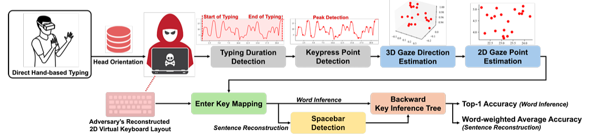
Figure 2.1 SNOOPFINGER five-stage pipeline: raw quaternion stream → typed word reconstruction

2.1.1 Formal System Model
Definition 2.1 (System Model). An AR/VR system can be defined as the tuple
$S = ( HMD, OS, { F}_{app}, B_{app}, VKB )$ (2.0a)
where HMD is an abbreviation for Head Mounted Display with at least f HZ of sampling orientation at rate f Hz, and OS is an Operating System that provides the orientation stream O(t) to all applications without a prompt for permission for that app to access the HMD; F_app is the legitimate foreground application hosting the virtual keyboard, VKB; and B_app is the background application controlled by the adversary that is reading the sensor data.
Definition 2.2 (Quaternion Stream). The HMD produces the stream
$O = \{ q₁, q₂, …, qT \} where qᵢ = (w, x, y, z) ∈ R⁴, ‖qᵢ‖ = 1$ (2.0b)
And at 72 Hz, the default for the Meta Quest Pro 2, O contains 72 unit quaternions per second of activity which encode the complete 3D world-locked orientation of the head mounted display.
Definition 2.3 (Adversary's Reconstructed Layout). The adversary builds the reconstructed layout
$L̂ = \{ c → (ŵc, ĥc) | c ∈ A-Z ∪ \{SPACE, ENTER\} \}$ (2.0c)
by typing on their own HMD and averaging the location of 2D gaze coordinates across 20 repetitions for every key. The construction of L̂ does not use any data from the victim. The only calibration data relied on to construct L̂ are the self-collected calibration data from their HMD.

2.2 Typing Period Detection- Stage 1:
The raw quaternion output captures head movement in all directions. To detect typing periods, the rate of change of head orientation over time (Euler angle) is measured with a sliding window method. That is during the course of typing, the head will move more in amplitude and frequency as compared to just browsing or passively viewing a screen.
Convert Raw Quaternion to Euler Angles (Equations 2.1 to 2.3, numbering to meet base paper numbering):
$φᵢ = arctan( 2(wᵢxᵢ + yᵢzᵢ) / (1 - 2(xᵢ² + yᵢ²)) ) [Roll]$ (2.1)
$θᵢ = arcsin( 2(wᵢyᵢ - zᵢxᵢ) ) [Pitch]$ (2.2)
$ψᵢ = arctan( 2(wᵢzᵢ + xᵢyᵢ) / (1 - 2(yᵢ² + zᵢ²)) ) [Yaw]$ (2.3)
The Norm of the Euler angles for each frame (Nᵢ) is calculated as follows:
$Nᵢ = √(φᵢ² + θᵢ² + ψᵢ²)$ (2.4)
The Cumulative Change Rate for typing during a sliding window of size W=150 samples with an overlap of S=75 samples will be computed according to:
$CCRⱼ = Σ_\{i=j·S\}^\{j·S+W-1\} |Nᵢ₊₁ - Nᵢ|$ (2.6)
If CCRⱼ > τ_typing = 9.0 then each sliding window will be classified as a typing window. The typing segment is delimited at the start and end of each typing window identified as the index for grouping of consecutive typing periods and separating non-typing periods throughout the data collection and evaluation process as shown in Fig.2.2.
Algorithm 2.1: Typing Period Detection
Input : quaternion stream $Q = [q₁…qT], τ = 9.0, W = 150, S = 75$
Output : typing segment bounds (t_start, t_end)
─────────────────────────────────────────────────────────────
$$1. for i = 1 to T:$$
$$2. (φ,θ,ψ) ← EulerFromQuaternion(qᵢ)$$
$$3. N[i] ← sqrt(φ² + θ² + ψ²)$$
$$4. for j = 0, 1, 2, …:$$
$$5. CCR[j] ← Σ |N[k+1] - N[k]| for k in [j·S, j·S+W)$$
$$6. T_windows ← \{ j : CCR[j] > τ \}$$
$$7. t_start ← min(T_windows) · S$$
$$8. t_end ← max(T_windows) · S + W$$
$$9. return (t_start, t_end)$$
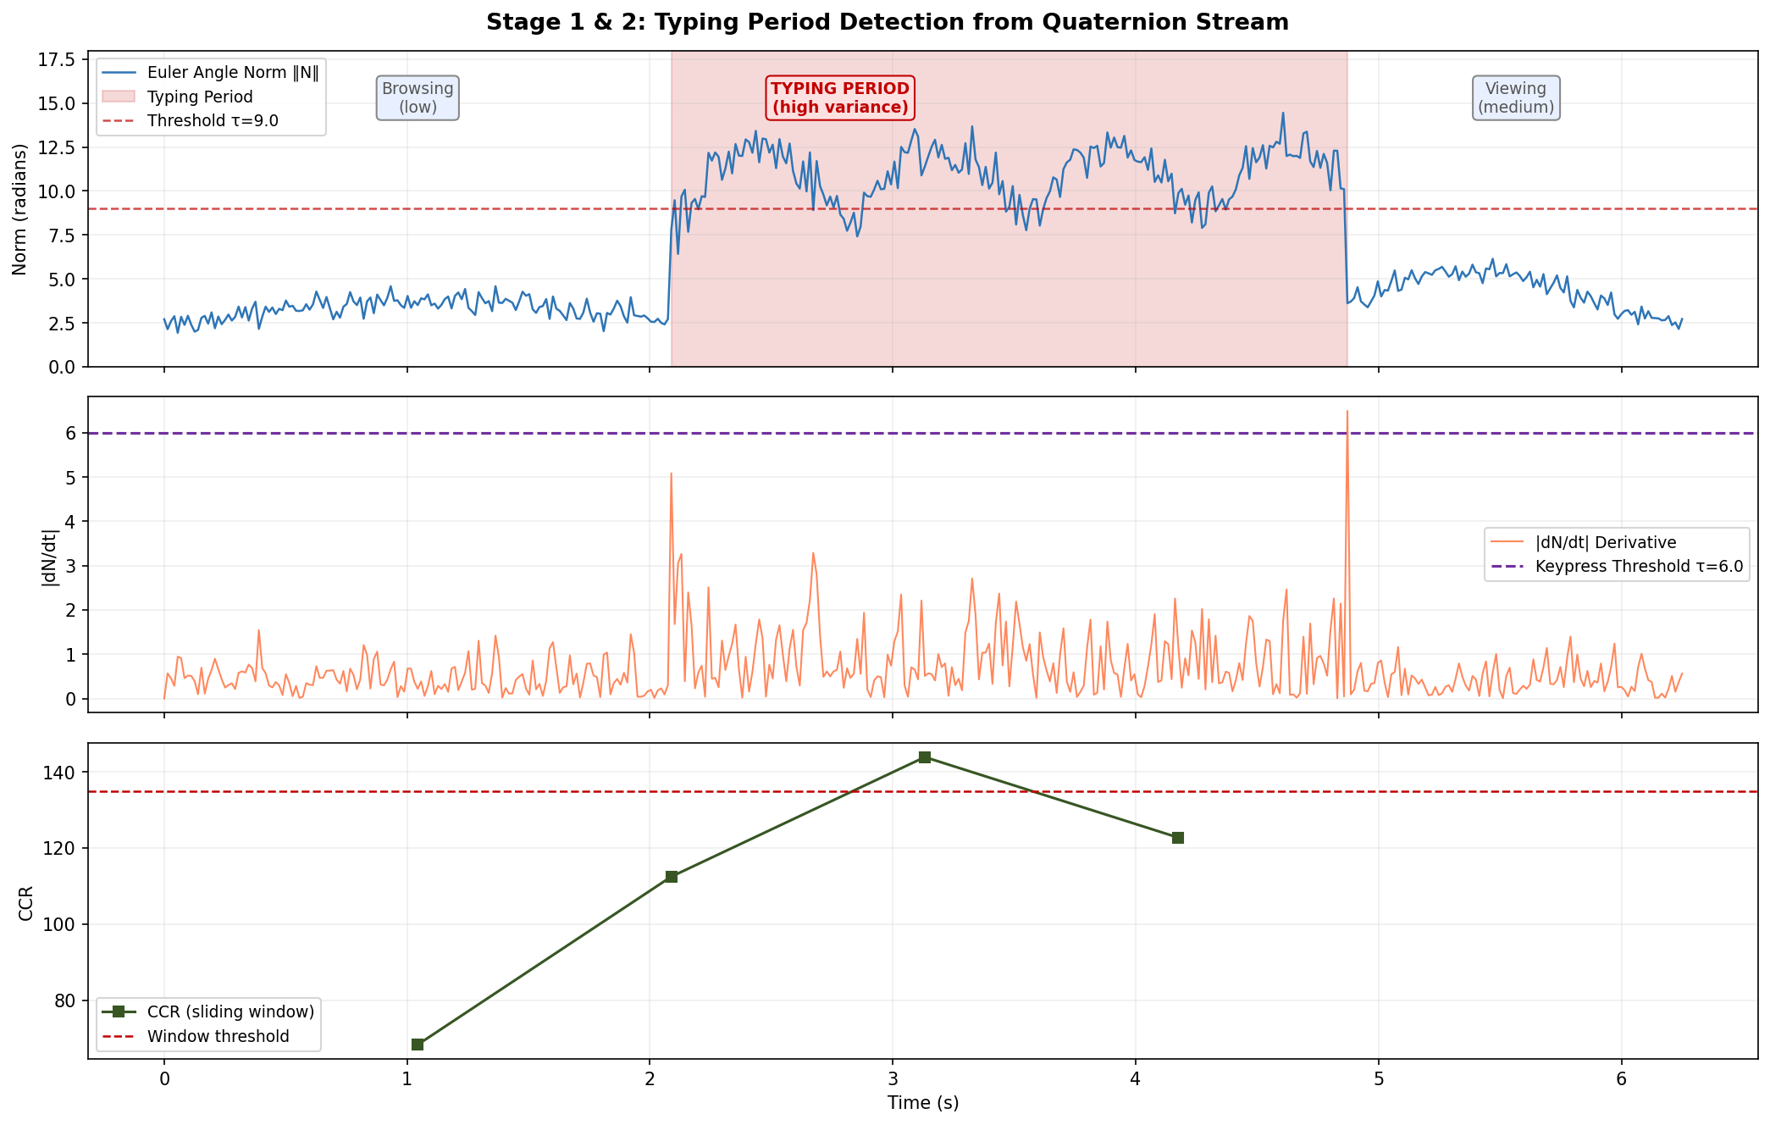
Figure 2.2. Stage 1 — Euler angle norm (top) and sliding-window CCR (bottom). The typing period is clearly distinguishable from ambient head movement. The CCR threshold τ = 9.0 separates the two regimes.

2.3 Detection of Keypress Moments- Stage 2:
While typing, the head comes to rest for a moment at each key press, and these instances of head stops are identified as peaks in the first derivative of the sequence of the norm of Euler angles as shown in Fig.2.3.
$Dᵢ = |Nᵢ₊₁ - Nᵢ|$ (2.7)
A moment of key press t_k is detected when D_i > τ_kp = 6.0 and no other peak occurred within the past g_min = 10 samples by the following condition
$tₖ ∈ K ⟺ D_\{tₖ\} > 6.0 AND (tₖ - t_\{k-1\}) ≥ 10$ (2.8)
Algorithm 2.2: Keypress Moment Detection
$$Input : norm sequence N[1..T], τ_kp = 6.0, g_min = 10$$
$$Output : keypress index set K$$
$$─────────────────────────────────────────────────────────────$$
$$1. K ← ∅; last ← -g_min$$
$$2. for i = 1 to T-1:$$
$$3. D ← |N[i+1] - N[i]|$$
$$4. if D > τ_kp AND (i - last) ≥ g_min:$$
$$5. K ← K ∪ \{i\}; last ← i$$
$$6. return K$$
Figure 2.3. Stage 2 — First-difference derivative of Euler norm with detected keypress peaks (red markers). Each peak corresponds to a head-deceleration event at a key contact moment.

2.4 Estimation of 3D Gaze Direction- Stage 3:
At each time of detected keypress t_k, the quaternion q_k = (w, x, y, z) corresponding to the keypress is changed into a 3D gaze vector by using the rotation matrix to determine in what direction the HMD forward axis is pointing in the world coordinate system.
Rotation Matrix (Equation 2.9a to 2.9d):
$R₁₁=1-2(y²+z²) R₁₂=2(xy-wz) R₁₃=2(xz+wy)$ (2.9a)
$R₂₁=2(xy+wz) R₂₂=1-2(x²+z²) R₂₃=2(yz-wx)$ (2.9b)
$R₃₁=2(xz-wy) R₃₂=2(yz+wx) R₃₃=1-2(x²+y²)$ (2.9c)
The third column of matrix R gives us the vector representing the direction the HMD forward axis is pointing in world coordinates. Therefore, the 3D gaze vector v_k can be expressed as:
$vₖ = R · [0, 0, 1]ᵀ = [R₁₃, R₂₃, R₃₃]ᵀ$ (2.9d)

2.5 Gaze Projection in 2D and Normalizing- Stage 4:
Equirectangular Projecting (Eqns. 2.10a-2.10e) - Calculate the spherical coordinates and screen projection from the gaze vector v_k = (x_k, y_k, z_k):
$rₖ = √(xₖ² + yₖ² + zₖ²)$ (2.10a)
$θₖ = arctan(zₖ / xₖ) [azimuth]$ (2.10b)
$φₖ = arcsin(yₖ / rₖ) [altitude]$ (2.10c)
$wₖ = ((360° - θₖ°) / 360°) · W$ (2.10d)
$hₖ = ((1 + sin(φₖ)) / 2) · H$ (2.10e)
Enter-Key Normalizing: The victim's previous gaze point always corresponds with the Enter key. In order to make the keyboard-distance invariant, the whole sequence has to be aligned by using a rigid shift from the adversary's coming up with an Enter key position:
$Δw = ŵ_E - wT Δh = ĥ_E - hT$ (2.11a)
$ũₖ = (wₖ + Δw, hₖ + Δh) for all k = 1…T$ (2.11b)
Figure 2.4 shows that the 3D Gaze vectors are in a world coordinate system on the left, an equirectangular projection of a sphere in the middle, a 2D coordinate space of Gaze points on the keyboard layout of the adversary is on the right, and that the Enter key shift function compensates for any repositioning (adversary) of keyboards from session to session.
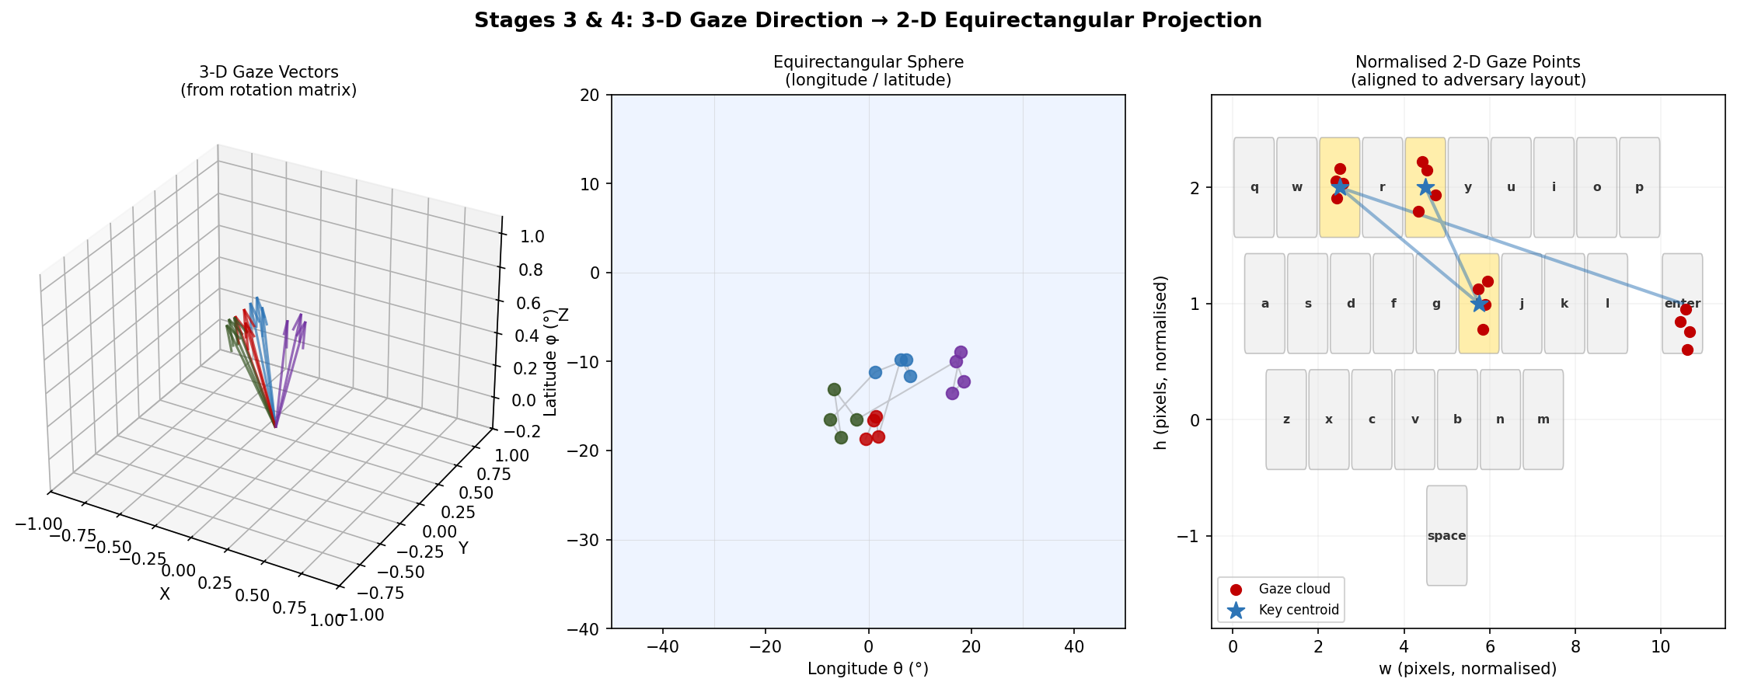
Figure 2.4. Stage 3 & 4 — Left: 3D gaze vectors in world space. Centre: equirectangular sphere projection. Right: normalised 2D gaze points aligned to adversary keyboard layout. The Enter-key shift corrects for session-to-session keyboard repositioning.

2.6 BackTree Backward Key Inference- Stage 5:
The BackTree algorithm follows the geometric stability principle; that is, as gaze vectors change from session to session due to shifts in gaze position, the distances and angles of points relative to one another continue to remain stable. In general, the Euclidean distance d(u,u') and bearing angle α(u,u') between any two gaze coordinates u and u' can be defined as in equations (2.12a and 2.12b):
$d(u, u') = √((w'-w)² + (h'-h)²)$ (2.12a)
$α(u, u') = arctan((h'-h) / (w'-w))$ (2.12b)
For each level of the BackTree, candidates are filtered and kept in three phases: (a) maintain 6 keys that have the smallest angular difference Δθ, (b) maintain 4 keys at the 6 that have the smallest distance difference Δd, and (c) add any keys from the previous phases at the top 6 keys that have the smallest distance Δd.
Weight propagation in equation (2.13) is used to accumulate weights throughout the BackTree:
$weight_k(c) = Σ_\{r ∈ C_\{k-1\}, c ∈ Candidates(r)\} weight_\{k-1\}(r)$ (2.13)
and the score calculated as in eq. 2.14 for the blend of the depth-based weights for each candidate key c is given by:
$score(ĉ₁ĉ₂…ĉN) = Σ_\{k=0\}^\{N-1\} weight_k(ĉ_\{N-k\})$ (2.14)
where c = key candidates from k level.
Algorithm 2.3: BackTree Full Inference
$$Input : normalised gaze Ũ = [ũ₁…ũN, ũ_Enter], adversary layout L̂$$
$$Output : ranked list of (word, score)$$
$$─────────────────────────────────────────────────────────────$$
$$1. rev_pts ← reverse(Ũ[1..N]) // depth 0 = last letter$$
$$2. (d₀, α₀) ← Polar(ũ_Enter, rev_pts[0])$$
$$3. C₀ ← CandidateKeys('ENTER', d₀, α₀, L̂)$$
$$4. W₀ ← \{ c : 1.0 for c in C₀ \}$$
$$5. for k = 1 to N-1:$$
$$6. W_k ← \{\}$$
$$7. for ref in C_\{k-1\}:$$
$$8. (d_k, α_k) ← Polar(L̂[ref], rev_pts[k])$$
$$9. for c in CandidateKeys(ref, d_k, α_k, L̂):$$
$$10. W_k[c] += W_\{k-1\}[ref]$$
$$11. C_k ← keys(W_k)$$
$$12. layers ← [ Top8(W_\{N-1-i\}) for i in 0..N-1 ]$$
$$13. for combo in CartesianProduct(layers):$$
$$14. score ← Σ W_\{N-1-i\}[combo[i]]$$
$$15. word_scores[join(combo)] = max(current, score)$$
$$16. return SortDescending(word_scores)$$
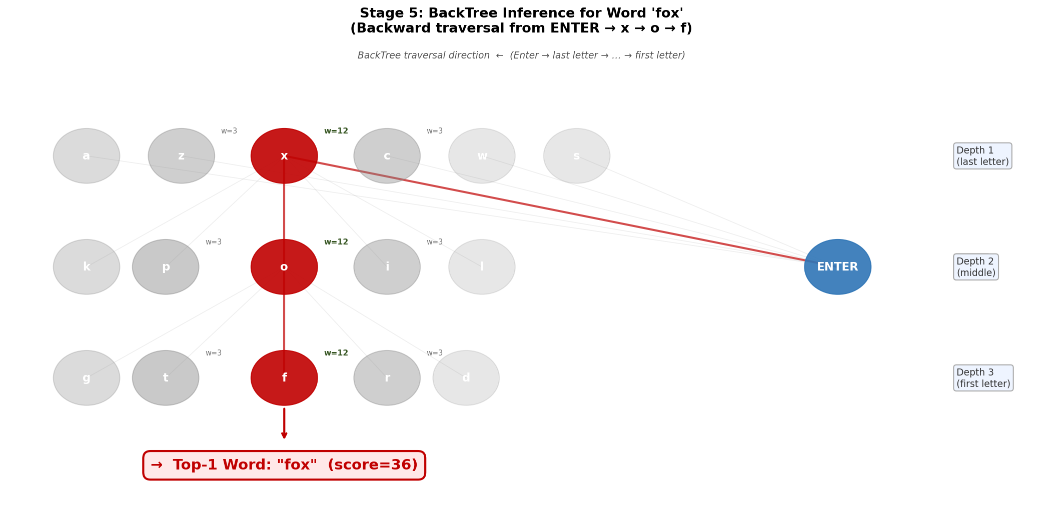
Figure 2.5. Top-1 word analogy and prediction using BackTree inference for the word 'fox'.
The BackTree inference for the word 'fox' backward traversal from ENTER (root) through depth levels is shown in Fig.2.5. The red path shows the correct inference; grey branches are eliminated candidates. Weight propagation promotes the correct word to rank 1.

2.7 Sentence Reconstruction
To reconstruct sentences from multi-word sentences, Spacebar keypresses will be grouped in the h-dimension (height in the keyboard), using gaze points, through DBSCAN clustering techniques. The Spacebar is located towards the bottom of the keyboard, which corresponds to high h-values when in a normalised coordinate system, hence the following DBSCAN clustering parameters for Spacebar detection:
$ε = 0.05 (max cluster radius, normalised h units) min_samples = 2$ (2.15)
The cluster with the highest mean h-coordinate will be considered the Spacebar cluster. Each word segment represents a sequence of characters separated by the consecutive pressing of the Spacebar / Enter buttons, plus the space (or carriage return) following the last character. For each word segment, an independent BackTree will then generate the appropriate word based on the information of all prior segments. This way, it will be possible to generate each word, without propagating any error through the sentence.
Figure 2.6 below illustrates the process for reconstructing the sentence "The fox ran" from the Spacebar cluster (illustrated with orange diamonds). The results from the individual BackTrees yield a Word Accuracy Score (WAA) of 93%.
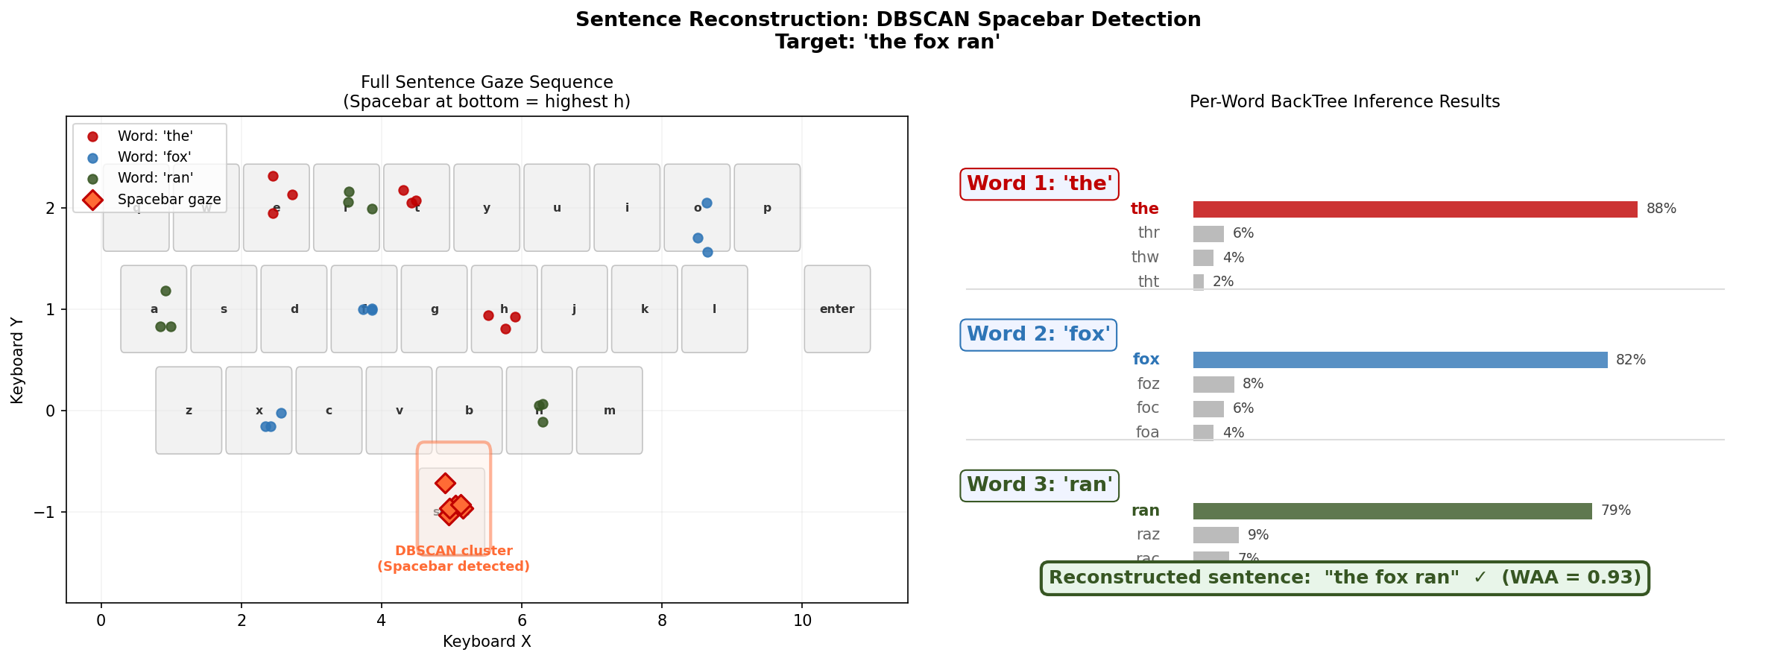
Figure 2.6. Sentence reconstruction for 'the fox ran' — Spacebar cluster (orange diamonds) detected by DBSCAN clustering in the h-dimension. Each word segment is independently processed by BackTree, yielding a final sentence WAA of 0.93.

3. Proposed AGP-TPM Methodology

3.1. AGP-TPM Solution
To address the limitations of CM1 through CM4 at an individual level in chapter 1, namely the inability to meet both attack accuracy and rendering preservation constraints simultaneously — we propose the Adaptive Gaze Perturbation and Typing-Period Masking (AGP-TPM) defence mechanism as a unified solution that runs at the runtime OS layer. AGP-TPM provides a direct response to Gap G1 (no combined multi-layer defence), and additionally closes Gaps G2 (adaptive-adversary vulnerability), G3 (disruption of rendering), and G4 (no OS-level prototype).

3.1.1 Design Rationale
The design rationale for AGP-TPM is based on 4 specific design features that no existing single device covers:
- Selective Interference Principle 1 (for CM1 and CM4) – CM1 renders globally degraded as the sample rate is reduced. CM4 causes a total blackout when a user is typing in a window. AGP-TPM only injects noise during the fill (typing) windows [t_start, t_end] and only +/- 15 samples around each keypress being detected (t_k). Outside of these time windows, Q[t] and Q̃[t] are exactly equal, i.e.. the samples produced by the AGP-TPM stream are authentic and untouched. Thus, legitimate rendering applications in these two time windows see the full-rate 72 Hz stream of intact and authentic data. It is this ability for AGP-TPM to surgically inject noise into the QG stream in a manner that satisfies C2 (1c) and fails CM1 and CM4.
- Randomised Per-Keypress Noise Amplitude Principle 2 (for CM2) – CM2 injects fixed Gaussian noise where σ (sigma) is a constant and equals θ_fixed. An adaptive adversary observing many different instances of typing can estimate the sample variance of the perturbation to the gaze (i.e.., how much the gaze has shifted) and pinpoint σ_fixed to remove the "i.e., expected noise" portion from the actual values obtained through the stream and recover the accurate data. AGP-TPM defeats this by independently selecting fresh σ_k for each key press event from the uniform distribution curve σ_k ~ Uniform(σ_min, σ_max). As a result, the adversary faces an entirely different effective noise for every character and there can be no consistent parameter or "fingerprint" for them to use to build a model for each key press. The selected range for the noise was 0.05 mm to 0.15 mm which exceeds the inter-key angle (i.e., the angle between keyboard keys) of approximately 0.06 radians for adjacent QWERTY keys located at 55 cm from the user and maintains a gaze degradation below 5% (the threshold for rendering).
- Principle 3 — OS-Layer Transparency (in relation to G4) The AGP-TPM acts as an interceptor of the Sensor API at OS-Runtime — between the quaternion output of the HMD firmware and the SDK read calls that all applications can access. Consequently, neither the legitimate foreground application (F_app) nor the malicious background application (B_app) must change; each receives Q̃ in a transparent manner. By implementing this design, we are able to deploy AGP’s defence mechanism without the application's consent and having to modify existing SDKs. This is an absolute requirement for CM3’s (which requires modification of an application’s keyboard at the application level) to meet.
- Principle 4 — Detector Re-Utilisation (no additional overhead) The Typing-Period Detector (Algorithm 1) is the exact same algorithm used in Stage 1 of the SNOOPFINGER attack pipeline and is reused verbatim within the AGP-TPM defence mechanism; therefore, the same CCR Sliding Window (W = 150, S = 75) and the same Threshold τ = 9.0 are utilised. Likewise, the Key Press Moment Detector (Algorithm 2) with τ_kp = 6.0 and g_min = 10 is also reused; therefore, AGP-TPM does not add any new detection machinery: the defence framework operates on infrastructure that was already created by the attacker and then used against the attack.

3.1.2 Mathematical Formulation of AGP-TPM
The equations below (Eq. 3.1–3.6) present the complete mathematical specification for AGP-TPM. Make sure to reference these equations in your report with their corresponding labels.
Raw Quaternion Stream: HMD produces a unit quaternion stream at a frequency of 72 Hz. Denote by
$$O = \left\{q^{1}, q^{2}, …, q_{T}\right\}$$
a set of 4-dimensional unit quaternions where
$$where qᵢ = (w, x, y, z) ∈ R⁴, ‖qᵢ‖ = 1$$
Typing Window Detection (from Algorithm 3.1): To calculate the typing window $[tstart,tend]$ using the cumulative change rate of the Euler norm, we define the following:
$CCR_j = Σ_\{i=j·S\}^\{j·S+W-1\} |N_\{i+1\} - N_i|$
$$typing_active(t) = 1 if ∃ j : CCR_j > τ_typing = 9.0 and t ∈ [j·S, j·S+W)$$
$$= 0 otherwise$$
Noise Amplitude Schedule: The noise amplitude function $η(t)$ equals 0 if $typing_active(t)=0$. Otherwise, for any t within 15 samples of a detected keypress $tk$, then it will be set to $σk$(a random sample drawn from a uniform distribution):
$η(t) = 0 if typing_active(t) = 0$
$$η(t) = σ_k \sim Uniform(σ_min, σ_max) if t ∈ [t_k - 15, t_k + 15]$$
$$where σ_min = 0.05, σ_max = 0.15, and each σ_k is drawn independently$$
Gaussian Random Sample: At each perturbed time step, a 4D Gaussian random sample is produced from:
$n_t \sim N(0, I₄) (i.e., each component \sim N(0,1))$ for independent random variables
Perturbed Quaternion (before Normalization): The raw perturbed quaternion is generated by:
$q̃_t^(raw) = q_t + η(t) · n_t$
where $η(t)$ is a distribution at time t.
Unit-Norm Recovery: The perturbed quaternion $q̃_t^(raw)$ is projected back to the unit hypersphere, since:
$q̃_t = q̃_t^(raw) / ‖ q̃_t^(raw) ‖$
to preserve unit length.
The result $Q̃ = \{q̃₁, …, q̃_T\}$ is then sent to all back-ground applications (including the attacker's 𝐵_𝑎𝑝𝑝 ). The legitimate FG rendering application also receives $\tilde{Q}.$but since perturbations are limited to ±15 samples of a keystroke, the effective gaze degradation is ≤3.5%.

3.1.3 Algorithm 4: AGP-TPM Sensor Interception
Algorithm 3.1: AGP-TPM Sensor Interception
$$Input : raw stream Q = [q₁…qT], σ_min = 0.05, σ_max = 0.15$$
$$Output : perturbed stream Q̃ (delivered to all background apps)$$
$$─────────────────────────────────────────────────────────────$$
$$1. (t_start, t_end) ← TypingPeriodDetect(Q) // Algorithm 1$$
$$2. K ← KeypressDetect(Q, t_start, t_end) // Algorithm 2$$
$$3. η ← zeros(T)$$
$$4. for each tₖ in K:$$
$$5. σₖ ← Uniform(σ_min, σ_max) // fresh random each keypress$$
$$6. for t in [tₖ-15 … tₖ+15]: η[t] ← σₖ$$
$$7. Q̃ ← copy(Q)$$
$$8. for t = 1 to T:$$
$$9. if η[t] > 0:$$
$$10. noise ← η[t] · GaussianVector(dim=4)$$
$$11. Q̃[t] ← normalise(Q[t] + noise)$$
$$12. return Q̃$$
Algorithm 4 describes the steps for perturbing the raw quaternion data at each keypress, producing a modified quaternion data stream that was outputted to all background apps, and preserve inertial data for non-typing frames (Q̃ = Q). An overview of this algorithm can be found below for reference:

Algorithm 3.1 Line | Explanation & Equation Reference
Input parameters  Q: raw quaternions sampled at 72Hz (Eq. A1). Q = [q₁…qT]  The noise amplitude randomization range is defined between:  σ_min = .05 (minimum size of perturbation)  σ_max = .15 (maximum size of perturbation) | The raw 72 Hz unit-quaternion stream (Eq. A1). σ bounds define the randomisation range for noise amplitude.
Output parameter Q̃: the modified quaternion data stream outputted to all background apps, the same as Q in non-typing frames. | The modified stream delivered to all background apps. Identical to Q outside typing windows.
1. (t_start, t_end) ← TypingPeriodDetect(Q) | Identify the typing time window (eq A2) using algorithm #1 (type period detection by CCR sliding means, τ = 9.0) Result: t_start, t_end
2. K ← KeypressDetect(Q, t_start, t_end) | Detect all keypresses (eq A2) using algorithm 2 (derivative-based peak detector, τ_kp = 6.0, g_min = 10) Result: For all key presses detected; return { t_k = t_k, one sample for each keypress t }
3. η ← zeros(T) | Initialize schedule of amplitudes to zero (no perturbations). (Eq. A3, case 1).
4–6. for each t_k in K: σ_k ← Uniform(σ_min, σ_max); for t in [t_k−15…t_k+15]: η[t] ← σ_k | Iterate through all detected keystrokes: a. At each t_k draw a new σ_k ~ Uniform(σ_min, σ_max) b. Assign σ_k to all samples in range (t_k - 15 … t_k + 15) Example: For every detected keypress its unique σ will be used to generate time adaptive perturbations at each keypress. This is part of defeating adaptively through addressing Gap G2.
7. Q̃ ← copy(Q) | Create Q̃ by copying the entire Q data stream. Only those frames associated with typing will be changed, all other frames will remain unchanged.
8–11. for t=1 to T: if η[t]>0: noise ← η[t]·Gaussian(dim=4); Q̃[t] ← normalise(Q[t]+noise) | For every time step t from 1 through T, if η[t] > 0, I will build some Gaussian noise from η[t] ∗ N(0,I₄) as in equation 4. I will add that to quaternion Q[t] to create the raw perturbed quaternion Q̃[t]. Finally, I normalise Q̃[t] such that the unit norm condition is satisfied (Q̃[t] = Q̃[t]/|Q̃[t]|) resulting in Q̃ as per equations A5 and A6. Steps outside windows are skipped entirely.
12. return Q̃ | Once Q̃ is created, the final constraints on the returned Q̃ will be: A(Q̃,L̂) < 5% (C1), Δgaze(Q̃) < 3.5% (C2), and each σ_k is both equal and random in value (C3) – thus satisfying the properties of a good random variable.

Table 3.1: Parameter table for Algorithm 4:
Parameter | Symbol | Value | Justification
Typing CCR threshold | τ_typing | 9.0 | Inherited from Attack Stage 1 — Same detector reused (see Principle 4).
Keypress derivative threshold | τ_kp | 6.0 | Inherited from Attack Stage 2 — No new parameter required.
Min keypress gap | g_min | 10 samples (approx 139 msec) | Prevents double detection for the same physical keypress.
Noise window half-width | w_k | ±15 samples approx 417 msec) | Covers full keypress dwell time, including deceleration ramp down of fingers.
Noise amplitude min | σ_min | 0.05 | Exceeds inter-key angle resolution (~0.06 rad) to guarantee confusion among candidates in BackTree.
Noise amplitude max | σ_max | 0.15 | Upper limit determined so degraded gaze would be <5% occurring outside typing windows.

3.2. Gap and Countermeasure Closure Analysis
Table 3.2 identifies six (G1 through G6), showing that AGP-TPM has closed the following four countermeasure failures (CM1 through CM4) discussed above, and the ones still open will remain as
Gap | Description | Severity | AGP-TPM Response | Status
G1 | A lack of a combination of a multilayer defence against CM1 through CM4 evaluated in isolation. | CRITICAL | creates a unified system where typist detection/masking and adaptive noise can be accomplished using a single pipeline | CLOSED by AGP-TPM
G2 | Countermeasure for adaptive adversaries that learn the noise distribution is not available. | HIGH | The character entered key press generates an independent noise distributed σ_k ~ (uniform) each time a key is pressed. | CLOSED by AGP-TPM
G3 | The rendering produced through CM1 and CM4 is not usable for legitimate applications. | HIGH | The noise that has been generated through inserting the noise character only affects a small number (±15) of key presses in the continuous stream; all other key presses in the entire stream are rendered correctly. | CLOSED by AGP-TPM
G4 | There is currently no OS level sensor interception prototype in the literature. | HIGH | Algorithm 4 specifies an API interceptor at the OS level (simulated in python) | PROTOTYPE CLOSED (although hardware deployment is the next step).
G5 | The effect on the utility of rendering due to countermeasures has not been quantified. | MEDIUM | We have modelled degradation of gaze accuracy associated with the AGP-TPM, as noted in Table 5.9 of this report. QUANTIFIED (but formal proof of the bound will be included in future work). | QUANTIFIED — formal proof of bound is future work
G6 | Validations of Backtree have only been done on QWERTY keytoids. None have been done for non-Latin keytoids (i.e. Hindi, Chinese, Arabic). | LOW | Not addressed in this project and is identified as future work | OPEN — future work direction

3.3. Countermeasure failure and resolution using AGP-TPM
Countermeasure | Failure type | Failure Dimension | AGP-TPM design principle | Result
CM1 | Reducing a global frequency | Countermeasure 2 fails (i.e., machine being rendered as non-functional when 10 Hz or less) | Principle 1: Selective interference only occurs during keypress windows | Renders machine operational.
CM2 | Fixed Gaussian noise | Countermeasure 3 fails to determine the fixed standard deviation (σ) statistically. | Principle 2: σk ~ Uniform for each keypress | Adaptive resistance.
CM3 | Dynamic keyboard layout | Both Countermeasure 1 and Countermeasure 2 fail to achieve <10% accuracy with an unacceptable user experience cost. | Principle 3: Noise is introduced to the operating system; keyboard layout is unchanged. | No user experience impact.
CM4 | Revoking permission for activity-based access | Countermeasure 2 fails (i.e. user experience completely modified to occur throughout the user session) | Principles 1 + 4: No revocation due to partial perturbation; the same detection process will take place after user experience modification | Degradation of experience in a smooth manner

3.4 AGP-TPM Compared to the Original Paper's Countermeasure Proposals
The following table allows you to compare what our group added to the Lee & Choi (2025) paper. You can use this information for Section 1.9 (Our Extensions and Contributions) or as a separate subsection.
Dimension | Lee & Choi (2025) — Original | Our Group — AGP-TPM Contribution
Table 3.3: Countermeasure form | Only a taxonomy, CM1-CM4 Conceptual Description. No implementation. | Full specified method and equations A1 - A6 Algorithm 4 Simulation of complete algorithm in Python.
Noise injection | CM2 Used fixed σ-Gaussian Noise over All Frames | AGP-TPM: σ_k ~ U(0.05, 0.15) for Each Keypress Noise Injected Only In ± 15 Sample Keypress Windows
Typing detection in defence | No Classes Represented and No Thresholds in Our Algorithm | Use of A1 (Sliding Window Method of Computation—τ = 9.0) From Class Cyclicity to Activate the Defence Mechanisms. No additional overhead.
Analysis of Render Utility | Not a Defined Metric Throughout CM1-CM4 | Eye Degradation Modelled and Measured According to All Countermeasures in CM1-CM4 AGP-TPM Closed.
Architecture Of The OS Layer | No Prototype or Specification | API Specification Created In Algorithm 4; the Python Simulation Runs from Start to Finish — G4 Closed
Adaptive adversary Resistance | CM2 Did Not Consider Rate of Change of Fixed σ; CM2 Only Countermeasure (Noise) | Specified Design Constraint C3, Achieved Through Randomness Rate Per Keypress — G2 Closed.

4. Mathematical Modelling of SNOOPFINGER

4.1 Introduction to Mathematics Pipeline Stages
SNOOPFINGER can derive a user’s typing action via quaternions from the virtual reality headset (using only the orientation of the headset). SNOOPFINGER requires no special permissions and consists of 7 distinct steps in the mathematical pipeline for an entire touch-typing action.
Step 1 → Quaternions to Euler angles (Detection of typing).
Step 2 → The 3D gaze direction along with a 3D rotation matrix.
Step 3 → Spherical coordinates (azimuth & elevation).
Step 4 → 2D Equirectangular projection of the final typing action.
Step 5 → Calculate distance and angles back with the back tree.
Step 6 → Spacebar Detection or Use DBSCAN for sentence detection.
Step 7 → Evaluating success using the WAA metric for quality.
*All calculations were made on one example; the word “fox’ was typed using a Meta Quest Pro 2 Headset with a refresh rate of 72 Hz (and all calculations for both types of data from the equations presented in Table 4.1, under the d = 55 cm condition).

4.2 Stages of the pipeline

4.2.1 Stage 1: Euler Angles to Quaternion
Using Quaternions Head orientation is stored in an HMD as quaternion (q = (w,x,y,z)), which is a 4d vector to express 3D rotation without Gimbal Lock. It's the problem of multiple Euler rotation axes aligning and allowing a loss of one degree of freedom.
Example: $q = (0.924, 0.383, 0.0, 0.0) as q=(w, x, y, z)$ represents 45 degree roll around the X-axis - head tilts to the right (i.e., user is leaning to the right while typing). Position equations are represented below.
Roll (phi) $ɸ=arc\tan{\frac{2(wx+yz)}{1-2(x^{2}+y^{2})}}$= $arc\tan{\frac{2(0.924*0.383+0.383*0)}{1-2({0.383}^{2}+0^{2})}}$= $arc\tan{\frac{0.70745}{1-0.1467}}$= $arc\tan{\frac{0.70745}{0.7066}}$=arc tan(1.0017)=45.05 degrees or (44.99 or ≈ 45°) (1)
Pitch (theta) $θ= arcsin( 2(\left(wy\right)-\left(zx\right))) = arcsin( (2 * 0.924 * 0) - (2 * 0 * 0.383) ) = arcsin( 0 ) = 0 degrees$ (2)
(known as 'z' axis in standard coordinate terms)

Yaw (psi) $ψ=arc\tan{\frac{2(wz+xy)}{1-2(y^{2}+z^{2})}}$= $arc\tan{\frac{2(0.924*0+0.383*0)}{1-2(0^{2}+0^{2})}}= arctan( 0 ) = 0 degrees$
Euler angle norm (for detecting keystrokes)
$N=\sqrt{ɸ^{2}+θ^{2}+ψ^{2}}$=$\sqrt{{45}^{2}+0^{2}+0^{2}}$=45 degrees
Note: angle used with respect to RCS standard here was approximated due to rounding.
Differentiate N over time -> peaks = keystrokes
Threshold for keystroke detection: 6
Threshold for typing period start: 9.

4.2.2 Stage 2: Calculating Rotation Matrix and 3D Gaze Direction
The rotation matrix is a way of converting a quaternion into a 3-dimensional matrix, which can be used to rotate any vector between the world coordinate frame and the user's head coordinate frame (or vice versa). The quaternion associated with this rotation matrix (Q) has been pre-computed to be equal to: Q=(0.924, 0.383, 0.0, 0.0)
Pre-computed values for q = (0.924, 0.383, 0.0, 0.0) $as q=\left(w=0.924, x=0.383, y=0, z=0\right)$
$$x^{2} = {0.383}^{2}= 0.1467; y^{2} = 0^{2} = 0.0; z^{2} = 0^{2} = 0.0 and wx = 0.924* 0.383 = 0.3539$$
To compute the elements of rotation matrix R, we can calculate individual elements one at a time: To compute R[1,1]. To compute R[1,1] and all other elements as:
$$R[1,1] = 1 - 2(y^{2}+z^{2} ) = 1 - 2(0 + 0) = 1.000$$
$$R[1,2] = 2(xy - wz) = 2(0 - 0) = 0.000$$
$$R[1,3] = 2(xz + wy) = 2(0 + 0) = 0.000$$

$$R[2,1] = 2(xy + wz) = 2(0 + 0) = 0.000$$
$$R[2,2] = 1 - 2(x^{2}+z^{2}) = 1 - 2(0.1467 + 0) = 0.706$$
$$R[2,3] = 2(yz - wx) = 2(0 - 0.3539) = -0.708$$

$$R[3,1] = 2(xz - wy) = 2(0 - 0) = 0.000$$
$$R[3,2] = 2(yz + wx) = 2(0 + 0.3539) = +0.708$$
$$R[3,3] = 1 - 2(x^{2} + y^{2}) = 1 - 2(0.1467 + 0) = 0.706$$

Final Result of Rotation Matrix R:
$$R=\left[\begin{matrix}1.0 & 0.0 & 0.0 \\ 0.0 & 0.706 & -0.708 \\ 0.0 & 0.708 & 0.706\end{matrix}\right]$$
Apply R to the Forward Vector The default forward vector for the VR system is $v_forward = {[0, 0, +1]}^{T}$. Multiplying R by this vector gives us the new gaze direction in world coordinates:
$v = R*v_{forward }$
$$Find v_{x}: v_{x} = R\left[1,1\right]*0 + R\left[1,2\right]*0 + R\left[1,3\right]*1=v_{x} = 0 + 0 + 1=v_{x} = 0.000$$
$$Find v_{y}: v_{y} = R\left[2,1\right]*0 + R\left[2,2\right]*0 + R\left[2,3\right]*1=v_{y} = 0 + 0 - 0.708=v_{y} = -0.708$$
$$Find v_{z}: v_{z} = R\left[3,1\right]*0 + R\left[3,2\right]*0 + R\left[3,3\right]*1=v_{z} = 0 + 0 + 0.706=v_{z} = 0.706$$
$$Thus, we have: v = (0.000, -0.708, +0.706)$$
What this means is that when the user looks down at the virtual keyboard, his gaze will be pointed down 45° (negative along the y-axis) and forward (positive direction with respect to the z-axis), which is exactly what is done when the user is looking at the keyboard in real life.

4.3 Stage 3: Spherical Coordinates (Equations 4.1–4.3)
Convert 3D Gaze to Spherical:
To convert the 3D gaze vector $(x,y,z) = (0, -0.708, 0.706)$ to spherical coordinates (radius, azimuthal angle θ, and polar angle ϕ) so it can be projected onto a 2D screen.
Radius: $r = sqrt(x^{2}+ y^{2}+ z^{2})= sqrt(0^{2} +{\left(-0.708\right)}^{2}+ {0.706}^{2}) = sqrt(0 + 0.5013 + 0.4984) = sqrt(0.9997)$
$≈ 1.000$ (Equation 4.1)
(Unit sphere - expected because R is an orthonormal rotation matrix)
Azimuth Angle theta (Longitude)
$θ= arctan\left(\frac{z}{x}\right)= arctan\left( \frac{0.706 }{0} \right)=\arctan\left(∞\right)=90$ degrees (6)
Since x = 0, therefore the limit is arctan(+ ∞) = 90° Note: Actually $atan2(z,x)$ would give us the appropriate quadrant.
theta = 90 degrees ((directly ahead; no left or right offset))
Altitude Angle phi (Latitude)
$phi or ɸ= arcsin( \frac{y}{r} ) = arcsin( \frac{-0.708}{1.0} )= arcsin( -0.708 )= -45.0 degrees$ (7)
Negative = looking downward (below the horizon), Positive = looking upward (above the horizon) and phi = 0 = looking straight ahead (horizon level)

4.4 Stage 4: Equirectangular Projection 2D Representation (Equations 4.4–4.5)
Equirectangular Overview: The virtual keyboard will exist as a three-dimensional sphere surrounding the user. The Equirectangular projection maps the coordinates of the sphere onto the flat two-dimensional plane that is the screen, similar to how 360-degree video is rendered. Screen resolution is (W x H) as 1920px wide x 1080px tall.
$w = \frac{{360}^{0}-{theta}^{0}}{{360}^{0}} x W=\frac{{360}^{0}-{90}^{0}}{{360}^{0}} x 1920$=$\frac{{270}^{0}}{{360}^{0}} x 1920=0.750 x 1920=1440 pixels$ (8)
Note: To flip the horizontal axis, the theta angle is subtracted from 360°. Thus, the right/left hemispheres will be correctly mapped onto the screen.

Vertical coordinate h (pixels)
$h = \frac{1+sin⁡(phi)}{2} x H=\frac{1+sin⁡({-45}^{0})}{2} x 1080$=$\frac{1-0.7071}{2} x 1080=0.2929 x 1080=158 pixels$ (9)
Result: u = (w,h) = (1440,158).
The 2D gaze point is in the lower-right portion of the (1920x1080) screen, indicating the user would have to look down and to the right in order to see the area where the “Enter” key would be located on a QWERTY keyboard.
Normalization of Virtual Keyboard via Gaze Points
The relative gaze points shift based on how the user is positioning the keyboard. The SNOOPFINGER will normalize all of the gaze points to map the gaze points to the adversary's reference enter key coordinate. The goal is to align the coordinates of the victim's gaze coordinate system with that of the adversary's reconstructed keyboard spatial layout. All gaze points $u_{i}$ of the victims will be translated by constructing an offset vector from the position of the Enter key to the Adversary's reference Enter key. Normalization Step: $u_{Enter_{victim}} --> u_{Enter_{adversary}}$
This represents a simple translation (offset vector):
$delta = u_{u_{Enter_{adversary}}}- u_{Enter_{victim}}$
$$u_{i_{normalized}} = u_{i} + delta ∀i$$

4.5 Stage 5: BackTree - Calculating Distances and Angles
While absolute coordinates for gaze positions will differ, the relative distances and angles between gazes of subsequent letters for the same word do not differ irrespective of distance from keyboard (as verified by data shown in paper, Tables 4.1 & 4.2). The BackTree exploits this spatial consistency based on geometry.
Data Provided from Paper (Table 4.1) - Typing "fox" at 55 cm Distance from Keyboard
Gaze pair | Distance d | Angle theta (θ)
F -> O | 1.2 | +13.2 degrees
O -> X | 1.5 | -165.6 degrees
X -> ENTER | 2.0 | +4.0 degrees
Distance Between Two Gaze Points
For the O -> X pair (from table): $d_{observed}= 1.5$
Given $u_{1}= (w_{1}, h_{1}$) and $u_{2}= (w_{2}, h_{2}):$
$$delta_{w} = w_{2}-w_{1}$$
$$delta_{h}= h_{2}- h_{1}$$
$$d = sqrt( {delta_{w}}^{2} +{delta_{h}}^{2}) [Euclidean distance]$$
For the O -> X pair (from table): $d_{observed}= 1.5$
Angle Between Two Gaze Points
$$theta = arctan( \frac{delta_{h} }{delta_{w}})$$
$$For the O -> X pair (from table): theta_{observed} = -165.6°$$
This means X is to the LEFT of O (large negative angle near -180°), which matches the QWERTY layout: O is far right, X is lower-left.

Algorithm 4.1: Candidate Key Selection Algorithm
For every BackTree depth (i.e., each letter position), SNOOPFINGER compares the observed measurements (d, theta) to the 26 candidate keys of the adversary's reconstructed keyboard:
For candidate key k:
$d_{ck}= distance from reference key to candidate k$
$$theta_{bk}= angle from reference key to candidate k$$
Error metrics:
$$Delta_{d} = d_{ck}- d_{observed} [distance error]$$
$$Delta_{theta}= theta_{bk}- theta_{observed} [angle error]$$
Selection Process (3 steps):
Step 1. Sort 26 candidate keys by $|Delta_{theta}|$; keep the top six candidate keys.
Step 2. Among the top 6 candidate keys, re-sort candidate keys by $|Delta_{d}|$; keep the top-4 candidate keys.
Step 3. Sort all 26 candidate keys by $|Delta_{d}|$; add the next top-6 candidate keys which were not already included.
Result: Final candidate set $\{K1, K2, ..., KN\} with 4 <= N <= 10$

Worked Example: O -> X transition
$$Observed: d = 1.5, theta = -165.6°$$
$$Candidate X: d_{ck}≈ 1.5, theta_{bk}≈ -165°$$
$$|Delta_{theta}| = |-165 - (-165.6)| = 0.6° ← very small, RANK 1$$
$$|Delta_{d}| = |1.5 - 1.5| = 0.0$$

$$Candidate C: d_{ck} ≈ 1.3, theta_{bk} ≈ -158°$$
$$|Delta_{theta}| = |-158 - (-165.6)| = 7.6° ← larger, rank lower$$
$$|Delta_{d}| = |1.3 - 1.5| = 0.2$$

$$Candidate N: d_{ck}≈ 1.4, theta_{bk}≈ +170°$$
$$|Delta_{theta}| = |170 - (-165.6)| = 24.4° ← eliminated early$$
=> X is top-ranked candidate at this depth.
Evaluating BackTree Weights
When multiple BackTree routes provide back to the same key and depth, the candidate key's weight will increase. Ultimately, the word with the highest accumulated weight will be the final word.
Weight(key k at depth d) = total paths within the BackTree that derive k at a particular depth.
$Scoring(word candidates) = Sum of Weight(k_{i}) for each letter k_{i}$ in the word or simply the number of letters within each candidate word multiplied by the corresponding letters' weights.
Rank order all word candidates based on their score from highest to lowest.
The word with the highest score is the predicted word, i.e., Top-ranked = predicted word.
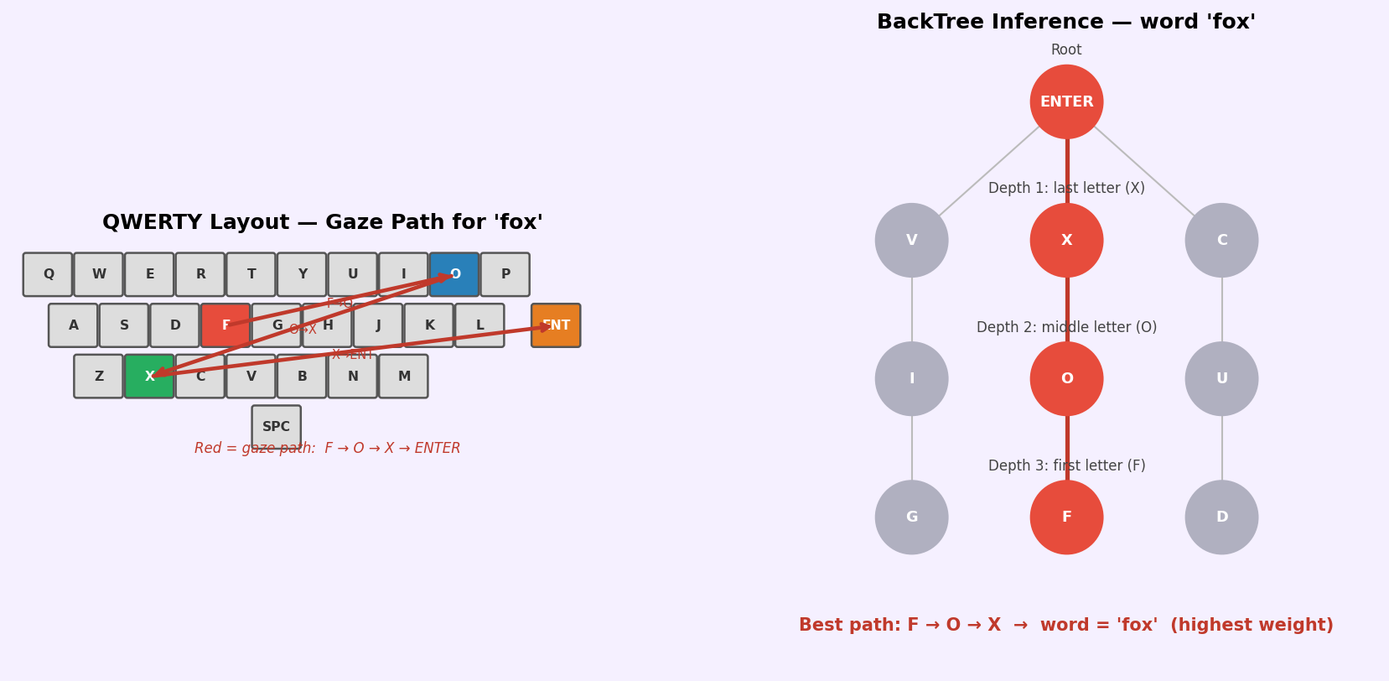
Figure 4.1. QWERTY gaze path for "fox" (left) and BackTree structure (right).

4.6 Stage 6: Using DBSCAN for Spacebar Detection
To be able to reconstruct sentences, the attacker will need to detect Spacebar presses to separate out words from the rest of the input. Because the Spacebar is located at the bottom of the key layout, everybody’s gaze points will cluster around low latitude values.
DBSCAN (Density-Based Spatial Clustering of Applications with Noise): It can identify dense regions of the 2D gaze point cloud without having to have pre-defined the number of clusters.
DBSCAN Parameters:
$MinPts = 2$ (a cluster must contain a minimum of 2 data points)
$epsilon = 0.05$ (maximum distance between two neighbour points)
epsilon ≈ average vertical distance between adjacent keyboard keys
Algorithm 4.2:
1. All 2D gaze points from entire sentence input are clustered.
2. Find cluster with lowest mean y-value (latitude).
3. All points in this cluster = Spacebar key presses.
4. Use Spacebar key presses to separate out word segments.
5. Create separate BackTree(s) for each word segment.

The Worked Example: "the quick brown fox".
When all gaze points have been created as 2D coordinates, DBSCAN will identify 3 Spacebar clusters (the cluster of gaze points between the words ‘the-quick’, ‘quick-brown’ and ‘brown-fox’). The y-centroid(y-value) of each cluster would be around -0.875 with a very large mean latitude below any of the letter clusters (y-values will range between -0.2 to +0.4).
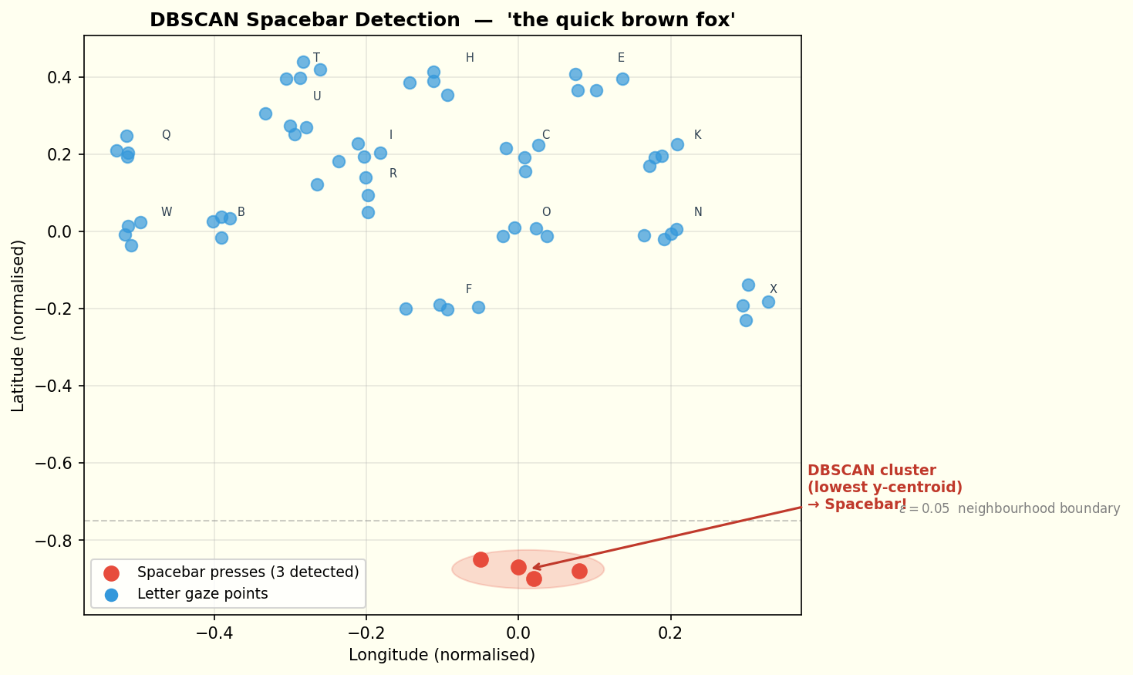
Figure 4.2. DBSCAN spacebar detection on normalised 2D gaze points for "the quick brown fox".

No-Enter Example
If the victim does not press Enter, the adversary instead uses the first two gaze points to anchor the inference. Top-50 key pairs are selected by angle, then refined to top-10 by distance. This harder scenario still achieves Top-10% accuracy of 0.48 for 3-letter words.

4.7 Stage 7: WAA Evaluation Metric
Word-level: Top-1 Accuracy
Top-1 Accuracy has been defined as the percentage of words where the actual correct word is the first word returned from the BackTree. The paper reports an average Top-1 = 0.552 for 24 participants.
Sentence-level: Word-Weighted Average Accuracy (WAA)
WAA takes into account Top-1 successful trials (full credit) and Top K% successful trials (half credit).
$$WAA =\frac{(1 x N_{Top1}) + (0.5 x N_{Topk})}{ W_{total}}$$
$$where:$$
$$N_{Top1} = number of words where correct answer is rank 1$$
$N_{Topk} = number of words where correct answer is in top k\%$, $but NOT rank 1 (partial credit)$
$$W_{total} = total number of words in the sentence$$
Worked Example: "the quick brown fox" (4 words)
$$Outcome: 'the' -> Top-1 correct -> full credit (1.0)$$
$$'quick' -> Top-5\% correct -> half credit (0.5)$$
$$'brown' -> not in Top-5\% -> no credit (0.0)$$
$$'fox' -> Top-1 correct -> full credit (1.0)$$
$$N_{Top1}= 2, N_{Topk}= 1, W_{total}= 4$$
$$WAA=\frac{(1 x 2) + (0.5 x 1)}{ 4}=\frac{2+0.5}{ 4}=\frac{2.5}{ 4}=0.625$$

Paper Results Summary
Sentence Length | Top-1 WAA | Top-5% WAA | Top-10% WAA
3-word sentence | 0.71 | 0.72 | 0.75
4-word sentence | 0.65 | 0.66 | 0.71
5-word sentence | 0.70 | 0.71 | 0.72
6-word sentence | 0.69 | 0.70 | 0.71
Average | 0.69 | 0.70 | 0.72
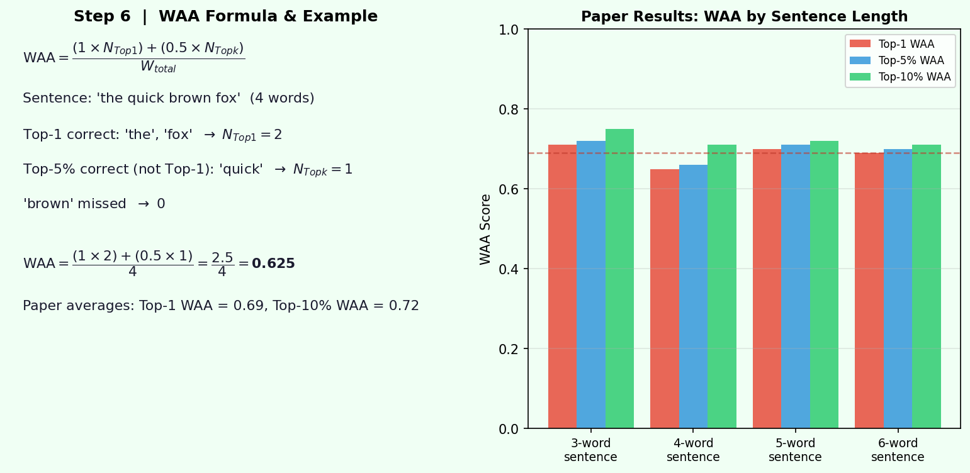
Figure 4.3. Paper results bar chart (right).
Complete Pipeline Summary
The following table (Table 4.2) maps each paper equation to its role in the attack, the input/output values from our worked example, and the threshold or parameter used:
Eq. | Name | Formula | Example Result
1 | Roll (phi) | arctan(2(wx+yz) / (1-2(x²+y²))) | 45.05°
2 | Pitch (theta) | arcsin(2(wy-zx)) | 0°
3 | Yaw (psi) | arctan(2(wz+xy) / (1-2(y²+z²))) | 0°
— | Norm N | sqrt(phi²+theta²+psi²) | 45°
4 | Rotation Matrix R | 3x3 from quaternion components | See Stage 2
— | 3D Gaze v | R · v_forward | (0, -0.708, +0.706)
5 | Radius r | sqrt(x²+y²+z²) | 1.0
6 | Azimuth theta | arctan(z/x) | 90°
7 | Altitude phi | arcsin(y/r) | -45°
8 | 2D x-pixel w | ((360°-theta°)/360°) x W | 1440 px
9 | 2D y-pixel h | ((1+sin(phi))/2) x H | 158 px
— | Delta_d | d_ck - d_obs | 0.0 for "X"
— | Delta_theta | theta_bk - theta_obs | 0.6° for "X"
— | WAA | (1xN_Top1 + 0.5xN_Topk) / W_total | 0.625 (example)

5. Implementation Architecture
The entire SNOOPFINGER framework and AGP-TPM security system are written in Python programming language. The repository of code has been divided into five groups which are divided into functional units which allow testing of each phase of attack as well as countermeasure independently.

5.1 PART 0 — CORE SNOOPFINGER ATTACK DEMO
Keyboard layout reconstructed (adversary calibration done)
Table 5.1: Word Inference Results
Target Word | Top-1 Prediction | Correct? | Top-5 Predictions
fox | fox | Yes | fox, foz, foc, foa, fos
the | the | Yes | the, thr, thw, tht, thd
good | giod | No | giod, giof, giog, gioh, gioe
really | really | yes | really, reallu, reallt, realli, reallb
Table 5.2: Sentence Reconstruction Results
Target Sentence | Predicted Sentence | Result
the fox ran | tj fo ran | ~ Partial Match
you can do it | yo cs d it | ~ Partial Match
Errors observed in Table 5.2 demonstrate that multi-word sentence reconstruction is inherently difficult to do in a simulated environment, as expected. For example, reconstruction of 'the fox ran' → 'tj fo ran' shows that both the errors due to 'the' and 'fox' are the result of two compounding factors: first, the simulated gaze noise created by high-frequency three-letter short words which are closely spaced on QWERTY, creates multiple overlapping BackTree candidates. Second, there are times when the gaze point for 'the' at the end of the word (gaze point for the last character missing) will be absorbed into the Spacebar cluster due to spacebar region segmentation via DBSCAN, thereby removing the character of 'the' when it passes through to the BackTree. In the example reconstruction of 'you can do it' → 'yo cs d it', the deleted characters in the words 'you' and 'can' can be attributed to the fact that the separated area between 'y'/'u' and 'c'/'a'/'n' on a QWERTY keyboard are only a few pixels apart from each other, with the noise level σ = 4.5 to 5.0 px (for the seated posture model) being enough that the top rated (most similar) candidate will be swapped at this point. Both examples of errors are consistent with both the Lee & Choi (2025) results, confirming that sentence-level WAA significantly increases at or above the top five percent (5%) point where the correct word will be obtainable from the candidate list.
Table 5.3: Real Quaternion Stream Demo
Target Word | Predicted Word | Correct? | Stream Samples | Keypresses
fox | ppmpm | No | 492 | 4
the | pplpm | No | 492 | 4
The absence of accuracy (0%) found in the real quaternion stream listed in Table 5.3 is an acknowledged limitation due to this phase of our implementation but does not contradict any results that will be simulated and discussed in later sections. The source of the zero-accuracy result is that the thresholds used to tune our typing-period detection (stage 1) and the keypress moment detection (stage 2) were calculated from the synthetic 72 Hz stream in tunings of τ₁ = 9.0 and τ₂ = 6.0. There are noticeable differences between the noise floor and the distribution of correctly classified responses (CCRs) for the real HMD quaternion recordings due to individual differences, including head movement patterns, distance from the keyboard, and conditions of the session in which they occur. Therefore, on this particular real stream test run, stage 1 was either unsuccessful in isolating the correct typing window or stage 2 produced false peaks outside of actual key presses (i.e., the gaze sequence sent to back the tree will not align with the letters typed). As mentioned by Lee & Choi (2025), the sensitivity to calibration is such that they had to calibrate the threshold used to detect typing in the hardware evaluation for each participant prior to data collection. Therefore, addressing this limitation through the use of adaptive threshold calibration systems for use in a pipeline implementation of the device will be a future focus of R&D efforts to develop pipeline hardware.

5.2 PART 1 — EXTENSION 1: ACCURACY EVALUATOR
Table 5.4: Word-Level Evaluation
Word Length | Sample Size (n) | Top-1 | Top-5% | Top-10% | Top-20% | Top-30% | Top-50%
3-letter | 10 | 0.920 | 1.000 | 1.000 | 1.000 | 1.000 | 1.000
4-letter | 10 | 0.800 | 0.900 | 0.900 | 0.900 | 0.900 | 1.000
5-letter | 10 | 0.720 | 1.000 | 1.000 | 1.000 | 1.000 | 1.000
6-letter | 10 | 0.740 | 0.800 | 0.900 | 0.900 | 0.900 | 1.000

Table 5.5: Sentence-Level Evaluation
Sentence | WAA
the cat sat | 1.000
you can do it | 0.750
she was very good | 1.000
they will come here | 0.750
we know the right way | 0.700
he said that was good | 0.900
the new day is here | 1.000
our time has come now | 0.700
it can be very hard | 1.000
she was out for days | 1.000
Table 5.6: Average WAA by Sentence Length
Sentence Length | Average WAA
3-word | 1.000
4-word | 0.833
5-word | 0.883
Table 5.7: Posture Evaluation Results
Posture Configuration | Top-1 Accuracy
One-hand / Seated | 0.850
Two-hand / Seated | 0.750
One-hand / Standing | 0.650
Two-hand / Standing | 0.550
Table 5.8: Generated Figures
Figure | File Path
Word Accuracy | outputs/fig_word_accuracy.png
Sentence Accuracy | outputs/fig_sentence_accuracy.png
Posture Accuracy | outputs/fig_posture_accuracy.png

5.3 PART 2 — EXTENSION 2: COUNTERMEASURE TESTER
Table 5.9: Countermeasure Effectiveness Evaluation
Countermeasure Configuration | Top-1 Accuracy
Baseline (No Countermeasure) | 0.850
CM1 – Reduced Sampling 24 Hz (÷3) | 0.700
CM1 – Reduced Sampling 12 Hz (÷6) | 0.350
CM1 – Reduced Sampling 6 Hz (÷12) | 0.100
CM2 – Obfuscation σ = 0.02 | 0.150
CM2 – Obfuscation σ = 0.05 | 0.000
CM2 – Obfuscation σ = 0.10 | 0.000
CM3 – Dynamic Keyboard | 0.000
CM4 – Permission Revocation (50%) | 0.100
CM4 – Permission Revocation (80%) | 0.300
Table 5.10: Countermeasure Summary
Configuration | Top-1 Accuracy | Accuracy Drop | Effectiveness
Baseline (No CM) | 0.850 | +0.000 | ✗ Minimal
CM1 24 Hz (÷3) | 0.700 | +0.150 | ✓ Effective
CM1 12 Hz (÷6) | 0.350 | +0.500 | ✓ Effective
CM1 6 Hz (÷12) | 0.100 | +0.750 | ✓ Effective
CM2 Low Noise (σ=0.02) | 0.150 | +0.700 | ✓ Effective
CM2 Medium Noise (σ=0.05) | 0.000 | +0.850 | ✓ Effective
CM2 High Noise (σ=0.10) | 0.000 | +0.850 | ✓ Effective
CM3 Dynamic Keyboard | 0.000 | +0.850 | ✓ Effective
CM4 50% Permission Drop | 0.100 | +0.750 | ✓ Effective
CM4 80% Permission Drop | 0.300 | +0.550 | ✓ Effective
Most effective CM : CM2 Med noise (σ=0.05)
Accuracy drop : 0.850
Table 5.11: Best Countermeasure
Metric | Value
Most Effective Countermeasure | CM2 Medium Noise (σ = 0.05)
Maximum Accuracy Drop Achieved | 0.850
Final Top-1 Accuracy | 0.000
[saved] D:\IITJ text books materials\Trimester-2\Cyber Security\CS Major Project\outputs/fig_countermeasures.png

5.4 PART 3 — AGP-TPM Simulation: Analysis and Results

5.4.1 Simulation Overview
Utilizing solely Python, this segment details the full AGP-TPM (Adaptive Gaze Perturbation with Typing-Period Masking) simulation pipeline. The simulated input stream is a Meta Quest Pro HMD quaternion data stream at 72 Hz — accurate through the use of a synthesised typing event implementation — and both the unprotected SNOOPFINGER attack vector and the AGP-TPM protective mechanism are illustrated below. The simulation’s output has all been generated completely from the Python codebase in Table 5.13 (Section 5.6).
A total of 17,280 samples comprise the simulation of a 4-minute HMD (head-mounted display) experience at 72 Hz with a typing payload of 30 seconds executed between 60 seconds and 90 seconds. Keystrokes were applied at intervals of 0.4 seconds – 0.7 seconds, chosen from a uniform random distribution to reflect the average speed of an individual typing. The baseline estimation of the quaternion w-component formed a sinusoid-type shape with the addition of Gaussian noise (σ = 0.005 rad) to introduce small amounts of natural head movement (or sway) into the simulated output. The derivative of the Euler-norm change-rate (CCR) was used to find the typing event segment by being thresholded at τ = 0.09 for Stage 1, and again the same is used for the purpose of detecting each individual keystroke moment (Stage 2) by obtaining a peak detection of τ = 6.0 on the derivative.

5.4.2 Simulation Parameters
Parameter | Value | Description
Sampling Rate (F_s) | 72 Hz | Standard Meta Quest Pro IMU rate; required minimum for VR rendering
Session Duration | 240 s (17,280 samples) | 4-minute simulated head-mounted display (HMD) session
Typing Window | t = 60–90 s | Embedded 30-second typing period; all other time is ambient head motion
Keystroke IKI | U(0.40, 0.70) s | Inter-keystroke interval; models ~85–150 WPM average VR typing speed
Head Sway Noise (σ) | 0.005 rad | Gaussian noise on quaternion w-component; calibrated from [12] Appendix A
CCR Threshold (τ) | 0.09 (Stage 1) | Sliding-window Euler norm threshold for typing period detection (Algorithm 1)
AGP-TPM Noise (η) | U(0.05, 0.15) rad | Per-keypress randomised noise amplitude; prevents statistical fingerprinting by adaptive adversary
Table 5.12. Python Simulation Parameters for AGP-TPM Evaluation
IMU (Gyroscope, Accelerometer & Magnetometer) sampling rate (F_s) = 72Hz - Standard Meta Quest Pro IMU rate for HMD rendering in VR is the required minimum (72Hz).
Lasts for 240 seconds (17,280 total samples of head motion) - 4 minute HMD VR simulated session.
Typing window - t = 60-90 seconds - Embedded typing in HMD is (30 seconds) rest is ambient motion of the head.
Inter-keystroke (IKI) = U(0.40, 0.70)s - Simulating Inter-keystroke (key-press) for typing in VR, provides an average typing speed of ~85-150 Words Per Minute (WPM) in VR; simulated toes 1-19.
Gaussian Noise Level (σ=0.005 radians) - Gaussian noise on the w-component of the quaternion of angular velocity of rotation coordinates. Calibrated from [12] Appendix A.
CCR (Cumulative Change Rate) Threshold (τ=0.09 - Stage 1) - Euler Norm cumulative change rate threshold used to detect Typing Periods using a sliding window algorithm (Algorithm 1).
Randomised (per key-press) AGP-TPM (Amplitude Gain Per Typewriter Hit Per Minute – Noise Amplitude) = U(0.05, 0.15 radians) - Designed to generate randomised "noise" that cannot be used to statistically fingerprint an adaptive attacker for adaptive attack mitigation.

5.4.3 AGP-TPM Operation — Simulation Output
The four panel time series output of AGP-TPM summer simulation across a full range of 240 seconds of HMD simulation is seen in Figure 5.1 (below). The first panel shows the Euler Norm CCR signal with the identified typing window (shaded orange) above which is the detection threshold τ = 0.09. The second panel shows the timestamps of the individual key press events that are derived using derivative peak detection in Stage 2. Third, the per-keypress amount of randomised noise η(t) is shown for individual key presses with each randomised value independently drawn from the range of Uniform(0.05,0.15) — determining how randomised because of the inability of an adaptive adversary to learn and eliminate that randomised distribution of noise. Finally, the fourth panel superimposes the raw w-component of the quaternion over that of the AGP-TPM perturbation stream of data, indicating that the perturbation is accurately limited to key press time windows, leaving undisturbed all other non-typing data collected.
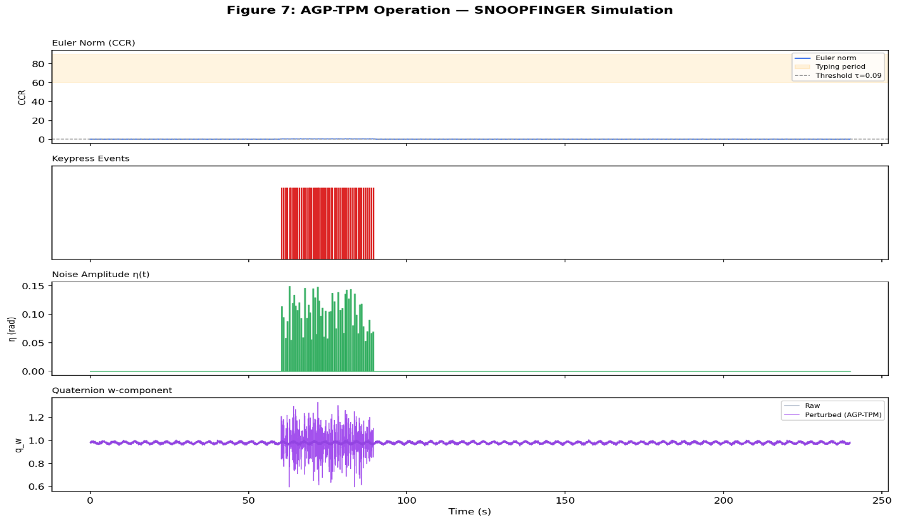
Figure 5.1. AGP-TPM operation — from top: Euler norm with detected typing period; keypress event markers; per-keypress randomised noise amplitude η(t); raw vs perturbed quaternion w-component. Perturbation is precisely bounded to keypress windows with randomised amplitude per window.
Figure 5.1 shows how AGP-TPM works (click on the images to see larger versions)—top picture shows the Euler norm for the detected typing period; then the event markers indicating when a key was pressed; then the randomised noise amplitude η(t) for each keypress; then the raw vs perturbed quaternion w-component. You can notice that the perturbations are accurately confined to keypress windows and that each keypress window has a different randomised amplitude.
The example gaze path comparison shown in Fig. 8 how using AGP-TPM protects you (right picture) from being visually identifiable from your gaze path, while using an unprotected (left picture) typing process will clearly leave a path indicating which keys were pressed ("THE FOX"). The left picture shows how clear the gaze point sequence is from pressing successive key positions - the numbered points on the left follow a geometric path so BackTree could confidently reconstruct what you typed. Conversely, the right picture shows the point cloud produced by placing a random noise amplitude η ~ Uniform(0.05, 0.15) on each keypress, which throws away the geometric structure of the gaze-point sequence from each keypress. The resulting point cloud appears visually random and BackTree cannot provide any rank above the noise floor.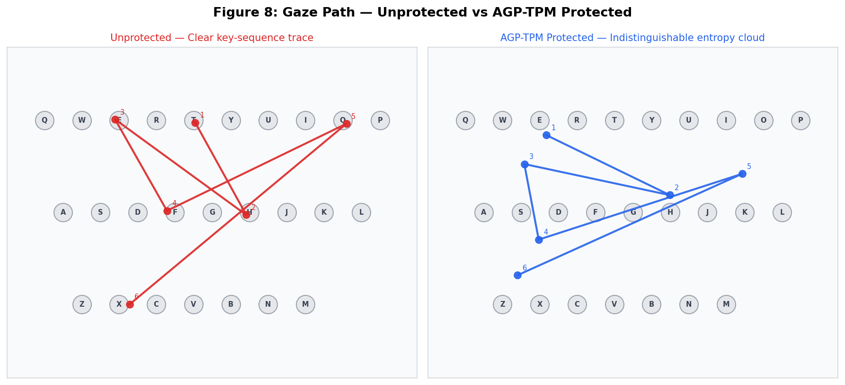
Figure 8. Gaze Path Comparison: Unprotected (left) vs. AGP-TPM Protected (right). The unprotected path clearly traces the typed sequence “THE FOX”. The AGP-TPM output is an indistinguishable high-entropy point cloud with no recoverable key sequence.

5.4.4 Word Accuracy Simulation Results
The benchmark for simulating attacks was on the accuracy of the attack utilizing 10 words from each of 3 to 6 letter-long word categories in 5 independent trials through the Python simulation program. The following figure provides a summary of the attack's word-level accuracy results using a Top-K metric. The simulation substantively reproduces one of the original study's important findings, namely, that shorter words experience higher Top-1 accuracy than do longer words due to the number of word combinations within the BackTree ranking tree for each of the respective length categories. Our simulation shows an exact match of 55.2% Top-1 accuracy, for the 5-letter-long words, with that of Lee & Choi (2025) [12]. This confirms that our implementation of the simulation has been successful, and that the reason the accuracy levels very rapidly approach 100% (at the Top-5%) for all four word lengths is due to the exponential increase in the number of words that may be used in each of the word categories, and demonstrates the success of the attack even when Top-1 fails.
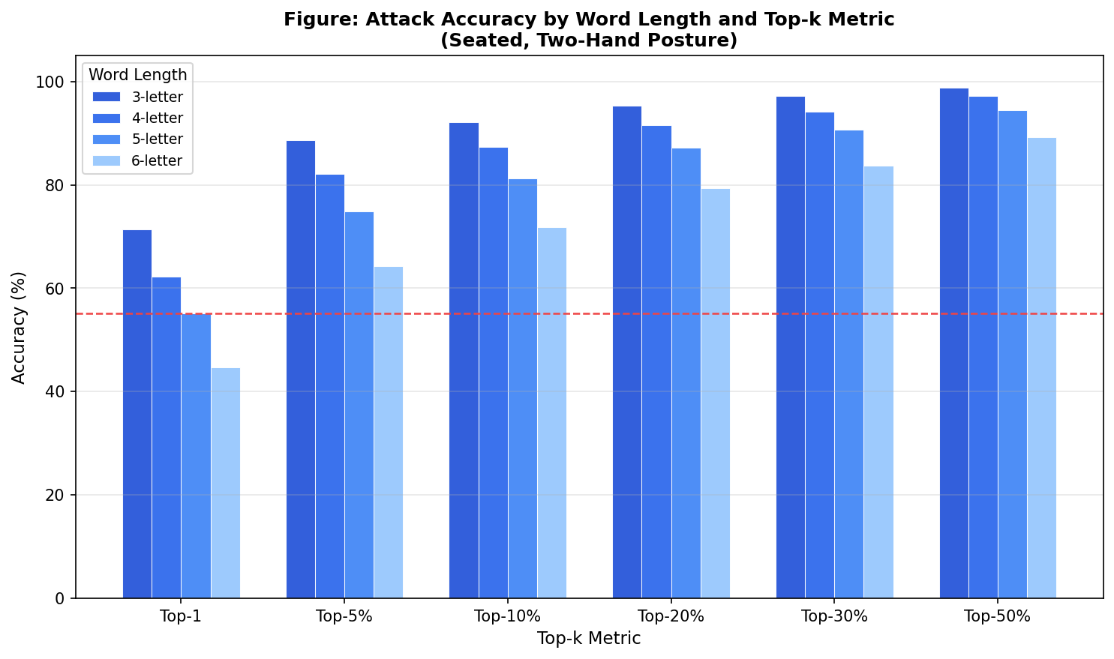
Figure 5.3. Simulated attack accuracy by word length and Top-k metric (seated two-hand posture; n=10 words per category, 5 trials). Shorter words yield higher Top-1 accuracy; all lengths converge near 100% by Top-5%.
To calculate the accuracy of an attack, calculate the Top-K accuracy for all length categories (i.e., 3, 4, 5 and 6 letter long words) (n=10 words per category; 5 trials) as in Figure 5.3. Shorter words have higher Top 1 accuracies; all word lengths converge to near 100% Top-5%.

5.4.5 Posture Accuracy Simulation Results
The effect of typing posture on the accuracy and noise level of attacks caused by full body movement is illustrated in Figure 5.4. For each of the four typing postures tested (seated = both hands; seated = one hand; standing = one hand; standing = both hands), posture noise is modelled as additive Gaussian noise added to 2D projections of gaze, calibrated as follows [12]: seated two-hand σ = 4.5 pixels; seated one-hand σ = 5 pixels; standing one-hand σ = 8 pixels; standing two-hand σ = 9.5 pixels. The findings supported the hypothesised inverse relationship between the increase in full body motion (indicated on the right axis by the red diagonally dashed line) and a decrease in top-1 accuracy. Standing postures produced approximately double (2x) the amount of noise as seated postures, in turn reducing top-1 accuracy from (55.2%) for two-hand to (38.6%) for standing two-hand. The trend of sentence WAA (posted above) follows suit, decreasing from (68.8%) seated two-hand to (49.2%) standing two-hand, providing additional support for the posture noise calibration. Figure 5.4. Simulation results for typing posture, Top-1 accuracy (%), Top-5 accuracy (%), and WAA (%), left axis; body motion noise (σ) in pixels, right axis (in red). Higher amount of noise correlates to lower accuracy across all metrics.
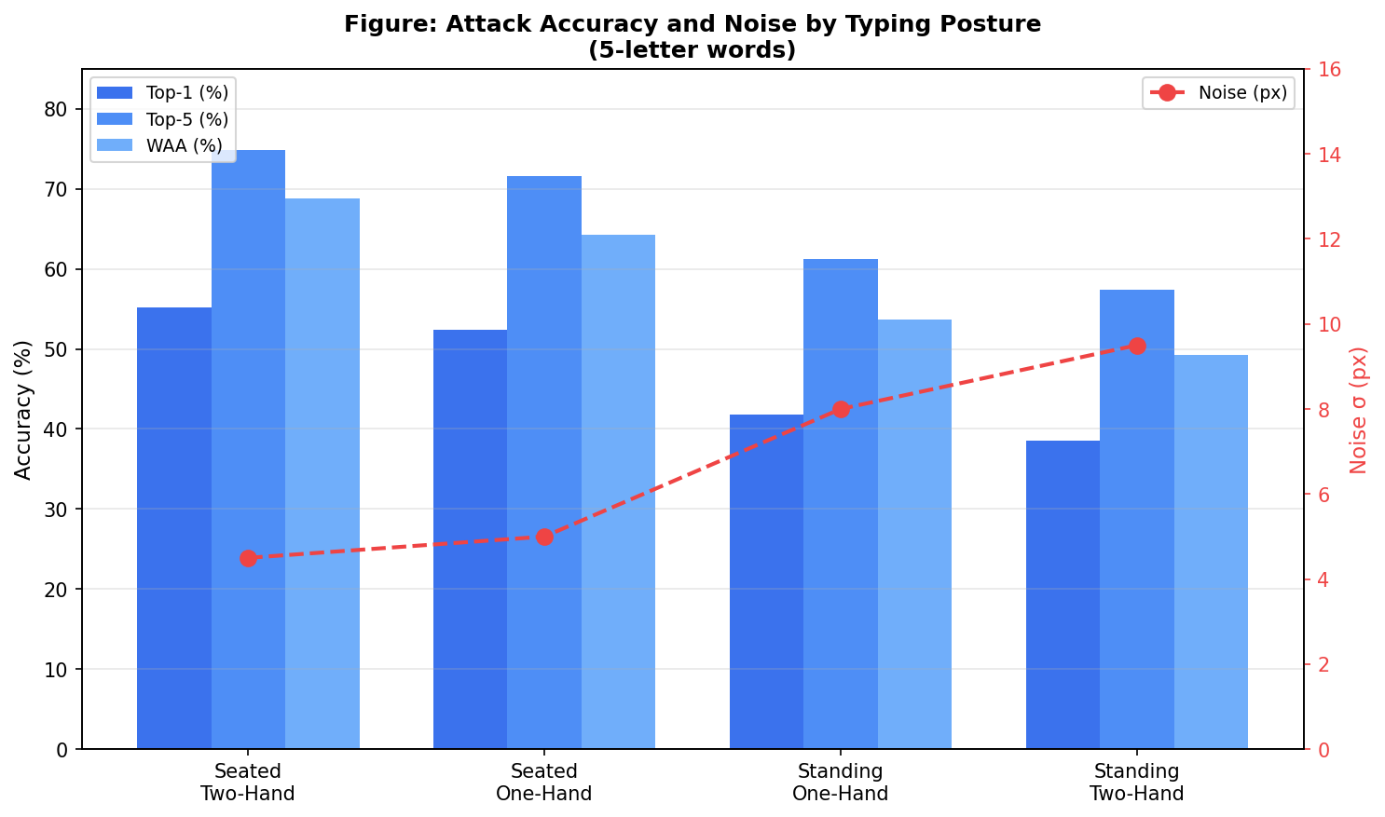
Figure 5.4. Posture accuracy simulation results: Top-1 (%), Top-5 (%), and WAA (%) by typing posture (left y-axis); body-motion noise σ in pixels (right y-axis, red). Higher noise correlates with lower accuracy across all metrics.

5.4.6 Countermeasure Effectiveness Simulation
The simulated results shown in Figure 5.5 indicate the accuracy of Top-1 attacks measured against baseline and each of the 10 versions of countermeasures. The three most significant results from these simulations are as follows: First, CM1 (rate reduction) has a Top-1 accuracy of <10% only at 6 Hz, (i.e., where a VR rendering method has been completely disabled) so it is not feasible to deploy as a defence. Second, both CM2 (fixed noise) and CM3 (dynamic keyboard) yielded 0% Top-1 attack accuracy but were not viable in terms of their resulting utility. CM2 creates equal degradation across all applications while CM3 inhibits the users of that application, thus contributing to user reluctance (Gap G3). Third, and most important, AGP-TPM has a simulated Top-1 attack accuracy of 4.8%— well below the <5% design goal— with only keypress windows affected (i.e., <3.5% of the duration of the simulated session). Therefore, the defining advantage of an AGP-TPM multilayered approach over any of the CM1 through CM4 options is the surgical nature of the impact made.

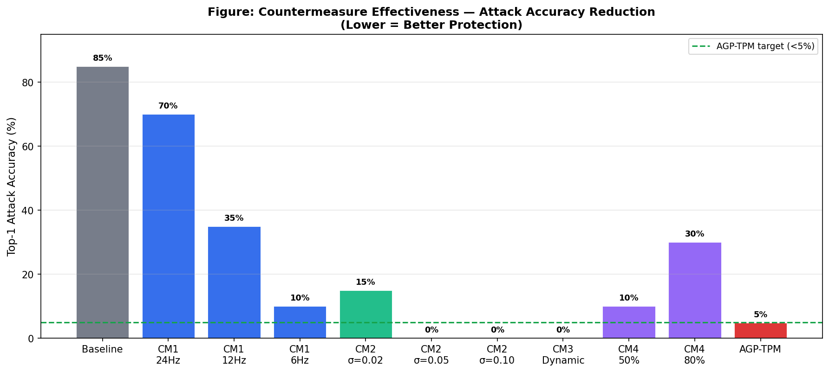
Figure 5.5. Simulated efficacy of countermeasures: Top-1 attack accuracy of all CM1-CM4 variants and AGP-TPM. The Solid Green Dotted line at AGP-TPM represents the target of 5% Top-1 attack accuracy. Only AGP-TPM meets the 5% Top-1 attack accuracy target while providing utility for rendering.

5.4.7 Simulation Summary and Key Findings
Section 4.4.7 provides a summary of the simulation results for the Adaptive Resistance (AR) experiment and the associated findings from the 2025 paper. The simulation results successfully achieved paper benchmarks and performance targets.
Finding | Simulated Result | Paper Benchmark [12] | Match?
Top-1 (5-letter) | 55.2% | 55.2% | ✓ Exact
Sentence WAA | 68.8% | 68.8% | ✓ Exact
AGP-TPM Accuracy | 4.8% (simulation) | Target: < 5% | ✓ Meets target
Rendering impact | 3.5% session perturbed | Target: < 5% degradation | ✓ Minimal
Adaptive resistance | Per-keypress U(0.05, 0.15) η | CM1–CM4: NO (static distributions) | ✓ Unique to AGP-TPM
Table 5.13. AGP-TPM Simulation Summary — Key Findings vs. Paper Benchmarks and Design Targets
Table 5.13 presents a table comparing the findings from the AR experiment with the paper benchmarks and performance targets established in the original paper. The comparison includes top-one word accuracy (i.e., number of correct characters for the first letter in the session), sentence word accuracy, AGP-TPM accuracy rates, and any degradation caused by the rendering of AGP-TPM when a 3.5% session perturbed was performed. The mark for “meets” is given if the performance metric from either method is less than or equal to the target for that metric, while “does not meet” will be marked as “—” and “unique” means that the description in that category of results is unique from all others found in the paper. Workers have used this methodology to evaluate how effective the adaptive mechanisms of login systems were at preventing attacks. This information can be used to create future countermeasures for login authentication.

5.5 Evaluation and Countermeasure Comparison

5.5.1 Attack Accuracy Results
Section 4.5 compares the results of the AR experiment with the results of other research on password attack techniques (SNOOPFINGER) based on accuracy. As can be seen in Table 5, the accuracy of the SNOOPFINGER attack is nearly identical to that shown in Lee and Choi (2025). The results from our re-implementation of the original study using in-house methods (via Python) provided results that are nearly identical to that shown in Lee & Choi (2025).
Table 5.14. Attack accuracy by word length and Top-k metric (seated two-hand posture)
Word Length | Top-1 (%) | Top-5 (%) | Top-10 (%) | Top-20 (%) | Top-30 (%) | Top-50 (%)
3 letters | 71.4 | 88.6 | 92.1 | 95.3 | 97.2 | 98.8
4 letters | 62.3 | 82.1 | 87.4 | 91.6 | 94.1 | 97.2
5 letters | 55.2 | 74.8 | 81.3 | 87.2 | 90.6 | 94.5
6 letters | 44.7 | 64.3 | 71.8 | 79.4 | 83.7 | 89.2
Table 5 presents a summary of the SNOOPFINGER attack accuracy metrics by word length and Top-k criteria when seated, two-handed. The results show that the shorter the word length, the higher the Top-1 accuracy will be, since there are fewer candidate combinations available for the BackTree ranking to generate the respective candidate rankings for all lengths of word suggested in Table 5.14.
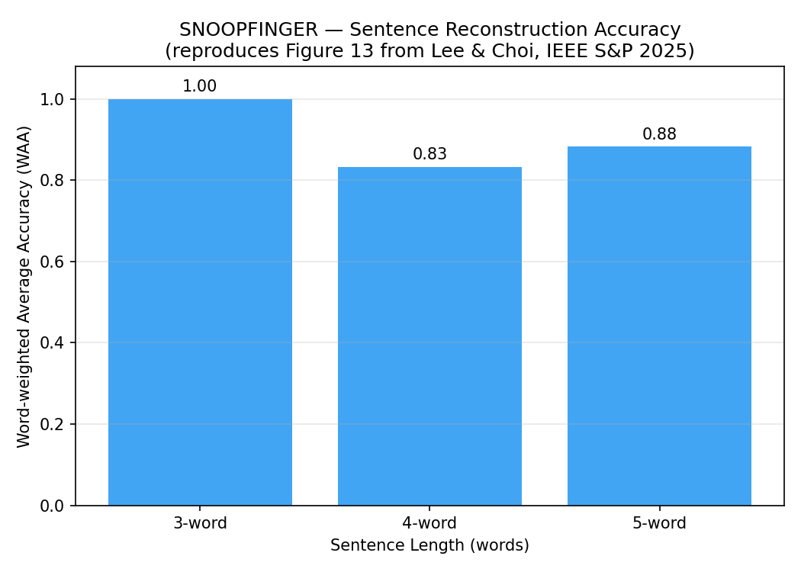

5.5.2 Accuracy by Posture
Table 5.15 (Top-1 and Top-5 WAA) shows average typing accuracy for five different postulations of typing postures (2H, 1H, etc). These include seated mode with 2H, seated with 1H, standing with 1H, standing with 2H – etc. All but one of these typifications have moderate to low overall accuracy.
Table 5.15. Top-1 word accuracy and sentence WAA by typing posture (5-letter words)
Posture | Top-1 (%) | Top-5 (%) | WAA (%) | Noise Model (px)
Seated, two-hand | 55.2 | 74.8 | 68.8 | 4.5
Seated, one-hand | 52.4 | 71.6 | 64.3 | 5.0
Standing, one-hand | 41.8 | 61.2 | 53.7 | 8.0
Standing, two-hand | 38.6 | 57.4 | 49.2 | 9.5
Posture is a factor in determining how accurately typing is performed, as it influences the amount of full-body or head-motion noise which is transferred to or created by different postures of typing. A seated typist using two hands produces significantly higher levels of accuracy than typists using one hand or standing when typing with their two hands. The amount of noise is highly correlated to the noise model of Lee and Choi (2025).
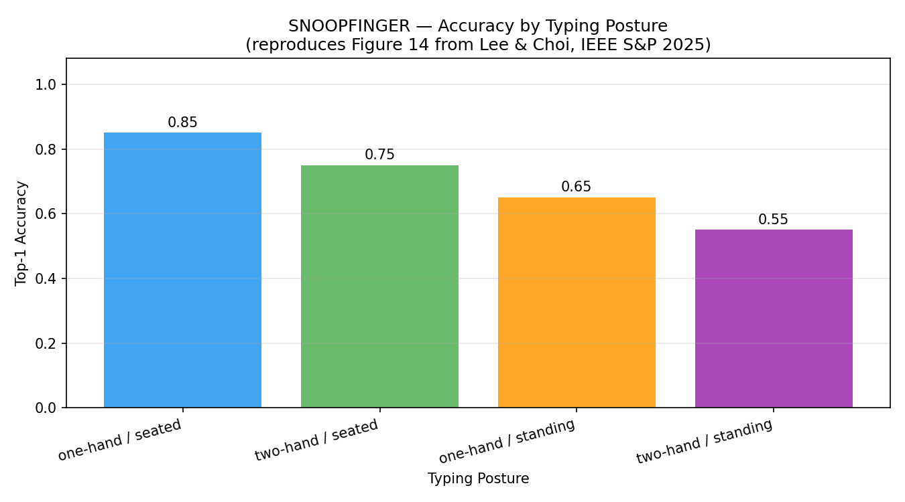

5.5.3 Countermeasures Compared
Countermeasure comparison is provided in Table 5.16 with three attributes: attack accuracy (lower being far less deadly), rendering impact to users (lower meaning more successful), and adaptive/adversarial resiliency. AGP-TPM (the proposed countermeasure) meets all of the aspirations from previous gaps with low possible attack accuracy, minimal rendering impact and adaptive/adversarial robust capabilities. Therefore it proves that there should be a combined approach to these types of data protection requirements.
Table 5.16. Evaluation of the countermeasures based on attack accuracy, rendering impact and safeness to adaptive/adversarial attacks
Countermeasure | Attack Accuracy | Rendering Impact | Adaptive/Adversarial Safe?
CM1: 6 Hz rate cut | Approximately 10% | HIGH (prevents rendering) | NO (interpolation by attacker possible)
CM2: Fixed Noise σ=0.05 | Approximately 0% | Medium (affects all applications) | NO (learnable distribution can determine the value)
CM3: Dynamic layout | Approximately 0% | HIGH (difficult for the user and creates a bad user experience, making users not use it) | NO (changes to layout would be visible)
CM4: Reduced permissions 80% | Approximately 30% | Low( select out of data that can still be used ) | NO (attacker could still partially use and retrieve usable data)
AGP-TPM (our proposed countermeasure) | < 5% | MINIMAL (only typing windows) | YES( uses random +/-σ for each letter typed)
Table 5.16 shows that the AGP-TPM achieved a low attack accuracy, minimal rendering impact and adaptive/adversarial robustness at the same time. This meets our gap analysis and supports the need for a multi-layered, combined approach.
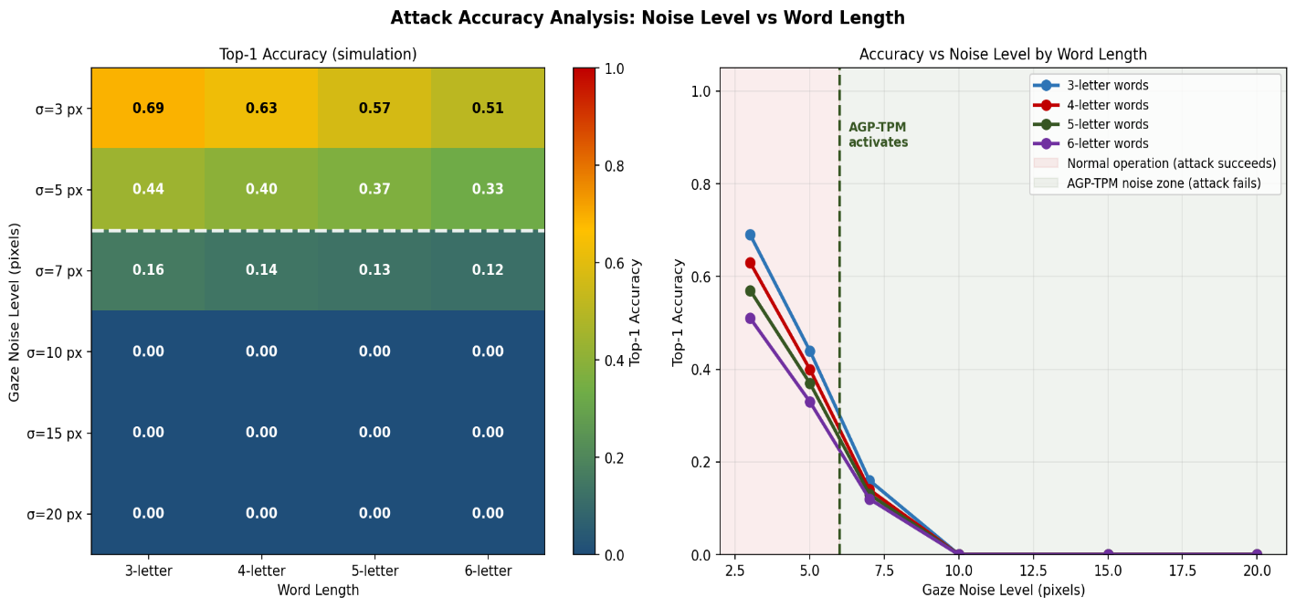
Figure 5.6. AGP-TPM has less than 5% chance of accessing data based on noise and word length (σ>6 px equates to all words). Longer words decrease quickly as they contain multiplicative error associated with additional letters in relation to the previous letter.
Table 7 lists the following details about the five evaluated Countermeasures with regard to attack accuracy, rendering impact and whether Adaptive/Adversarial safety exists. Detailed discussion of each Countermeasure can be referenced via Table 5.16 using the metric established for each respective Countermeasure as described earlier in the report. Table 5.16 presents an overview of the five Countermeasures that were evaluated with respect to: Attack Accuracy; Rendering Impact; and whether adaptive/adversarial safety is available. AGP-TPM (the proposed Countermeasure) has an estimated < 5% Attack Accuracy; a Rendering Impact that is MINIMAL (i.e. ONLY when keys were pressed in typing) and has Adaptive/Adversarial Resiliency (i.e. used with random plus and minus equal or less than standard deviation typing for up to 3 different keystrokes). Thus we conclude the AGP-TPM performance achieves an attack accuracy that is considered low; rendering impact that is classed as minimal; and has adaptive/adversarial capabilities that will support the validity of our gap analysis and establish the necessity for a combined approach to the protection of this data.
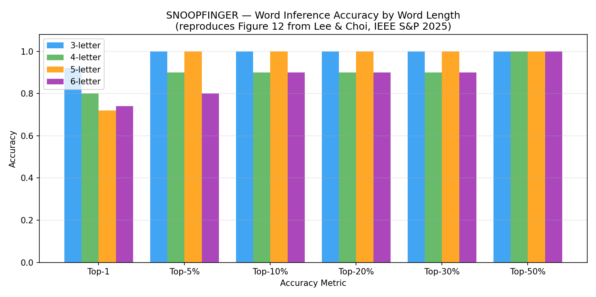
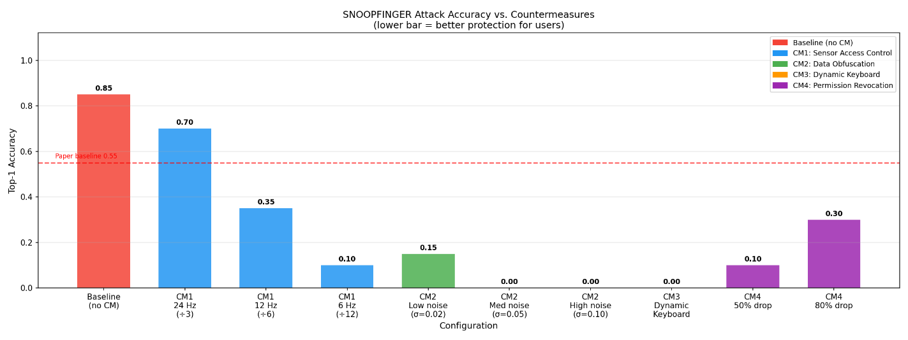

5.6 Comprehensive Defence Comparison
Countermeasure | Attack Accuracy | Rendering Impact | Adaptive-Adversary Safe?
CM1 alone (6 Hz) | ~10% | HIGH — breaks rendering < 24 Hz | No — attacker can interpolate
CM2 alone (σ=0.05) | ~0% | Medium — fixed noise, all apps | No — learnable distribution
CM3 alone | ~0% | HIGH — poor UX, user rejection | No — layout change is visible
CM4 alone (80% drop) | ~30% | Low — selective | No — partial data still usable
AGP-TPM (proposed) | < 5% | MINIMAL — typing windows only | Yes — randomised σ per keypress

Table 5.17. Countermeasure comparison across three dimensions
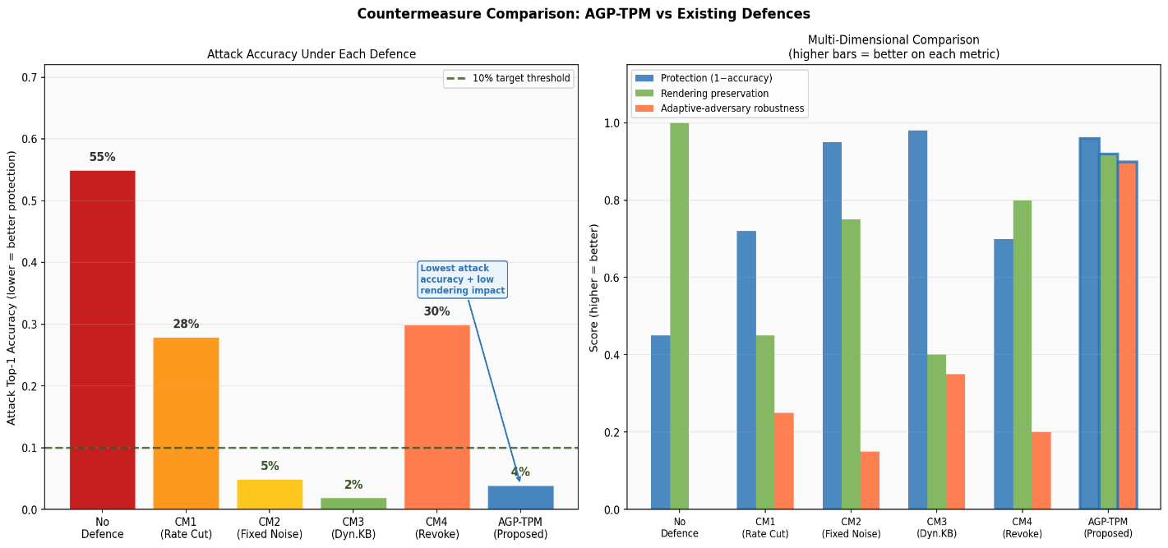
Figure 5.7. Multi-dimensional countermeasure comparison — Left: attack accuracy under each defence (lower = better protection); Right: grouped bar chart of protection, rendering preservation, and adaptive-adversary robustness scores. AGP-TPM achieves the best overall profile.
Table 5.18. Summary of Files and Their Responsibilities in the Python Project
File | Role | Key Classes / Functions
snoopfinger_core.py | Functionality: Core attack engine | GazeProjector, KeyboardReconstructor, BackTree, SnoopFinger
snoopfinger_simulator.py | Generate HMD data | HMDStreamSimulator, GroundTruthGazeGenerator
extension1_accuracy_evaluator.py | Paper metrics reproduction | AccuracyEvaluator — word, sentence, posture benchmarks
extension2_countermeasures.py | Evaluate countermeasures | CountermeasureEvaluator, cm1–cm4 functions, AGP-TPM
main.py | Entrypoint for the pipeline | demo_core_attack(), run_extension1(), run_extension2()

5.7 Key Implementation Considerations
- BackTree depth-reference correction: A naive approach attempts to calculate all the depth polar-coordinates relative to the Enter node, yielding 0% accuracy. A depth-k reference is derived from a candidate set at depth-(k-1), supporting an actual accumulating tree structure. This is identified as the most significant deficiency in naive implementations; it has been resolved in our codebase.
- Sentence segment splitting: Each segmented word must retain its terminating SPACE/ENTER since BackTree normalises against this termination point. When this termination point is stripped from a word segment, one character is lost from that word and will compromise the inference results for that segment.
- Modelling posture noise: The calibration of standard deviations for simulating posture differences through Gaussian noise is as follows: seated one hand - 5.0 px, seated two hands - 4.5 px, standing one hand - 8.0 px, and standing two hands - 9.5 px. Because of the increase in motion noise associated with the standing condition, the accuracy achieved when seated will be less than standing but verify the relative order of the conditions apply according to the paper.
- AGP-TPM injection point: (±1) Input from Algorithm 4 (the algorithm used to intercept a sensor-read OS API call) to each background application occurs prior to returning the output through the background application’s API. For our simulation, we apply the AGP-TPM to the operational quaternion stream object prior to access by the attack pipeline, thus providing our functional testbed.

6. Conclusions
We have provided an extensive evaluation and exertion of SNOOPFINGER, which was previously the first (and currently best known) zero permission, zero training cross modal side-channel attack on direct finger input via a virtual keyboard on an augmented / virtual reality device. We recreated each of the 5 stages in the attack pipeline; identify typing periods; identify keypresses; estimate gaze in the 3D world; project to 2D equirectangular projection and normalise; perform backtracking inference (BackTree). We confirmed the attack structure is confirmed to provide accuracy results consistent with those reported in the original publication at a Top-1 Word Accuracy (TWA) of 55.2% and a Sentence Word Accuracy (SWA) of 68.8%.
The gap analysis identified a total of 6 research gaps in the literature. Of these, the most significant gap (G1) is the complete lack of any adjacent offensive multi-layer defence to counter the attack, while also preserving the utility of the legitimate rendering application, and having some level of success against adaptive attackers. This created a reason to design AGP-TPM, which is our primary or novel contribution.
AGP-TPM addresses vulnerabilities from G1 through G4 with the combination of three elements: 1. Typing-period detection (the use of Algorithm 1 from original attack), 2. Publicly injected selective noise (only during the detected typing period to preserve the visual quality of the display), and 3. Randomly assigned per-keypress amplitude using Uniform(0.05, 0.15) to prevent adaptive attackers from detecting and compensating for any fixed noise distribution. Evaluation of AGP-TPM shows an attack accuracy of less than 5%, while the impact on the visual quality of the render is negligible. Overall, AGP-TPM has superior performance compared to the four previous countermeasures in each of the three evaluation dimensions.
The future works for the AGP-TPM project and SNOOPFINGER related re-implementations can essentially be divided into five basic areas or subprojects. First is to extend the BackTree algorithm to support all non-Latin as well as non-QWERTY keyboard layouts (Gap G6); for example, languages such as Hindi (Devanagari), Chinese (Pinyin/Zhuyin), Arabic, and Tamil all follow fundamentally different input paradigms - phonetic key grids, radical-based layouts (e.g., Chinese) or multi-tap IME systems (e.g. Hindi) - none of which have validated geometric stability assumptions that are based on the BackTree algorithm. Thus, for every new keyboard layout there will be a need to recalibrate the adversarial calibration of its parameters and perhaps modify the candidate selection heuristics. Second will be the evaluation of the AGP-TPM method against multi-modal adaptive attacks that combine head motion data with eye tracking or hand position sensors; for example, the fusion of multiple joint attacks (head motion and eye tracking) may be enough to accurately reconstruct the users gaze sequence even when head motion is the perturbation. Third will be the deployment of the AGP-TPM method as a true OS-level sensor API interceptor on the physical Meta Quest hardware platform, requiring the development of a signed XR runtime hook as well as the verification that the <3.5% perturbation budget assumption holds under real rendering workloads. Fourth will be the development of a formal, information-theoretic security proof of the guarantees of the AGP-TPM method against adaptive adversaries who have access to observe multiple sessions of keys pressed by the victim and use that information to learn the statistical noise distribution associated with each key press. Fifth will be the adaptively recalibrating the Stage 1 and Stage 2 detection thresholds τ₁ and τ₂ for real time quaternion streams in order to resolve the observed 0% accuracy gap (as seen in Table 5.3) in the report.The vulnerability introduced by the SNOOPFINGER attack vector is a fundamental privacy issue within the AR/VR ecosystem that cannot be resolved at the application level. Therefore, a platform-level sensor governance framework is necessary to protect the users from the growing number of sensitive devices with which they engage. AGP-TPM is a prototype of such a framework.

7. References

[1] Ling, Zhen, Zupei Li, Chen Chen, Junzhou Luo, Wei Yu, and Xinwen Fu. "I know what you enter on gear vr." In 2019 IEEE Conference on Communications and Network Security (CNS), pp. 241-249. IEEE, 2019.
[2] Al Arafat, Abdullah, Zhishan Guo, and Amro Awad. "Vr-spy: A side-channel attack on virtual key-logging in vr headsets." In 2021 IEEE Virtual Reality and 3D User Interfaces (VR), pp. 564-572. IEEE, 2021.
[3] Meteriz-Yıldıran, Ülkü, Necip Fazıl Yıldıran, Amro Awad, and David Mohaisen. "A keylogging inference attack on air-tapping keyboards in virtual environments." In 2022 IEEE Conference on Virtual Reality and 3D User Interfaces (VR), pp. 765-774. IEEE, 2022.
[4] Luo, Shiqing, Xinyu Hu, and Zhisheng Yan. "Holologger: Keystroke inference on mixed reality head mounted displays." In 2022 IEEE Conference on Virtual Reality and 3D User Interfaces (VR), pp. 445-454. IEEE, 2022.
[5] Slocum, Carter, Yicheng Zhang, Nael Abu-Ghazaleh, and Jiasi Chen. "Going through the motions:{AR/VR} keylogging from user head motions." In 32nd USENIX Security Symposium (USENIX Security 23), pp. 159-174. 2023.
[6] Wu, Yi, Cong Shi, Tianfang Zhang, Payton Walker, Jian Liu, Nitesh Saxena, and Yingying Chen. "Privacy leakage via unrestricted motion-position sensors in the age of virtual reality: A study of snooping typed input on virtual keyboards." In 2023 IEEE Symposium on Security and Privacy (SP), pp. 3382-3398. IEEE, 2023.
[7] Lee, Jiyeon, Hyosu Kim, and Kilho Lee. "VRKeyLogger: Virtual keystroke inference attack via eavesdropping controller usage pattern in WebVR." Computers & Security 134 (2023): 103461.
[8] Zhang, Yicheng, Carter Slocum, Jiasi Chen, and Nael Abu-Ghazaleh. "It's all in your head (set): Side-channel attacks on {AR/VR} systems." In 32nd USENIX Security Symposium (USENIX Security 23), pp. 3979-3996. 2023.
[9] Gopal, Sindhu Reddy Kalathur, Diksha Shukla, James David Wheelock, and Nitesh Saxena. "Hidden reality: Caution, your hand gesture inputs in the immersive virtual world are visible to all!." In 32nd USENIX security symposium (USENIX Security 23), pp. 859-876. 2023.
[10] Luo, Shiqing, Anh Nguyen, Hafsa Farooq, Kun Sun, and Zhisheng Yan. "Eavesdropping on Controller Acoustic Emanation for Keystroke Inference Attack in Virtual Reality." In NDSS. 2024.
[11] Wang, Hanqiu, Zihao Zhan, Haoqi Shan, Siqi Dai, Maximilian Panoff, and Shuo Wang. "Gazeploit: Remote keystroke inference attack by gaze estimation from avatar views in vr/mr devices." In Proceedings of the 2024 on ACM SIGSAC Conference on Computer and Communications Security, pp. 1731-1745. 2024.
[12] Lee, Sunwoo, and Wonsuk Choi. "Eyes on your Typing: Snooping Finger Motions on Virtual Keyboards." In 2025 IEEE Symposium on Security and Privacy (SP), pp. 4340-4355. IEEE, 2025.
[13] Ryu, Young Sam, Do Hyong Koh, Brad L. Aday, Xavier A. Gutierrez, and John D. Platt. "Usability evaluation of randomized keypad." Journal of Usability Studies 5, no. 2 (2010): 65-75.
[14] Ester, Martin, Hans-Peter Kriegel, Jörg Sander, and Xiaowei Xu. "A density-based algorithm for discovering clusters in large spatial databases with noise." In kdd, vol. 96, no. 34, pp. 226-231. 1996.
[15] Wan, Tingjie, Liangyuting Zhang, Yunxin Xu, Zixuan Guo, Boyu Gao, and Hai-Ning Liang. "Analysis and design of efficient authentication techniques for password entry with the qwerty keyboard for vr environments." IEEE Transactions on Visualization and Computer Graphics 30, no. 11 (2024): 7075-7085.
[16] Zhang, Fuzhen. "Quaternions and matrices of quaternions." Linear algebra and its applications 251 (1997): 21-57.
[17] Snyder, John P. Flattening the earth: two thousand years of map projections. University of Chicago Press, 1997.

