
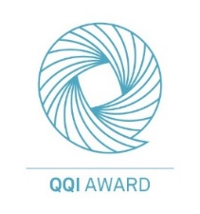
Quality and Qualifications Ireland
Dearbhú Cáilíochta agus Cáilíochta Éireann

Moate Business College

Web Development
6N1277

Skills Demo 1
35%

QQI Level 6

Tutor: Aideen Brennan
2024/2025

Student Name: Enver Osmanov

Table of Contents
Introduction 2
Part A: Design of a Website 3
Wireframing 3
Colour Theory 3
Part B: Creation of a Website 4
File Organisation: 4
Stylesheets: 4
Layout Design: 5
Guaranteeing Accessibility: 6
Part C: Hosting the Save Energy Website 6
Part D: Testing 9
Usability Testing: 9
Accessibility Testing: 11
Browser Compatibility: 12
Conclusion 13
Bibliography 14

Introduction
In this development document, you will find a detailed description of the tasks and processes involved in creating a website for Solar PV Energy, a company specializing in solar panel installation. This document describes each stage of the website development, from planning and design to technical implementation and optimization. Solar PV Energy specializes in promoting renewable energy solutions, aiming to provide customers with accessible information about the benefits of solar energy and an easy way to contact the company for advice or installation.
In this document, you will see how the site was structured to reflect Solar PV Energy's commitment to sustainability, as well as the technical features implemented to improve user experience and site functionality.

Part A: Design of a Website

Wireframing
Wireframe development is an important part of planning, it saves time and money, sometime it starts even before designing, coding or creating graphics (design phase). The frame is a rough drawing or the structure of the site on which it is planned to place all the elements of the site, such as texts, images, bottom parts or navigation structures. There are two different types of wireframe graphics — low-precision and high-precision wireframe graphics. The first option is a simple drawing on paper with basic blocks without details, and the second is a more detailed and accurate frame with the addition of special elements. The site framework includes information architecture, navigation elements and layout design that helps the user to navigate the site easily. During the creation process, a site map is first compiled, then a rough drawing is created (a low-quality frame), and only then, after approval by the client, it is brought to a detailed version (a high-precision frame). A site map is a schematic representation of the site structure, showing the pages and their relationships. The role of the sitemap is to define the hierarchy and relationships between pages before creating a wireframe to ensure proper navigation and layout of elements. Placeholders are used to indicate the location of various elements, such as images, texts, forms, in a wireframe. These are temporary elements that show where certain blocks will be located on the page, but do not contain the final content.

Colour Theory
Color theory in web development refers to the principles and guidelines for selecting and combining colors to create a visually appealing, user-friendly, and effective website. It includes aspects such as contrast, harmony, and the emotional impact of colors, which together influence how users perceive a brand. Choosing a Palette Using Paletton, I created a color palette based on yellow-green tones, reflecting the sustainable and eco-friendly concept of solar photovoltaic energy. The choice of yellow-green tones symbolizes energy, growth and care for the environment, which aligns well with the company's focus on solar energy and renewable energy.
The right color palette enhances brand associations, helping users intuitively connect it with sustainable and eco-friendly solutions. The right choice of colors helps direct attention to important elements, improving the perception of information and creating a positive first impression, which helps to retain users on the site and build their trust in the brand.
Key aspects to consider when creating a color scheme:
1. Contrast, high contrast is essential for accessibility as it helps visually impaired users read content more easily.
2. Harmony, provides a balanced, cohesive feel that makes a website look professional and thoughtfully designed.
3. Psychological impact, choosing colors that align with the brand message is crucial to creating the right impression on users.

Part B: Creation of a Website

File Organisation:
The main folder of the project is SolarPVEnergy, where all the files and folders of the project are located. The Images folder contains all the images necessary for the project, and the Pages folder contains files with HTML code personal for each page of the website (project).
Also, CSS files are stored in the root folder. MyStyle.css is a style file for general use, all the others are personal for each of the pages being implemented. Script.js contains the functionality necessary for the site, implemented in JavaScript.
This system was created to provide a clear structure that is easy to follow for developers working on the project. An organized layout also promotes consistency and a smooth workflow, facilitating navigation and management of the various components of the website project.

Stylesheets:
On my site, I have created a master stylesheet called `mystyle.css` that contains common styles used across multiple pages, helping to maintain a consistent look. This master CSS file makes it easy to make style changes, as any updates to `mystyle.css` will automatically be applied to all pages that reference it.
In addition to `mystyle.css`, I also have specific CSS files for each individual page. These styles allow me to add custom, unique page elements without changing the overall design of the other pages. For example, if one page has a unique layout or a specific color scheme, a page-specific stylesheet ensures that it is styled accordingly without disrupting the consistency provided by `mystyle.css`.
Some specific styles in `mystyle.css` might include:
- Font and color settings to ensure text is readable and consistent with your brand.
- Margins and padding to create balanced spacing around elements, making the site easier to navigate.
- Styling of buttons and links to maintain a consistent look for interactive elements across the site.
- Rounded corners - this is especially useful for styling buttons, forms, and other site elements.

Layout Design:
My website layout is designed to be clean, modern, and easy to use, with a focus on helping people navigate and enjoy the content. Here’s a quick breakdown of how I set it up and why I chose this design:
1. Layout Description
- Header and Navigation Bar: I included a fixed header with a site banner and navigation links at the top. This way, the main menu is always visible, making it easy for users to find what they need.
- Content Sections: The content is divided into clear sections with plenty of space between them, making everything easy to read. Each section is visually separated, either by different background colors or subtle dividers, which helps people focus on one area at a time.
- Footer: At the very bottom of each page, there’s a footer with essential information like the address and phone number, so users don’t have to hunt for these details.

2. Why I Chose This Design
- Visual Appeal: I wanted the site to look modern and clean, with large, high-quality visuals and simple typography.
- Content Focus: By organizing information into sections, users can find what they’re looking for quickly without feeling overwhelmed by too much on the page at once.

3. How I Made It Work
- CSS Grid and Flexbox: I used CSS Grid and Flexbox to make sure the layout works well on all devices. These tools allow me to control the spacing and alignment of everything, so the site looks good on any screen size.
- Consistent Styling (mystyle.css): I created a main stylesheet called `mystyle.css` for consistent styles across the whole site, like font choices, colors, and button designs. This helps keep the look of the site the same on every page.
- Page-Specific Styles: For pages that need a unique look, I added separate CSS files to make those changes without affecting the rest of the site.
Overall, this design is meant to be simple, professional, and user-friendly, giving visitors an easy and enjoyable experience while helping them find the information they need.

Guaranteeing Accessibility:
Making websites accessible is essential to ensure that all users, regardless of their abilities or disabilities, can access, navigate, and interact with content. Accessible websites benefit users with disabilities, such as vision, hearing, motor, or cognitive impairments.
Here are some steps taken to ensure accessibility on a website:
1. Text alternatives for images (alt text): Each image includes descriptive alternative text that screen readers can read aloud to users with visual impairments. This helps convey the meaning and purpose of the image.
2. Keyboard navigation: Ensuring that a website can be fully navigated using only the keyboard (e.g., the Tab key) is critical for users who rely on assistive technology or are unable to use a mouse.
3. Adequate color contrast: Using high-contrast color schemes makes text and interactive elements more readable, especially for users with low vision or color blindness.
4. Semantic HTML elements: Semantic HTML tags such as <header>, <section>, <label>, <footer> are used to create a clear and logical structure. This helps screen readers interpret the page more effectively, allowing users to navigate the content more easily.
5. Responsive design: The website is designed to be responsive, so it adjusts smoothly to different screen sizes. This ensures ease of use across all devices including mobile phones, tablets and desktop computers, which is beneficial for users with visual and motor impairments.

Part C: Hosting the Save Energy Website
In order to successfully host a website, first I’ll create an account with a hosting provider.
The hosting provider that I’ll use for this website is AwardSpace.com. When uploading a website, there are several factors that need to be considered. These are:
- The selection of domain name
- The hosting of the website
- The transfer of the website onto the hosting company server
Step 1: Register of domain name
For the purpose of this website, I’ll use AwardSpace to register a domain name. As this is a free subscription service, I’ll be using a subdomain of AwardSpace. The registration is as follows:
- Select Hosting Tools on AwardSpace dashboard
- Access the Domain Manager
- Create a free subdomain
I’ll choose subdomain name saveenergyeo
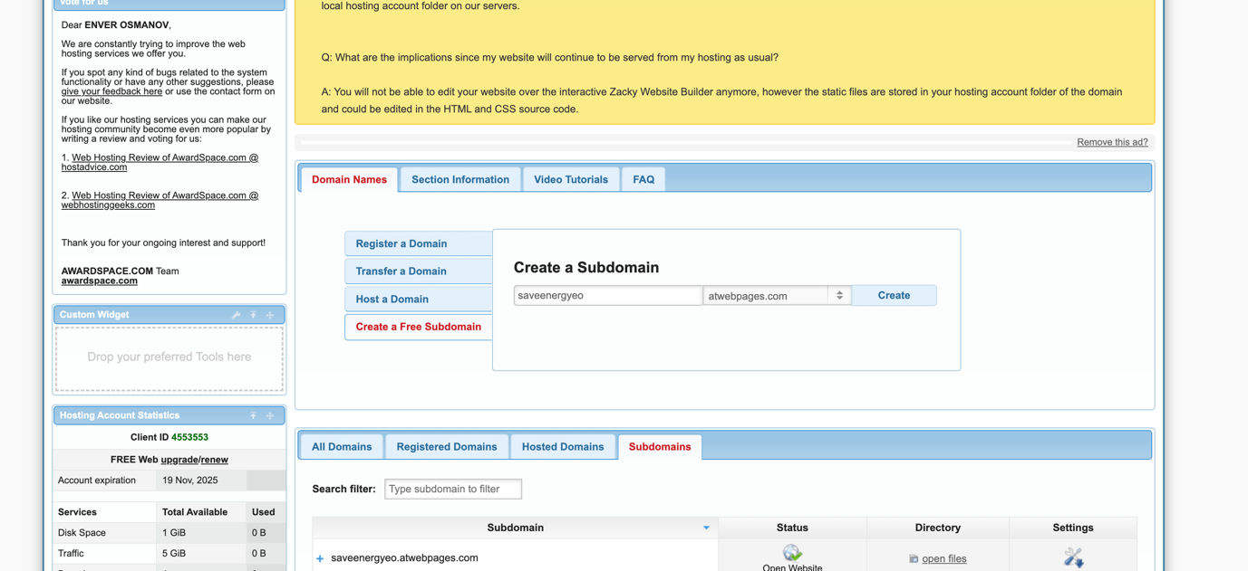

Step 2: Hosting a Website.

In order to host the website, I need to structure/organise my web files using the File Manager on the hosting company dashboard. The file manager will display my subdomain. Inside the parent directory of this subdomain, I’ll organise my webpage structure.
Because my webpage files will be uploaded to the root directory (/home/www/), directory protection must be disabled.
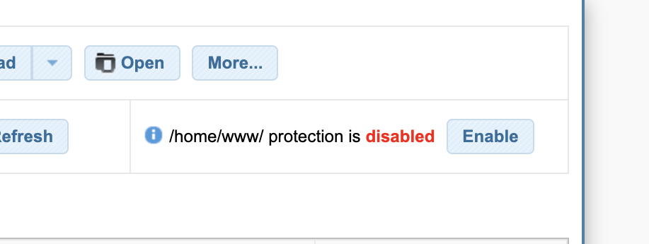

Step 3: Uploading files to Hosting Server.

The webpage files will be uploaded to the hosting server using the folder structure that exist on my local disk. All images are stored inside in image folder, all webpage are stored inside in page folder and external stylesheet is uploaded outside of this structure.
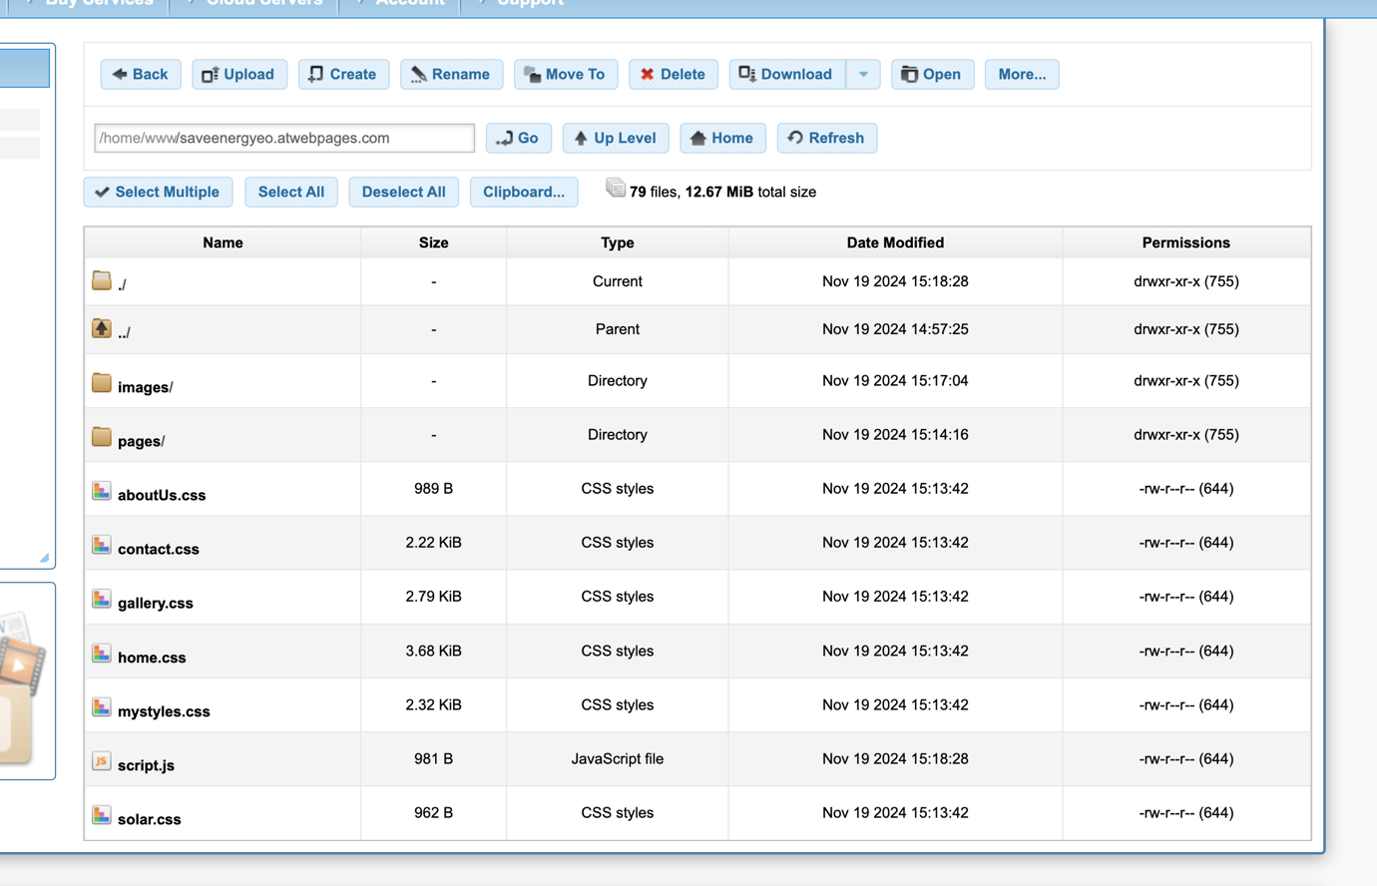

The Save Energy website has been finalised according to the company’s design and objectives. The website is now live and can be accessed from the following URL:
http://saveenergyeo.atwebpages.com/pages/index.html

Part D: Testing
Testing your website software removes obstacles that may affect your website ranking, increases interactivity through optimal design, and simplifies backlinks. While designing a website to increase brand awareness, generate leads, and drive sales is important, make sure all website features are working optimally.
- Minimizes Website Errors: Testing helps identify and fix bugs or issues that could cause the website to function incorrectly.
- Makes A Website Look Professional: A well-tested website appears polished and professional.
- Ensures Website's Compatibility With Different Devices : Testing allows you to confirm that the website looks good and functions properly on a variety of devices.
- Removes The Need to Continuously Redesign Website: By thoroughly testing the website before launch, you reduce the chances of having to constantly fix issues or update the design due to usability problems. This saves time and resources in the long run.
- •
- Improves Website Design: Testing can reveal ways to improve the site’s design, making it more user-friendly and interactive.
- Boosts Website Security: Testing includes checking for security vulnerabilities that could put user data at risk. (IDK, 2022)
There are a number of tests that have been carried out on the website. These include:
- Functional testing.
- Usability testing.
- Accessibility testing.
- Cross-browser testing.
- Load testing.
- Compatibility testing.
- Performance testing.

Usability Testing:
Usability Testing is a method used to evaluate how easy and user-friendly a product, system, or website is for its target audience. The main focus of this testing is to assess the user experience by observing real users as they interact with the product to identify any usability issues.
Usability relates to everyone, designing with the best user experience in mind for every visitor to the website, but obviously being mindful not to impact people with disabilities.
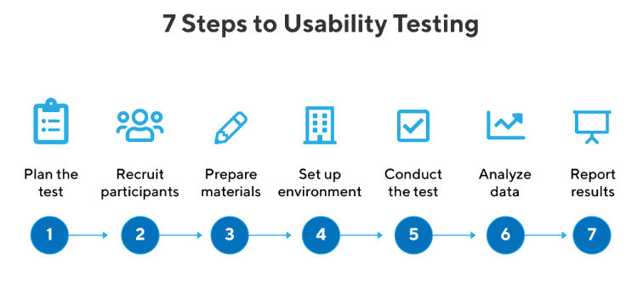

Positive Results:
- Responsive Design: The website adapts well to different devices (desktop, tablet, mobile) without any issues with layout or functionality.
- Clear Navigation: The navigation bar (nav bar) is intuitive, links are easy to find and use.
- Alt Tags on Images: Alternative text for images ensures accessibility for visually impaired users and better SEO.
- Fast Load Time: Pages and media load quickly, improving user experience.
- Readable Content: Text is clear, properly sized, with legible fonts and good contrast to the background.
- Keyboard Navigation: The site is accessible to users who use a keyboard instead of a mouse.
- Consistent Design: All elements of the website look and function consistently.
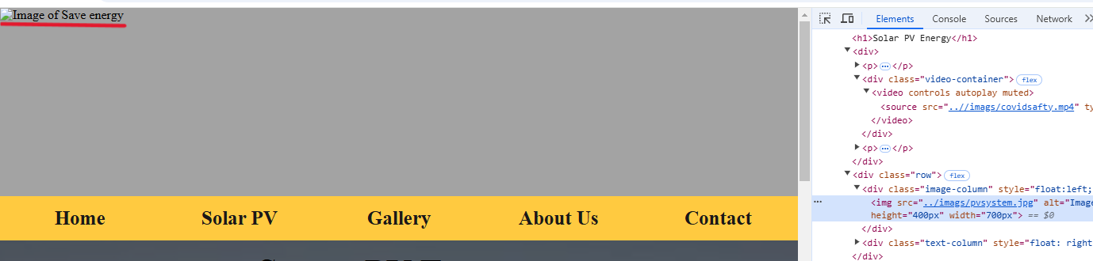

Negative Results:
- Lack of Subtitles for Videos: This makes the site less accessible to deaf, hard of hearing, or non-native speakers and makes navigation difficult.
- Pop-ups or Overlays: Excessive or intrusive pop-ups can interrupt the user experience and cause frustration.
- Poor Feedback on Actions**: Buttons or interactive elements do not provide clear feedback (such as visual or text confirmation).

Accessibility Testing:
Accessibility testing evaluates how well a website or application can be used by people with disabilities, including visual, auditory, motor, and cognitive impairments.

Key areas evaluated include:
- Keyboard Navigation: Verified if all elements are accessible via keyboard alone.
- Color Contrast: Ensured that the contrast ratio meets WCAG standards for readability.
- Text Resizing: Checked if content remains readable and functional when text size is increased.
- Forms: Verified that form fields have labels

Results:
Passed:
- Alt Text: Images had descriptive alt attributes for screen readers.
- Keyboard Navigation: Navigation menus and buttons were operable using the keyboard.
- Color Contrast: Text and background colors met WCAG 2.1 contrast standards.
Failed:
- Video Content: Videos lacked captions or transcripts, making them inaccessible to users with hearing impairments.
Conclusion:
The website partially passed the accessibility test. While major elements were accessible, the absence of captions for videos and a missing label in a form field resulted in non-compliance. Addressing these issues will improve the site's accessibility and user experience for all.

Browser Compatibility:
This type of testing ensures that a website or web application functions correctly across different browsers (e.g., Chrome, Firefox, Safari, Edge) and browser versions. It verifies that the design, layout, and functionality remain consistent and meet user expectations regardless of the browsing environment.
Browsers Tested:
- Google Chrome
- Safari
Observations: The website was tested for layout consistency, functionality, and performance across the two browsers. In both Google Chrome and Safari:
- The layout and design appeared uniform with no visible misalignments.
- Interactive elements such as buttons and menus worked as intended in both browsers.
- The media elements, including images and videos, loaded without issues.
- Performance (e.g., load time) was consistent and acceptable.
Conclusion: The website demonstrated **browser compatibility** by maintaining uniformity in design and functionality across Chrome and Safari. This ensures a positive user experience regardless of the browser used.
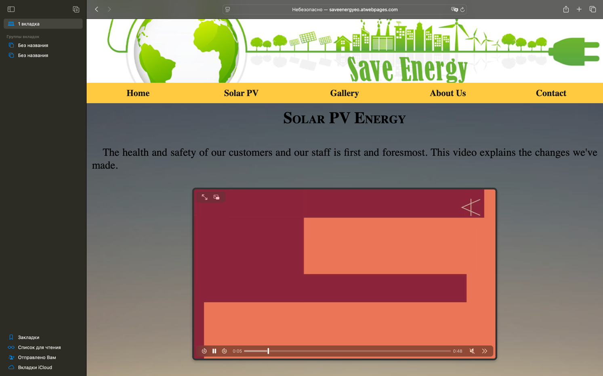
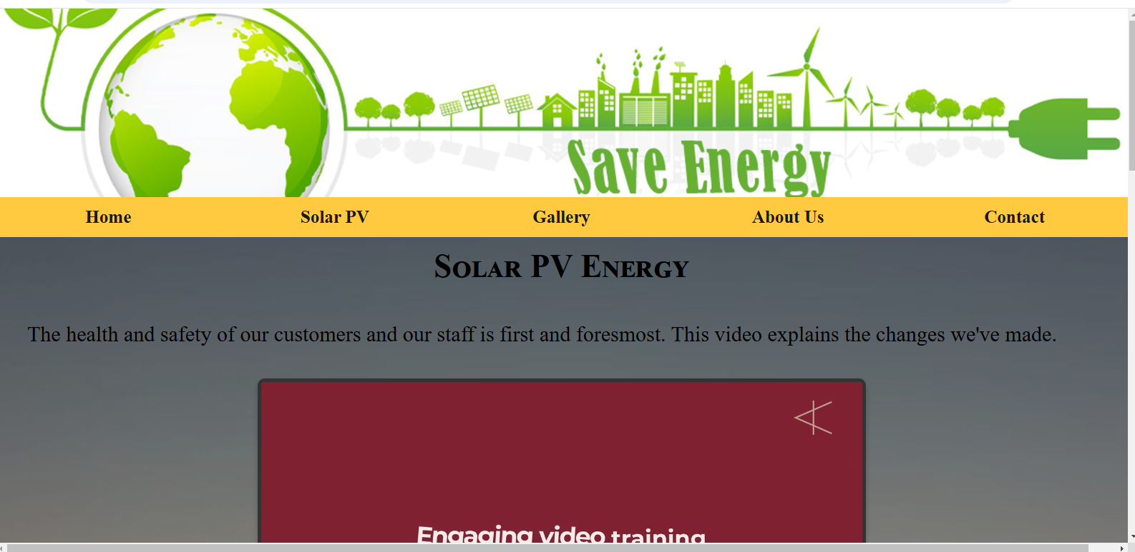

Conclusion
Conclusion Draft:
Based on the documentation provided, website design, and the testing carried out, the website appears to meet customer requirements and align with the target audience's needs. Key observations include:
1. Design Consistency: The website maintains a cohesive structure across all pages, with a well-functioning navbar and appropriate use of elements like images with descriptive `alt` tags. However, the lack of subtitles for videos highlights an area for improvement in accessibility.
2. Cross-Browser Compatibility: Testing in Chrome and Safari demonstrated uniformity in appearance and functionality, suggesting the website is compatible with multiple browsers, which is essential for user accessibility.
3. Accessibility Testing: While some accessibility measures are in place (e.g., `alt` tags for images), there are still improvements to be made, such as adding subtitles for videos and enhancing keyboard navigation features.
4. Usability: Navigation is intuitive, and content is structured logically, improving the overall user experience. However, usability for individuals with specific needs could be enhanced further.

Has the Website Passed Testing?
Overall, the testing process was sufficiently thorough, covering usability, accessibility, and browser compatibility. While the website passes the general testing phase, addressing identified shortcomings (e.g., video subtitles) would improve its overall quality and inclusivity.

