Assingment3
Austin Silaghi
7/27/2025
- 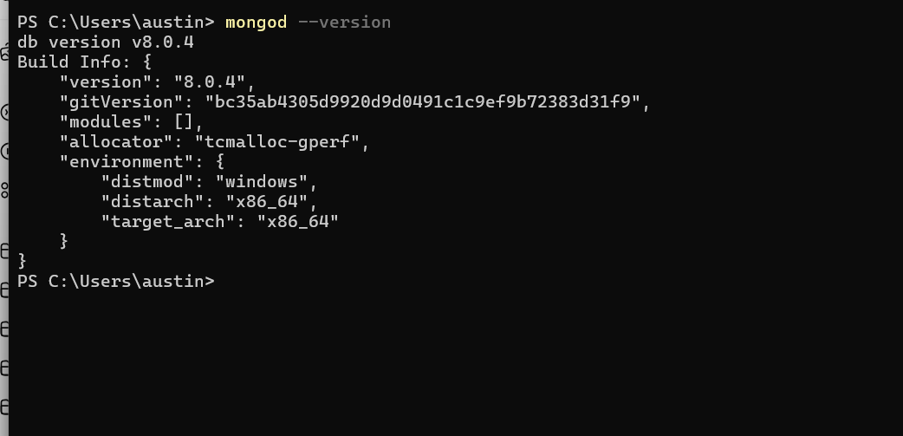
- Display version
- 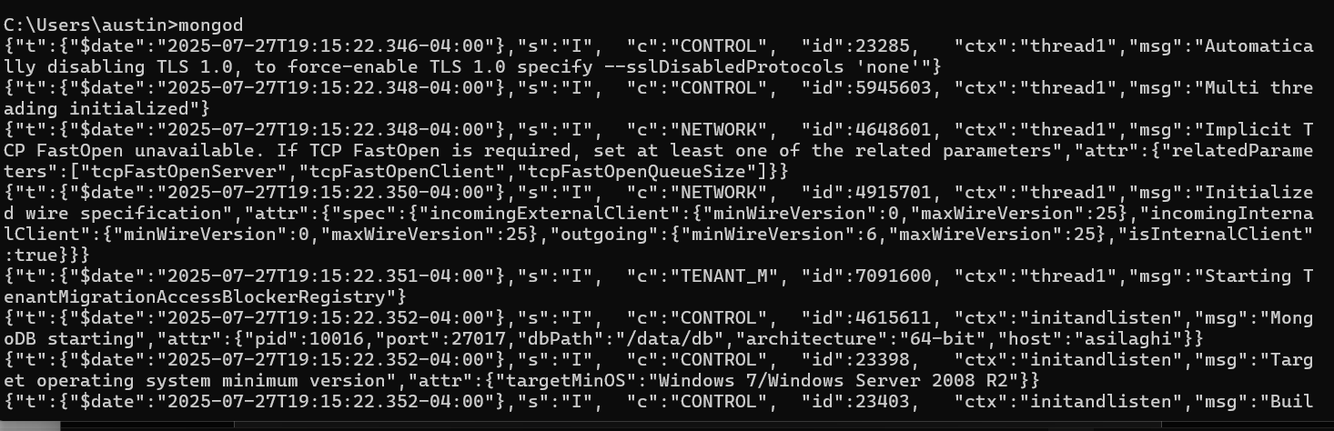
- Start server
- 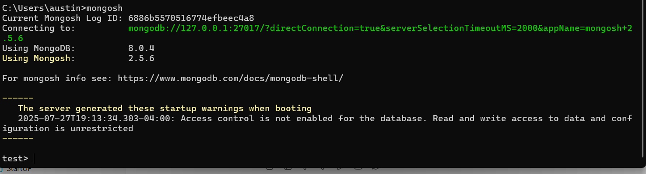
- Start mongo shell
- 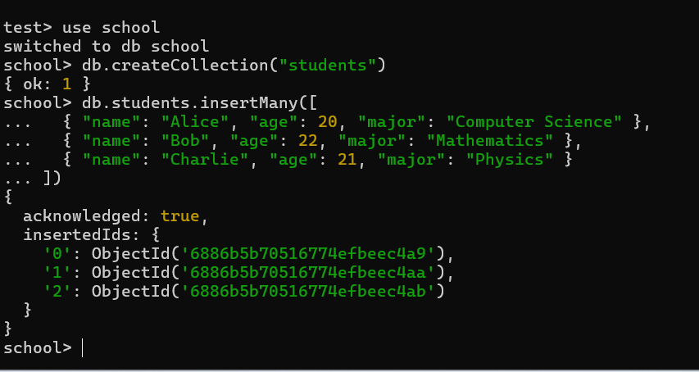
- Used to create new collection with 3 new objects
- 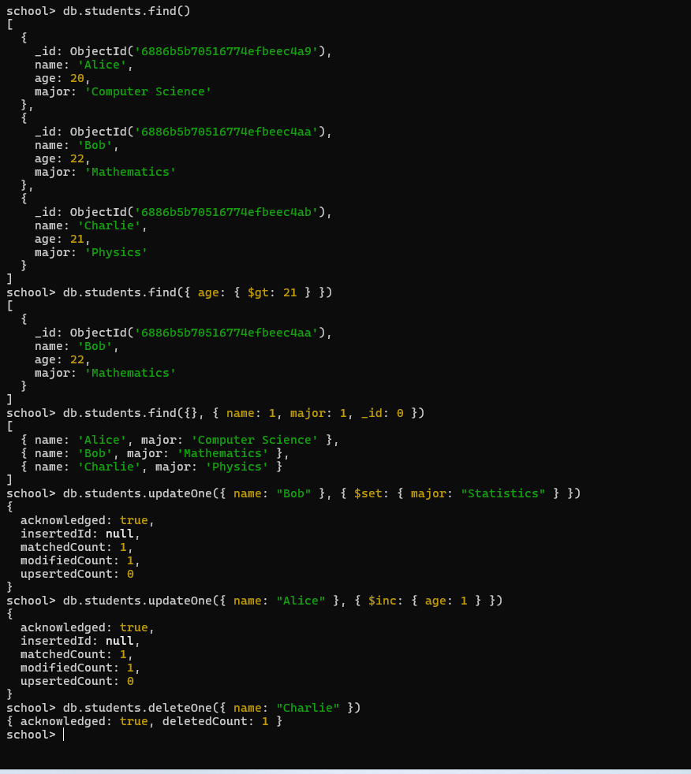
- Ran queries against my collection
- 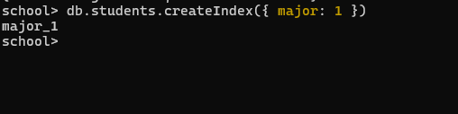
- Created index
- Used to improve speed of reads, for example when searching for major the index allows the fast lookup instead of full scan of the collection. Only downside is that they take up more space and slow down write speeds.

