Laboratory work No. 2
«Linear Algebraic Equations 12.39»

Submitted by
Farrakhetdinova Azaliya
05/12/2025
Problem statement

The steady-state distribution of temperature on a heated plate can be modeled by the Laplace equation,
$$0=\frac{∂^{2}T}{{∂x}^{2}}+\frac{∂^{2}T}{{∂y}^{2}}$$
If the plate is represented by a series of nodes (Fig. 1), centered finite-divided differences can be substituted for the second derivatives, which results in a system of linear algebraic equations. Use the Gauss-Seidel method to solve for the temperatures of the nodes in Fig. 1.

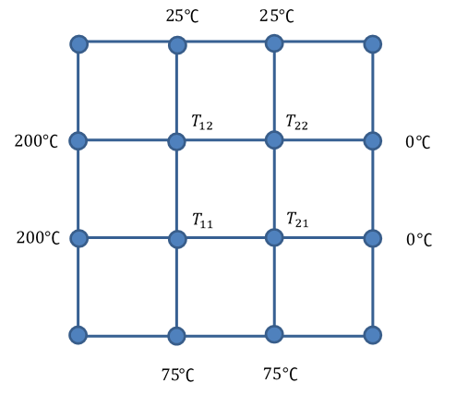
Fig. 1 – Heated plate with nodes

Mathematical model

Mathematical model of the problem consists of the Laplace equation
$$0=\frac{∂^{2}T}{{∂x}^{2}}+\frac{∂^{2}T}{{∂y}^{2}}$$
The second derivatives can be approximated with centered finite-divided differences
$$\frac{∂^{2}T}{{∂x}^{2}}≈\frac{T\left(x+h\right)-2T\left(x\right)+f(x-h)}{h^{2}}$$
After that we can obtain a system of linear algebraic equations.

Numerical method
Let system of linear equations be given in matrix form like represented below
$$A\vec{x}=\vec{b}$$
where $A$ – is a matrix with dimension $[n x n]$,
$\vec{x}$, $\vec{b}$ – are vectors with dimension $[n]$
Given system can be solved with iterative method
$${x_{i}}^{(k+i)}=\frac{1}{a_{ii}}\left[b_{i}-\sum_{j=i}^{i-1}{a_{ij}{x_{j}}^{\left(k+i\right)}}-\sum_{j=i+1}^{n}{a_{ij}{x_{j}}^{(k)}}\right]$$

The convergence criterion of Gauss-Seidel method:
$$\left|a_{ii}\right|≥\sum_{j≠i}^{n}{\left|a_{ij}\right|}$$

Result of numerical solution
The main window of interface is shown on Fig.1. There are the input fields and nodes with solutions.

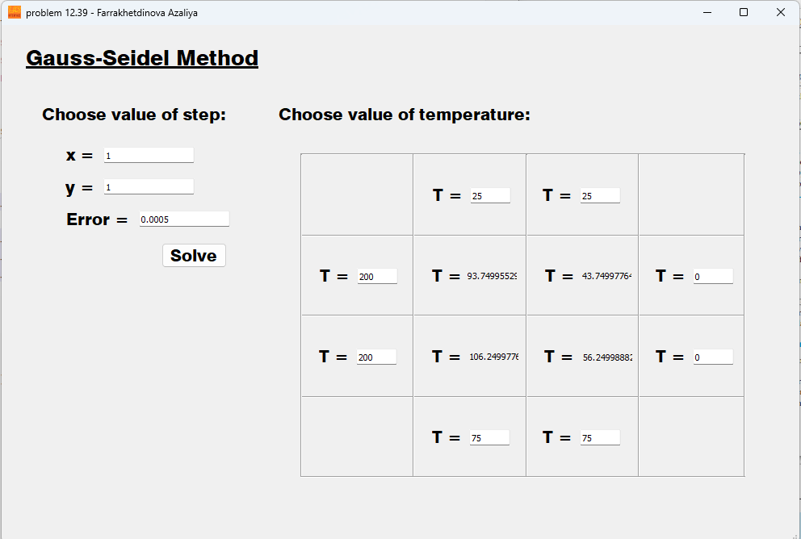
Fig.1 – Main window

Conclusion
For given steps of $x$ and $y$, the program outputs the value corresponding to the equation's solution. The solution can be described from a physical point a view. The high temperature influences on neighbor nodes with less temperature and vice versa.

Appendix.
A. Main Window Code
import numpy as np
from PyQt5 import QtWidgets, uic
from solution import Solution
class MainWindow(QtWidgets.QMainWindow):
def __init__(self):
super(MainWindow, self).__init__()
uic.loadUi('interface.ui', self)
self.solve_button.clicked.connect(self.show_solution)
def show_solution(self):
self.x = float(self.x_edit.text())
self.y = float(self.y_edit.text())
self.Error = float(self.Error_edit.text())
T_arr: np.ndarray = np.array([
[0, float(self.T12_edit.text()), float(self.T13_edit.text()), 0 ],
[float(self.T21_edit.text()), 0, 0, float(self.T24_edit.text())],
[float(self.T31_edit.text()), 0, 0, float(self.T34_edit.text())],
[0, float(self.T42_edit.text()), float(self.T43_edit.text()), 0 ]
])
self.solution = Solution(T=T_arr,
x=self.x,
y=self.y,
Error=self.Error)
T_solution = self.solution.solve()
print('solved')
self.T22_edit.setText(str(T_solution[0]))
print('read')
self.T23_edit.setText(str(T_solution[1]))
self.T32_edit.setText(str(T_solution[2]))
self.T33_edit.setText(str(T_solution[3]))
if __name__ == '__main__':
app = QtWidgets.QApplication([])
main = MainWindow()
main.show()
app.exec_()

B. Gauss-Seidel Method Solver Class
import numpy as np
from gauss_seidel_method import gauss_seidel
class Solution():
""" Class for solution problem 12-39 with Gauss-Seidel Method """
def __init__( self,
T: np.ndarray,
x: float,
y: float,
Error: float ):
self.T_arr: np.ndarray = T # it's a matrix [4 x 4]
self.x: float = x
self.y: float = y
self.Error: float = Error
self.T_start: np.ndarray = np.zeros(shape=4, dtype=float) # it is a vector of unresolved T
a = 1/pow(self.x, 2)
b = 1/pow(self.y, 2)
c = -2 * (a + b)
self.A: np.ndarray = np.array([
[c, a, b, 0],
[a, c, 0, b],
[b, 0, c, a],
[0, b, a, c]
])
self.b: np.ndarray = np.array([
-(self.T_arr[1][0] * a + self.T_arr[0][1] * b),
-(self.T_arr[1][3] * a + self.T_arr[0][2] * b),
-(self.T_arr[2][0] * a + self.T_arr[3][1] * b),
-(self.T_arr[2][3] * a + self.T_arr[3][2] * b),
])
def solve(self):
T_old: np.array
T_new: np.array = np.copy(self.T_start)
cur_error: float = 1e5
while cur_error > self.Error:
T_old = np.copy(T_new)
T_new = gauss_seidel(T_old=T_old, A=self.A, b=self.b)
cur_error = abs(T_old[0] - T_new[0])
print("cur_error = ", cur_error)
print("T_new = ", T_new)
print("T_old = ", T_old)
return T_new

C. Gauss-Seidel Method Implementation
import numpy as np
def gauss_seidel(
T_old: np.ndarray,
A: np.ndarray,
b: np.ndarray ):
""" returns new set (T_arr) """
N: int = len(T_old)
T_new: np.ndarray = np.zeros(shape=N, dtype=float)
for i in range(N):
T_new[i] = 1/A[i][i] * ( b[i] - np.sum(A[i][0:i] * T_new[0:i]) - np.sum(A[i][i+1:N] * T_old[i+1:N]) )
return T_new

