Laboratory work No. 3
«Roots of equations 20.27»

Submitted by
Farrakhetdinova Azaliya
19/09/2025
Problem statement

The vertical stress $σ_{z}$ under the corner of a rectangular area subjected to a uniform load of intensity $q$ is given by the solution of Boussinesq’s equation:
$$σ=\frac{q}{4π}\left[\frac{2mn\sqrt{m^{2}+n^{2}+1}}{m^{2}+n^{2}+1+m^{2}n^{2}}\frac{m^{2}+n^{2}+2}{m^{2}+n^{2}+1}+\sin^{-1}{\frac{2mn\sqrt{m^{2}+n^{2}+1}}{m^{2}+n^{2}+1+m^{2}n^{2}}}\right]$$
Because this equation is inconvenient to solve manually, it has been reformulated as
$$σ_{z}=qf_{z}(m,n)$$
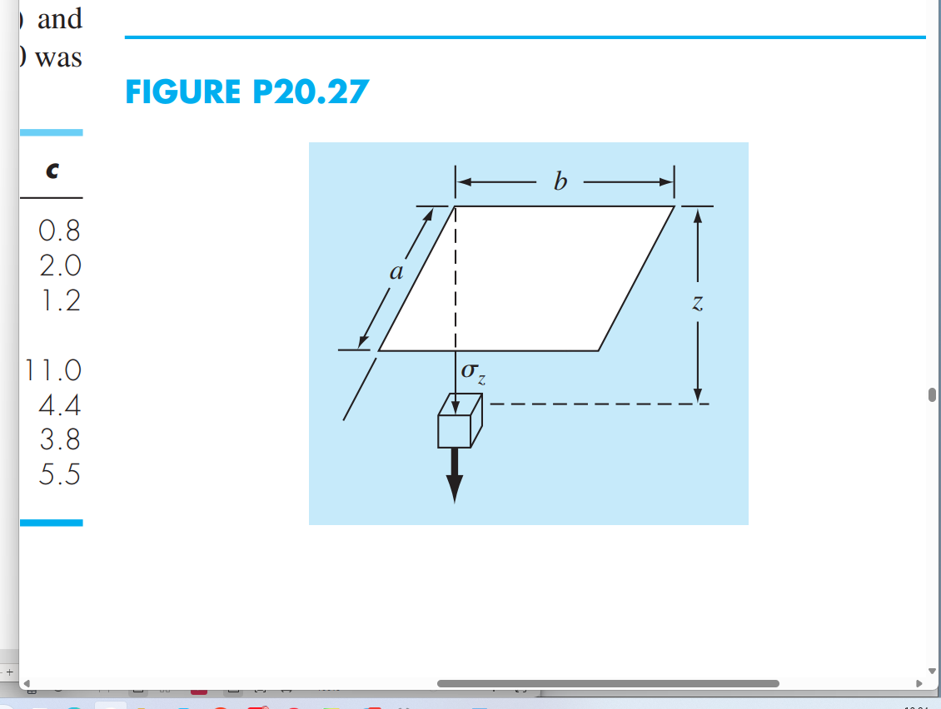
Fig. 1 – Rectangular area
where $f_{z}(m, n)$ is called the influence value and $m$ and $n$ are dimensionless ratios, with $m=a/z$ and $n=b/z$ and $a$ and $b$ as defined in Fig. 1. The influence value is then tabulated, a portion of which is given in Table 1. If $a= 4.6$ and $b= 14$, use a third-order interpolating polynomial to compute $σ_{z}$ at a depth $10 m$ below the corner of a rectangular footing that is subject to a total load of $100 t$ (metric tons). Express your answer in tonnes per square meter. Note that $q$ is equal to the load per area.
$$m$$ | $$n = 1.2$$ | $$n = 1.4$$ | $$n = 1.6$$
$$0.1$$ | $$0.02926$$ | $$0.03007$$ | $$0.03058$$
$$0.2$$ | $$0.05733$$ | $$0.05894$$ | $$0.05994$$
$$0.3$$ | $$0.08323$$ | $$0.08561$$ | $$0.08709$$
$$0.4$$ | $$0.10631$$ | $$0.10941$$ | $$0.11135$$
$$0.5$$ | $$0.12626$$ | $$0.13003$$ | $$0.13241$$
$$0.6$$ | $$0.14309$$ | $$0.14749$$ | $$0.15027$$
$$0.7$$ | $$0.15703$$ | $$0.16199$$ | $$0.16515$$
$$0.8$$ | $$0.16843$$ | $$0.17389$$ | $$0.17739$$
Table 1 – Influence value $f_{z}(m, n)$

Mathematical model

Mathematical model of the problem consists of the non-linear algebraic equation of the form
$g\left(f\right)=0$, (1)
where the function $f$ is defined as follows
$$g\left(f\right)=\frac{1}{\sqrt{f}}-4\log_{10}\left(Re\sqrt{f}\right)+0.4$$

Numerical method
The bisection method will be used for numerical solution of the equation (1). The algorithm of the bisection method can be summarized as the follows:
Step 1. Choose two values, $a$ and $b$, such that $f(a)$ and $f(b)$ have opposite signs. This means $a$ root lies between $a$ and $b$.
Step 2. Calculate the midpoint $c$:
$$c=\frac{a+b}{2}$$
Step 3. Evaluate $f(c)$: if $f(c)=0$, then c is the root. If $f(c)<ε$ ($ε$ is prescribed accuracy), then $c$ is the root. If not, continue.
Step 4. Determine which sub-interval contains the root: if $f(a)$ and $f(c)$ have opposite signs, root is in $[a,c]$; set $b=c$. Otherwise, set $a=c$.
Step 5. Repeat steps 2–4 until the interval is small enough (desired accuracy).

Result of numerical solution
The main window of interface is shown on Fig.1. There are the input fields, the solution, and the graph output for defining the solution area. If an incorrect area is selected, the program will issue a warning and suggest to choose a different area

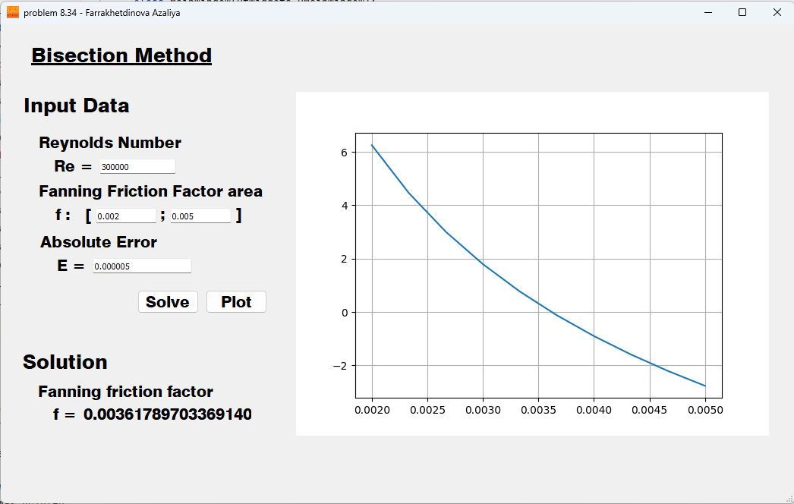
Fig.1 – Main window

Conclusion
For given Reynolds numbers, the program outputs the value corresponding to the equation's solution. This value can be approximated from the graph of the equation's values, where the equation is represented as a function.

Appendix.
A. Main Window Code
from PyQt5 import QtWidgets, uic
from solution import Solution
class MainWindow(QtWidgets.QMainWindow):
def __init__(self):
super(MainWindow, self).__init__()
uic.loadUi('interface.ui', self)
self.solve_button.clicked.connect(self.show_solution)
self.plot_button.clicked.connect(self.plot_data)
def plot_data(self):
self.Re = float(self.re_edit.text())
self.f_0 = float(self.f_0_edit.text())
self.f_n = float(self.f_n_edit.text())
self.Error = float(self.error_edit.text())
self.solution = Solution(Re=self.Re,
f_0=self.f_0,
f_n=self.f_n,
Error=self.Error)
self.widget_graph.canvas.axes.clear()
self.widget_graph.canvas.axes.plot(self.solution.f_arr, self.solution.var_Func_arr, "-", label='Func(f)')
self.widget_graph.canvas.axes.grid(True)
self.widget_graph.canvas.draw()
def show_solution(self):
self.Re = float(self.re_edit.text())
self.f_0 = float(self.f_0_edit.text())
self.f_n = float(self.f_n_edit.text())
self.Error = float(self.error_edit.text())
self.solution = Solution(Re=self.Re,
f_0=self.f_0,
f_n=self.f_n,
Error=self.Error)
message: str = self.solution.solve()
print(message)
self.error_message.setText(message)
self.f_solved = self.solution.f_n
self.solution_label.setText(str(self.f_solved))
if __name__ == '__main__':
app = QtWidgets.QApplication([])
main = MainWindow()
main.show()
app.exec_()
B. Bisection Method Solver Class
import numpy as np
import math as m
from bisection_method import bisec
class Solution():
""" Class for solution problem 8-34 with Bisection Method """
def __init__( self,
Re: float,
f_0: float,
f_n: float,
Error: float ):
self.Re: float = Re
self.f_0: float = f_0
self.f_n: float = f_n
self.Error: float = Error
self.f_arr: np.ndarray = np.linspace(start=self.f_0, stop=self.f_n, num=10)
self.var_Func_arr: np.ndarray = self.Func_arr(self.Re, self.f_arr)
def Func(self, Re: float, f: float):
return 1 / m.sqrt(f) - 4 * m.log10(Re * m.sqrt(f)) + 0.4
def Func_arr(self, Re: float, f: np.ndarray) -> np.ndarray:
return 1 / np.sqrt(f) - 4 * np.log10(Re * np.sqrt(f)) + 0.4
def solve(self):
Func_0: float
Func_n: float
Func_middle: float
cur_error: float = 10000
if (self.Func(self.Re, self.f_0) * self.Func(self.Re, self.f_n) < 0):
while cur_error > self.Error:
Func_0 = self.Func(self.Re, self.f_0)
Func_n = self.Func(self.Re, self.f_n)
Func_middle = self.Func(self.Re, (self.f_n + self.f_0) / 2)
self.f_0, self.f_n = bisec(self.f_0, self.f_n, Func_0, Func_n, Func_middle)
cur_error = (abs(self.f_0 - self.f_n) / abs(self.f_n))
return ''
else:
self.f_n = 0
return 'there is no solution!\n
please, choose different\n
area for f'
C. Bisection Method Implementation
def bisec(
a: float,
b: float,
f_a: float,
f_b: float,
f_middle: float ):
""" returns new set (a, b) """
a_new: float = 0
b_new: float = 0
if (f_a*f_middle < 0):
a_new = a
b_new = (a + b) / 2
if (f_b*f_middle < 0):
a_new = (a + b) / 2
b_new = b
return a_new, b_new

D. Plotting Class (using Matplotlib)
import matplotlib
matplotlib.use('Qt5Agg')
from PyQt5 import QtWidgets
from matplotlib.backends.backend_qt5agg import FigureCanvasQTAgg
from matplotlib.figure import Figure
class MplCanvas(FigureCanvasQTAgg):
def __init__(self):
fig = Figure()
self.axes = fig.add_subplot(111)
super().__init__(fig)
class MplWidget(QtWidgets.QWidget):
def __init__(self, parent=None):
super().__init__(parent)
self.canvas = MplCanvas()
self.layout = QtWidgets.QVBoxLayout()
self.layout.addWidget(self.canvas)
self.setLayout(self.layout)

