Wireless Light-Intensity Controlled Motor using RF Communication

K.AZAAN AHAMED- 23BEC0362
S.S.SREENITHIE – 23BEC0423

ABSTRACT:
This project presents a wireless system that dynamically controls the motor based on the light intensity. This project uses a Light Dependent Resistor (LDR) as the sensing element, the transmitter reads the light levels from the sensor and sends the data wirelessly through a 433 MHz RF module. At the receiver end, an Arduino is placed to process the transmitted light intensity values. These values are then used to control the DC motor through the motor driver (L298N). An lcd in the receiver side is placed to display the received data, that is, the values of light intensity from the LDR Sensor. The motor speed is proportional to the light intensity, which provides the fundamental closed-loop control system, where sensor inputs regulate actuator outputs. This low-cost setup gives a practical example of integrating sensors, wireless communication, and actuator control, with potential applications in smart lighting, solar tracking, and automation systems.

INTRODUCTION:
Automation systems depends more on sensor-based feedback to perform tasks efficiently without human intervention. Light intensity-based automation is particularly common in energy-saving applications such as street lighting, solar panel orientation systems, and indoor smart lighting. By using the sensor to continuously monitor the environment and an actuator to respond, the system forms a basic control loop.
This project focuses on the design and implementation of a wireless LDR-based motor control system. The LDR measures the surrounding light, converts it into an electrical signal, and transmits the information to a receiver through RF communication. The receiver uses this data to process the motor speed in real-time, forming a feedback-controlled actuator system. LCD displays the light intensity value thus confirming that data is received. This project highlights how control systems concepts, like input sensing, processing, and output actuation, can be implemented in a simple wireless automation application.

SYSTEM MODEL:
The system is divided into transmitter and receiver modules. Both modules work together to form the wireless closed-loop system where sensor readings controls the actuator (dc motor) behavior.
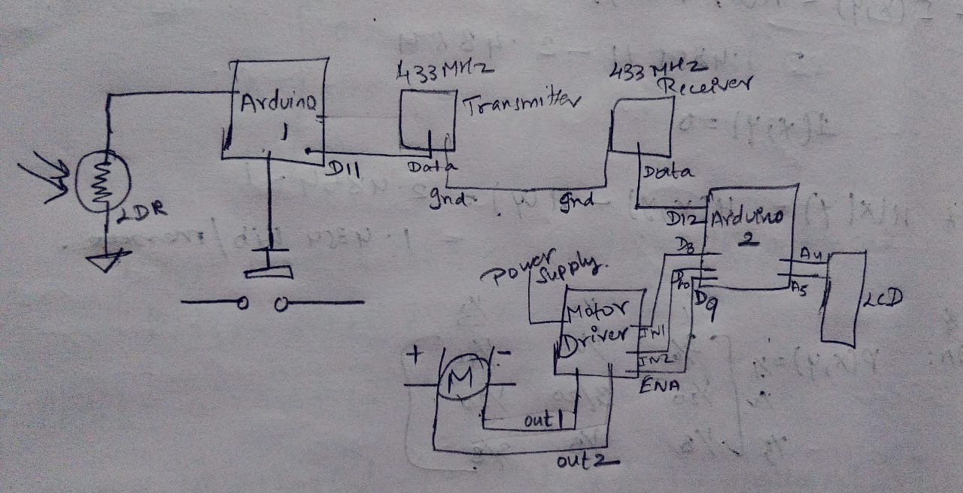

Transmitter Side:
Components:
- Arduino Uno
- LDR (Light Dependent Resistor)
- RF Transmitter module (433 MHz)
- Push button
- Connecting wires and power supply
Method:
The transmitter continuously monitors the light using the LDR. The LDR is directly connected to the Arduino analog input (A0) and 5 V. In this configuration, the Arduino reads the analog voltage generated across the LDR, which varies with the light intensity. No external resistor is used. The Arduino converts this voltage to a digital value (0–1023) and transmits it through the RF module.
Circuit Explanation:
- The LDR alone forms a variable voltage divider internally recognized by the Arduino ADC.
- RF transmitter DATA pin connects to Arduino digital pin D12.
- VCC and GND of the RF module connect to Arduino 5V and GND.
- Arduino reads analog LDR values, processes them, and sends them via RF in real time.
The transmitter acts as the sensor node in a control loop, converting environmental input (light) into an electrical signal that serves as feedback to the actuator.
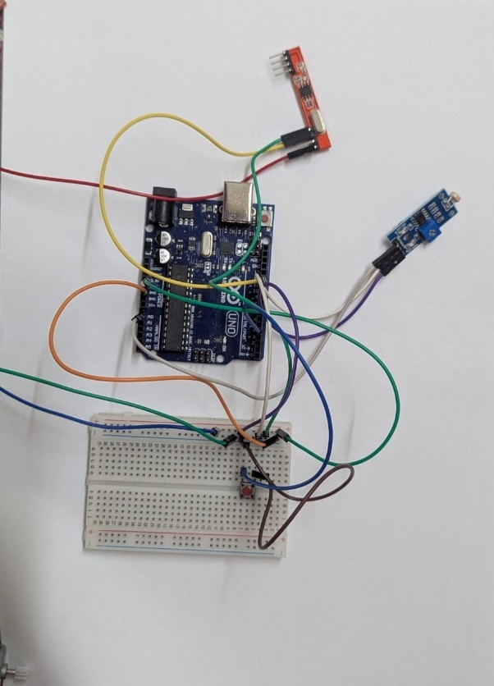

Receiver Side :
Components:
- Arduino Uno
- RF Receiver module (433 MHz)
- L298N Motor Driver
- DC Motor
- LCD
- Power supply
Method:
The receiver receives the transmitted LDR light intensity values and processes them to determine the motor speed. Using the motor driver, the Arduino varies the PWM (Pulse Width Modulation) signal to the motor based on the light intensity, the lcd placed displays the value of the received light intensity data thus providing a visual feedback.

Circuit Explanation:
- RF receiver DATA pin connects to Arduino digital pin D11.
- Motor driver connections:
  - ENA → D9 (PWM for speed control)
  - IN1 → D8
  - IN2 → D10
- LED connected to built-in Arduino pin D13 for reception indication.
- The Arduino interprets the received LDR values and adjusts motor PWM proportionally.
The receiver forms the actuator node of the control system. The system implements a feedforward control behavior, where actuator output (motor speed) is directly proportional to sensor input (light intensity). Thresholds prevent the motor from running under low-light conditions, effectively implementing a simple decision-based control logic.

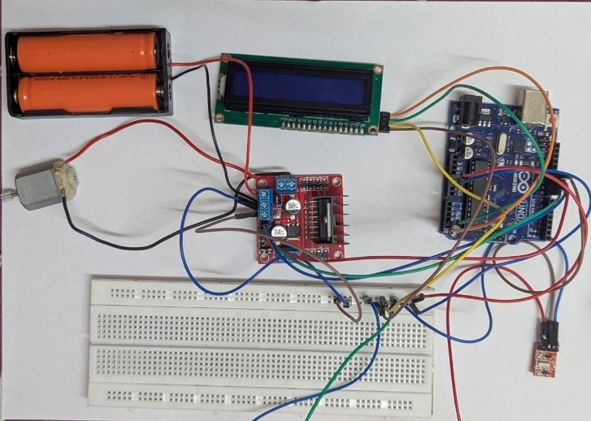

CODES:

Transmitter:

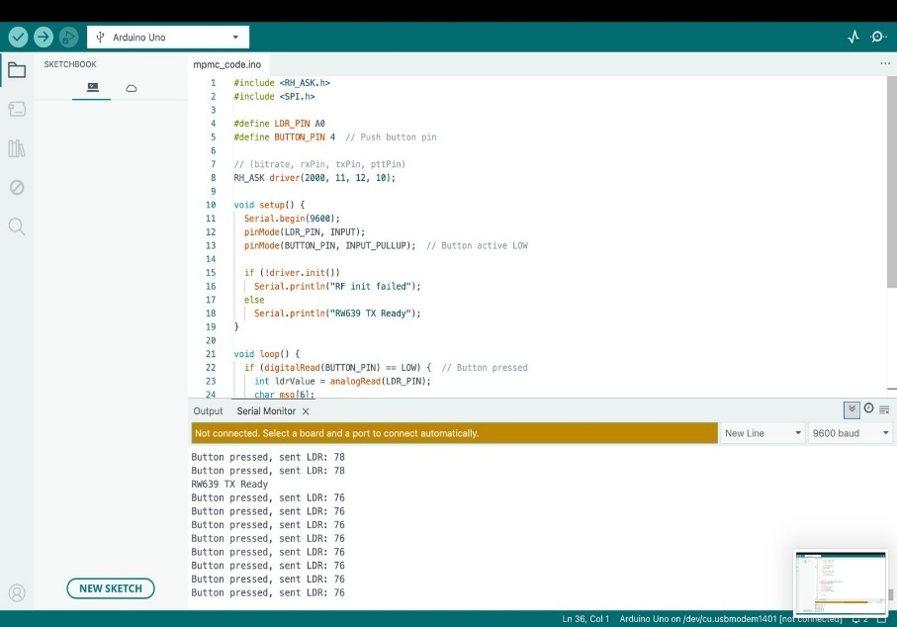

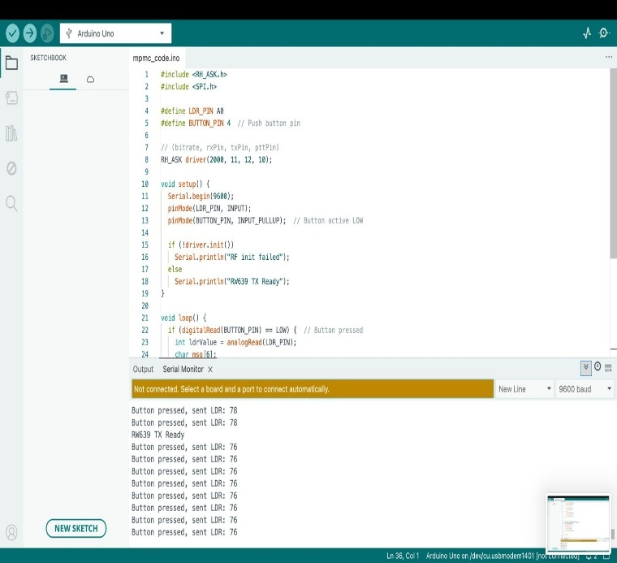

Receiver:

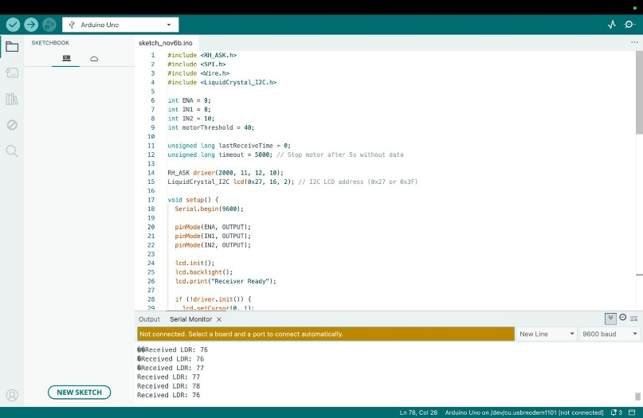

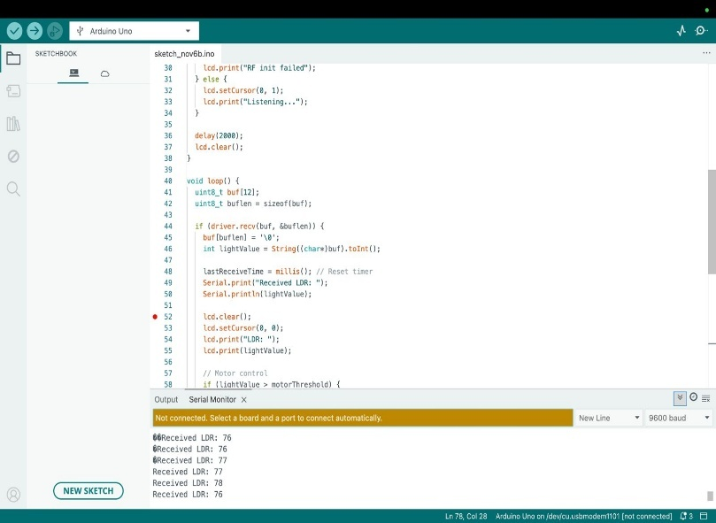

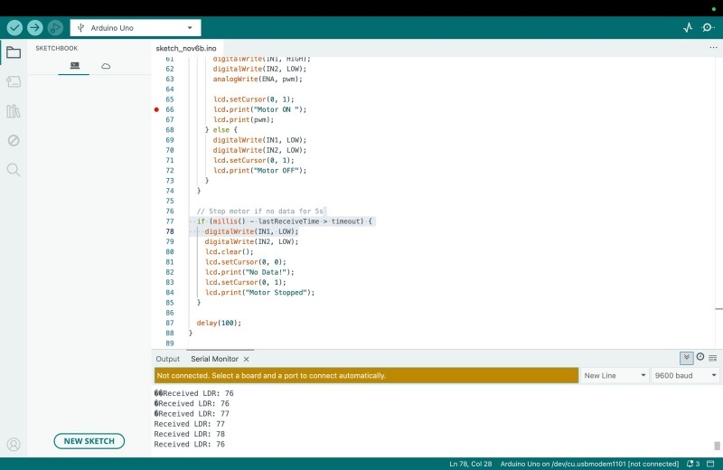
PERFORMANCE ANALYSIS:
- Transmission Reliability:
Data is consistently received within 1–10 meters, with negligible packet loss.
- Motor Response:
PWM output varies linearly with LDR values above a threshold (50), providing proportional speed control.
- Latency and Responsiveness:
Delay between sensor reading and motor response remains below 500 ms, sufficient for human-perceptible control systems like lighting or fan regulation.
- Power Efficiency:
RF modules consume minimal power, providing energy-efficient actuation.
- Control Behavior:
The system forms a simple analog control loop: sensor → transmitter → wireless link → receiver → motor driver → motor.
This loop can be expanded to more complex feedback or PID control systems in advanced automation applications.

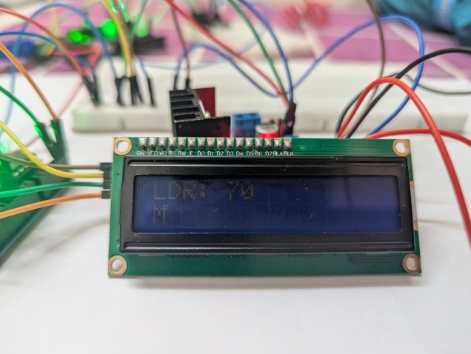
RESULTS:
- Serial Monitor Output:
Displays transmitted and received LDR values for debugging and monitoring purposes.
- LCD Feedback:
Confirms that the transmitted data is received and its value in real-time.
- Motor Performance:
  - Motor is off for LDR values ≤ 50.
  - Speed increases proportionally as LDR values rise above threshold.
  - Maximum speed corresponds to maximum light intensity.
- Graphical Representation:
A plot of light intensity vs. motor PWM output demonstrates proportional control behavior, effectively illustrating sensor-to-actuator mapping.
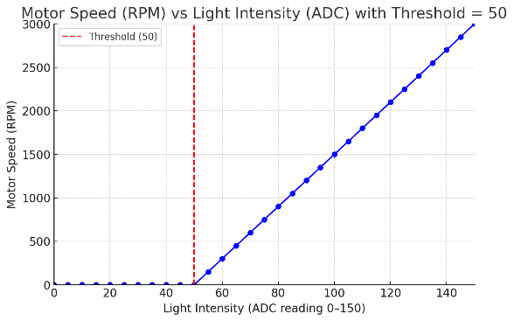
- Practical Observations:
The motor responds quickly to changing light conditions, validating the system's suitability for real-time automation applications.
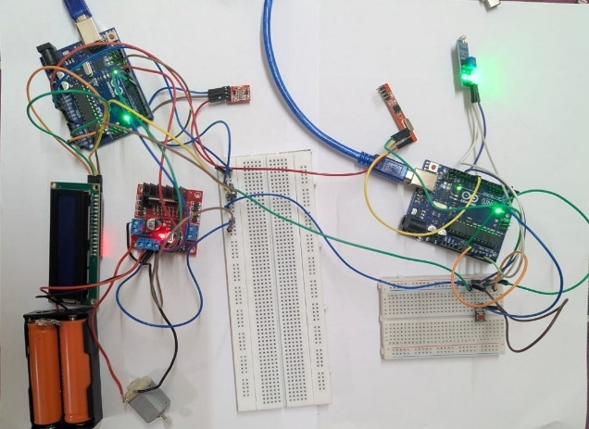
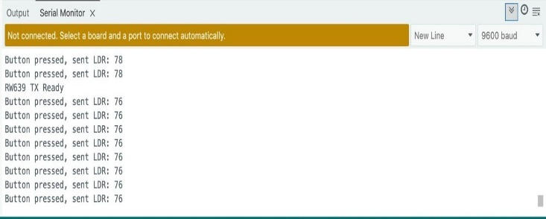

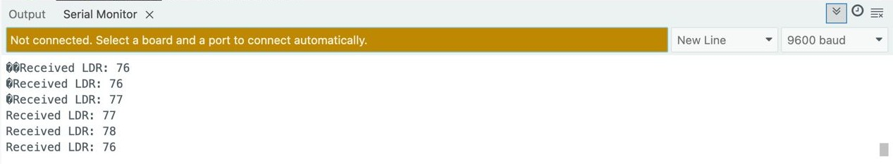

CONCLUSION:
This project demonstrates a practical control system where sensor input (light intensity) directly regulates an actuator (motor) through wireless communication. The LDR-based transmitter and RF receiver form a simple, low-cost wireless feedback loop. The motor responds proportionally to light levels, and the LCD provides feedback. This system can be extended to:
- Smart lighting and automated shading systems
- Solar tracking panels
- Distributed wireless automation systems
By incorporating the basic principles of sensor feedback, actuator control, and wireless communication, the project highlights the application of control systems in real-world wireless automation.

REFERENCES:
- R. T. Howe, Wireless Communication for Embedded Systems, IEEE Transactions on Industrial Electronics, vol. 65, no. 2, pp. 1205–1213, 2018.
- A. Kumar, Light-Dependent Motor Control Systems, International Journal of Electronics, vol. 10, no. 3, pp. 50–56, 2020.
- K. Ogata, Modern Control Engineering, 6th Edition, Pearson, 2022.

