Wireless Transmission of LDR-Based Digital Light Information Using RF Communication and Binary LED Representation

Problem Statement
Traditional LDR-based light monitoring systems work only in wired configurations and display simple bright/dark status. There is a need for a low-cost wireless technique that can transmit light-intensity information digitally and represent it in a more meaningful form, such as binary.
The system must:
→Read real-time light intensity using an LDR
→Transmit the brightness indicator wirelessly
→Extract information at the receiver side
→Perform digital computation on the received data
→Display the results visually on both LCD and binary LEDs
Abstract
This project presents a low-cost wireless digital communication system that transmits LDR-based brightness information using an RF (Radio Frequency) transmitter and receiver module. The transmitter measures ambient light using a 3-pin LDR sensor and encodes the data as a single digital bit (1 for bright, 0 for dark).
At the receiver side, the bit is used to simulate a corresponding LDR value, from which the tens digit (A) and ones digit (B) are extracted. The absolute difference c = |A – B| is calculated and displayed both numerically and in 3-bit binary form using LEDs. An I²C LCD simultaneously displays LDR, A, B, and C values.
The system demonstrates real-time wireless digital sensing, simple computation, and hardware-based binary representation, making it suitable for digital communication mini-projects and teaching demonstrations.

Introduction
Wireless communication is widely used in sensing applications where wired connections are impractical. Low-cost RF modules such as 433 MHz TX/RX pairs enable short-range digital transmission with ease. Light Dependent Resistors (LDRs) are commonly used to sense environmental brightness and produce analog signals.
This project combines both concepts to form a wireless optical monitoring system. The transmitted signal is a simple digital key derived from the LDR reading. The receiver performs additional computation to extract valuable digital information represented visually using LEDs.
The binary LED representation technique based on the extracted difference c = |A – B| adds a digital communication flavor, making the project suitable for academic demonstrations.

System Model
- Block Diagram
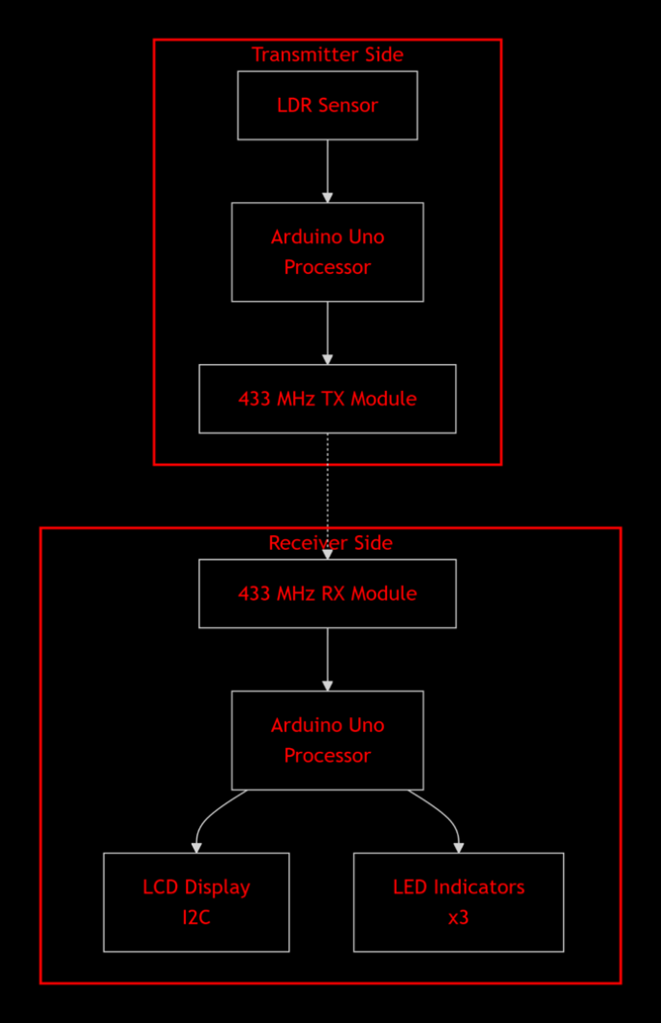
Flowchart
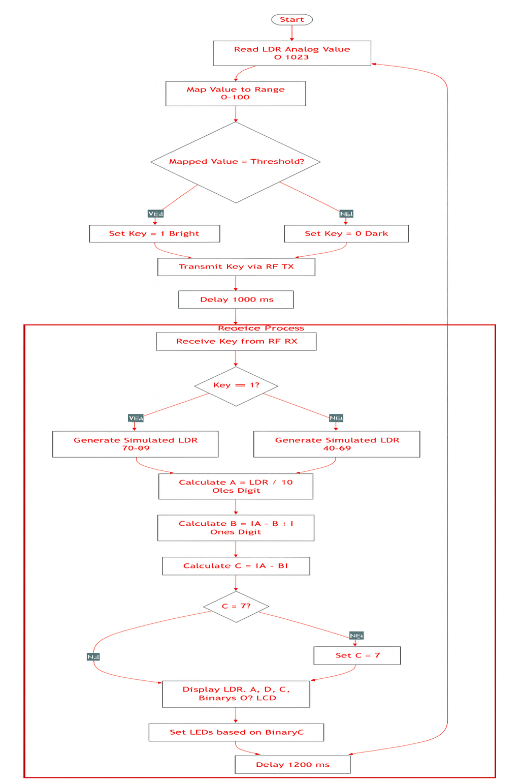

Hardware and Software Description:

Hardware

→Arduino Uno (Tx and Rx)
Used as the main controller for sensing, encoding, transmitting, receiving, and computing.

→LDR Sensor Module (3-pin)
Provides analog light intensity value used for brightness detection.

→RF Transmitter – 433 MHz
Sends digital key bit using ASK/OOK modulation.

→RF Receiver – 433 MHz
Receives the bit and outputs it to Arduino.

→16×2 I²C LCD
Displays simulated LDR, digits A/B, difference C, and binary output.

→Three LEDs
Show binary value (c2, c1, c0) of the computed difference.

→Breadboard and Jumper Wires
Used for prototyping connections.

(B) Software Used

→Arduino IDE
Used for coding and uploading programs.

→Serial Monitor
Used for debugging and viewing transmitted/received data.

Proposed Work/Implementation (With Mathematical Model)
The proposed project implements a wireless digital communication system that transmits light-dependent data using a 433 MHz RF link. The system consists of two units: a transmitter that senses environmental light using an LDR module, and a receiver that processes the transmitted bit to generate digital output and binary LED indication. The entire implementation integrates sensing, signal conditioning, digital encoding, wireless transmission, decoding, mathematical processing, and binary representation.

→ Light Sensing
The LDR’s analog value is read using Arduino's 10-bit ADC.
Raw value:
$ADC=\frac{V_{LDR}}{5V}×1023$
Since your module outputs roughly 0–150:
$L=map\left(ADC,0,150,0,100\right)$

→ Thresholding
A threshold decides brightness:
$Key=\{1 L>70 0 L≤70$

→ RF Transmission
The 433 MHz RF module uses OOK (On–Off Keying):
- Key 1 → carrier ON
- Key 0 → carrier OFF
$s\left(t\right)=\{Acos\left(2πfct\right), if Key=1 0, if Key=0$

→ RF Reception
The receiver demodulates and outputs the bit as:
$b∈\{0,1\}$

→ Simulated LDR Value
Since only 1 bit is transmitted:
$L_{recv}=\{70–99 \hat{b}=1 40–69 \hat{b}=0$
This keeps the receiver’s processing meaningful.

→ Extracting Tens and Units Digits
Let:
$L_{recv}=10A+B$
Then:
$A=⌊\frac{L_{rec}}{10}⌋$ ; $B=L_{recv} mod 10$

→ Computing the Difference
$C=\left|A−B\right|$
Since only 3 LEDs are used, we restrict:
$C_{final}=min\left(C,7\right)$

→ Binary Conversion
Convert C to binary:
$C=c_{2}c_{1}c_{0}$
Where:
$c_{i}=\left(⌊\frac{C}{2^{i}}⌋\right) mod 2$

→ LED Output
- LED1 → c₀
- LED2 → c₁
- LED3 → c₂
Example:
C = 5 → 101 → LED3 ON, LED2 OFF, LED1 ON

Pseudo Code
Transmitter
read LDR value
map to 0–100
if value > 70 → key = 1
else key = 0
digitalWrite(txPin, key)

Receiver
read key from RF
if key==1 → generate bright range LDR
else → generate dark range LDR
A = LDR / 10
B = LDR % 10
C = abs(A - B)
display C and binary on LCD
set LED bits according to C

Results:
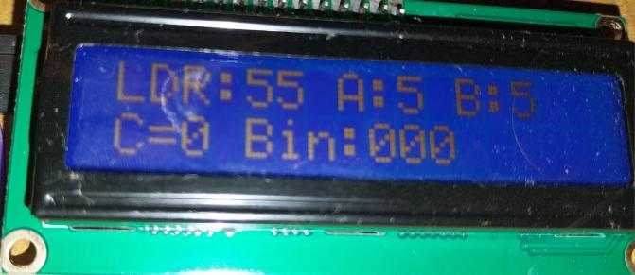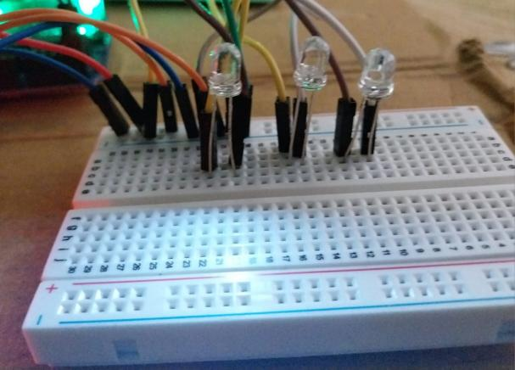
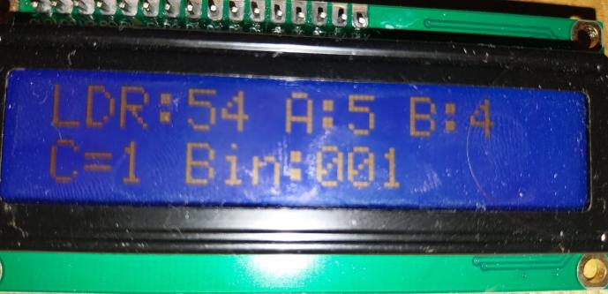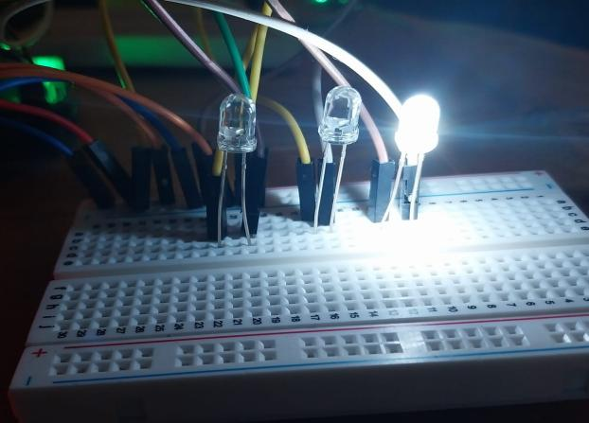
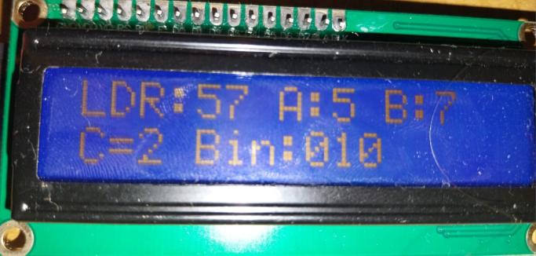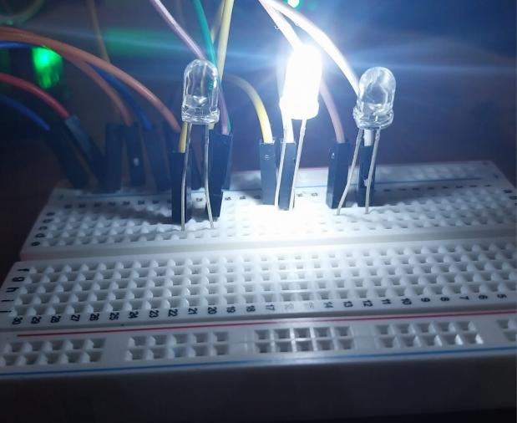
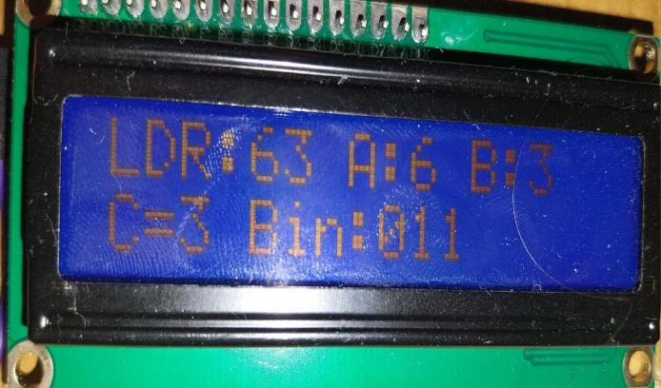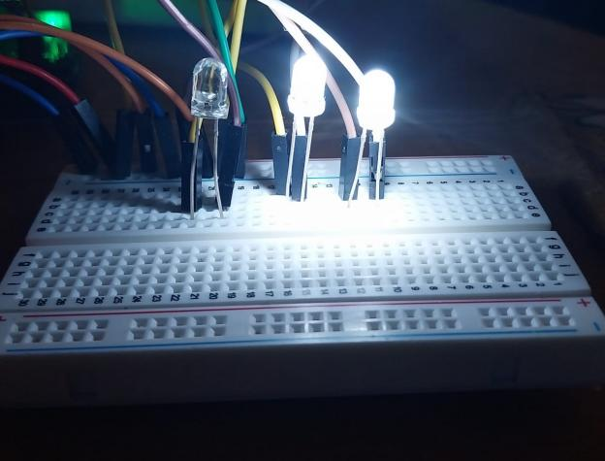
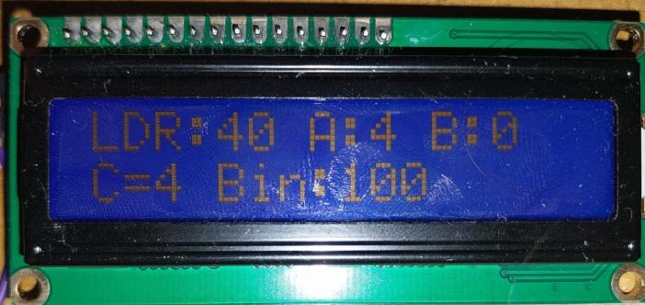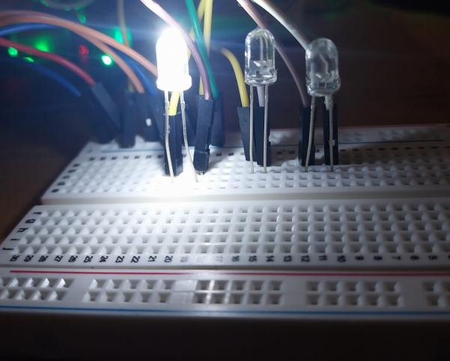
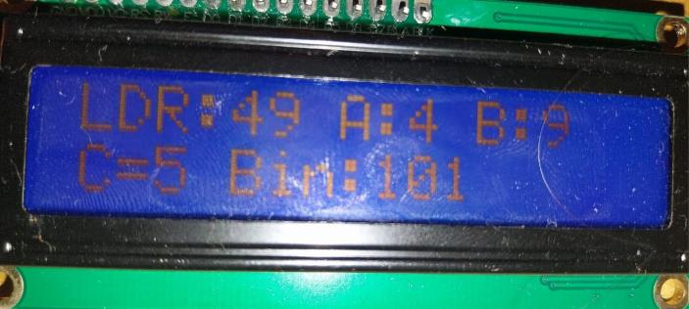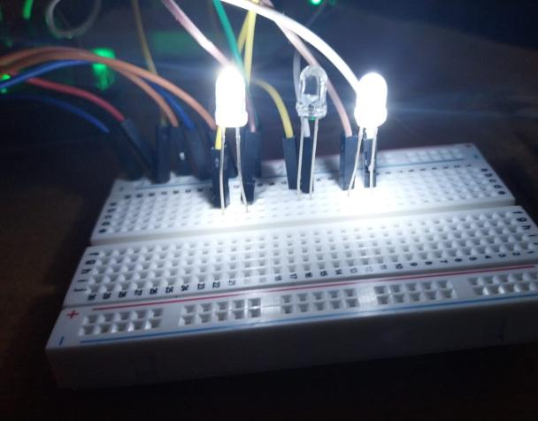

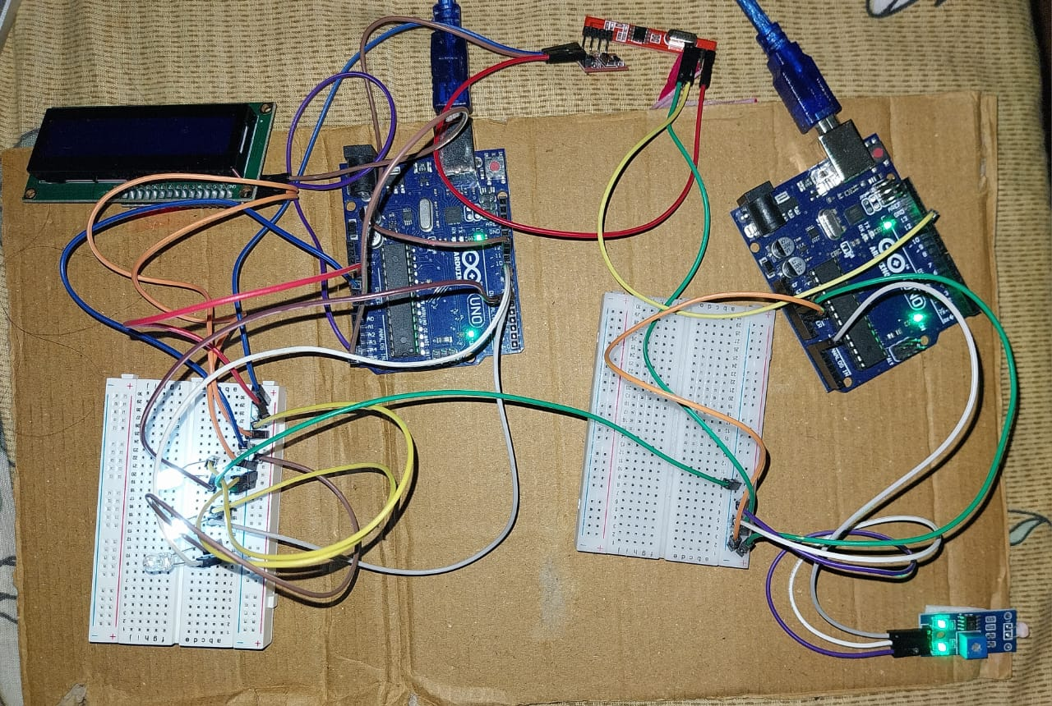
Tabulation:

Transmitter Output
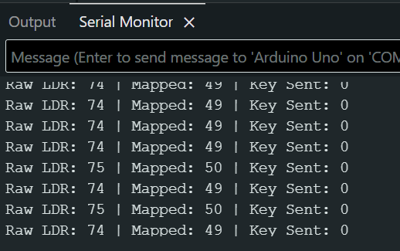
Raw | Mapped | Key
95 | 63 | 1
78 | 52 | 0
120 | 80 | 1

Receiver Output
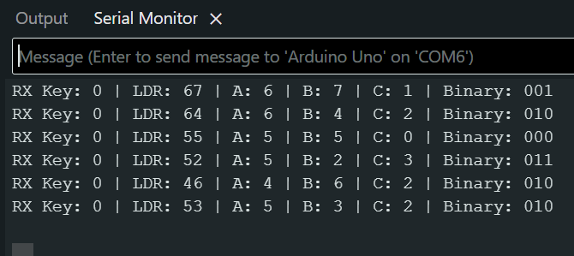
Key | LDR | A | B | C | Binary
1 | 86 | 8 | 6 | 2 | 010
0 | 52 | 5 | 2 | 3 | 011
1 | 91 | 9 | 1 | 8 → 7 | 111

Conclusion
The project successfully implements a wireless digital sensing system using an LDR and RF modules.
The transmitter compresses analog data into a single bit, enabling simple and power-efficient wireless transmission.
The receiver reconstructs useful information, performs a mathematical operation, and visually represents the result using LEDs and an LCD.
The project demonstrates the integration of sensing, encoding, wireless communication, digital logic, and display subsystems.

Future Enhancements
→Transmit full LDR value instead of a single bit
→Add IoT integration using ESP8266/ESP32
→Replace ASK with FSK or LoRa for more reliable communication
→Include motor control or alarm systems
→Use actual LDR at receiver for true sensing at both ends
References
- Arduino Foundation. (2023). Arduino Language Reference. https://www.arduino.cc/reference/en/
- "Using 433MHz RF Modules with Arduino." Last accessed: Nov 2024. [Online]. Available: https://lastminuteengineers.com/433mhz-rf-wireless-arduino-tutorial/
- "LiquidCrystal I2C Library." Last accessed: Nov 2024. [Online]. Available: https://github.com/johnrickman/LiquidCrystal_I2C

REGISTER NUMBER | NAME
23BEC0362 | AZAAN AHAMED K
23BEC0423 | SREENITHIE S S
23BEC0457 | NIVANDHINI B L

