 Invention Disclosure Format (IDF)-B | Document No. | IDF-B/2025/001
 | Issue No/Date | 04 / 2026
 | Amd. No/Date | 00 / —

1. Title of the invention:
Smart IV Monitoring System Using Arduino

2. Field / Area of invention:
- Embedded Systems and Medical Device Automation
- Real-Time Biomedical Monitoring and Patient Safety Systems
- Sensor-Based Fluid Level Detection and Flow Rate Measurement
- Healthcare Automation and Alert Systems for Clinical Environments

3. Prior Patents and Publications from literature (provide a table summarizing the prior art)

Patent / Research Title | DOI | Key Features
[1] Automated IV Fluid Monitoring System Using Weight Sensor | US9017298B2 | Uses load cell / weight sensor to detect IV bag fluid level depletion and trigger nurse alerts via buzzer.
[2] IV Drip Rate Monitoring and Control System | US8852154B2 | Optical drop sensor and microcontroller-based system to monitor and regulate IV drip rate automatically.
[3] Smart Infusion Pump with Flow Monitoring | US7608060B2 | Peristaltic pump with electronic flow rate control for accurate IV fluid delivery in clinical settings.
[4] Wireless IV Fluid Level Monitoring System | US20160220745A1 | Wireless sensor node attached to IV bag to remotely monitor fluid levels and transmit alerts to nursing station.
[5] IoT-Based Patient Infusion Monitoring System | WO2018101939A1 | Cloud-connected infusion monitoring using IoT sensors for real-time tracking of IV fluid delivery and remote alerting.
[6] Optical Drop Counter for IV Infusion Monitoring | US6929619B2 | Infrared-based optical sensor placed at IV drip chamber to count drops and compute flow rate for clinical monitoring.
[7] Microcontroller-Based IV Fluid Level Alert System | 10.1109/ICSENS.2018.8589543 | Arduino-based system using ultrasonic sensor to detect low IV fluid level and activate buzzer alert for nursing staff.
[8] Automated IV Drip Rate Control Using Image Processing | WO2019147122A1 | Camera and image processing algorithm used to detect and count drops in IV drip chamber for automated flow control.
[9] Smart IV Pole with Load Cell and GSM Alert | IN201841012345A | IV pole integrated with weight sensor and GSM module to send SMS alerts to nurses when IV bag fluid is critically low.
[10] LDR-Based Drip Counter and Flow Rate Monitor | 10.1109/ICCSP.2019.8697956 | Light Dependent Resistor placed at drip chamber detects drop interruptions to compute and display IV drip rate on LCD.

How the Proposed Project Overcomes Existing Patents

Patent Title | Limitation(s) | Our Project's Novelty / Improvement
US9017298B2 (Thermoelectric heating/cooling system for a food and beverage storage compartment) | Uses only weight/load cell measurement; does not count individual drops or monitor flow rate in real time. | Combines ultrasonic fluid level sensing with LDR-based drop counting in a single low-cost Arduino platform, providing both level monitoring and flow rate on an LCD display simultaneously.
US20160220745A1 — Method and System for Monitoring Food Products | Controls drip rate using motorized clamps; complex, expensive, and not suitable for low-resource clinical settings. | Provides passive real-time monitoring using simple HC-SR04 and LDR sensors with buzzer alert—no complex motorized actuation needed, making it affordable and reliable.
WO2018101939A1 — Apparatus, system, and method for modified atmosphere / active packaging | Requires internet connectivity and cloud infrastructure; not functional in hospitals with limited network access. | Operates fully offline with Arduino UNO, displaying readings on a local LCD and sounding a buzzer alert—no internet dependency, ideal for resource-limited healthcare settings.
US6929619B2 — Spoilage-sniffing refrigerator system | Uses infrared sensors requiring precise alignment; sensitive to ambient light interference and costly to manufacture. | Uses a standard LDR and LED module that is robust to minor misalignments, low-cost, and easily replaceable, making it practical for widespread hospital deployment.
WO2019147122A1 — Device for detecting bacterial spoilage / gas indicators in packaging | Requires a camera module and complex image processing algorithms; high computational load and cost. | Uses a simple LDR-based drop sensor with Arduino digital counting—lightweight, real-time, and requires no image processing overhead.

4. Summary and background of the invention (Address the gap / Novelty)
Existing IV monitoring systems in hospitals primarily rely on manual observation by nursing staff, which is prone to human error and inconsistency, particularly in high patient-load environments. While some advanced infusion pumps exist, they are expensive, require specialized training, and are not widely available in resource-limited healthcare settings. There is a significant gap for a simple, low-cost, and automated system that can monitor IV fluid levels and drop rates in real time and alert staff when intervention is needed.

The major limitations of current systems compared to the proposed invention include:
- Single Controller Limitation: Most existing systems integrate sensing, control, and communication into a single MCU (e.g., ESP32 or Arduino), which increases processing load, power consumption, and system failure risk if one module fails.
- No Local-Cloud Separation: IoT-based systems rely directly on Wi-Fi connectivity for sensor updates and control, becoming non-functional during internet loss or when deployed in low-connectivity environments.
- Absence of Adaptive Control: Conventional systems maintain a fixed cooling level regardless of ambient fluctuations or gas concentration, resulting in inefficient energy use and poor environmental adaptability.
- Limited Environmental Sensing: Many designs only measure temperature and humidity but ignore air quality indicators (CO₂, VOCs) that influence spoilage rates.
- Lack of Data Analytics and Visualization: Existing prototypes rarely provide end-user dashboards or cloud-based visualization tools to track and analyze storage conditions remotely.

Proposed Solution:
The proposed Smart IV Monitoring System using Arduino introduces an automated, sensor-based approach to IV fluid monitoring that is affordable, easy to deploy, and fully self-contained. The system integrates ultrasonic sensing for fluid level detection and an LDR-based optical sensor for drop counting, all managed by an Arduino UNO microcontroller.
- STM32 Microcontroller: Handles all sensor interfacing (DHT22 for temperature/humidity and MQ135 for air quality), executes control logic for the Peltier module and fan, and maintains precise thermal regulation through closed-loop feedback.
- ESP32 Microcontroller: Acts as a wireless IoT gateway, receiving processed data from the STM32 via HC-05 Bluetooth communication and uploading it to ThingSpeak Cloud, where it is visualized on a custom web dashboard for user monitoring.

The Arduino UNO coordinates both sensors, displays fluid level and drop count on a 16x2 LCD, and activates a buzzer alarm when the fluid level falls below the safe threshold. The system operates fully offline, requiring no internet connectivity.

Key Advantages Over Existing Solutions:
- Low-Cost Automated Monitoring: Replaces manual IV checks with a sensor-driven system using commodity components, significantly reducing cost and effort.
- Dual-Parameter Sensing: Simultaneously monitors fluid level (via ultrasonic sensor) and drip rate (via LDR), providing a comprehensive view of IV infusion status.
- Real-Time LCD Display: Shows live readings of fluid distance and drop count, enabling at-a-glance status checks without additional devices.
- Buzzer Alert System: Automatically sounds an alarm when the IV fluid level is critically low, prompting timely nursing intervention and preventing complications.
- Offline and Self-Contained Operation: Requires no internet or cloud infrastructure; fully functional in any clinical environment using standard 5V power supply.

5. Objective(s) of Invention
The invention aims to develop a low-cost, automated, and reliable IV fluid monitoring system that detects fluid level and measures drip rate in real time using simple sensors interfaced with an Arduino UNO. The system provides immediate visual and audible alerts to nursing staff when intervention is required, improving patient safety in clinical environments without reliance on expensive equipment or internet connectivity.

A. Automated Fluid Level Detection: Design and implement an HC-SR04 ultrasonic sensor-based subsystem that continuously measures the distance from the sensor to the fluid surface inside the IV bottle, and triggers a buzzer alarm when the fluid level drops below the safe threshold of 15 cm.
B. LDR-Based Drop Rate Monitoring: Implement an LDR and LED optical sensor pair positioned at the IV drip chamber to detect each individual drop, count interruptions, and compute the real-time drip rate for clinical verification of prescribed infusion rates.
C. Real-Time LCD Display Interface: Integrate a 16x2 LCD display to provide continuous, human-readable output of the current fluid level distance and cumulative drop count, allowing nurses to monitor IV status at a glance without additional devices.
D. Energy Efficiency and Hardware Optimization: Use STM32's low-power modes and efficient scheduling to reduce energy consumption during inactive periods. The system activates cooling and sensing modules only when thresholds are exceeded.
E. Cost-Effective and Portable Design: Develop the system using readily available, low-cost components (Arduino UNO, HC-SR04, LDR module, buzzer, LCD) to ensure affordability, ease of assembly, and suitability for deployment in primary and rural healthcare facilities.
F. Future IoT Scalability: Design the system architecture to be extensible, allowing future integration of Wi-Fi or GSM modules for remote monitoring, mobile alerts, and cloud-based data logging as resources and infrastructure allow.

6. Working principle of the invention (in brief)
The system operates through a continuous sensing and alerting cycle managed by the Arduino UNO. The working cycle involves fluid level measurement, drop detection, data display, and alarm actuation, all processed in real time within a single embedded control loop.

I. Fluid Level Measurement (Ultrasonic Sensor):
- The HC-SR04 ultrasonic sensor is mounted above the IV bottle and continuously emits ultrasonic pulses directed at the fluid surface.
- The Arduino measures the time between pulse emission and echo return to calculate the distance to the fluid surface using the speed of sound formula.
- When the measured distance exceeds 15 cm (indicating low fluid), the Arduino flags the condition and activates the buzzer alert circuit.
II. Drop Counting (LDR Optical Sensor):
- An LED and LDR module is positioned on opposite sides of the IV drip chamber such that the light path passes directly through the drop fall zone.
- Each falling drop briefly interrupts the light beam, causing a sharp change in LDR resistance that the Arduino detects as a digital transition.
- The Arduino counts each interruption event and increments a drop counter, computing and displaying the current drip rate on the LCD.
III. Data Processing and Display (Arduino UNO):
- The Arduino UNO continuously reads data from both the ultrasonic sensor and the LDR module within its main processing loop.
- Processed values (fluid distance in cm and cumulative drop count) are formatted and sent to the 16x2 LCD display via I2C or parallel interface for real-time user readout.
- The display refreshes at regular intervals, providing nurses with up-to-date monitoring information without requiring any manual interaction.
IV. Buzzer Alert Activation:
- When the ultrasonic distance reading exceeds the threshold of 15 cm, the Arduino sets a digital output pin HIGH, activating the buzzer module.
- The buzzer produces a continuous audible alert, notifying nearby nursing staff of the critical low fluid level condition.
- The alarm remains active until the IV bottle is replaced or the fluid level returns above the threshold, at which point the Arduino deactivates the buzzer automatically.
V. System Reset and Continuous Operation:
- After a bottle replacement, the ultrasonic distance reading drops below 15 cm, the buzzer is deactivated, and the drop counter resets.
- The system re-enters its normal monitoring loop, continuously polling both sensors and updating the LCD display.
- This self-resetting behaviour ensures continuous, uninterrupted monitoring across multiple IV bottle administrations without requiring manual system restart.
VI. Power Supply and System Stability:
- The entire system is powered via a standard 5V USB supply connected to the Arduino UNO, ensuring compatibility with hospital-grade USB power adapters and power banks.
- No internet or external network is required for system operation, making it fully self-contained and reliable in any clinical setting, including rural hospitals and field medical units.

7. Description of the invention in detail (Include drawing and/or photograph as needed):
The invention consists of a single Arduino UNO-based embedded system integrated with an ultrasonic sensor, LDR optical module, LCD display, and buzzer. Together, these components form a compact, self-contained unit that monitors IV fluid level and drip rate in real time, providing visual readout and audible alerts without requiring internet connectivity or specialized hardware.

(a) Arduino UNO Microcontroller Unit
- The Arduino UNO acts as the central processing unit, coordinating all sensor inputs, display outputs, and alert actuation.
- It interfaces with the HC-SR04 ultrasonic sensor on digital pins (Trig/Echo) and the LDR module on an analog input pin, reading data at defined polling intervals.
- Based on sensor readings, it drives a 16x2 LCD display to show current readings and controls a buzzer via a digital output pin for alarm actuation.
- The Arduino continuously compares the ultrasonic distance reading against the 15 cm threshold and the LDR analog value against a calibrated drop-detection threshold to trigger appropriate responses.
- All control logic executes locally on the Arduino, ensuring autonomous, offline operation in any clinical environment.
(b) Ultrasonic Fluid Level Sensing Subsystem
- The HC-SR04 ultrasonic sensor is the primary fluid level detector, mounted above the IV bottle with its sensing face directed downward toward the fluid surface.
- The Arduino sends a 10-microsecond trigger pulse; the sensor emits an ultrasonic burst and times the returning echo to compute distance using the formula: Distance = (Echo Time × Speed of Sound) / 2.
- The computed distance is compared to the 15 cm threshold. Values above 15 cm indicate critically low fluid, triggering the buzzer. The distance value is also displayed on the LCD in real time.
- The sensor is powered at 5V and communicates via standard TTL digital signals, requiring no additional interface circuits.
(c) LDR-Based Drop Detection Subsystem
- The LDR and LED module is positioned at the IV drip chamber such that each falling drop passes through the light path between the LED and LDR.
- When a drop falls, it momentarily blocks the light, causing a sharp increase in LDR resistance. The Arduino detects this as a LOW-to-HIGH transition on the analog or digital input pin.
- Each valid transition (above a debounce threshold) is counted as one drop. The cumulative drop count and estimated drip rate (drops per minute) are updated and sent to the LCD display.
- The LDR module is low-cost and easily replaceable, making the drop detection subsystem practical for routine hospital use.
(d) LCD Display Interface
- A standard 16x2 character LCD display is used to present real-time monitoring data to clinical staff in a clear and readable format.
- Line 1 of the LCD displays the current fluid level as the distance measured by the ultrasonic sensor (e.g., "Level: 12 cm").
- Line 2 displays the cumulative drop count and estimated drip rate (e.g., "Drops: 45 | 30/min").
- The display refreshes at approximately one-second intervals, providing nurses with continuously updated information without flickering or display artifacts.
(e) Buzzer Alert Module
- A 5V active buzzer is connected to a digital output pin of the Arduino UNO and serves as the primary alert mechanism.
- When the fluid level distance exceeds the 15 cm threshold, the Arduino sets the buzzer pin HIGH, activating the buzzer to produce a continuous audible alarm.
- The buzzer is deactivated automatically when the IV bottle is replaced and the fluid level reading returns below the threshold, requiring no manual reset by staff.
- The buzzer module is compact, low-power, and compatible with Arduino’s 5V digital output, requiring no additional driver circuitry.
(f) System Integration and Power Supply
- All components are mounted on a breadboard or custom PCB and connected to the Arduino UNO via standard jumper wires and connectors, enabling easy assembly and maintenance.
- The system is powered by a single 5V USB supply connected to the Arduino’s power input, compatible with standard phone chargers, power banks, or hospital USB outlets.
- No external power rails, relays, or high-voltage components are required, making the system safe for direct hospital deployment without electrical safety concerns.
- The compact form factor allows the unit to be clipped or mounted directly onto an IV stand alongside the IV bottle, minimising cable clutter and maintaining clinical tidiness.

8. Experimental validation results

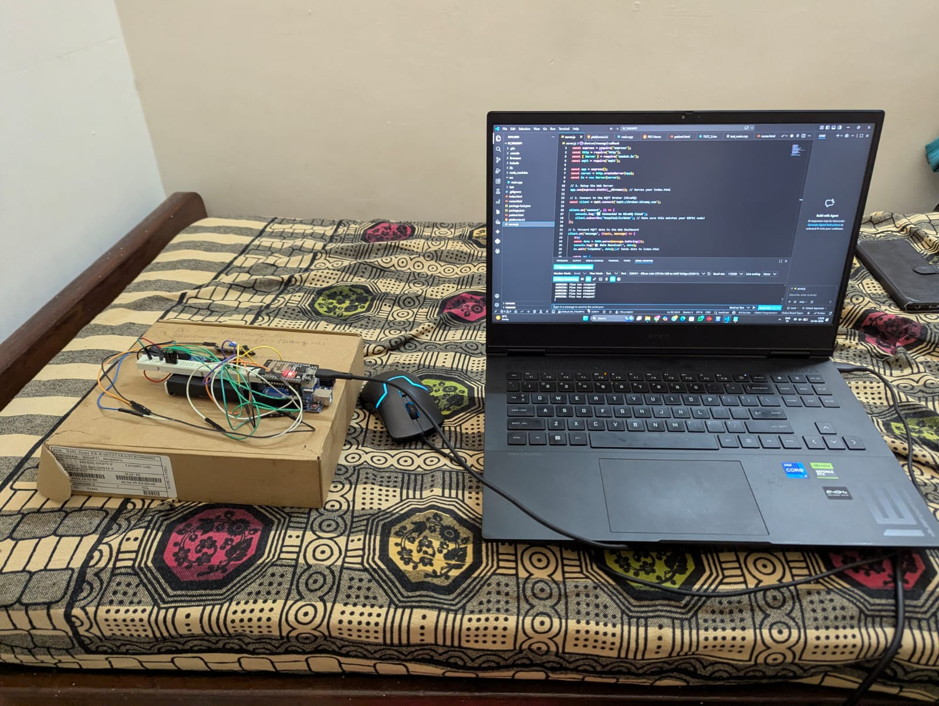

9. What aspect(s) of the invention need(s) protection?
The following unique and inventive aspects of the Smart IV Monitoring System form the core of its novelty. Each represents a significant functional or technological improvement over existing manual or automated IV monitoring approaches.

I. Integrated Dual-Sensor IV Monitoring Architecture
Key Novelty:
- Simultaneous integration of ultrasonic fluid level sensing and LDR-based drop counting within a single Arduino UNO platform.
- Unified embedded control loop that handles sensing, display, and alert actuation in real time without requiring external processors or wireless modules.
Protection Scope:
- The combined sensor fusion architecture for simultaneous fluid level and drip rate monitoring on a single microcontroller.
- The self-contained, offline-capable design that operates without internet or cloud dependency.
II. Threshold-Based Automated Buzzer Alert System
Key Novelty:
- Automatic buzzer activation based on ultrasonic distance threshold (15 cm) without requiring manual input from nursing staff.
- Self-resetting alert logic that deactivates the buzzer automatically upon bottle replacement, enabling continuous multi-bottle monitoring.
Protection Scope:
- The threshold detection and auto-reset logic for buzzer activation and deactivation based on real-time fluid level readings.
- The self-contained alert mechanism requiring no manual reset or additional interface hardware.
III. LDR Optical Drop Counter and Drip Rate Calculator
Key Novelty:
- LED-LDR optical pair positioned at the IV drip chamber to detect individual drops through light interruption events.
- Software-based drop counting and drip rate computation (drops per minute) executed on the Arduino without additional counters or timers.
- Debounce logic implemented in firmware to prevent false drop counts due to vibration or ambient light variation.
Protection Scope:
- The optical drop detection method and associated drop-counting firmware algorithm.
- The drip rate computation technique using time-stamped drop event data on a resource-constrained microcontroller.
IV. Real-Time Dual-Parameter LCD Display Interface
Key Novelty:
- Simultaneous display of both fluid level distance and drop count on a 16x2 LCD within a structured, readable layout.
- Display refresh logic that updates both parameters at one-second intervals without causing flicker or display corruption.
Protection Scope:
- The dual-parameter display formatting and refresh algorithm for concurrent fluid level and drip rate readout.
- The priority-based display update logic ensuring alarm status is reflected on the LCD alongside sensor readings.
V. Low-Cost, Clinically Deployable Hardware Architecture
Key Novelty:
- Full system constructed from standard, low-cost components (Arduino UNO, HC-SR04, LDR, buzzer, LCD) with no proprietary or specialised hardware.
- USB-powered design compatible with standard 5V hospital power outlets, power banks, and USB wall adapters without additional power conditioning.
Protection Scope:
- The complete hardware architecture and component selection enabling clinical-grade IV monitoring at minimal cost.
- The USB-only power design eliminating high-voltage components and enabling safe deployment in direct patient-care environments.

10. What is Technology Readiness Level of your invention? (Tick the appropriate TRL)

Research |  |  | Development |  |  | Deployment
TRL 1 | TRL 2 | TRL 3 | TRL 4 | TRL 5 | TRL 6 | TRL 7 | TRL 8 | TRL 9
Basic Principles observed | Technology concept formulated | Experimental proof of concept | Technology validated in a lab | Technology validated in a relevant environment | Technology demonstrated in a relevant environment | System prototype demonstration in an operational environment | System complete and qualified | Actual system proven in an operational environment
 |  |  | 

─────────────────── END OF DOCUMENT ───────────────────

