

Project on
Physical Design Implementation of
Serial Peripheral Interface
Using Qflow

Submitted by

K AZAAN AHAMED
Course: VLSI Physical Design
1. Introduction

1.1 What is Qflow?
Qflow is a fully open-source digital synthesis toolchain used for designing Application-Specific Integrated Circuits (ASICs). It provides a complete RTL-to-GDSII flow, enabling users to take a hardware description written in Verilog and convert it into a fully placed, routed, and verified physical layout ready for fabrication. Qflow is particularly valuable for academic purposes, research, and hobbyist VLSI design, as it offers a no-cost alternative to expensive commercial Electronic Design Automation (EDA) tools.
Qflow was developed with the goal of making VLSI backend design more accessible, allowing engineers and students to understand and implement the full ASIC design flow using free tools. It integrates a number of other open-source tools, including Yosys, blifFanout, GrayWolf, Magic, Netgen, and OpenSTA, to provide a seamless and automated design pipeline.
One of Qflow's greatest strengths lies in its ability to bridge the gap between front-end RTL design and backend physical layout implementation. While many learners gain exposure only to high-level hardware description and simulation, Qflow makes it possible to explore the physical design aspects of ASIC development — a crucial area of VLSI that includes placing standard cells, routing interconnects, and ensuring layout correctness through DRC and LVS checks.
Qflow Component Tools:
- Yosys — RTL Synthesis
- blifFanout — High Fanout Net Synthesis
- GrayWolf — Placement
- Magic — VLSI Layout Tool
- Netgen — LVS (Layout vs. Schematic)
- OpenSTA — Static Timing Analysis Tool
Applications of Qflow:
- Academic VLSI projects and training
- Research in low-cost or open-hardware-based chip design
- Prototyping small-scale digital ASIC designs
- Teaching tool in universities and online VLSI courses
- Open-source silicon design initiatives (such as TinyTapeout or Efabless workflows)

2. Serial Peripheral Interface (SPI)

The Serial Peripheral Interface (SPI) is a synchronous, full-duplex communication protocol that enables efficient data exchange between a master device and one or more slave devices. Originally developed by Motorola, SPI has become a widely adopted standard in embedded systems due to its high-speed operation and low hardware complexity. Unlike parallel communication, SPI uses a minimal number of wires — typically four:
- MOSI (Master Out Slave In)
- MISO (Master In Slave Out)
- SCLK (Serial Clock)
- SS/CS (Slave Select or Chip Select)
This makes it ideal for compact and cost-sensitive hardware designs. SPI supports high data throughput and can be easily configured for varying clock rates and data formats, making it a versatile choice for communication between microcontrollers, sensors, EEPROMs, and other peripheral devices.
In the context of VLSI digital design, SPI can be modeled using Register Transfer Level (RTL) code written in Verilog. The RTL implementation typically includes modules such as shift registers, clock dividers, and state machines to manage communication control and synchronization. Implementing SPI in silicon provides hands-on experience in digital protocol design and helps designers understand how communication systems are built, tested, and physically realized at the chip level.
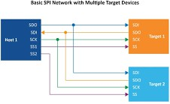
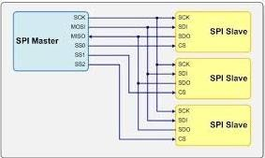

3. Invoke the Tool — Qflow GUI

To invoke the Qflow tool, open a terminal and run the command:
$ qflow gui
The Qflow GUI is a graphical interface that simplifies management of the digital design project. It provides a straightforward interface to:
- Create and configure new projects
- Add Verilog source files
- Set the top module
- Run synthesis, placement, and routing with buttons
- View logs and errors in real-time
- Easily re-run failed or individual flow steps
Before running any tool, select the Technology File (e.g., osu018). Then select the top module of the Verilog Source File — for the SPI project, this is spi_top.v. The Verilog module name is the same as the source filename without the .v extension.
After configuration, clicking Run on Preparation creates four new folders automatically in the project directory: layout, source, log, and synthesis.

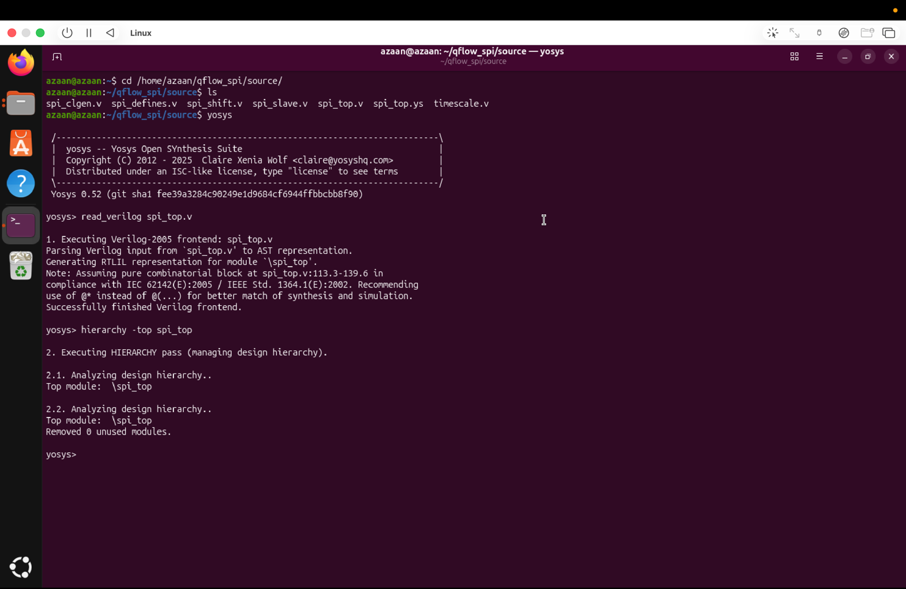

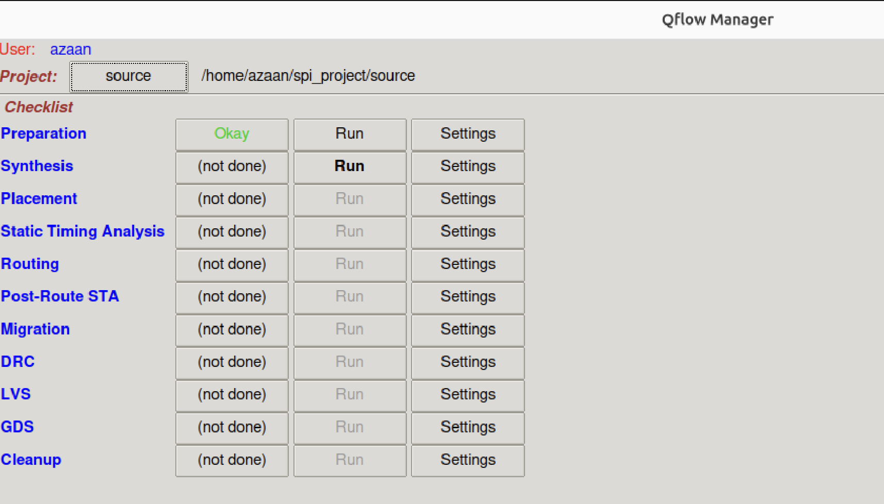

4. Synthesis

Synthesis is the key initial step in the Qflow digital ASIC design workflow. It transforms high-level Verilog RTL code — such as an SPI controller — into a gate-level netlist composed of logic gates from a specified technology library. This process is carried out by the open-source tool Yosys. Synthesis converts the functional design into a network of actual logic gates, setting the stage for subsequent placement, routing, and chip fabrication.
During synthesis, Qflow leverages Yosys to verify the functional correctness of the Verilog code and map it to standard cells defined by the target fabrication process (e.g., 130 nm or 45 nm technology). The resulting gate-level netlist preserves the original behaviour of the RTL design but represents it through physical components like AND, OR, NOT gates, and flip-flops.

4.1 Yosys — Synthesis Engine
Yosys converts high-level hardware description languages (HDLs), such as Verilog, into gate-level netlists. One of its key outputs is the Berkeley Logic Interchange Format (.blif), which is crucial for placement, routing, and generating the final bitstream.
Key Yosys Commands:
- read_verilog spi_top.v
- hierarchy -check -top spi_top
- proc
- opt
- fsm
- memory
- techmap
- abc -liberty osu018_stdcells.lib
- write_verilog synth.v

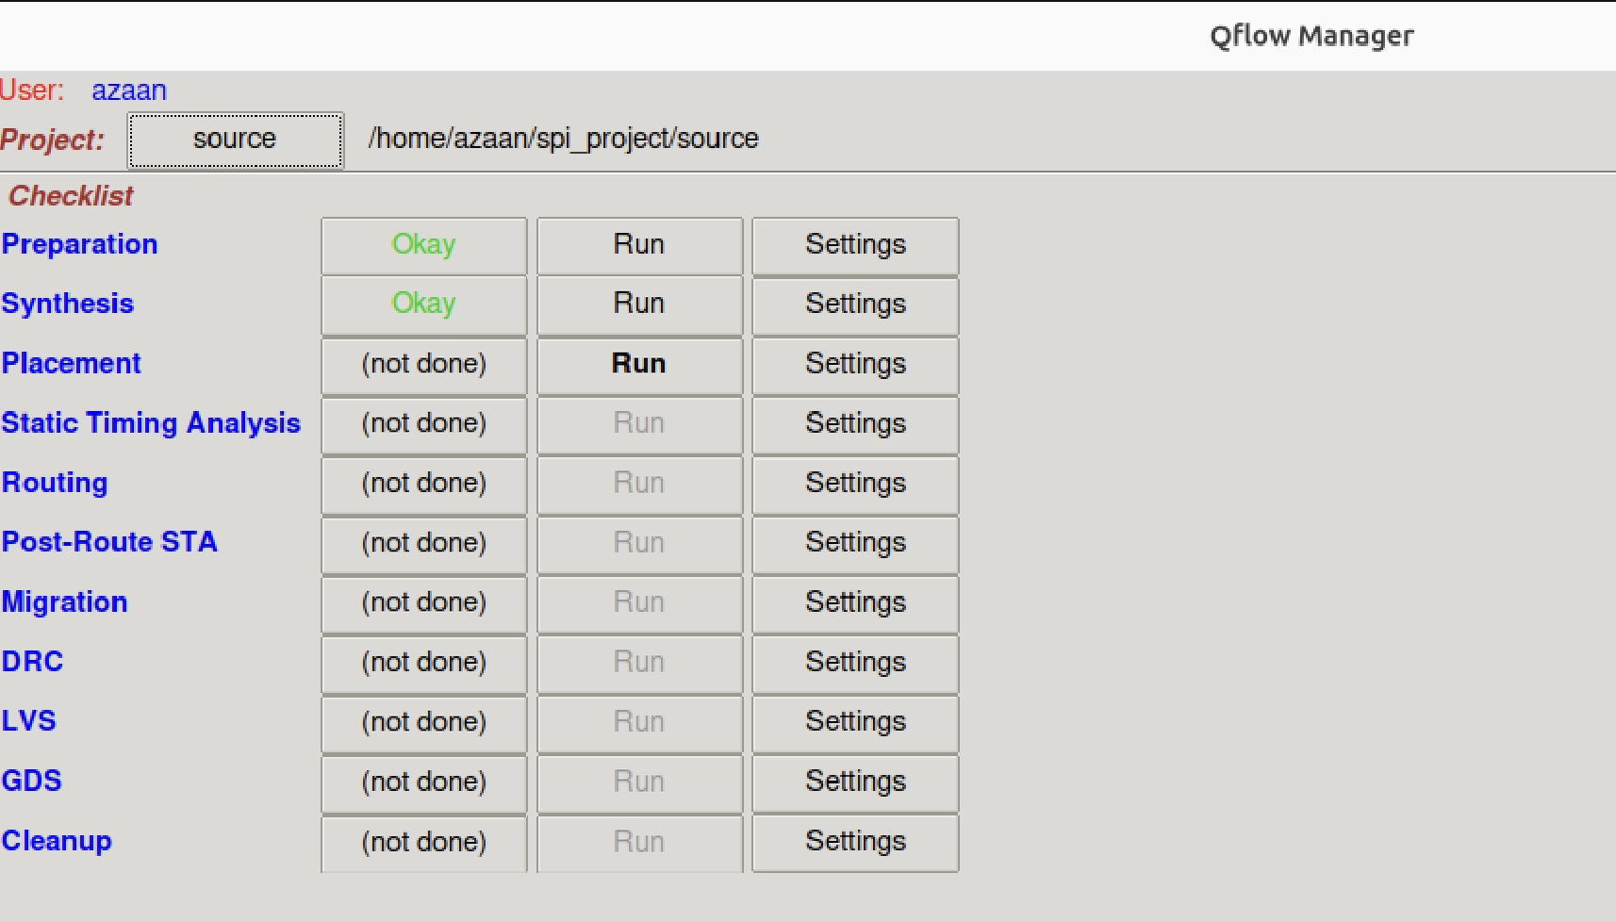

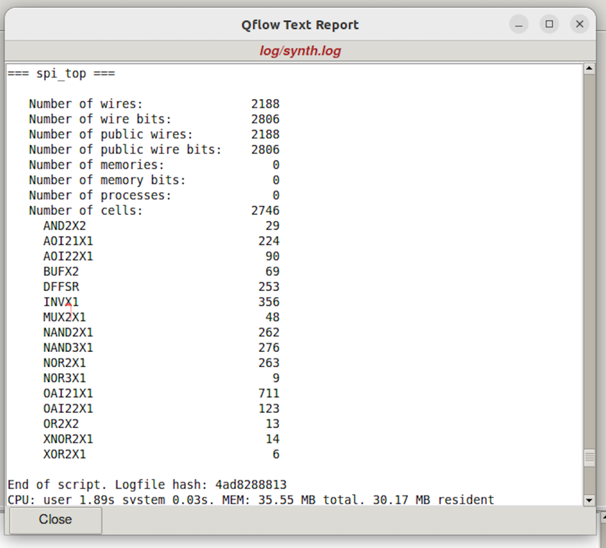

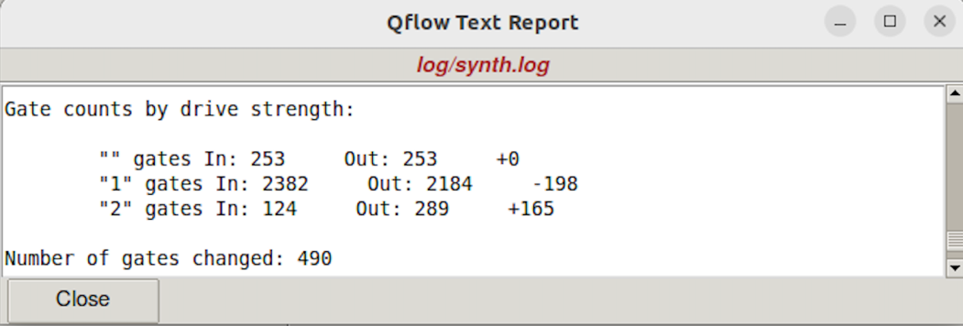

5. Placement

Placement is a crucial phase in the Qflow digital ASIC design process where the synthesized logic gates from the netlist are assigned specific physical positions on the chip layout. This step comes immediately after synthesis and is performed using the GrayWolf tool within Qflow. GrayWolf arranges the standard cells strategically to minimize wire lengths, reduce congestion, and comply with the overall chip area limitations.
Effective placement significantly impacts the quality of the final integrated circuit, influencing performance, power consumption, and manufacturability. For an SPI controller, placement ensures that the logic gates are organized to achieve a balance between high performance and efficient use of silicon area. Poor placement can cause longer interconnects, increased signal delay, and routing difficulties.

5.1 GrayWolf — Placement Tool
GrayWolf serves as the placement tool responsible for positioning logic cells on the chip layout. Its main goal is to reduce signal delay and routing congestion by strategically placing cells in a way that supports efficient routing and helps meet timing requirements. It employs algorithms that consider factors such as cell density and interconnect distances, ensuring the layout fits within the available area.

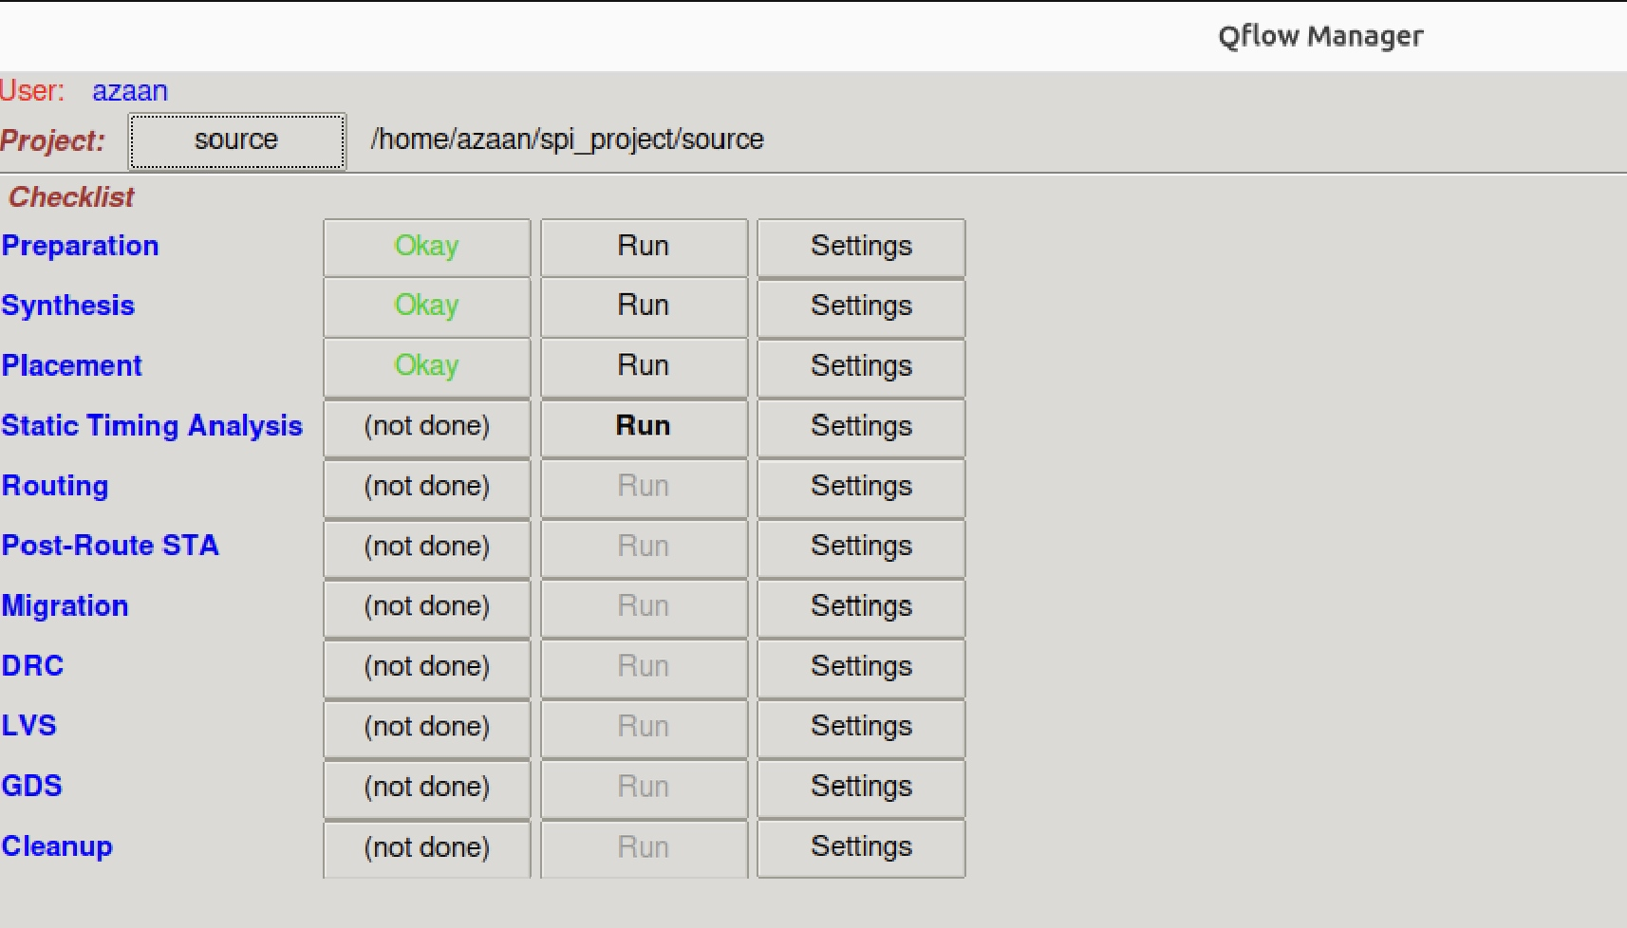

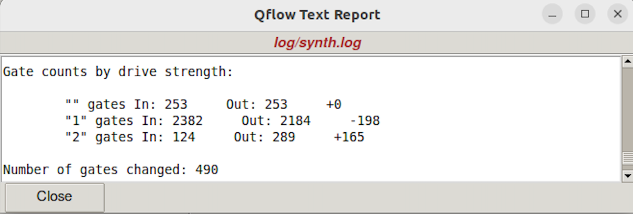
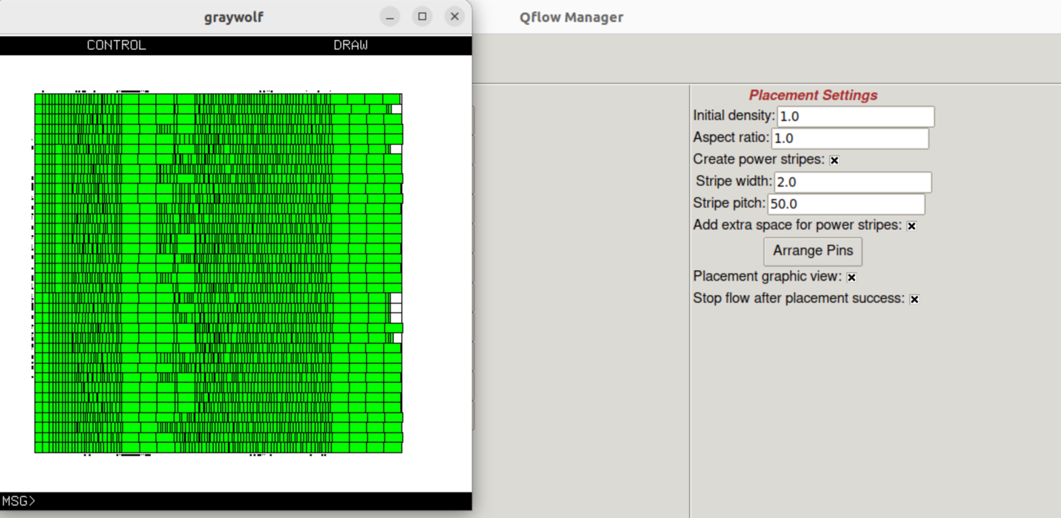
6. Static Timing Analysis (STA)

Static Timing Analysis (STA) is a method used to evaluate whether a digital circuit will operate correctly at a specified clock frequency, without needing to simulate every possible input combination. Instead of running test vectors, STA checks the timing of all signal paths in the circuit using calculated delays and constraints. It ensures that signals arrive at their destinations in time to be correctly latched by sequential elements on every clock edge.
STA is essential for ensuring that a chip like an SPI controller runs reliably at its intended clock frequency. Without timing analysis, even a functionally correct design could fail in silicon due to timing violations, leading to incorrect data transfers or metastability.

6.1 How STA Works:
- Path Identification: Finds all possible paths from one register to another
- Delay Calculation: Calculates propagation delay of logic gates and interconnects for each path
- Timing Constraints: Checks whether delays violate setup time and hold time constraints
- Slack Analysis: Computes slack (required time minus actual arrival time); negative slack = timing violation

6.2 OpenSTA — Timing Analysis Tool
OpenSTA is an open-source STA tool integrated in the QFlow design suite. It delivers a full-featured solution for analyzing timing paths and validating constraints. OpenSTA evaluates setup and hold times and includes advanced capabilities such as path-specific analysis and in-depth constraint verification.

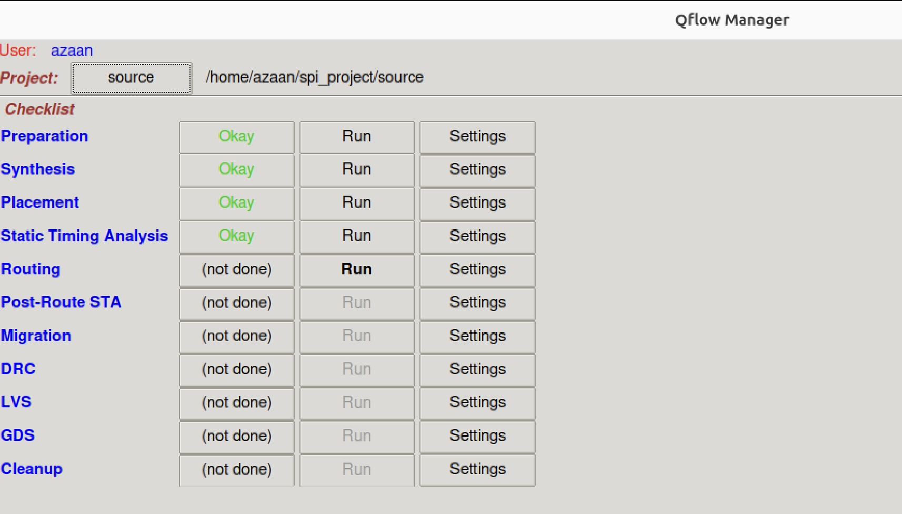
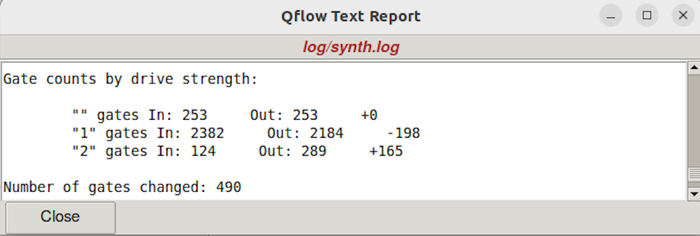

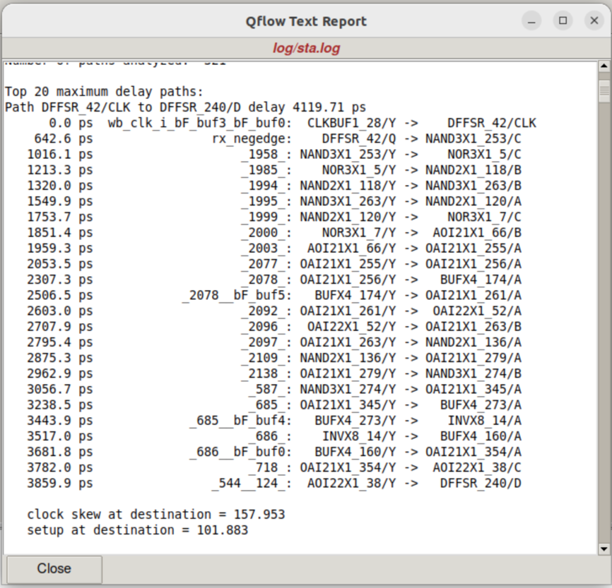

7. Routing

Routing is the process of creating physical connections (wires or interconnects) between the placed logic cells on a chip. In Qflow, once placement is completed, routing is performed using the open-source tool Qrouter, which automatically connects the inputs and outputs of gates and flip-flops based on the netlist. Routing finalizes the physical layout of the digital design, translating logical connections into real metal paths on silicon.
Routing greatly impacts timing, power, and signal integrity. A well-routed design ensures that all logic gates are properly connected without violations, making it ready for the final GDSII layout export and fabrication. For an SPI controller, successful routing is critical to ensuring reliable and correct hardware behaviour.

7.1 Qrouter — Routing Process:
- Input: The cell placement file and the netlist describing cell interconnections
- Global Routing: Qrouter first estimates rough paths for each connection to reduce congestion
- Detailed Routing: Assigns specific metal layers and tracks to each net while avoiding overlaps and shorts
- DRC Check: Ensures wires meet spacing, width, and via rules defined by the technology library

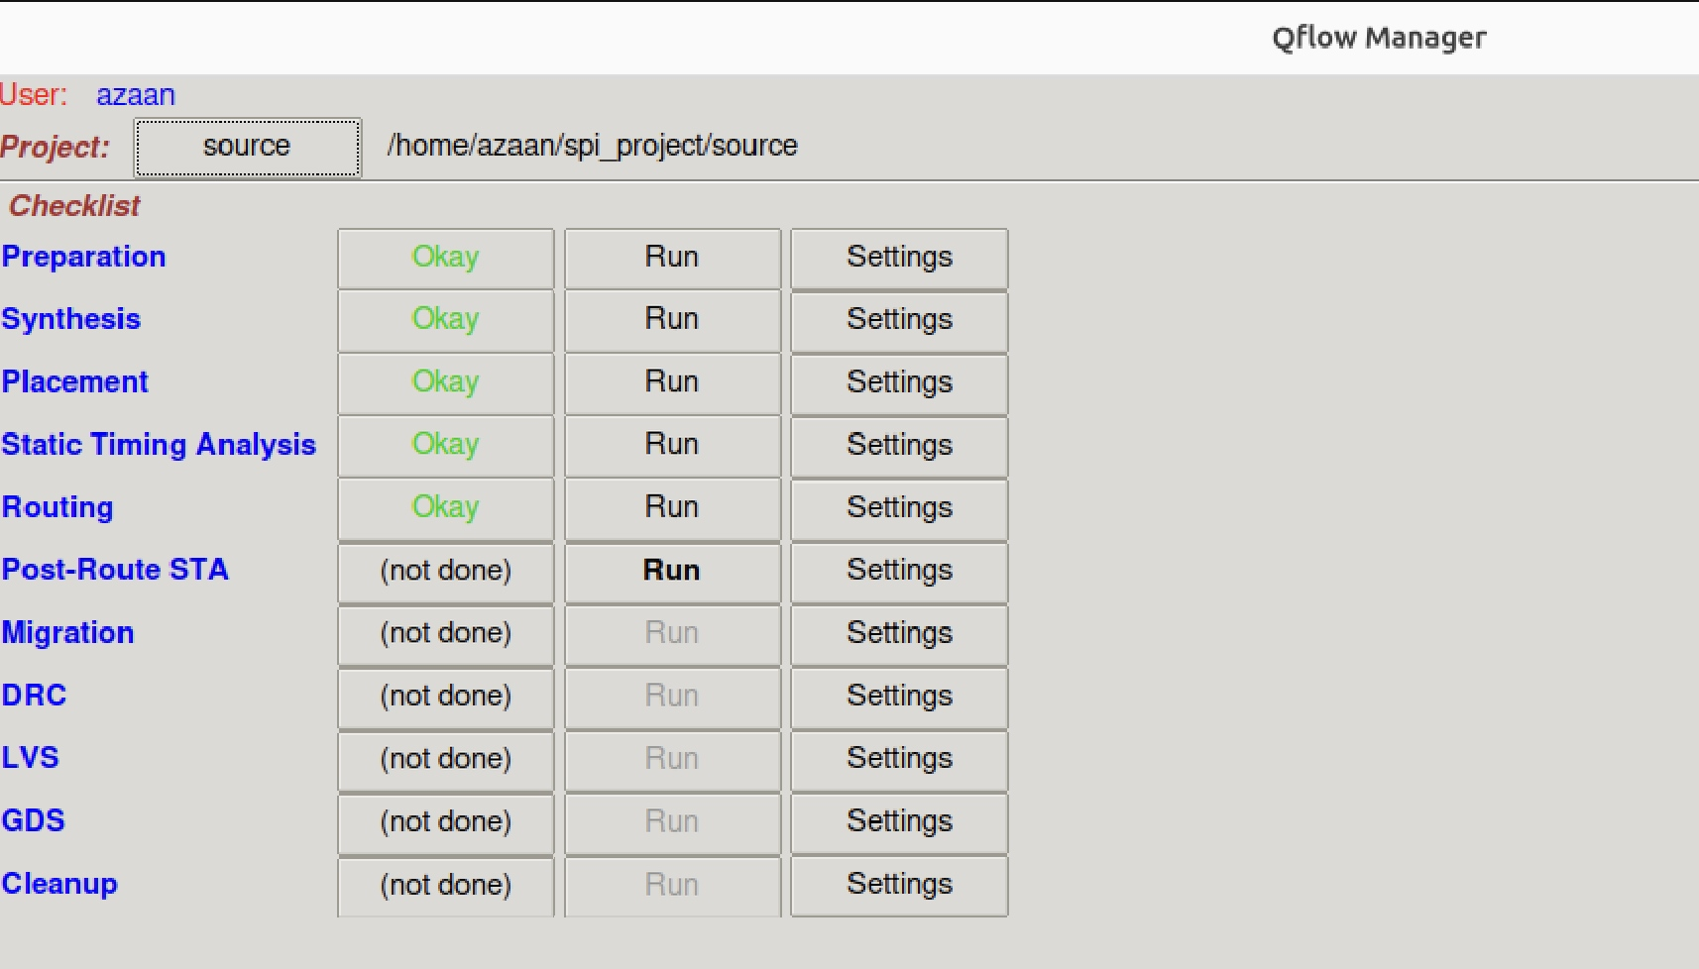

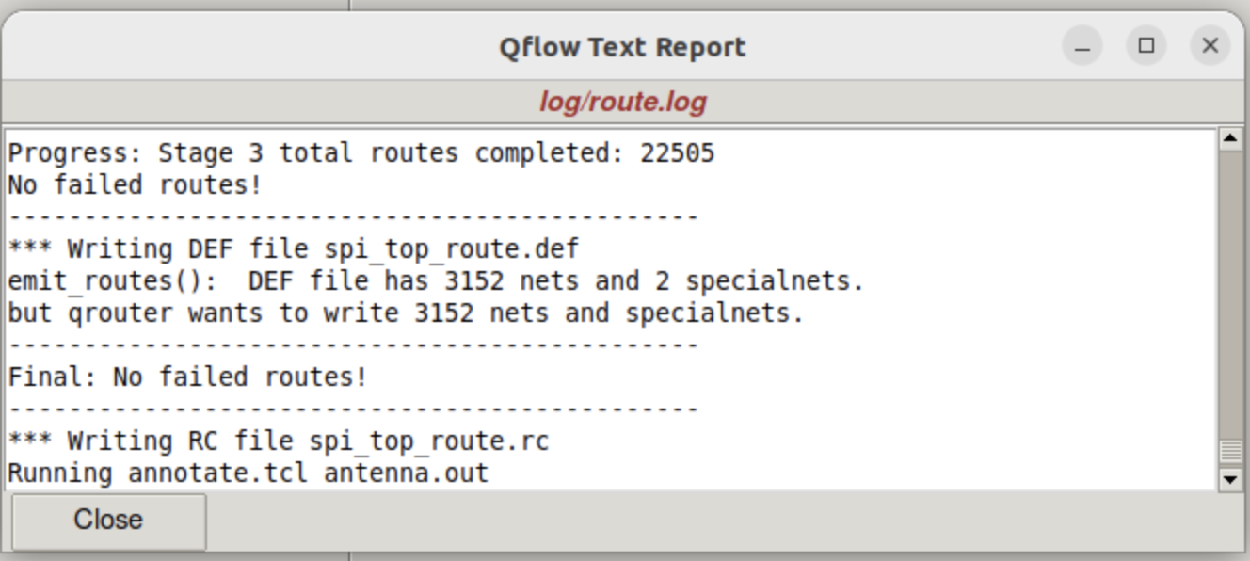

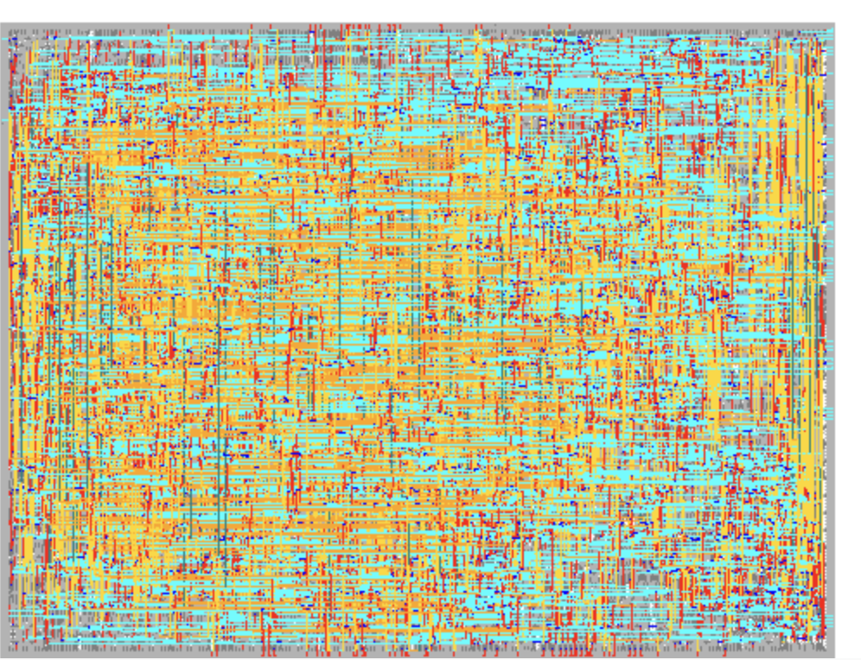

8. Post-Route STA

Post-Route Static Timing Analysis is performed after the routing step to verify the circuit's timing with actual routed wire delays. Unlike pre-route STA (which uses estimated wire delays), post-route STA uses the actual extracted parasitics from the routed layout, making it a much more accurate timing verification.
This step ensures that routing has not introduced any new timing violations. If violations exist, the designer must iterate — either adjusting placement, modifying routing, or revisiting synthesis constraints — until all timing requirements are satisfied.

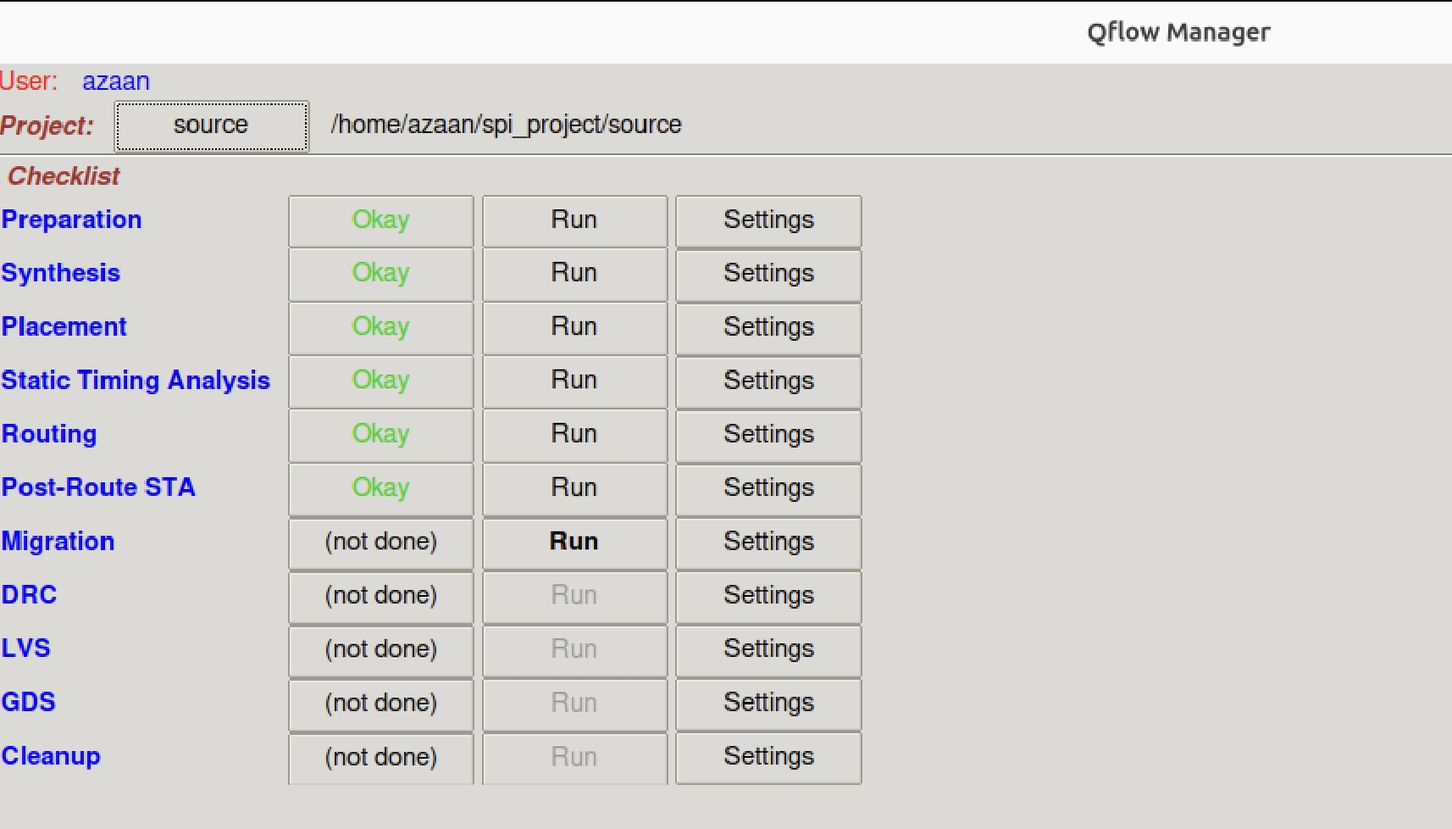
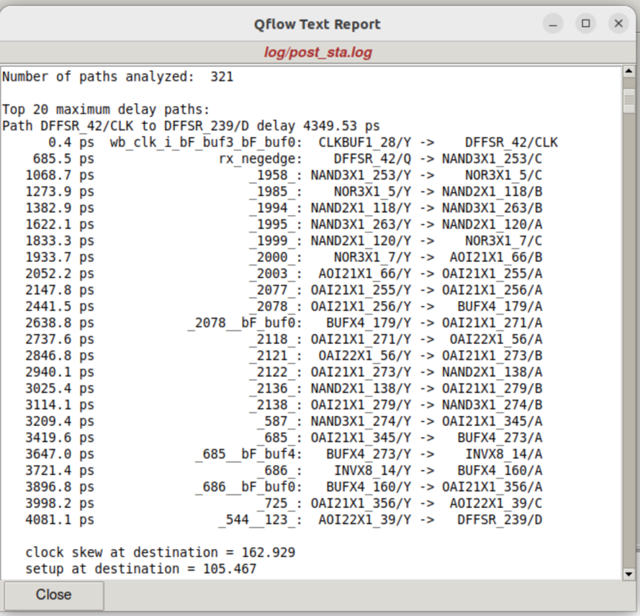

9. Migration
Migration is an important stage in the Qflow physical design process that prepares the routed layout for final verification and fabrication-related outputs. During this stage, the design data generated by placement and routing tools is translated and organized into the format required by downstream verification tools such as DRC and LVS.
The migration process ensures that all layout information, including cell placements, routing geometries, technology layer definitions, and connectivity data, is correctly transferred between different design databases and tool environments. This step helps maintain consistency throughout the design flow and prevents data mismatches that could affect verification results.
Although migration does not directly modify the design functionality, it is a critical step that enables accurate physical verification and final GDSII generation. A successful migration ensures that the layout database is complete, consistent, and ready for manufacturing checks.

8.1 What Migration Does:
• Converts routed layout data into the format required for verification tools
• Transfers technology layer and design rule information
• Preserves cell placement and routing connectivity data
• Prepares layout databases for DRC and LVS execution
• Ensures consistency between physical design and verification environments
• Generates intermediate files required for GDSII export and fabrication preparation

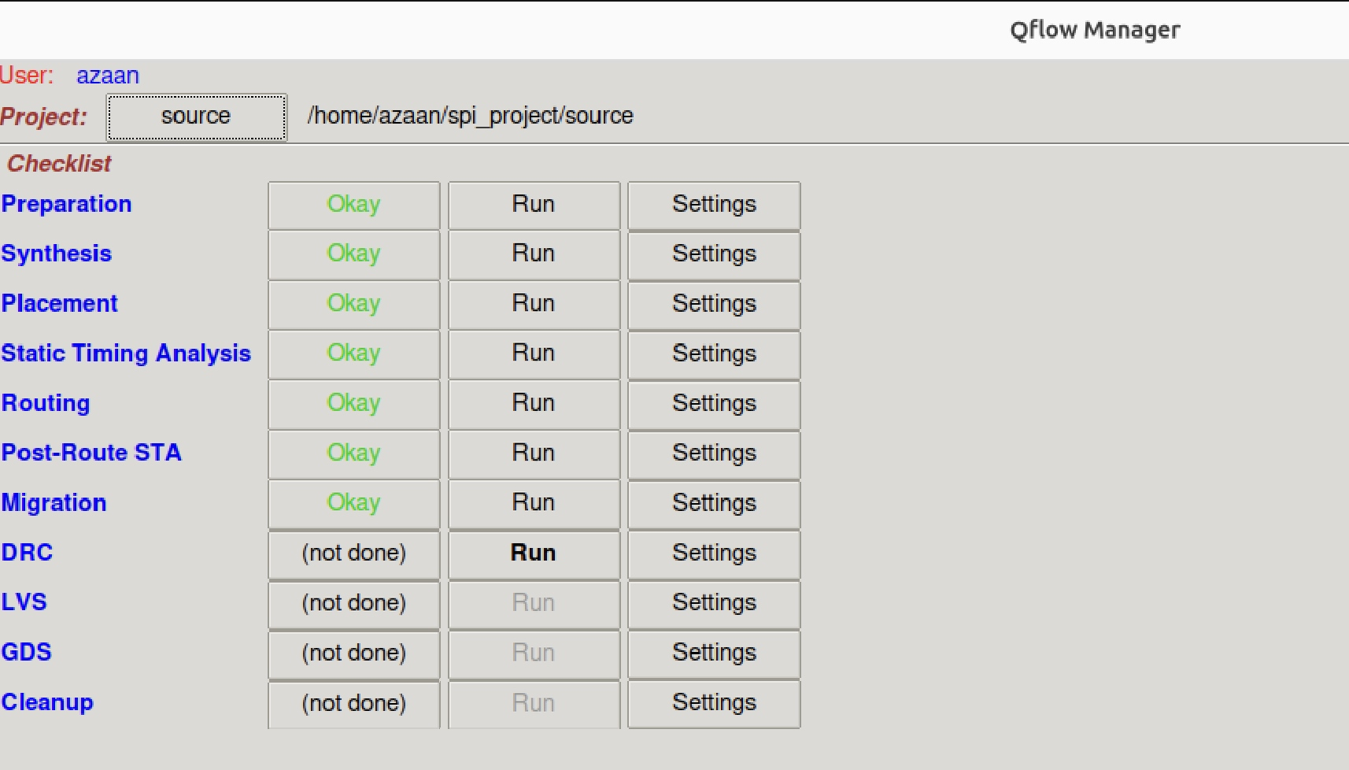

10. DRC — Design Rule Check

Design Rule Check (DRC) is a crucial verification process that verifies whether the physical layout adheres to the manufacturing guidelines established by the semiconductor foundry. These guidelines specify the allowed minimum and maximum dimensions for various layout features, including metal line widths, spacing between wires, via sizes, and other critical design constraints necessary for reliable chip fabrication.
Any violation of these rules can lead to a chip that is either non-functional or prone to failure. DRC ensures that the layout meets all the foundry's physical requirements, making it an indispensable step before creating the GDSII files for tape-out. Even if a design is logically correct, failing DRC means it cannot be manufactured reliably.

10.1 What DRC Checks:
- Minimum Width and Spacing of metal layers
- Via and Contact Sizes and Spacing
- Enclosure Rules (e.g., how far a via must be enclosed within a metal layer)
- Antenna Effects, if applicable
- Layer Overlaps and Shorts

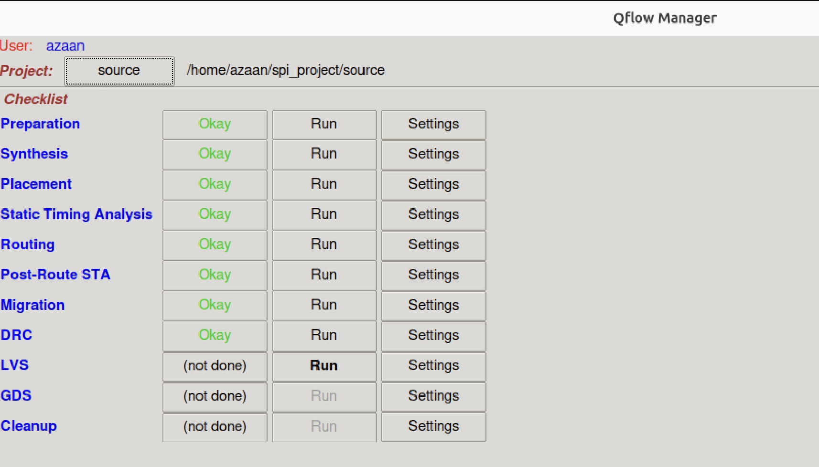

11. LVS — Layout vs. Schematic

Layout vs. Schematic (LVS) is a verification process used in ASIC design to ensure that the physical layout of a chip exactly matches its schematic or netlist. LVS checks that the logical connections and components in the layout correspond precisely to those in the synthesized or schematic-level design. This is critical for catching errors like missing connections, extra components, or incorrect pin mapping before fabrication.
LVS is essential to ensure that the final layout faithfully implements the intended circuit logic. A layout that fails LVS might produce incorrect behaviour even if it passes DRC and timing checks. In Qflow, running LVS verifies that the final SPI design is not only manufacturable but also functionally identical to what was originally described in Verilog.

11.1 What LVS Checks:
- Netlist Equivalence: Compares the netlist extracted from the layout (post-routing) to the schematic or synthesized netlist
- Connectivity: Verifies that all wires and pins are correctly connected
- Device Matching: Confirms that all gates and flip-flops in the layout exist in the logical design, and vice versa
- Pin Names and Positions: Ensures correct I/O placement and naming

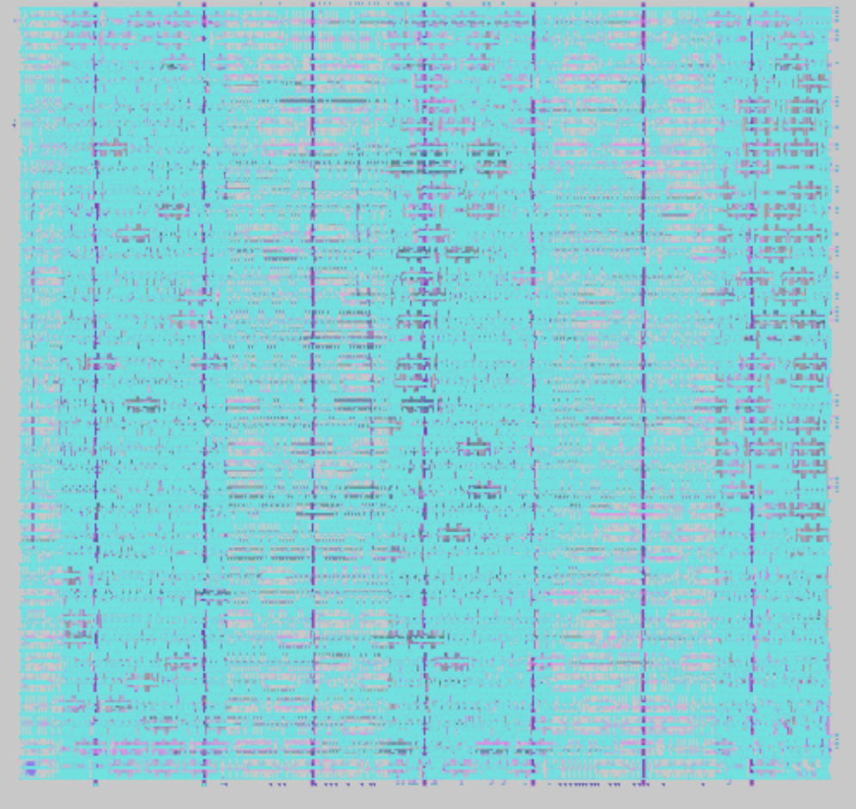

12. GDS — GDSII File Generation

GDSII (Graphic Data System II) is the industry-standard file format used to represent the physical layout of integrated circuits. It is a binary format that organizes the geometric details of the IC layers in a hierarchical structure. The file contains comprehensive layout data, including shapes for transistors, metal interconnects, vias, contacts, implants, and other process-specific elements essential for semiconductor manufacturing.
GDSII serves as the final and most important representation of an integrated circuit's physical design before manufacturing. It captures every geometric detail required by the foundry to fabricate the chip. The hierarchical nature of GDSII allows complex designs to be organized efficiently by reusing smaller cells or modules multiple times.

12.1 What Happens During GDSII Creation:
- Layout Conversion: The chip's detailed design is converted into the GDSII format
- Hierarchical Organization: The design is split into cells and sub-cells so repeated pieces don't have to be saved many times
- Layer Mapping: Each part of the design is assigned to the correct manufacturing layer based on foundry rules
- Data Compression and Precision: The file is made smaller using compression while maintaining exact measurements
- File Verification: Before sending to the factory, the GDSII file is checked to ensure it follows all design rules
- Manufacturing Hand-off: The final checked GDSII file is sent to the chip factory for mask creation

13. Final Output

The final output is the complete, verified design file that is ready for chip manufacturing. This refers to the GDSII file, which contains all the detailed layout information of the chip including all layers, shapes, and connections. Before this file is sent to the foundry, it must pass important checks like Design Rule Check (DRC) and Layout Versus Schematic (LVS) to ensure it meets all manufacturing and functional requirements.
Once verified, the final output file is handed off to the semiconductor fab, where photomasks are created from it. These masks are then used to physically fabricate the chip on silicon wafers.

13.1 The Role of the Final Output:
- It acts as the blueprint for manufacturing the chip
- Foundries use this file to create photomasks — templates that guide how each layer of the chip is built on the silicon wafer
- Ensures that the chip is fabricated exactly as designed, with all components and connections in the right places
- It is the last step before actual physical production, turning the digital design into a real, working silicon chip
In summary, the complete Qflow flow for the SPI project takes the design from RTL Verilog → Synthesis → Placement → STA → Routing → Post-Route STA → Migration → DRC → LVS → GDS, producing a silicon-ready layout of the Serial Peripheral Interface.

THANK YOU
K Azaan Ahamed | VLSI Physical Design | Maven Silicon

