**Created tables ,then i did reverse engineering for er diagram and populated data for each table**

**Tables**

**-- Walk-in table**

CREATE TABLE Walk_in (

walk_in_id INT NOT NULL PRIMARY KEY,

role_type VARCHAR(255),

from_date DATETIME,

to_date DATETIME,

location VARCHAR(255),

general_instructions TEXT,

exam_instruction TEXT,

min_system_requirement TEXT,

process TEXT,

datecreated DATETIME,

datemodified DATETIME

);

-- Time_slot table

CREATE TABLE Time_slot (

time_slot_id INT NOT NULL PRIMARY KEY,

from_time DATETIME,

to_time DATETIME,

walk_in_id INT,

datecreated DATETIME,

datemodified DATETIME,

FOREIGN KEY (walk_in_id) REFERENCES Walk_in (walk_in_id)

);

-- job_application_preference table

CREATE TABLE job_application_preference (

id INT NOT NULL PRIMARY KEY,

role_name VARCHAR(100),

package INT,

role_description TEXT,

role_requirement TEXT,

walk_in_id INT,

datecreated DATETIME,

datemodified DATETIME,

FOREIGN KEY (walk_in_id) REFERENCES Walk_in (walk_in_id)

);

**-- UserLogin table**

CREATE TABLE UserLogin (

user_id INT NOT NULL PRIMARY KEY,

username VARCHAR(100),

password VARCHAR(50),

email VARCHAR(100),

datecreated DATETIME,

datemodified DATETIME

);

**-- Hall ticket table**

CREATE TABLE Hall_ticket (

id INT NOT NULL PRIMARY KEY,

date_and_time DATETIME,

venue TEXT,

thing_to_remember TEXT,

walk_in_id INT NOT NULL,

FOREIGN KEY (walk_in_id) REFERENCES Walk_in (walk_in_id)

);

**-- Walkin_Registration table**

CREATE TABLE Walkin_Registration (

registration_id INT NOT NULL PRIMARY KEY AUTO_INCREMENT,

user_id INT NOT NULL,

walk_in_id INT NOT NULL,

time_slot_id INT NOT NULL,

chosen_role TINYINT NOT NULL,

resume BLOB,

datecreated DATETIME,

datemodified DATETIME,

FOREIGN KEY (user_id) REFERENCES UserLogin (user_id),

FOREIGN KEY (walk_in_id) REFERENCES Walk_in (walk_in_id),

FOREIGN KEY (time_slot_id) REFERENCES Time_slot (time_slot_id)

);

**-- job_role_applicants table**

CREATE TABLE job_role_applicants (

id INT NOT NULL PRIMARY KEY,

walk_in_id INT,

time_slot_id INT,

chosen_role TINYINT,

resume BLOB,

user_id INT,

datecreated DATETIME,

datemodified DATETIME,

FOREIGN KEY (walk_in_id) REFERENCES Walk_in (walk_in_id),

FOREIGN KEY (time_slot_id) REFERENCES Time_slot (time_slot_id),

FOREIGN KEY (user_id) REFERENCES UserLogin (user_id)

);

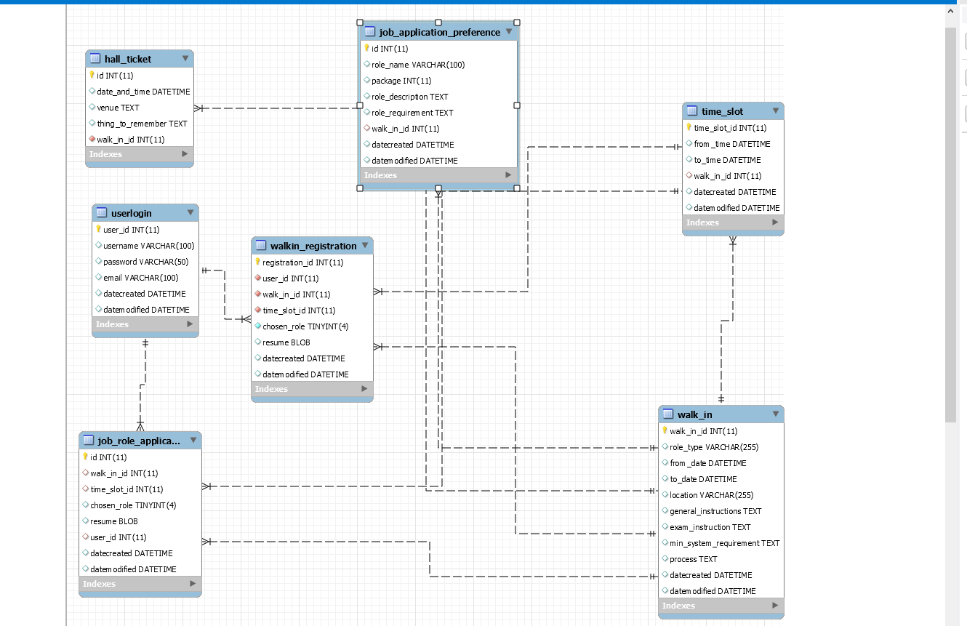

**INSERTION DUMMY DATA**

INSERT INTO Walk_in (walk_in_id, role_type, from_date, to_date, location, general_instructions, exam_instruction, min_system_requirement, process, datecreated, datemodified)

VALUES

(1, 'Software Engineer', '2023-07-31 09:00:00', '2023-07-31 17:00:00', 'New York', 'Please bring your resume and a valid ID.', 'The exam will be computer-based.', 'Minimum system requirements: Windows 10, 8GB RAM, and a modern web browser.', 'Candidates will undergo a coding assessment and technical interview.', NOW(), NOW()),

(2, 'Data Analyst', '2023-08-15 10:00:00', '2023-08-15 16:00:00', 'San Francisco', 'Candidates should be familiar with SQL and data visualization tools.', 'The exam will be written and may include data analysis exercises.', 'No specific system requirements.', 'Candidates will have to analyze a given dataset and present insights.', NOW(), NOW());

INSERT INTO Time_slot (time_slot_id, from_time, to_time, walk_in_id, datecreated, datemodified)

VALUES

(1, '2023-07-31 09:00:00', '2023-07-31 10:00:00', 1, NOW(), NOW()),

(2, '2023-07-31 10:00:00', '2023-07-31 11:00:00', 1, NOW(), NOW()),

(3, '2023-07-31 14:00:00', '2023-07-31 15:00:00', 1, NOW(), NOW()),

(4, '2023-08-15 10:00:00', '2023-08-15 11:00:00', 2, NOW(), NOW()),

(5, '2023-08-15 11:00:00', '2023-08-15 12:00:00', 2, NOW(), NOW());

INSERT INTO UserLogin (user_id, username, password, email, datecreated, datemodified)

VALUES

(1, 'john_doe', 'password123', 'john.doe@example.com', NOW(), NOW()),

(2, 'jane_smith', 'pass456', 'jane.smith@example.com', NOW(), NOW()),

(3, 'mike_smith', 'mike123', 'mike.smith@example.com', NOW(), NOW());

INSERT INTO Hall_ticket (id, date_and_time, venue, thing_to_remember, walk_in_id)

VALUES

(1, '2023-07-31 09:00:00', 'New York City Hall', 'Bring a valid ID for verification.', 1),

(2, '2023-08-15 10:00:00', 'San Francisco Convention Center', 'Remember to bring your admission ticket.', 2);

INSERT INTO Walkin_Registration (user_id, walk_in_id, time_slot_id, chosen_role, resume, datecreated, datemodified)

VALUES

(1, 1, 1, 1, NULL, NOW(), NOW()),

(2, 1, 2, 1, NULL, NOW(), NOW()),

(3, 2, 4, 1, NULL, NOW(), NOW());

INSERT INTO job_application_preference (id, role_name, package, role_description, role_requirement, walk_in_id, datecreated, datemodified)

VALUES

(1, 'Software Engineer', 80000, 'Looking for a skilled software engineer with experience in web development.', 'Proficiency in JavaScript, React, and Node.js is required.', 1, NOW(), NOW()),

(2, 'Data Analyst', 60000, 'Seeking a data analyst to analyze and interpret large datasets.', 'Proficiency in SQL and Python is required.', 2, NOW(), NOW());

INSERT INTO job_role_applicants (id, walk_in_id, time_slot_id, chosen_role, resume, user_id, datecreated, datemodified)

VALUES

(1, 1, 1, 1, NULL, 1, NOW(), NOW()),

(2, 1, 2, 1, NULL, 2, NOW(), NOW()),

(3, 2, 4, 1, NULL, 3, NOW(), NOW());

