

**PROJECT NAME**

**JSP-JDBC-MySQL**

**Course code: SE 410**

**Course title:** Advance Enterprise Java Lab

**Submitted by:**

|  |  |
| --- | --- |
| **NAME** | **ID** |
| **Mehedi Hasan** | **ID: 163432507** |

**Submitted To:**

[**MD. SAFAET HOSSAIN**](https://cityuniversity.edu.bd/md-safaet-hossain/)

**Associate Professor and Head**

**City University**

**Date: 25-03-2020**

**JSP-JDBC-MySQL**

**Objective:**

In this system shall be able to record the student details then system shall be able to retrieve student details. after clicked the edit link of the page redirect to update.jsp  along with selected row data.all the data will be passing to the relavent textboxes.after made the changes system shall be able to update the records.

**CODE:**

**Index**

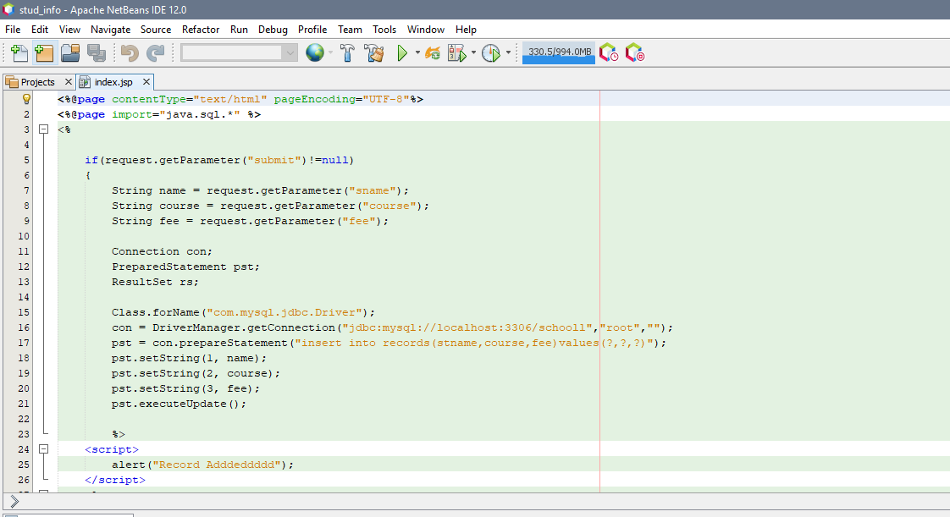

**DELATE**

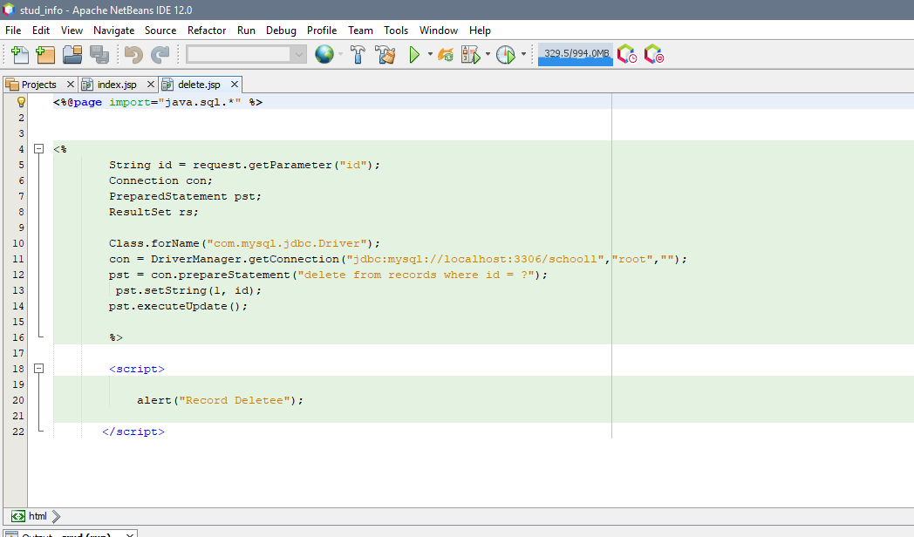

**UPDATE**

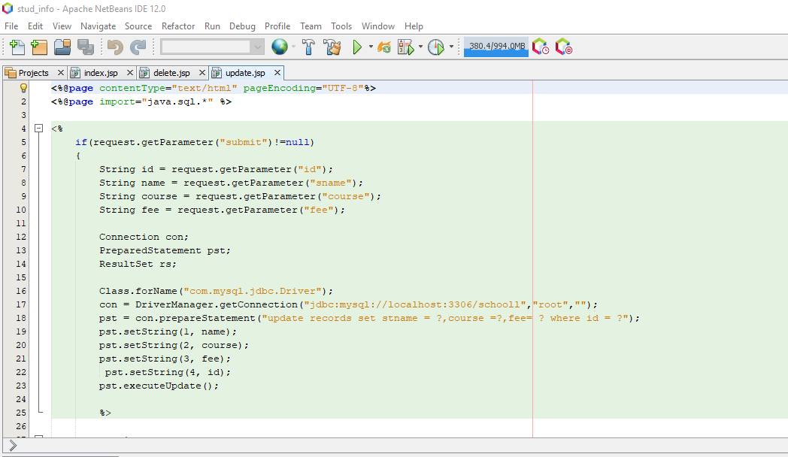

**RESULT:**

