# Introduction :

What is Solfege?

It is a musical method to understand pitch and sight singing. It means Solfege enables musicians to mentally hear the pitches of t a music piece being seen for the first time and then sing it aloud.

The word Solfege or Solfeggio comes from Italian Guido d’Arezzo back to 11th century. Every note of scale is given a specific syllable similar to set of letters in western music. (C=Do, D=Re, E=Mi, F=Fa, G=Sol, A=La, B=Si or Ti).

Lets do some practice:



Do Re Me Fa Sol La Ti Do



Ti Fa Re Re







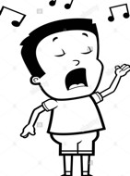

# Main points to Remember:

Whole notes should be held for 4 beats. The Comma Symbol on top of measures means you can take a small breath. The symbol on top of the last measure means you can hold the note a bit longer.

Be careful not to lose the rhythm when you take your breath.

**Let’s Go **

Ascending/Descending C Major with Whole Notes:

This is your base practice. Practice it every time before you start.

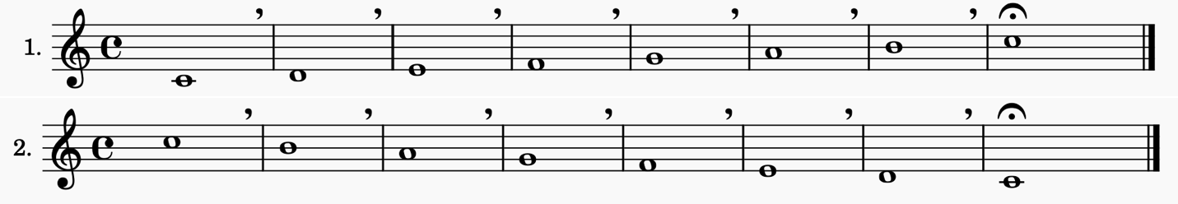

First and Second Intervals with Half Notes:

Half notes should be held for 2 beats.

What is First Interval? When two notes are the same, they are in first interval. Example: Do-Do or La-La.

What about Second Interval? When two notes do not have any other notes in between they are in second interval. Example: Do-Re or Sol-La.

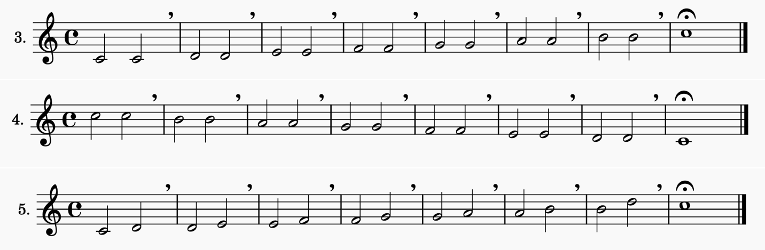

# Let’s Add Some Quarter Notes

Quarter notes should be held for 1 beat.

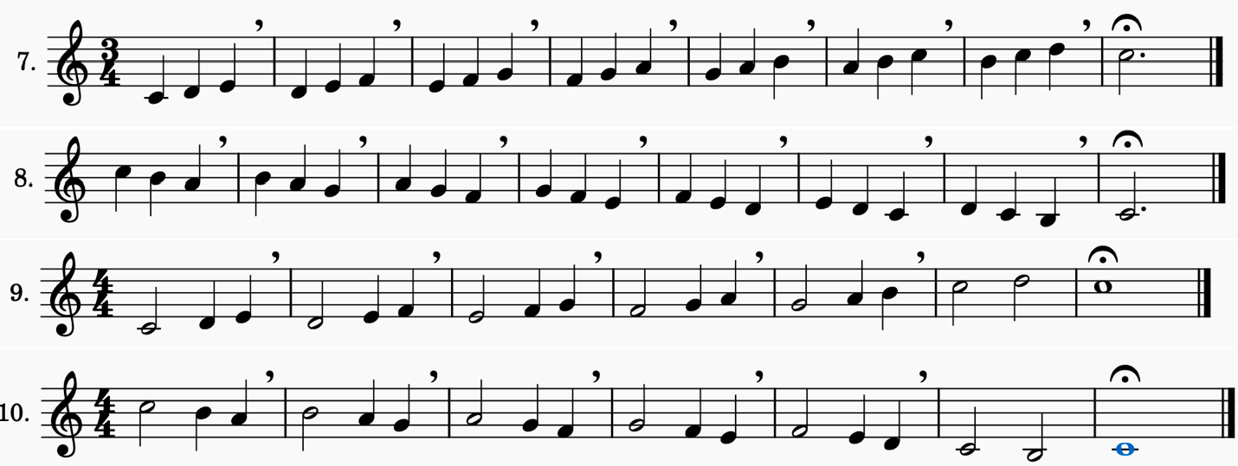

# It’s Third Intervals Turn!

What is third interval anyway? When there is another note in between the two notes, they are in third interval. Example: Do and Mi. There is Re in between right? Or La and Do which they have Si in between**.**

The curve line on last line calls Tie, means Do is to be held as a single note with duration of a half note and whole note in this case which will be 6 beats.









**Learning point:** The Tie, curved line connecting the heads of two notes here, indicates that they are to be played as a single note with a duration equal to the sum of the individual notes' values. Here we have a half note and a whole note so we should keep the C for 6 beats!



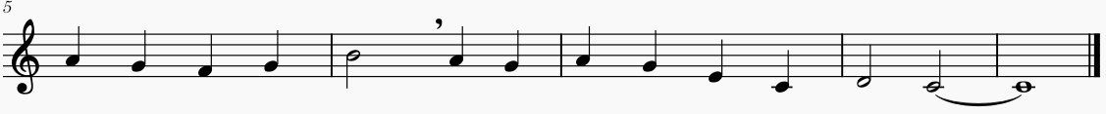



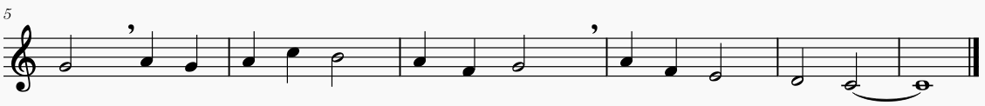

Now Let’s do something exciting: 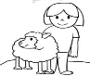



Did you realize you just sang “Mary Had A Little Lamb”?

|  |  |
| --- | --- |
| You can do even better. This is Symphony NO.9 by Ludwig Van Beethoven.  He is one of the greatest classical composers who is ever lived. He lost his hearing when he was 31, but he continued to compose. You know how? Using the methods, you are learning here! |  |



**Introduction to Rest:**

Rest in music means how long we should be in silence. There are different symbols and names in Rest which shows how long our silence should last. We will learn three types of Rest here:

|  |  |
| --- | --- |
| **Whole Note Rest:** A small rectangle that hangs off the 2nd line from the top of the stave. It has a value of four beats. |  |
| **Half Note Rest:** A small rectangle, very similar to the Whole Note rest but, instead of hanging from the second line it sits on the middle line of the stave. It has a value of two beats |  |
| **Quarter Note Rest:** A bit complicated to draw. It has one beat |  |