**PRACTICAL ASSIGNMENT-01**

**Name**: Azad Gunjal

**Roll No.**: SAI&D32

-- Create DataBase named ProjectDB

mysql> create database ProjectDB;

mysql> use ProjectDB;

-- Create Table named Project1 in ProjectDB

mysql> create table Project1 (

Pid int, Pname varchar(30), Tech varchar(20), Start_Date date, No_Stud int

);

-- Insert Data into Table Project1

mysql> insert into Project1(Pid, Pname, Tech, Start_Date, No_Stud) values(100, 'SBI', 'AI', '2020-05-01', 5);

mysql> insert into Project1(Pid, Pname, Tech, Start_Date, No_Stud) values(109, 'B0I', 'ML', '2018-07-20', 9);

mysql> insert into Project1(Pid, Pname, Tech, Start_Date, No_Stud) values(116, 'MGB', 'DS', '2019-10-21', 6);

mysql> insert into Project1(Pid, Pname, Tech, Start_Date, No_Stud) values(129, 'HDFC', 'DL', '2021-02-07', 10);

mysql> insert into Project1(Pid, Pname, Tech, Start_Date, No_Stud) values(126, 'BOM', 'CN', '2020-08-06', 8);

mysql> select * from Project1;

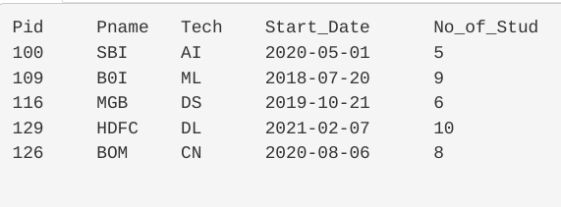

-- Adding Column named Guidename and Assigning Values

mysql> alter table Project1

add Guidename varchar(30);

mysql> update Project1 set Guidename = 'Prof. Shubhangi S.' where Pid = 100;

mysql> update Project1 set Guidename = 'Prof. Shubhangi S.' where Pid = 109;

mysql> update Project1 set Guidename = 'Prof. Vanita K.' where Pid = 116;

mysql> update Project1 set Guidename = 'Prof. Bharti S.' where Pid = 129;

mysql> update Project1 set Guidename = 'Prof. Swati N.' where Pid = 126;

mysql> select * from Project1 order by Pid ASC;

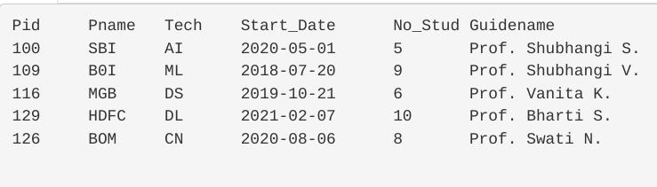

--

Minimum and Maximum No. of Students

mysql> select MIN(No_Stud) from Project1;

mysql> select MAX(No_Stud) from Project1;

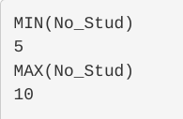

-- Project and its details having Guidename Prof. Shubhangi S.

mysql> select * from Project1 where Guidename = 'Prof. Shubhangi S.';

