<http://thumbs.dreamstime.com/t/plastic-digital-data-card-5587567.jpg>

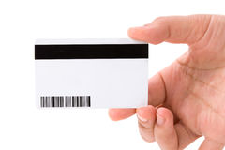

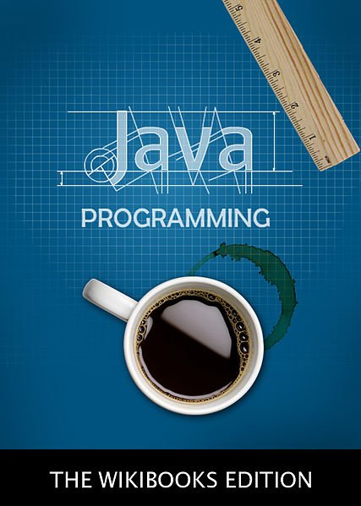

<http://commons.wikimedia.org/wiki/File:Java_Programming_Cover.jpg>



<https://www.math.wisc.edu/~keisler/calc.html>



<http://www.zavvi.com/dvd/bob-the-builder-can-we-fix-it-yes-we-can/10647449.html>

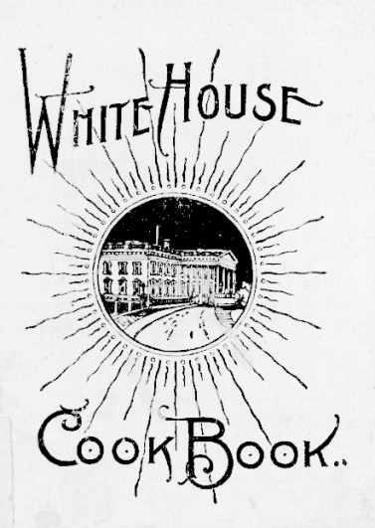

<http://commons.wikimedia.org/wiki/File:White_House_Cookbook.jpg>



<http://commons.wikimedia.org/wiki/File:Big_Red_Barn,_illustrated_by_Felicia_Bond,_children's_book_illustrator.jpeg>



<https://openclipart.org/detail/20501/books-icon-by-cod_fsfe>

https://openclipart.org/detail/168880/owl-with-books-by-bocian

<http://www.public-domain-image.com/full-image/objects-public-domain-images-pictures/books-public-domain-images-pictures/bookshelves-at-the-library.jpg-royalty-free-stock-photograph.html>

<https://www.flickr.com/photos/dfsmith/1404218129>

<https://www.flickr.com/photos/quinnanya/8225310487/in/photostream/>

<https://www.flickr.com/photos/andwat/3482273752>

