**Modelling diagrams**

Below are the diagrams I’ve used to make and design my site.

**Use case model**

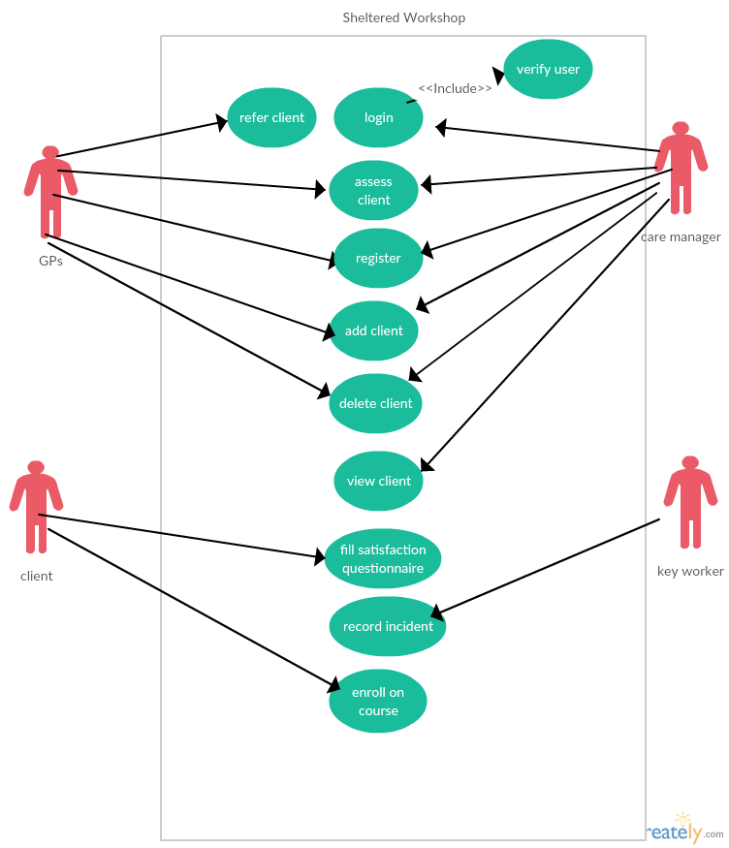

**Main Use case descriptions**

|  |  |
| --- | --- |
| **Use Case Number: 3** | **Use Case Name: view** |
| **Overview:**  Allow the user to view a client on the system and their details | |
| **Actors: care manager and Gps** | |
| **Criticality: very high** | |
| **Other non-functional requirements:** | |
| **Pre-conditions:**  **Must create an account and log in** | |
| **Post-conditions:**  **The user can now add, view or delete a client** | |
| **Primary Path:**   1. **Care manager clicks on the view page button** 2. **Website displays the view page and all clients currently added** 3. **Care manager selects a user to view by clicking their name** 4. **Website displays the details page of the user selected** 5. **care manager can now view the details of the selected user** | |
| **Use Cases related to Primary Path: add client** | |
| **Alternatives:**  **3. care manager doesn’t select a user to display** | |
| **Use Cases related to Alternatives:** | |
| **Exceptions:** | |
| **Use Cases related to Exceptions:** | |
| **Notes:** | |

|  |  |  |  |
| --- | --- | --- | --- |
| **Use Case Number:1** | | **Use Case Name: add client** | |
| **Overview:**  Being able to add a client and their details to the database | | | |
| **Actors: GPs and care manager** | | | |
| **Criticality: very high** | | | |
| **Other non-functional requirements:** | | | |
| **Pre-conditions:**  **Must create an account and log in** | | | |
| **Post-conditions:**  **Can now add and view or delete current client** | | | |
| **Primary Path:**   1. **Care manager clicks on the add client navigation button** 2. **Website displays add client form** 3. **Care manager adds the details of the clients such as name, their email address and the courses they will be attending, and clicks the add button** 4. **Website displays a message saying the details have been added** 5. **Use case ends here** | | | |
| **Use Cases related to Primary Path:** | | | |
| **Alternatives:**  **4.The site form displays a message saying a field has not been filled in**  **4.The site form displays a message saying the course id doesn’t exist** | | | |
| **Use Cases related to Alternatives: none** | | | |
| **Exceptions:** | | | |
| **Use Cases related to Exceptions: view** | | | |
| **Notes:** | | | |
| **Use Case Number: 2** | | **Use Case Name: delete** | |
| **Overview:**  Allow the user to delete a client from the system | | | |
| **Actors: care manager, GPS** | | | |
| **Criticality: very high** | | | |
| **Other non-functional requirements:** | | | |
| **Pre-conditions:**  **Must create an account and log in** | | | |
| **Post-conditions:**  **Can now add, view and delete clients** | | | |
| **Primary Path:**   1. **Care manager clicks the delete page button** 2. **Website opens delete page** 3. **Care manager selects the users he wants to delete** 4. **Care manager clicks the delete button** 5. **Website tells the care manager that the user has been deleted** | | | |
| **Use Cases related to Primary Path:** | | | |
| **Alternatives:**   1. **Care manager doesn’t select a user to delete and clicks delete user** 2. **Site shows a message saying no one has been selected to delete.** | | | |
| **Use Cases related to Alternatives:** | | | |
| **Exceptions:**  **none** | | | |
| **Use Cases related to Exceptions:** | | | |
| **Notes:** | | | |

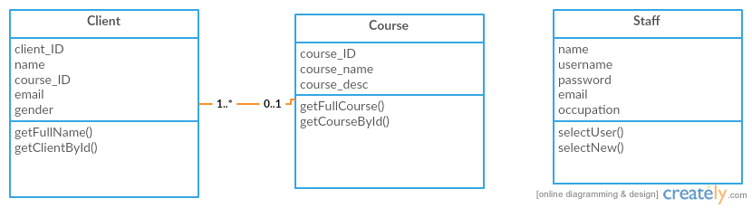**Class diagram**

**Sequence diagrams**

**Add sequence (add use case)**

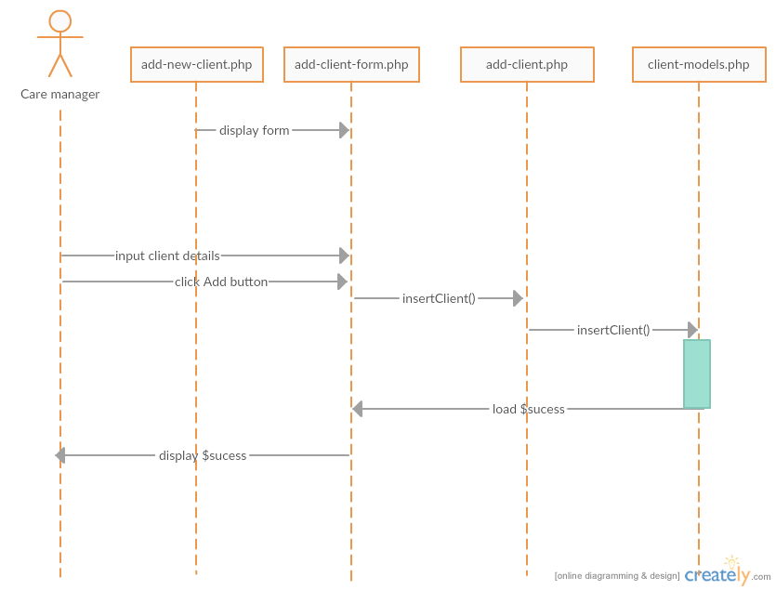

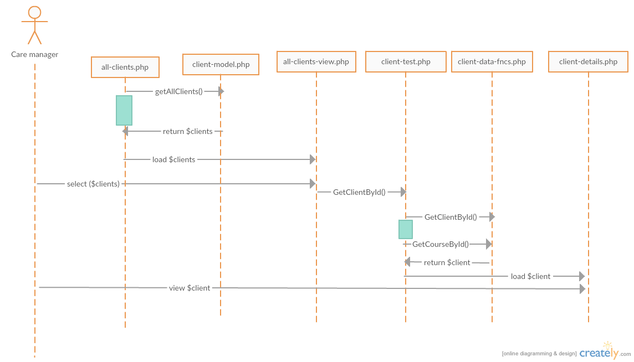**View sequence (view use case)**

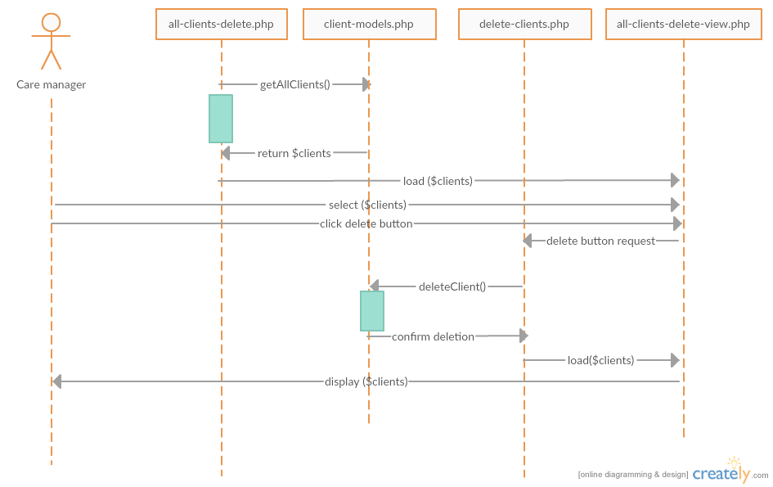**Delete view (delete use case)**