DESCRIPTION

Science Q-Tech Employee Performance Mapping.

ScienceQtech is a startup that works in the Data Science field. ScienceQtech has worked on fraud detection, market basket, self-driving cars, supply chain, algorithmic early detection of lung cancer, customer sentiment, and the drug discovery field.

With the annual appraisal cycle around the corner, the HR department is in need of generating reports on employee details, their performance, and on the project that the employees have undertaken, to analyze the employee database and extract specific data based on different requirements.

Objective:

To facilitate a better understanding, managers have provided ratings for each employee which will help the HR department to finalize the employee performance mapping. As a DBA, you should find the maximum salary of the employees and ensure that all jobs are meeting the organization's profile standard. You also need to calculate bonuses to find extra cost for expenses. This will raise the overall performance of the organization by ensuring that all required employees receive training.

Dataset description:

emp_record_table: It contains the information of all the employees.

EMP_ID – ID of the employee

FIRST_NAME – First name of the employee

LAST_NAME – Last name of the employee

GENDER – Gender of the employee

ROLE – Post of the employee

DEPT – Field of the employee

EXP – Years of experience the employee has

COUNTRY – Country in which the employee is presently living

CONTINENT – Continent in which the country is

SALARY – Salary of the employee

EMP_RATING – Performance rating of the employee

MANAGER_ID – The manager under which the employee is assigned

PROJ_ID – The project on which the employee is working or has worked on

Proj_table: It contains information about the projects.

PROJECT_ID – ID for the project

PROJ_Name – Name of the project

DOMAIN – Field of the project

START_DATE – Day the project began

CLOSURE_DATE – Day the project was or will be completed

DEV_QTR – Quarter in which the project was scheduled

STATUS – Status of the project currently

Data_science_team: It contains information about all the employees in the Data Science team.

EMP_ID – ID of the employee

FIRST_NAME – First name of the employee

LAST_NAME – Last name of the employee

GENDER – Gender of the employee

ROLE – Post of the employee

DEPT – Field of the employee

EXP – Years of experience the employee has

COUNTRY – Country in which the employee is presently living

CONTINENT – Continent in which the country is

data_science_team



emp_record_table



proj_table



1. Create a database named employee, then import **data_science_team.csv** **proj_table.csv** and **emp_record_table.csv** into the **employee**database from the given resources.

CREATE DATABASE employee;

USE employee;

1. Create an ER diagram for the given **employee**database.

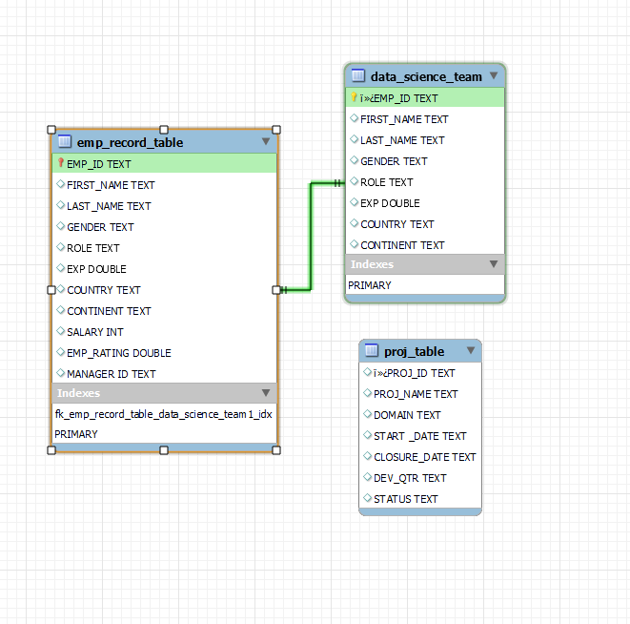

1. Write a query to fetch EMP_ID, FIRST_NAME, LAST_NAME, GENDER, and DEPARTMENT from the employee record table, and make a list of employees and details of their department.

SELECT * FROM emp_record_table;

ALTER TABLE employee.emp_record_table RENAME COLUMN ï»¿EMP_ID TO EMP_ID;

SELECT * FROM emp_record_table;

SELECT EMP_ID, FIRST_NAME, LAST_NAME, GENDER, DEPT FROM employee.emp_record_table

ORDER BY DEPT,FIRST_NAME,LAST_NAME;

1. Write a query to fetch EMP_ID, FIRST_NAME, LAST_NAME, GENDER, DEPARTMENT, and EMP_RATING if the EMP_RATING is:

* less than two
* greater than four
* between two and four

SELECT EMP_ID, FIRST_NAME, LAST_NAME, GENDER, DEPT, EMP_RATING FROM employee.emp_record_table WHERE EMP_RATING <2;

SELECT EMP_ID, FIRST_NAME, LAST_NAME, GENDER, DEPT, EMP_RATING FROM employee.emp_record_table WHERE EMP_RATING >4;

SELECT EMP_ID, FIRST_NAME, LAST_NAME, GENDER, DEPT, EMP_RATING FROM employee.emp_record_table WHERE EMP_RATING >=2 AND EMP_RATING <=4 ORDER BY EMP_RATING;

1. Write a query to concatenate the FIRST_NAME and the LAST_NAME of employees in the Finance department from the employee table and then give the resultant column alias as NAME.

SELECT concat(FIRST_NAME, ' ',LAST_NAME) AS NAME FROM employee.emp_record_table WHERE DEPT = 'FINANCE';

1. Write a query to list only those employees who have someone reporting to them. Also, show the number of reporters (including the President).

SELECT A.`MANAGER ID`,count(A.`MANAGER ID`)AS REPORTERS, concat(b.FIRST_NAME, ' ',B.LAST_NAME) AS NAME FROM employee.emp_record_table AS A JOIN employee.emp_record_table AS B

ON A.`MANAGER ID` = B.EMP_ID

GROUP BY A.`MANAGER ID` ORDER BY A.`MANAGER ID` ;

1. Write a query to list down all the employees from the healthcare and finance departments using union. Take data from the employee record table.

SELECT * FROM employee.emp_record_table AS FIN_DATA WHERE DEPT = 'FINANCE'

UNION All

SELECT * FROM employee.emp_record_table AS HC_DATA WHERE DEPT = 'HEALTHCARE'ORDER BY EMP_ID;

#SELECT * FROM employee.emp_record_table AS FIN_DATA WHERE DEPT IN ( 'FINANCE','HEALTHCARE')

1. Write a query to list down employee details such as EMP_ID, FIRST_NAME, LAST_NAME, ROLE, DEPARTMENT, and EMP_RATING grouped by dept. Also include the respective employee rating along with the max emp rating for the department.

SELECT EMP_ID,FIRST_NAME,LAST_NAME,`ROLE`,DEPT,EMP_RATING,MAX(EMP_RATING) OVER (PARTITION BY DEPT) AS MAX_RATING,CONCAT(EMP_RATING , "/", MAX(EMP_RATING) OVER (PARTITION BY DEPT) )AS EFF,REPEAT("*", EMP_RATING) AS STARS

FROM

employee.emp_record_table

ORDER BY EMP_RATING DESC;

1. Write a query to calculate the minimum and the maximum salary of the employees in each role. Take data from the employee record table.

SELECT   
`ROLE`, MIN(SALARY), MAX(SALARY)   
FROM employee.emp_record_table   
WHERE `ROLE`!= 'PRESIDENT'  
GROUP BY `ROLE`;

1. Write a query to assign ranks to each employee based on their experience. Take data from the employee record table.

SELECT EMP_ID, FIRST_NAME, LAST_NAME, GENDER, DEPT, EXP,

RANK() OVER(ORDER BY EXP DESC) AS 'Rank'

FROM employee.emp_record_table

ORDER BY 'Rank';

1. Write a query to create a view that displays employees in various countries whose salary is more than six thousand. Take data from the employee record table.

CREATE VIEW V_COUNTRY_SAL AS

SELECT EMP_ID, FIRST_NAME, LAST_NAME, GENDER, DEPT, EXP,COUNTRY,SALARY

FROM employee.emp_record_table

WHERE SALARY>6000;

SELECT * FROM V_COUNTRY_SAL;

1. Write a nested query to find employees with experience of more than ten years. Take data from the employee record table.

SELECT EMP_ID, FIRST_NAME, LAST_NAME, GENDER, EXP, DEPT, EMP_RATING FROM employee.emp_record_table WHERE EMP_ID IN (SELECT EMP_ID FROM employee.emp_record_table WHERE EXP >10);

1. Write a query to create a stored procedure to retrieve the details of the employees whose experience is more than three years. Take data from the employee record table.

DELIMITER //

CREATE PROCEDURE EMP_DETAILS()

BEGIN

SELECT * FROM employee.emp_record_table WHERE EXP>3;

END //

DELIMITER //;enecccbettbglghiuukeegdcbhvdrrenbjfgcnrlngfi

CALL EMP_DETAILS();

1. Write a query using stored functions in the project table to check whether the job profile assigned to each employee in the data science team matches the organization’s set standard.

The standard being:

For an employee with experience less than or equal to 2 years assign 'JUNIOR DATA SCIENTIST',

For an employee with the experience of 2 to 5 years assign 'ASSOCIATE DATA SCIENTIST',

For an employee with the experience of 5 to 10 years assign 'SENIOR DATA SCIENTIST',

For an employee with the experience of 10 to 12 years assign 'LEAD DATA SCIENTIST',

For an employee with the experience of 12 to 16 years assign 'MANAGER'.

DELIMITER $$ ;

ALTER FUNCTION Role_VERIFY (

EXP double

)

RETURNS VARCHAR(200)

DETERMINISTIC

BEGIN

DECLARE Role_Validation VARCHAR(200);

IF EXP<=2 THEN

SET Role_Validation = 'JUNIOR DATA SCIENTIST';

ELSEIF (EXP>=2 AND

EXP<=5) THEN

SET Role_Validation = 'ASSOCIATE DATA SCIENTIST';

ELSEIF (EXP>=5 AND

EXP<=10) THEN

SET Role_Validation = 'SENIOR DATA SCIENTIST';

ELSEIF (EXP>=10 AND

EXP<=12) THEN

SET Role_Validation = 'LEAD DATA SCIENTIST';

ELSEIF (EXP>=12 AND

EXP<=16) THEN

SET Role_Validation = 'MANAGER';

END IF;

-- return the customer occupation

RETURN (Role_Validation);

END $$

DELIMITER $$;

SELECT *,

CASE ROLE WHEN Role_VERIFY(EXP)

THEN 'VALID' ELSE 'INVALID'

END AS VALIDATION

FROM employee.data_science_team;

1. Create an index to improve the cost and performance of the query to find the employee whose FIRST_NAME is ‘Eric’ in the employee table after checking the execution plan.

ALTER TABLE employee.emp_record_table DROP INDEX idx_first_name;

CREATE INDEX idx_first_name

ON employee.emp_record_table(FIRST_NAME(20));

SELECT * FROM employee.emp_record_table

WHERE FIRST_NAME='Eric';

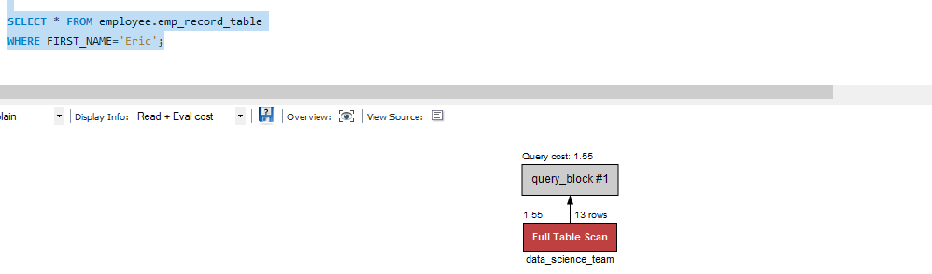

Query cost before creating the index taking FIRST_NAME is 1.55

.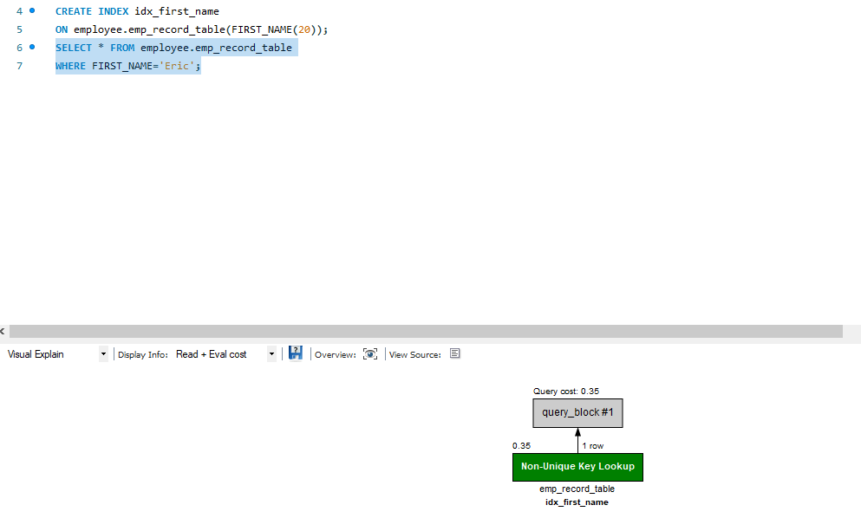

Query cost decreased by 1.2 to get the final query cost as 0.35

1. Write a query to calculate the bonus for all the employees, based on their ratings and salaries (Use the formula: 5% of salary * employee rating).

SELECT EMP_ID, FIRST_NAME, LAST_NAME, GENDER, EXP, DEPT, EMP_RATING, 0.05*SALARY*EMP_RATING AS BONUS FROM employee.emp_record_table ORDER BY BONUS DESC;

1. Write a query to calculate the average salary distribution based on the continent and country. Take data from the employee record table.

SELECT EMP_ID, FIRST_NAME, LAST_NAME, GENDER, EXP, DEPT, EMP_RATING, AVG(SALARY) AS AVG_SAL FROM employee.emp_record_table GROUP BY CONTINENT,COUNTRY;