Team 04 - Sprint 1 Testing & Bug Log
Final Testing Record
Item | Details
Project | 04-IBM Team Page
Sprint | Mock Sprint 1
Tester | Love Kumar
Feature areas | Login Restyling and Team Page
Overall status | PASS - final testing completed

1. Testing Scope
Testing covered the Login Restyling and Team Page against the approved BA requirements and UX deliverables. The test round included manual functional testing, edge-case testing, responsive layout checks, deployed end-to-end checks, and the repository's available automated verification commands.

2. Manual and Edge-Case Test Results
ID | Area | Test | Expected Result | Status
LG-01 | Login | Empty email and password | Sign In remains disabled | PASS
LG-02 | Login | Email only | Sign In remains disabled | PASS
LG-03 | Login | Password only | Sign In remains disabled | PASS
LG-04 | Login | Email and password entered | Sign In becomes enabled | PASS
LG-05 | Login UI | Input focus state | Blue focus outline displays correctly | PASS
LG-06 | Login UI | Google button hover | Required hover styling displays | PASS
LG-07 | Login UI | Sign In hover | Required hover styling displays | PASS
LG-08 | Login | Invalid credentials | Authentication fails correctly; user is not signed in | PASS
LG-09 | Login | Responsive layout | Login remains usable across desktop/tablet/mobile | PASS
LG-10 | Login | Existing authentication behaviour | Existing authentication flow remains functional after restyling | PASS
EC-01 | Access control | Direct Team Page URL without active session | Unauthenticated access is blocked/redirected | PASS
EC-02 | Team Page | Missing/broken photo | Initials fallback displays with no broken image/layout shift | PASS
EC-03 | Team Page | Blurb over 150 characters | Blurb truncates with ellipsis and card height is preserved | PASS
TP-01 | Team Page | Required content | Exactly five cards with name, photo, role and blurb | PASS
TP-02 | Team Page | Desktop layout | Three cards first row; remaining two centred below | PASS
TP-03 | Team Page | Tablet layout | Two cards per row | PASS
TP-04 | Team Page | Mobile layout | One full-width card per row | PASS
TP-05 | Navigation | Team info sidebar link and active state | Link opens Team Page and active state displays | PASS
TP-06 | Team Page | Card interaction | Member cards are display-only and do not navigate | PASS
TP-07 | Team Page | Long member name | Name wraps/truncates without breaking card layout | PASS
TP-08 | Team Page | Long role | Role remains single-line and truncates if required | PASS
E2E-01 | Deployed flow | Valid login on deployed application | User authenticates successfully | PASS
E2E-02 | Deployed flow | Post-login redirect | Successful login redirects to intended authenticated page | PASS
E2E-03 | Deployed flow | Team Page after login | Required Team Page content is available after authentication | PASS

3. Test Observations and Verification
Observation ID | Area | Initial Observation | Verification | Final Status | Notes
OBS-01 | Post-login redirect | On one test device, the page appeared to remain on Login after successful authentication. | Retested on two other PCs; redirect worked correctly. | PASS | Device/browser-specific observation; no reproducible application defect confirmed.
OBS-02 | Missing photo fallback | During local testing, a broken/blank image area appeared instead of the initials fallback. | Retested on other PCs; initials fallback worked correctly. | PASS | Local/browser-specific observation; no reproducible application defect confirmed.
Two concerns were initially observed during testing. Further verification on other devices confirmed that the login redirect and missing-image fallback were working correctly. Both checks are therefore recorded as PASS and no code fix was required.

4. Automated Verification
Check | Command | Observed Result | Status
Type checking | pnpm run typecheck | Frontend and backend TypeScript checks completed successfully. | PASS
Linting | pnpm run lint | Frontend and backend lint checks completed without reported errors. | PASS
Frontend tests | pnpm run test:component | Existing frontend test suite passed. | PASS
Backend tests | pnpm run test | Existing backend test suite passed. | PASS
Combined tests | pnpm run test:all | Available frontend and backend automated tests passed. | PASS
Production build | pnpm run build | Frontend and backend production build completed successfully. | PASS
Placeholder validation | pnpm run validate | No unreplaced placeholders were reported. | PASS
Note: These commands verify the repository's existing automated checks. Login- and Team-Page-specific acceptance criteria were additionally verified through the manual and edge-case tests recorded above.

5. Test Evidence
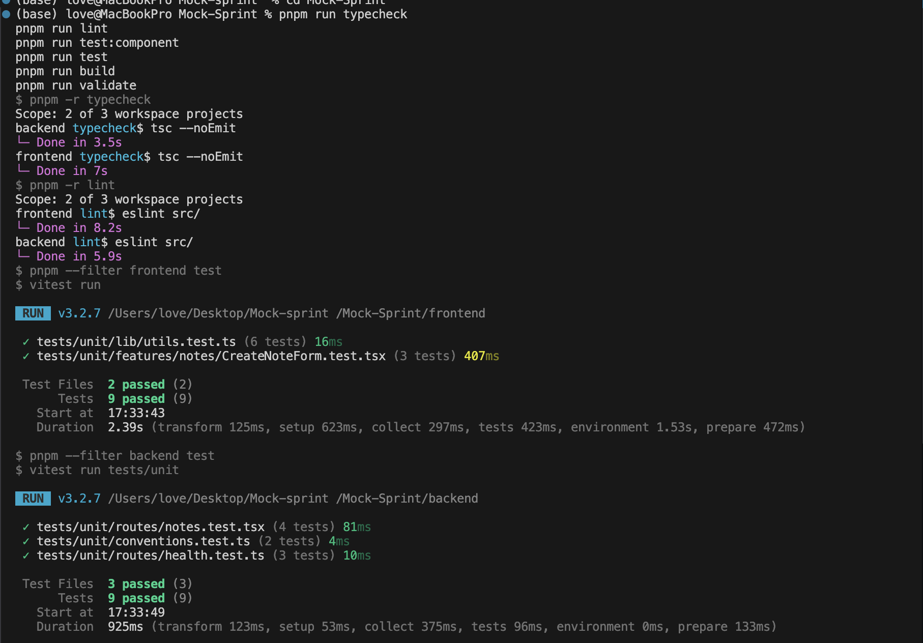
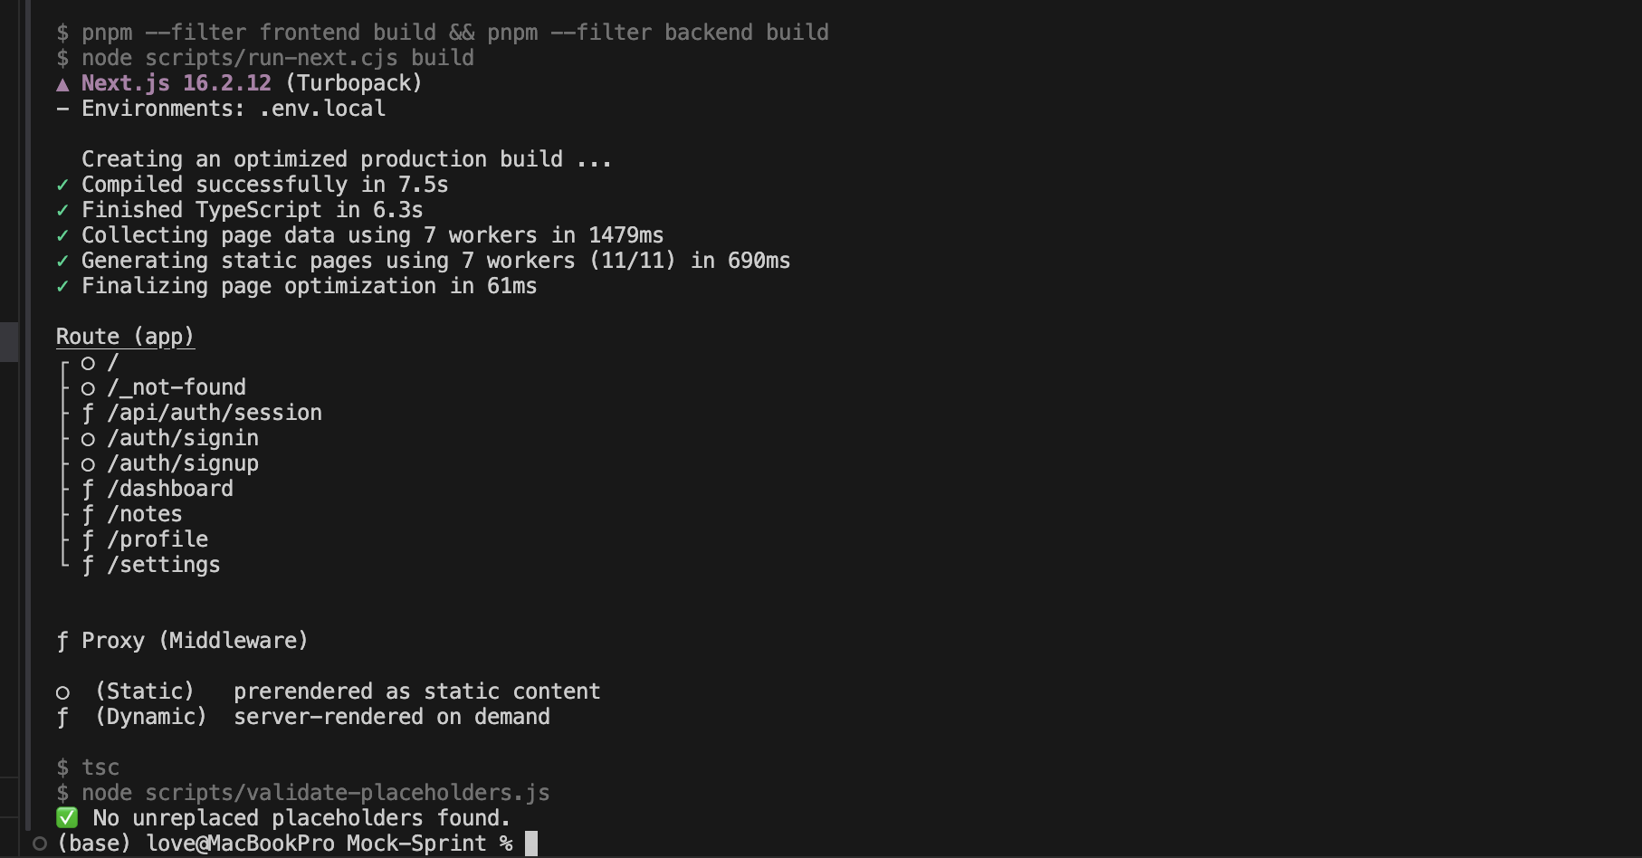

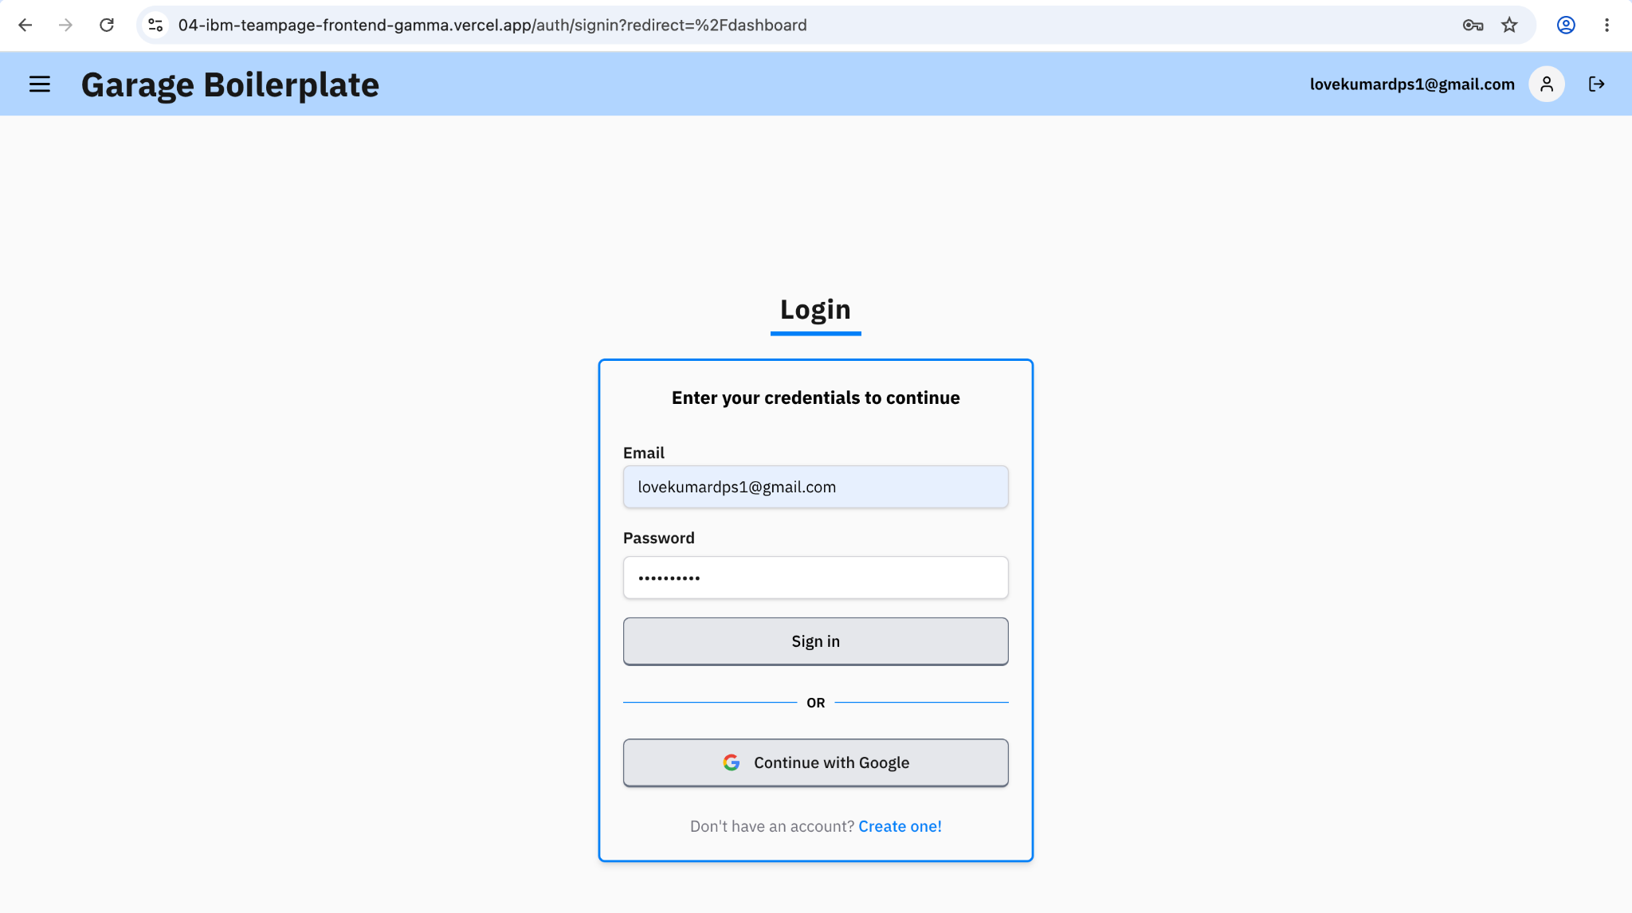
The behaviour was checked again on two other PCs, where the login redirect worked correctly. The final result is PASS.
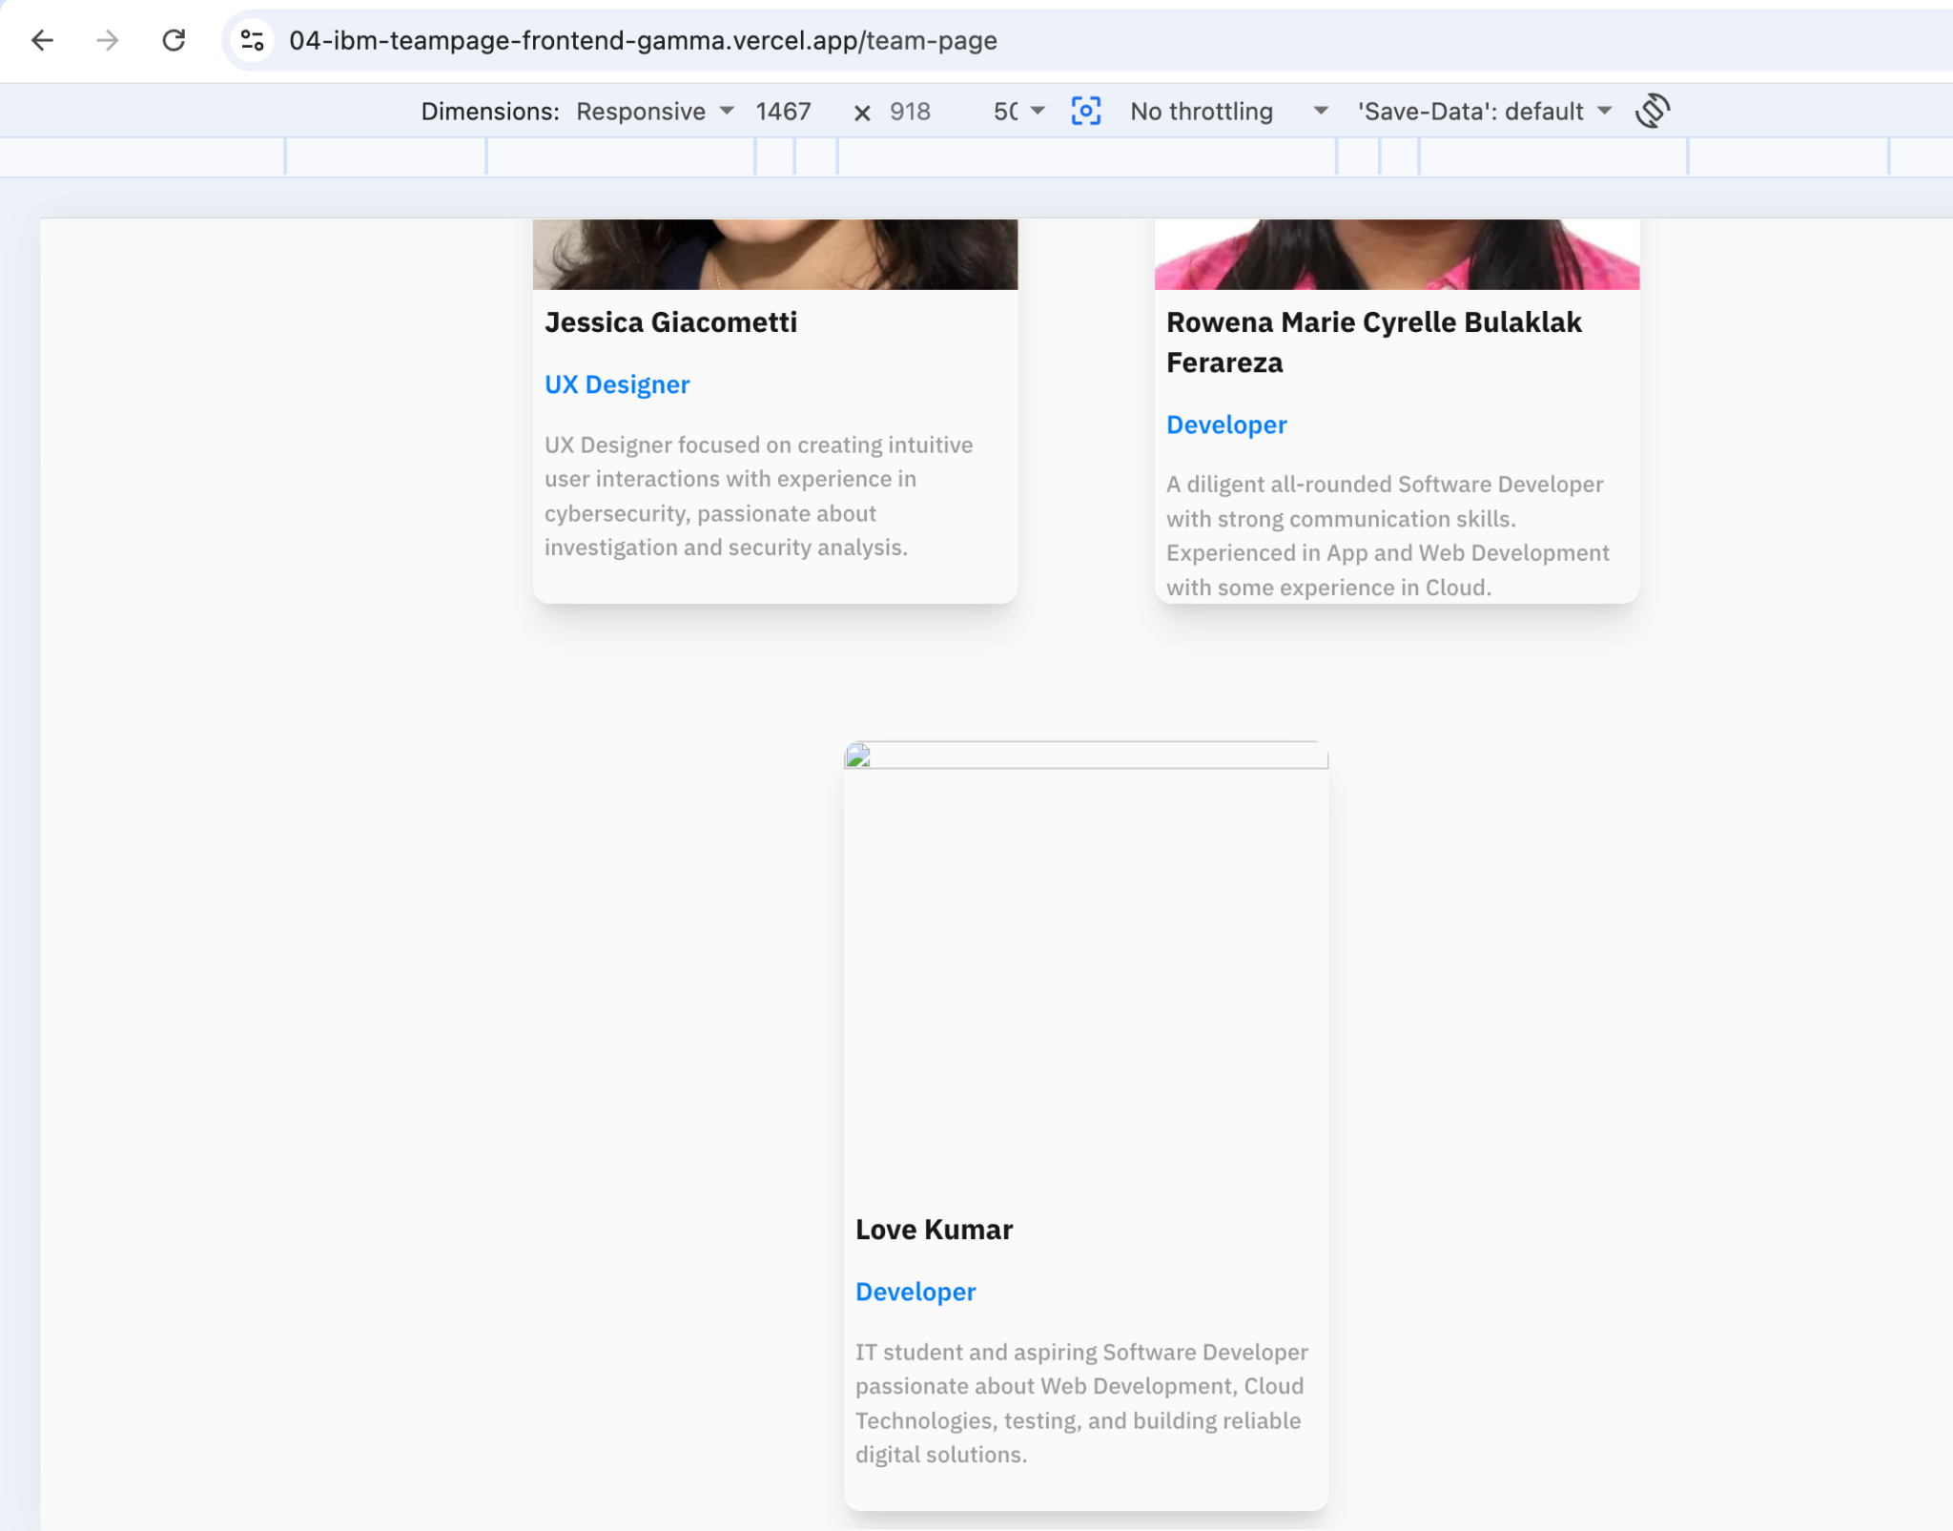
The missing-photo fallback was checked again on other PCs and worked correctly. The final result is PASS.

6. Final Test Summary
Metric | Result
Manual / edge-case / E2E test cases | 24
Final passed | 24
Final failed | 0
Confirmed application bugs | 0
Initial concerns verified on other devices | 2 - both PASS
Automated verification | PASS
Overall Sprint 1 testing status | COMPLETE - PASS

Conclusion: The final Sprint 1 test round completed successfully. The Login Restyling and Team Page met the tested functional, responsive, edge-case and end-to-end expectations. Two device/local-specific concerns were observed during testing, but both worked correctly when verified on other PCs and were not reproducible as application defects. The available automated repository checks also passed.

Document status: FINAL
This document records the completed Sprint 1 testing outcome. It should only be updated if further Sprint 1 code changes require regression testing or if additional defects are identified after this final test round.

