SQL Answers

* Using SQL, answer the following questions:
  + Top 3 brands with maximum number of Mobile Referrer Instances for Search Engines.
  + Total number of page views generated by news.com.au- Finance between 4am and 6am.
  + Total number of Desktop/Tablet page views generated by all the brands between August 2019 to October 2019.

Answers:-

1. **Select Brand from NCA_Verticals_by_Referrer_Device**

**Where Referrer Type=’Search Engines’ and Device Type =’Mobile’**

**order by Referrer Instances desc limit by 3**

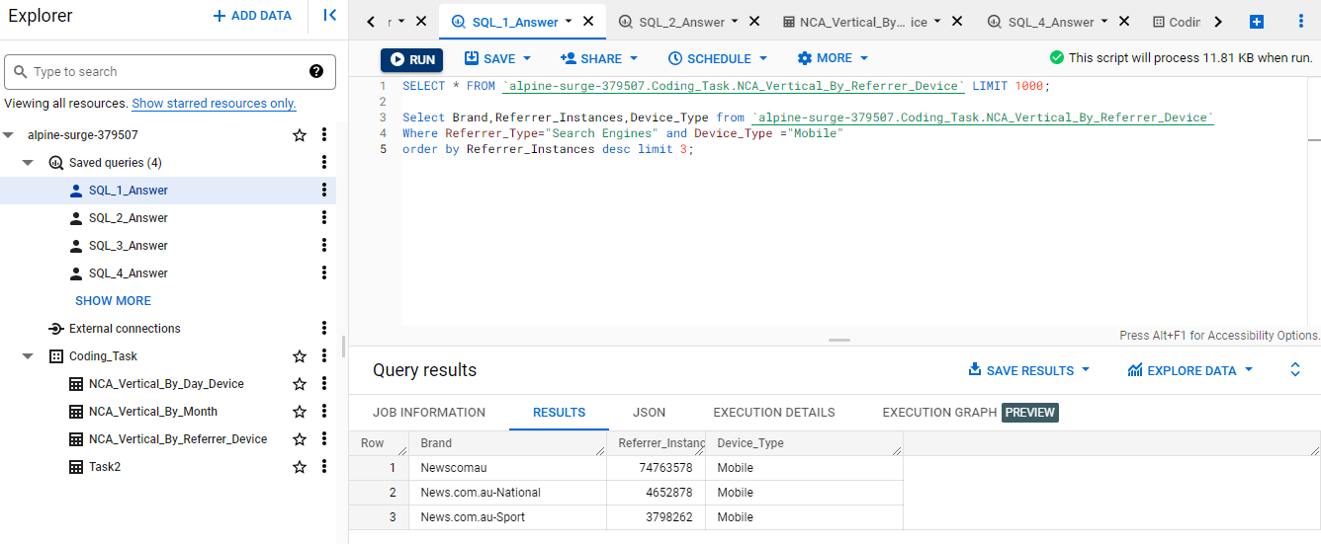

1. **Select sum(Page Views) from NCA_Verticals_by_Time_of_Day_Device**

**Where Brand=’news.com.au-Finance’ and hour(Hour of the Day) between ‘04:00:00’ AND ‘06:00:00’**

1. **Select sum(Page Views) from NCA_Verticals_by_Month_Device**

**Where Device_Type=’ Desktop/Tablet’ and Date(Month) Between ‘2019-08-01’ and**

**‘2019-10-31’**

**Task 2**

Input table:

|  |  |  |  |  |
| --- | --- | --- | --- | --- |
| **content_id** | **title** | **primary_category** | **primary_tag** | **ops_loaded_datetime** |
| p55k10 | Buffett's firm hit by virus but profit soars | markets | managed funds | 2020-08-09 15:08:43 |
| p565ny | Brazilian President's ally caught hiding cash in his underwear | world | stashed cash | 2020-11-16 09:02:15 |
| p565ny | Brazilian President's ally caught hiding cash in his underwear | world | world politics | 2020-10-16 09:02:15 |
| p56gbf | Pool of death? Wallaroos react to drawing Black Ferns at Women's World Cup | sport | wallaroos | 2020-11-20 07:15:52 |
| p56u8u | Australia to kill pigeon that crossed the Pacific Ocean from the United States | national | pigeon diplomacy | 2021-01-15 23:01:08 |
| p56u8u | Australia to kill pigeon that crossed the Pacific Ocean from the United States | national | animals | 2021-01-14 23:01:08 |
| p57fr1 | Deliveroo shares slump in UK IPO as investor appetite wanes | markets | IPO | 2021-04-02 04:49:18 |
| p57fr1 | Deliveroo shares slump in UK IPO as investor appetite wanes | markets | sharemarket | 2021-04-01 04:49:18 |
| p57hf8 | Mbappe stars as PSG beat Bayern, Chelsea take a big step | sport | uefa champions league | 2021-04-08 10:48:19 |
| p596um | Verstappen wins in Mexico, extends lead in F1 title chase | sport | formula 1 | 2021-11-08 10:05:20 |

**Output table:**

|  |  |  |  |  |
| --- | --- | --- | --- | --- |
| **content_id** | **title** | **primary_category** | **primary_tag** | **ops_loaded_datetime** |
| p55k10 | Buffett's firm hit by virus but profit soars | markets | managed funds | 2020-08-09 15:08:43 |
| p565ny | Brazilian President's ally caught hiding cash in his underwear | world | stashed cash | 2020-11-16 09:02:15 |
| p56gbf | Pool of death? Wallaroos react to drawing Black Ferns at Women's World Cup | sport | wallaroos | 2020-11-20 07:15:52 |
| p56u8u | Australia to kill pigeon that crossed the Pacific Ocean from the United States | national | pigeon diplomacy | 2021-01-15 23:01:08 |
| p57fr1 | Deliveroo shares slump in UK IPO as investor appetite wanes | markets | IPO | 2021-04-02 04:49:18 |
| p57hf8 | Mbappe stars as PSG beat Bayern, Chelsea take a big step | sport | uefa champions league | 2021-04-08 10:48:19 |
| p596um | Verstappen wins in Mexico, extends lead in F1 title chase | sport | formula 1 | 2021-11-08 10:05:20 |

Create an SQL script to remove duplicate content rows using content_id as the unique identifier and keeping only the latest row by ops_loaded_datetime. Result should be containing all the rows we want to keep.

**Answer:-**

select * from (select *, row_number() over (partition by content_id order by ops_loaded_datetime desc) as seq from `alpine-surge-379507.Coding_Task.Task2`) `alpine-surge-379507.Coding_Task.Task2` where seq=1

**Task 3**

You have a table called listen_history which contains Newscorp’s audio shows’ history log level data sets with the following columns:

|  |  |  |
| --- | --- | --- |
| **COLUMN_NAME** | **DATA_TYPE** | **Description** |
| date_syd | date | Date when user listens a podcast |
| hour_syd | integer | Hour of day when user listens a podcast |
| media_type | varchar(100) | Contains values which differentiates LongForm, ShortForm or Live contents |
| platform_type | varchar(100) | Contains values which differentiates Web, Mobile or tablet consumptions |
| user_id | varchar(100) | Contains USER ID |
| gender | varchar(100) | Contains Gender of User |
| age_group | varchar(100) | Contains Age group of User |
| show_name | varchar(500) | Identifies the Name of podcast show e.g. Teacher’s Pet, Healthyish etc. |
| episode_name | varchar(500) | Identifies the Episode name of the show e.g. “I saw what you did”,”Season Finale” etc. |
| genre | varchar(100) | Identifies the Genre of the show e.g. “true crime”, “news” etc. |

One day, someone from the products team was asking you to produce some analysis output for the following questions:

1. How many unique users of the Newscorp’s audio platform listened to anything in the show ‘I catch Killers with Gary Jubelin’?
2. Out of those users, how many of them have listened to the episode named “Your blood, my knife”
3. How many users have watched more than one different episode of the show Healthyish?

Create 3 SQL scripts to obtain the output for each questions.

**Answers:-**

1. **Select distinct user_id from listen_history where show_name= ‘I catch Killers with Gary Jubelin’**

1. **Select count(distinct (user_id)) from listen_history where show_name= ‘I catch Killers with Gary Jubelin’ and episode_name = “Your blood, my knife”**
2. **Select count(user_id) from listen_history where show_name=’ Healthyish’ and count(show_name)>1**

**Task 4**

There is talk of creating a Chinese language version of news.com.au. What steps would you take to find out whether or not this would be a reasonable proposition? Please outline your method/approach, what tools you would use, and anything else that you would do to come up with a recommendation.

Feel free to offer any other thoughts or recommendations you have based on all the information provided.

**Steps : Whether or Not it is a reasonable Proposition**

1. **Find out if we have considerable number of existing users or subscribers from the Region.**
2. **Analyse the User traffic from the region. If we have a high user visit/interaction from the Region.**
3. **Consider its feasibility, cost effectiveness and time and resources to spare.**

* **We can gather the information about the first two points from the Data warehouse, and based on the result we can analyse the audience we have that will be likely to use the new service.**
* **Use cost effective tools, with auto as well as manual translators for a better contextual and grammatical point of view.**
* **Advertising the incorporation to the Target audience.**

**-----------------------------------------------------===----------------------------------------------------------------**