Final Project Report

Library Information System



Project Supervisor
Muhammad Luqman

Submitted By

S23022D443

Muhammad Azam BC200202920

Software Projects & Research Section,
Department of Computer Sciences,
Virtual University of Pakistan


CERTIFICATE

This is to certify that Muhammad Azam (BC200202920), have worked on and completed their Software Project at Software & Research Projects Section, Department of Computer Sciences, Virtual University of Pakistan in partial fulfillment of the requirement for the degree of BS in Computer Sciences under my guidance and supervision.

In our opinion, it is satisfactory and up to the mark and therefore fulfills the requirements of BS in Computer Sciences.

Supervisor / Internal Examiner

Muhammad Luqman
Supervisor,
Software Projects & Research Section,
Department of Computer Sciences
Virtual University of Pakistan

___________________
(Signature)

External Examiner/Subject Specialist
<<External Supervisor Name>>

___________________
(Signature)

Accepted By:

_____________
(For office use)

EXORDIUM

In the name of Allah, the Compassionate, the Merciful.

Praise be to Allah, Lord of Creation,
The Compassionate, the Merciful,
King of Judgment-day!

You alone we worship, and to You alone we pray for help,
Guide us to the straight path

The path of those who You have favored,

Not of those who have incurred Your wrath,
Nor of those who have gone astray.

DEDICATION

To

The Last Prophet
Hazrat Muhammad (ﷺ)

All words dedicated with respect to

LOVING PARENTS
Whose love and prays always accompanies like a shining star whenever was in darkness
ACKNOWLEDGEMENT

I would like to extend my sincere gratitude to my respected supervisor, Mr. Muhammad Luqman, whose expertise, creative ideas, and constant assistance were important in helping me to successfully finish this project.
PREFACE

From the first System Requirements Specification (SRS) to the final deliverable, this project has taken an amazing journey, which I consider as I explain it. This project is a reflection of the inspiration, encouragement, and support I've received throughout the journey, in addition to being the result of my own efforts.

I would like to express my sincere appreciation to Virtual University and especially to my supervisor, Sir Muhammad Luqman. The Library Information System was made possible by his support at the SRS phase, and his ongoing advice and insights were crucial in guiding this project through all phases of development, including the design phase.

Furthermore, I acknowledge the unwavering support of my family, friends, and mentors who stood by me during the highs and lows of this project, especially during the prototype phases. Their encouragement kept me motivated and Focused. The prototype phase, with its assigned tasks and viva conducted by Sir Muhammad Luqman, was a critical milestone, and I'm grateful for the constructive feedback received.

This Library Information System is a product of collective effort, dedication, and a passion for enhancing accessibility to educational resources.

As I present this work, I hope it serves as a valuable contribution to modernizing library management systems and facilitating seamless access to information

Thank you to everyone who played a part in this journey. Your belief in this project has been my greatest motivation.
TABLE OF CONTENTS

CHAPTER NO. 1
gathering & Analyzing info 9

  - Introduction ………………………………………………..…………….10

1.2 purpose …………………………………………..………………………..10

1.3 scope ………………………………………………………………………..10

1.4 definitions, acronyms and abbreviations ………………………….. 11

1.5 Project requirements …………………………………………………..11

1.5.1 Functional Requirements ……………………………………………….11

1.5.2 Non-Functional Requirements …………………………………………12

1.6 use cases and usage scenarios ……………………………………….13

1.6.1 Use Case Diagrams …………………………………………………….13

1.6.2 Usage Scenarios ………………………………………….…………….14

1.7 Development Methodology …………………….……………………..20

1.7.1 Chosen Methodology …………………………………………………..20

1.7.2 Reasons for Chosen Methodology ……………………………………..20
1.7.3 Work Plan (Gantt Chart) ……………………………………………….21
1.7.4 Project Schedule (Submission Calendar) ……………………………….21

CHAPTER NO. 2
designing the project 22

2.1 Introduction ………………………………………….……………….…….23

2.2 purpose ……………………………………………………………….….23

2.3 scope ………………………………………………………………....….23

2.4 definitions, acronyms and abbreviations ……………………….…...24

2.5 Architectural Representation (Architecture Diagram) ……..…..24

2.6 Dynamic Model: Sequence Diagrams …………………………….……25

2.7 Object Model/Logical Model: Class Diagram …………………….32

2.8 Database Model (Database Diagram) …………………………………33

2.9 Graphical User Interfaces ……………………………………………...34

Chapter no.3
DEvelopment 37
3.1 Development plan (Architecture Diagram) ……………………...38

CHAPTER 1
Gathering & Analyzing Info

1.1 Introduction
The Library Information System is a desktop application designed to provide online access to the library for students, faculty & librarian.

This system automates library’s activities. The best way to maintain, organizes, and handles countless books systematically.

User can find books in an instant, issue/reissue books quickly, and manage all the data efficiently and orderly using this system. The purpose of a library information system is to provide instant and accurate data regarding any type of book, thereby saving a lot of time and effort.

1.2 purposes
The current library information system is a standalone desktop system available in campus. Students and faculty have no online access to the current library information system remotely. Students will be able to view report of the available, issued and returned books by taking login in to the library information system online. Students can also search books through this platform. The proposed system will cover up this gap.

1.3 Scope
Library Information System is basically updating the offline library system into a web-based online system for assisting both the students/faculty and librarian/staff in borrowing and supervising the books. The system would provide fundamental set of features for adding and/or updating members, adding and/or updating books, getting the list of books, finding out the list of books currently checked out and borrowing books.

This system completely automates all your library’s activities. The best way to maintain, organize, and handle countless books systematically is to implement a library management system software.

A Library Information System is software that is designed to manage all the functions of a library. It helps librarian to maintain the database of new books and the books that are borrowed by members along with their due dates and impose fine in-case of late return.

1.4 DEFINITIONS, ACRONYMS AND ABBREVIATIONS

Term | Definition
LIS | Library Information Student
Member | A person who has been allowed to borrow book, return book and pay fine. ) Person can be student or faculty
Admin | A person who has been allowed to manage user, manage book and impose fine.

1.5 PROJECT REQUIREMENTS

1.5.1 Functional Requirements
- Admin Login
  - Member Registration
  - Assigning rights to Faculty/ Student’s account
  - Admin can add, delete or modify the details of the books.
- Members:
  - Student/ faculty can search for the required book(s) based on author name, book name etc.

- Borrow books
  - A registered user can borrow the book for particular time.
- Return books
  - On returning a book the number of books in database should be updated/ increased
  - Imposing fine in case of returning the book(s) late
- Report generation for checking:
  - Number of available books in database
  - Information regarding remaining copies of a specific book borrowed
  - List of Borrowed books
  - Displaying all members got fine

1.5.2 Non-Functional Requirements

• Usability
Usability is the main non-functional requirement for a library management system. The UI should be simple enough for everyone to understand and get the relevant information without any special training

• Accuracy
Accuracy is another important non-functional requirement for the library management system. The data stored about the books / members and the fines calculated should be correct, consistent, and reliable. The Server would perform desired tasks as expected. The system does its work with more accuracy like user registration to the system, user validation and authorization, book search and issue operations, return status, and updating the database by synchronizing between database and application.

• Reliability
The system shall provide 100% access reliability

• Performance
The Server would be able to perform desired tasks in reasonable unit of time.

• Availability
The system is available 100% for the user and is used 24 hrs. a day and 365 days year. The system shall be operational 24 hours a day and 7 days a week

• Maintainability
The software should be easily maintainable and adding new features and making changes to the software must be as simple as possible. In addition to this, the software must also be portable.

• Security
System will use secured database Normal users can just read information but they cannot edit or modify anything except their personal and some other information. System will have different types of users and every user has access constraints.

1.6 USE CASES AND USAGE SCENARIOS

1.6.1 Use Case Diagram

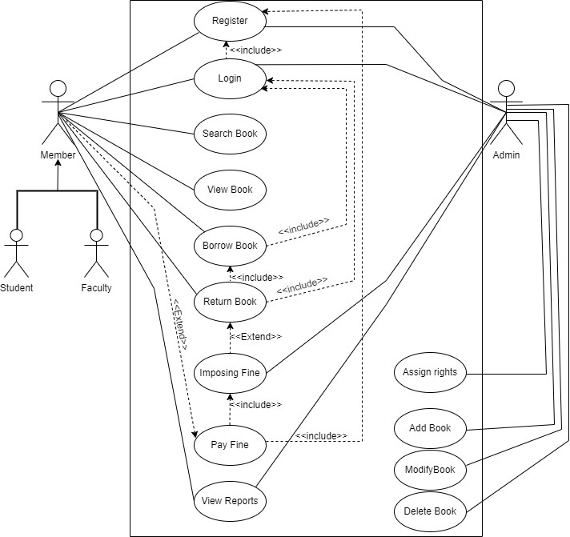

1.6.2 Usage Scenario

Use Case Title | User Registration (Member / Admin)
Use Case Id | UC-01
Actions | - User enters their name, email address, and password.  - System validates the user's input.  - System creates a new user account.
Description | The user is able to create a new account and log in to the system.
Alternative Paths | The user's email address is already in use. The user enters invalid information.
Pre-Conditions | The user's information must be valid.
Post Conditions | User account is created and registration details are stored
Author | BC200202920
Exception | Duplicate registration details, invalid inputs, system errors

Use Case Title | Login (Member / Admin)
Use Case Id | UC-02
Actions | - User enters their email address and password.  - System validates the user's input.  - System logs the user in.
Description | A user login to system to access the functionality of the system
Alternative Paths | The user's email address or password is incorrect. The user's account is not active.
Pre-Conditions | User account exists in the system, and login credentials are valid.
Post Conditions | User is authenticated and granted access to the system.
Author | BC200202920
Exception | Invalid login credentials, account locked, system errors

Use Case Title | Search Book
Use Case Id | UC-03
Actions | - User enters keywords or selects specific filters to search for a book.  - User clicks on the "Search" button to initiate the search process.  - User can further refine the search results by applying additional filters or sorting options.
Description | Student or faculty can search for the required books.
Alternative Paths | The search book is not found. The user enters an invalid search.
Pre-Conditions | The user must enter a valid search term.
Post Conditions | Relevant books matching the search criteria are displayed.
Author | BC200202920
Exception | Invalid search criteria, no results found, system errors

Use Case Title | View Book
Use Case Id | UC-04
Actions | - User selects a book from the search results.  - User clicks on the "View Details" button to see more information about the selected book.  - The system displays the detailed information of the book to the user.
Description | The user is able to view the details of a book, such as the name, author, description, reviews and available for borrow.
Alternative Paths | The book is not found. The user clicks on an invalid book.
Pre-Conditions | User is logged in.
Post Conditions | Book details, availability, and related information are displayed.
Author | BC200202920
Exception | The product details are not displayed.

Use Case Title | Borrow Book
Use Case Id | UC-05
Actions | - User navigates to the borrowed books section.  - User selects a book from the available books list.  - User confirms the borrowing request by clicking on the "Borrow" button.
Description | This use case allows a user to borrow a book from the library.
Alternative Paths | User cancels the borrow book process.
Pre-Conditions | User is logged in and has not reached the borrowing limit and the book must be available.
Post Conditions | Book is marked as borrowed. User's borrowing history is updated and the book decreased from the stock.
Author | BC200202920
Exception | Book not available, borrowing limit reached, system errors

Use Case Title | Return Book
Use Case Id | UC-06
Actions | - User selects the option to return a book.  - User selects the book to be returned from their list of borrowed books.  - User confirms the return by clicking on the "Return" button.
Description | The user indicates their intention to return a borrowed book and the user chooses the specific book they wish to return.
Alternative Paths | User cancels the return book process.
Pre-Conditions | User is logged in and has borrowed books.
Post Conditions | Book is marked as returned, user's borrowing history is updated, and the book becomes available for other users to borrow.
Author | BC200202920
Exception | Book not borrowed, system errors

Use Case Title | Assign Rights (Admin)
Use Case Id | UC-07
Actions | - Admin navigates to the user management section.  - Admin selects the user account to which rights need to be assigned  - Admin selects the appropriate rights or permissions to be assigned to the user.  - Admin saves the changes or confirms the rights assignment by clicking on the "Save" button or a similar option.
Description | The admin assigns rights to a user in the system.
Alternative Paths | If the admin does not select a user, the system will prompt them to select a user.
Pre-Conditions | Admin is logged in with administrative privileges. The selected user account exists in the system.
Post Conditions | The system updates the user account with the assigned rights or permissions, reflecting the changes in the user's access and privileges.
Author | BC200202920
Exception | System errors, unauthorized access

Use Case Title | Add Book (Admin)
Use Case Id | UC-08
Actions | - Admin navigates to the book management section.  - Admin clicks on the "New" button.  - Admin fills in the required details.  - Admin saves by clicking on the "Save" button.
Description | The admin adds a new book to the system by providing necessary details.
Alternative Paths | If the admin does not fill in all required details, the system displays an error.  If the admin cancels the addition, no book is added.
Pre-Conditions | Admin is logged in with administrative privileges.
Post Conditions | The new book is added to the system.
Author | BC200202920
Exception | invalid inputs, system errors

Use Case Title | Modify Book Details (Admin)
Use Case Id | UC-09
Actions | - Admin navigates to the book management section.  - Admin can / modify the book.  - Admin makes the necessary changes to the book details.  - Admin updates the modifications by clicking on the "Update" button.
Description | The admin edits the relevant fields of the selected book, such as title, author, or description.
Alternative Paths | If the admin does not select a book, the system will prompt them to select a book and If the admin enters invalid details, the system will not save the changes
Pre-Conditions | Admin is logged in with administrative privileges.  The selected book exists in the system.
Post Conditions | The updated book details are saved in the system, reflecting the modifications made by the admin.
Author | BC200202920
Exception | Book not found, invalid inputs, system errors

Use Case Title | Delete Book Details (Admin)
Use Case Id | UC-10
Actions | - Admin navigates to the book management section.  - Admin can delete the book.  - Admin selects a book to delete.  - Admin delete book by clicking on the "delete" button.
Description | The admin deletes an existing book from the system.
Alternative Paths | If the admin does not select a book, the system will prompt them to select a book.
Pre-Conditions | Admin is logged in with administrative privileges.  The selected book exists in the system.
Post Conditions | The selected book is deleted from the system.
Author | BC200202920
Exception | Book not found, system errors

Use Case Title | Imposing Fine (Admin)
Use Case Id | UC-11
Actions | - Admin navigates to the fine management section.  - Admin selects the user account on which the fine is to be imposed.  - Admin enters the amount of the fine and confirms the imposition by clicking on the "Impose Fine" button.
Description | The admin inputs the appropriate fine amount to be imposed on the selected user's account and then confirms the imposition action.
Alternative Paths | Admin cancels the fine imposition process.
Pre-Conditions | Admin is logged in with administrative privileges and the selected user account exists in the system.
Post Conditions | The specified amount is added to the user's fine balance, and the fine imposition is recorded in the system.
Author | BC200202920
Exception | User account not found, invalid inputs, system errors

Use Case Title | Pay Fine (Member)
Use Case Id | UC-12
Actions | - User navigates to the fine payment section.  - User selects the option to pay the fine.  - User enters the payment details and confirms the payment by clicking on the "Pay" button.  - Attached payment slip.
Description | The user accesses the section of the system dedicated to paying fines.
Alternative Paths | User cancels the payment process.
Pre-Conditions | User is logged in with a valid account and The user has an outstanding fine in their account.
Post Conditions | The payment is processed, and the user's fine balance is updated accordingly. The payment details are recorded in the system for future reference.
Author | BC200202920
Exception | User account not found, invalid payment, system errors

Use Case Title | View Reports (Member / Admin)
Use Case Id | UC-13
Actions | - User navigates to the reports section.  - User selects the desired report from the available options.  - User filters or customizes the report parameters, if applicable.
Description | The user accesses the section of the system dedicated to viewing reports.
Alternative Paths | User cancels the report viewing process.
Pre-Conditions | User is logged in with user defined privileges and The selected report is available in the system.
Post Conditions | The report is generated based on the user's selected parameters, displaying the desired information or insights
Author | BC200202920
Exception | Unauthorized access, system errors.

1.7 DEVELOPMENT METHODOLOGY

1.7.1 Chosen Methodology
My Adopted Methodology is VU Process Model. VU process Model is combination of Water Fall model and Spiral Model.

1.7.2 Reasons for Chosen Methodology
The following are some justifications for selecting the VU Process Model for this system:

- The sequential VU Process Model repeats backwards.
- The VU Process Model requires that all tasks be completed in a specific order.
- The VU Process Model is more advanced and efficient than the waterfall model since it allows us to go back at any point in the development process, something that the waterfall model does not allow.
- We can select the VU Process Model if we want repetition.
- We can make corrections at any point due to the VU Process Model.
- We can select the VU process model whenever we wish to improve our system.

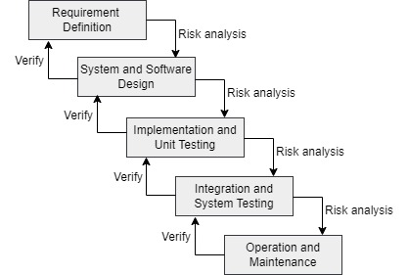

1.7.3 Work Plan (Gantt chart)

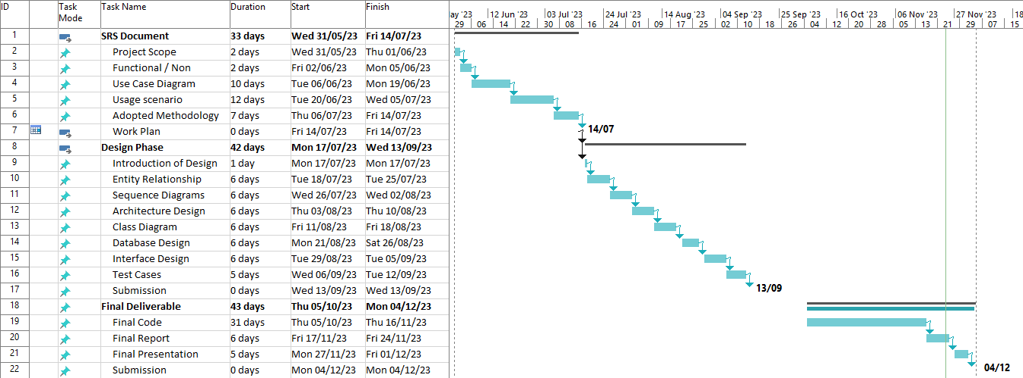

1.7.4 Project Schedule (Submission Calendar)
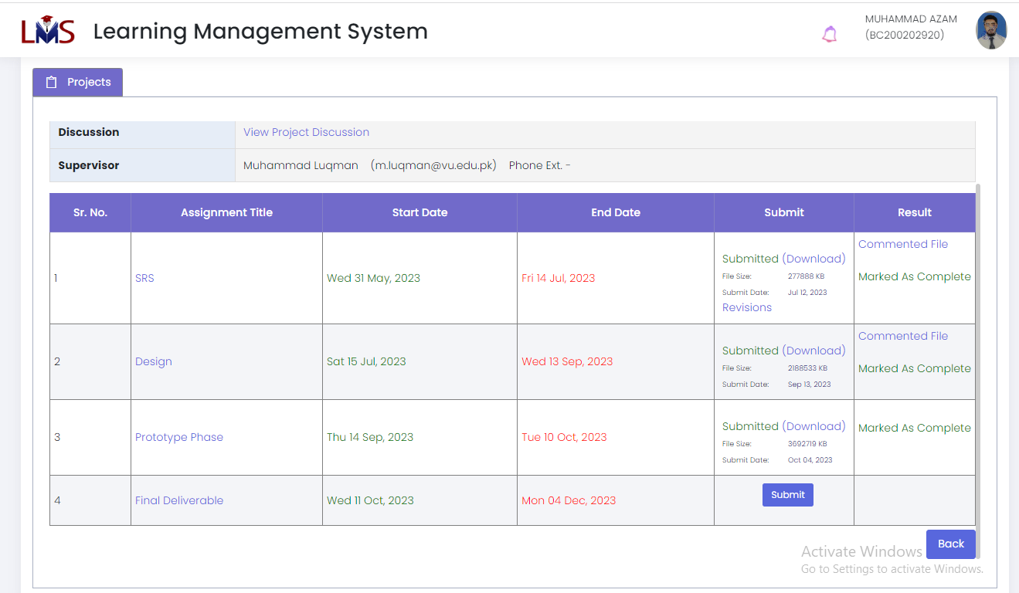

CHAPTER 2
Designing the Project

2.1 Introduction
This comprehensive chapter describes the crucial elements included in the Library Information System project, highlighting their significance and purpose. Each stage is essential to a well-organized and productive development process, which is necessary for seamless library administration, efficient user engagement, and the system's successful deployment. With the help of these essential elements, we hope to provide users with an easy-to-use interface and streamlined services as we build an amazing library management experience. This chapter acts as a road map for an effective library information system, where each element is essential to attaining the goals of our library.

2.2 PURPOSE
The purpose of form the design document is to provide a comprehensive roadmap for the development of the Library Information System. This document systematically covers vital aspects such as system architecture, functionalities, user experience, scalability, integration points, and performance metrics. Serving as a crucial reference, its purpose is to facilitate a collective understanding of the project's vision among stakeholders. Noteworthy sections, including the Entity Relationship Diagram (ERD), Sequence Diagrams, Architecture Design Diagram, Class Diagram, Database Design, Interface Design, and Test Cases, are purposefully integrated to contribute collaboratively to an organized and efficient approach in constructing the Library Information System.

2.3 SCOPE
The scope of the design document is extensive, covering critical elements for the development of the Library Information System. It involves defining the system's architecture, specifying functionalities, ensuring an improved user experience, planning for scalability, identifying integration points, setting performance metrics, and detailing specific design components. This comprehensive approach is designed to offer clear guidance and facilitate an efficient development process for the Library Information System

2.4 definitions, acronyms and abbreviation

Term | Definition
LIS | Library Information Student
Member | A person who has been allowed to borrow book, return book and pay fine. ) Person can be student or faculty
Admin | A person who has been allowed to manage user, manage book and impose fine.

2.5 Architectural Representation (Architecture Diagram)

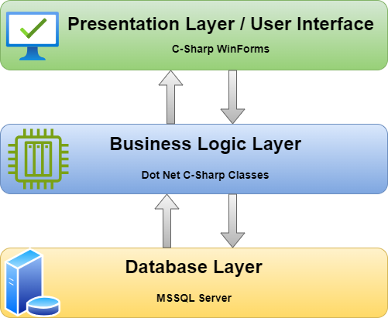

2.6 DYNAMIC MODEL: SEQUENCE DIAGRAMS

- User Registration
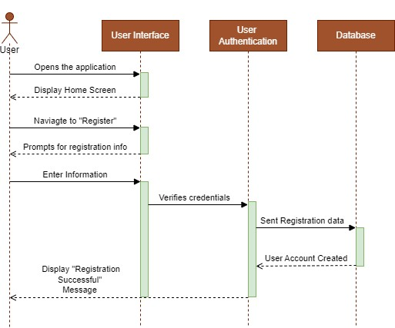

- Login
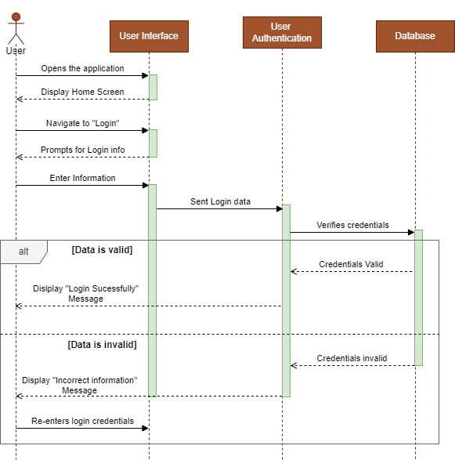
- Search Book
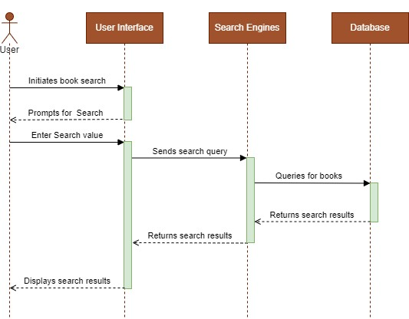

- View Book
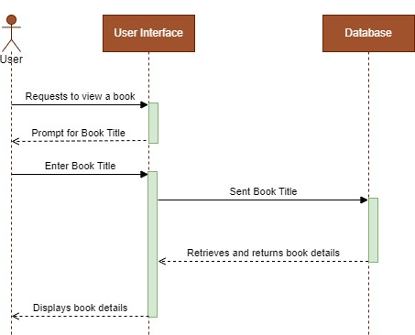

- Borrow Book
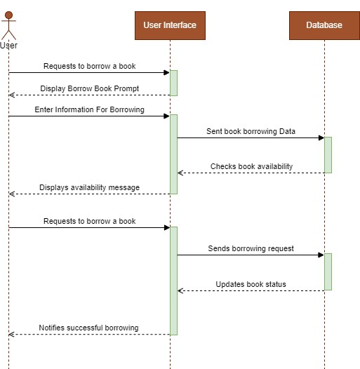

- Return Book
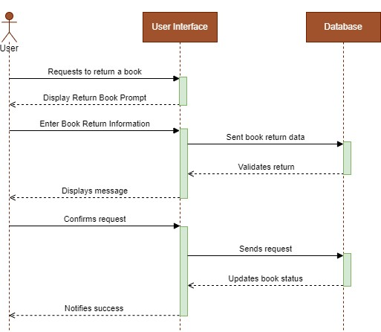

- Assign Rights.
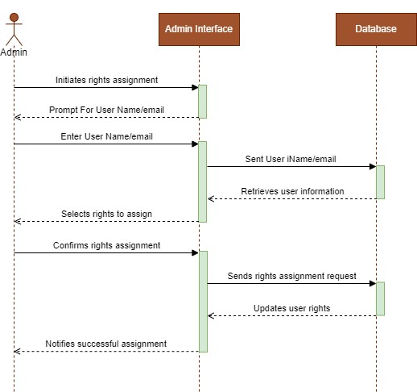

- Add Book
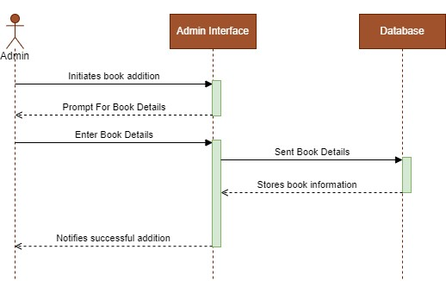

- Modify Book

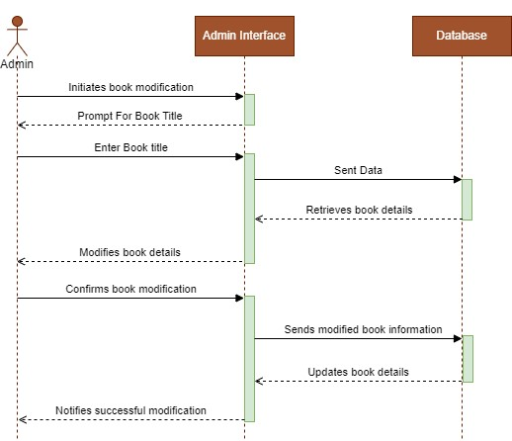

- Delete Book
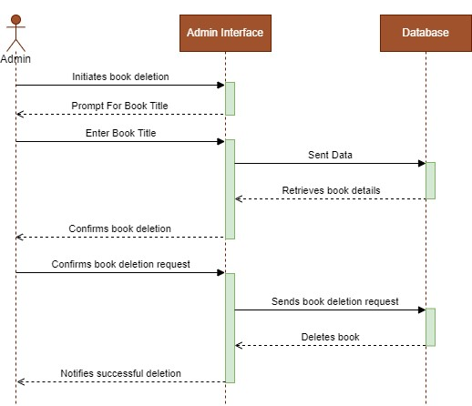
- Impose Fine
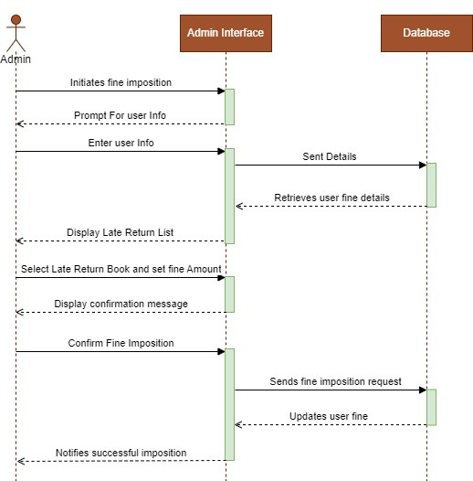

- Pay Fine
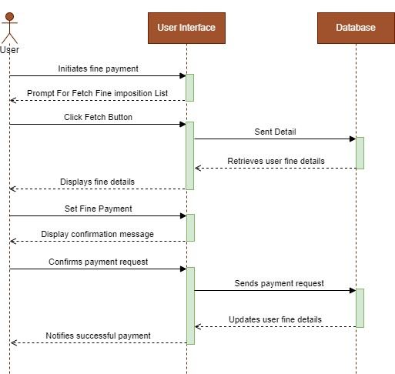
- View Reports

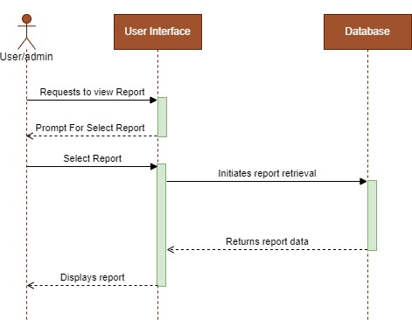

2.7 OBJECT MODEL/LOGICAL MODEL: CLASS DIAGRAM

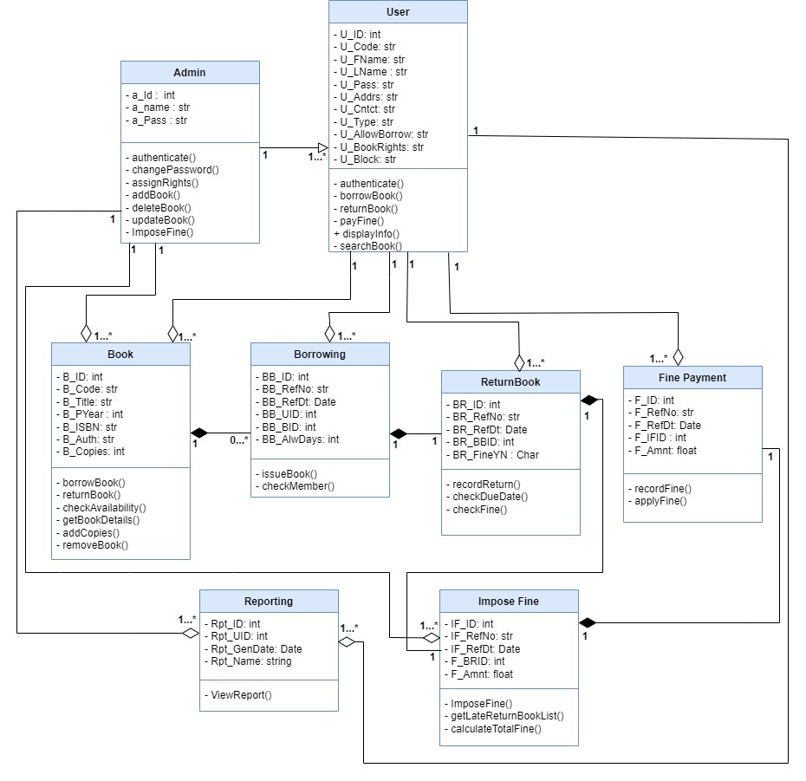

2.8 DATABASE MODEL (DATABASE DIAGRAM)

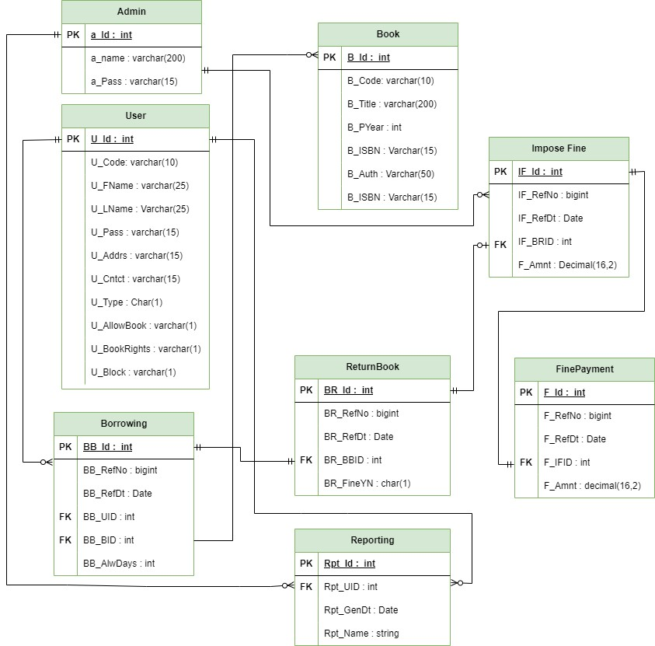

2.9 GRAPHICAL USER INTERFACES

Login

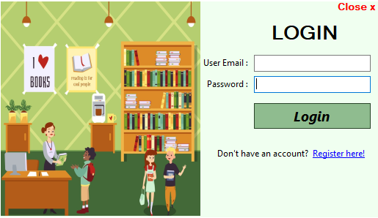

Register

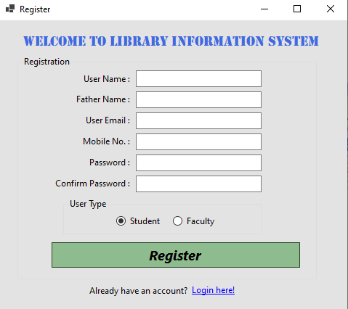

User Management

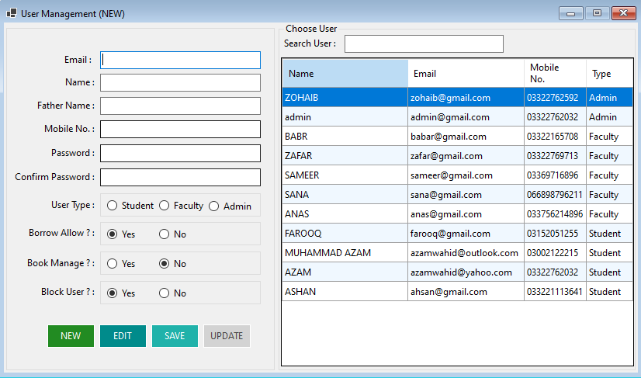

Add Book

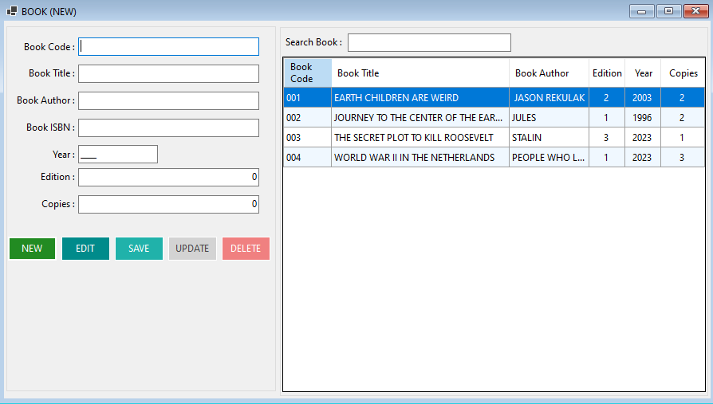

Borrow Book

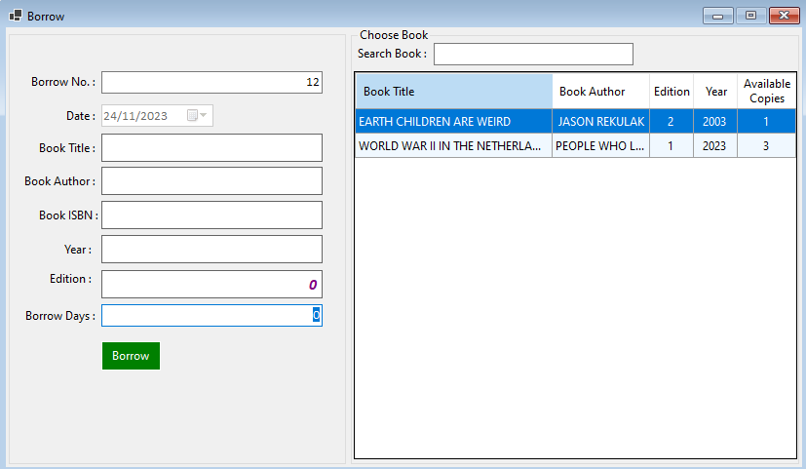

Impose Fine

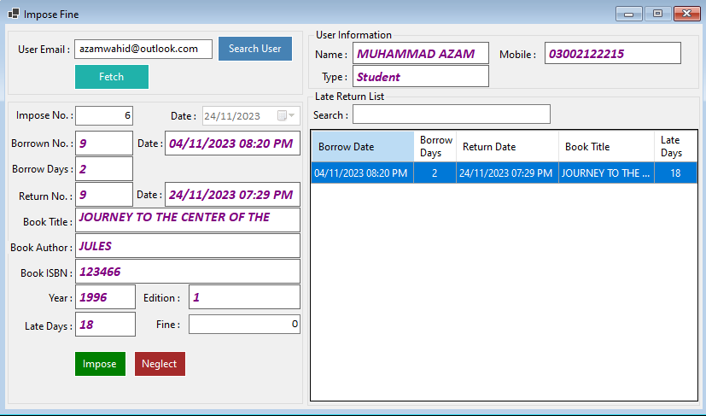

CHAPTER 3
Development

3.1 DEVELOPMENT PLAN (ARCHITECTURE DIAGRAM)

REFERENCES

https://app.diagrams.net/
https://learn.microsoft.com/en-us/dotnet/fundamentals/
https://learn.microsoft.com/en-us/sql/?view=sql-server-ver16
https://online.visual-paradigm.com/diagrams/tutorials/use-case-diagram-tutorial/
https://www.lucidchart.com/pages/er-diagrams

APPENDIX
A. Use Case Diagrams
Include detailed diagrams illustrating the use cases and usage scenarios.

B. Gantt Chart
Attach the Gantt chart representing the work plan for development methodology.

C. Project Schedule
Include the Project Schedule (Submission Calendar) outlining important milestones.

D. Architecture Diagram
Include the architectural representation, highlighting the overall structure of the project.

E. Sequence Diagrams
Attach dynamic models represented by sequence diagrams for the development process.

F. Class Diagram
Include the object model or logical model represented through class diagrams.

G. Database Diagram
Attach the database model diagram representing the structure of the database.

H. GUI Screenshots
Include screenshots of the Graphical User Interfaces developed during the project.

