Project Proposal

Smartphone-based fall detection system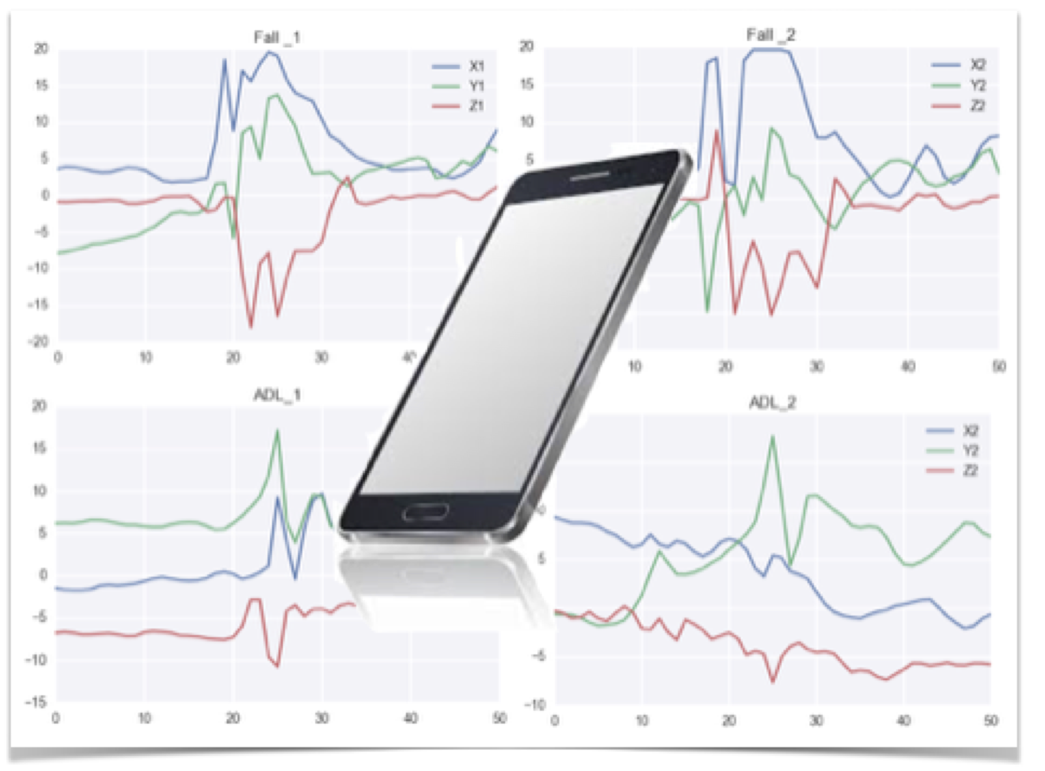

Prepared for:

AssISTIVE TECHNOLOGIES

Prepared by: Anna Zamaraeva

8 February 2017

Proposal number: 000-1234

# EXECUTIVE SUMMARY

## Overview

Falls are a major health risk that impacts the quality of life of many people. Young people engaging in extreme leisure activities, disabled persons and elderly people, patients recovering from injuries - are all subject to a higher risk of accidental falls. When a fall occurs, a prompt notification would help to provide quick help and reduce potential injuries.

With modern technologies, a smartphone can serve as a detection system for the falls. Smartphones are wide spread, do not introduce any additional costs, can be used in any place and are accepted by people as a part of everyday life. Smartphones have inbuilt sensors: an accelerometer and a gyroscope, data from which can be used for falls detection.

An effective smart-phone based system can provide multiple benefits: (1) automatic notification of occurred falls; (2) promptness in order to provide quick assistance and (3) communication capabilities in order to alert the caregivers. The system can be further evolved into a commercial smartphone app which can be used in several application domains: assisted living settings, care-providing and by general users.

ASSISTIVE TECHNOLOGIES

## Goal

To train a machine-learning based algorithm to classify human activities and to detect the falls using patterns recorded by smartphone accelerometers.

## Project Data

Recently several accelerometer datasets for human activities have been collected by researchers worldwide and made publicly available. These datasets can be broadly divided by two criteria: a type of sensor used in data acquisition ( a smartphone or a specialised device) and inclusion of falls into a dataset. For the purpose of the project, the datasets were evaluated in terms of the following requirements: (a) accelerometer data captured by smartphones located in the pockets of study participants, rather than by specialised device; (b) a wide range of human activities and a rich variety of study participants; and (c) a large number of simulated falls in a dataset.

After the analysis, two datasets have been selected for the project:

* 1. **UniMiB SHAR** - A New Dataset for Human Activity Recognition Using Acceleration Data from Smartphones. Made available by researchers of University of Milano-Bicohcca at <http://www.sal.disco.unimib.it/technologies/unimib-shar/>
  2. **MobiAct** - The MobiAct Dataset: Recognition of Activities of Daily Living using Smartphones. Made available by researchers of Tehnological Educational Institute of Crete at <http://www.bmi.teicrete.gr/index.php/research/mobiact>

Both datasets contain triaxial acceleration data captured by smartphones during a wide range of activities. Recorded daily activities and simulated falls are performed by a large number of subjects varying in age, gender and physical characteristics. UniMiB SHAR dataset contains total 7,013 activities performed by 30 subjects, mostly females (24), of ages ranging from 18 to 60 years. MobiAct dataset contains data from 24 subjects: 17 males and 7 females, of ages ranging from 22 to 47 years. These datasets are labelled, rich and complete collections of acceleration patterns, and will serve as a good base for conducting data experiments.

## Project Outline

An intended project approach is to solve a classification problem as a machine-learning task. A fact that the acceleration data is collection of short 3-dimensional time series (each window is 1 sec length with 50-70 sample points) allows for two potential approaches:

ASSISTIVE TECHNOLOGIES

* *Anomaly detection in time series*. Daily activities can be viewed as normal behaviour of time series, while falls as a novelty or anomaly;
* *Classification/regression problem*. From a raw acceleration data, we can extract useful features ( e.g. total acceleration, total power, general acceleration shapes) and then use classification algorithms to classify the entries into 2 categories: normal daily activities and falls. In this approach, we can consider several detection techniques: k-nearest neighbour (kNN) and Support Vector Machines (SVM).

UniMiB SHAR dataset is intended to be used as a primary set for training a machine learning algorithm. While the the second dataset (MobiAct) can be later used as a backup for expanding a learning base if it becomes necessary.

## Project Deliverables

A paper describing the analysis, code and a slide deck.