**Lab 10 Azamat Jubandyqov**

To complete the given task on object detection and augmentation, I used the new website called <https://blog.roboflow.com/advanced-augmentations/> ,you can only enter this site by using VPN, I don’t know why so.

Recent research has shown there is still plenty of room to grow model performance through augmenting our training data. Roboflow has written extensively about data augmentation and has highlighted some of the recent advances that have made new models like YOLOv4 and YOLOv5 state of the art.

I think this is a great tool, to generate new images for object detection. They can also augment images for instance segmentation.

This is my example:

I loaded my dataset into roboflow.

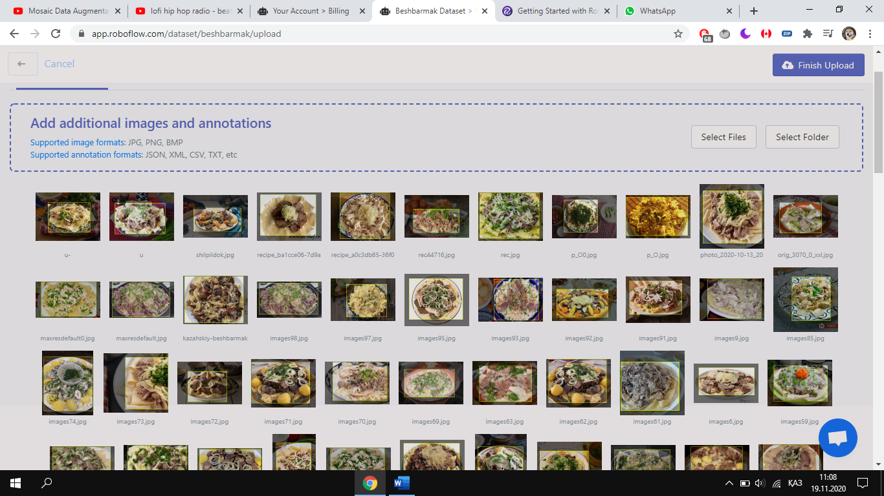

In total I had 193 images from my previous task and this is my full dataset:

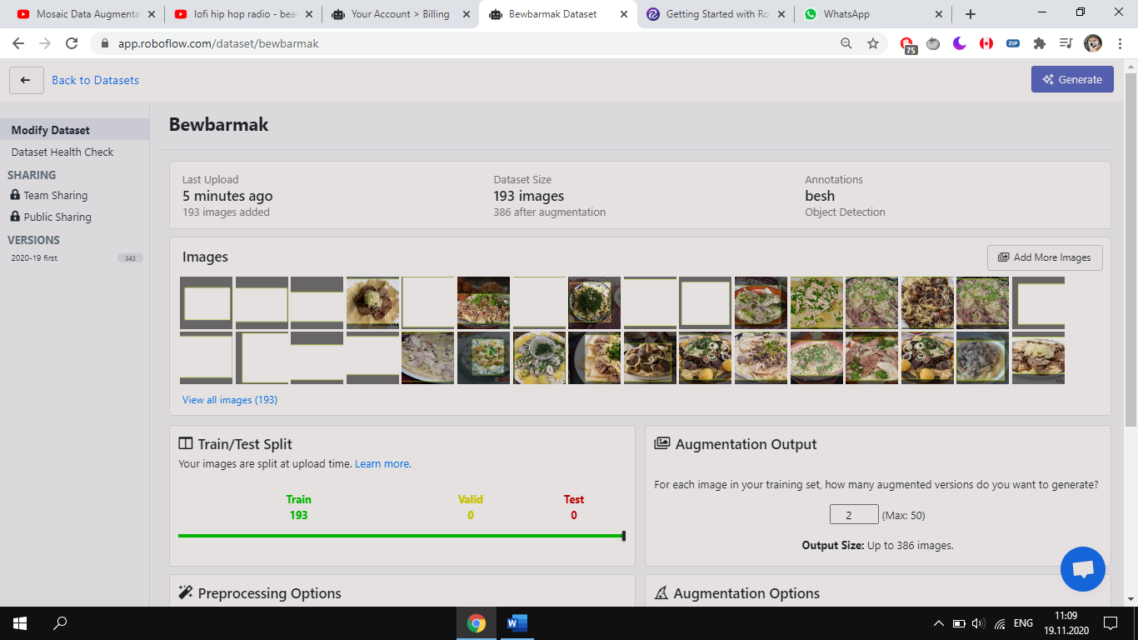

Website has a great tools, it offered me data preprocessing. I picked **Auto-orient** and decided to **resize** my images into 416*416.

Augmentation options were quite better. 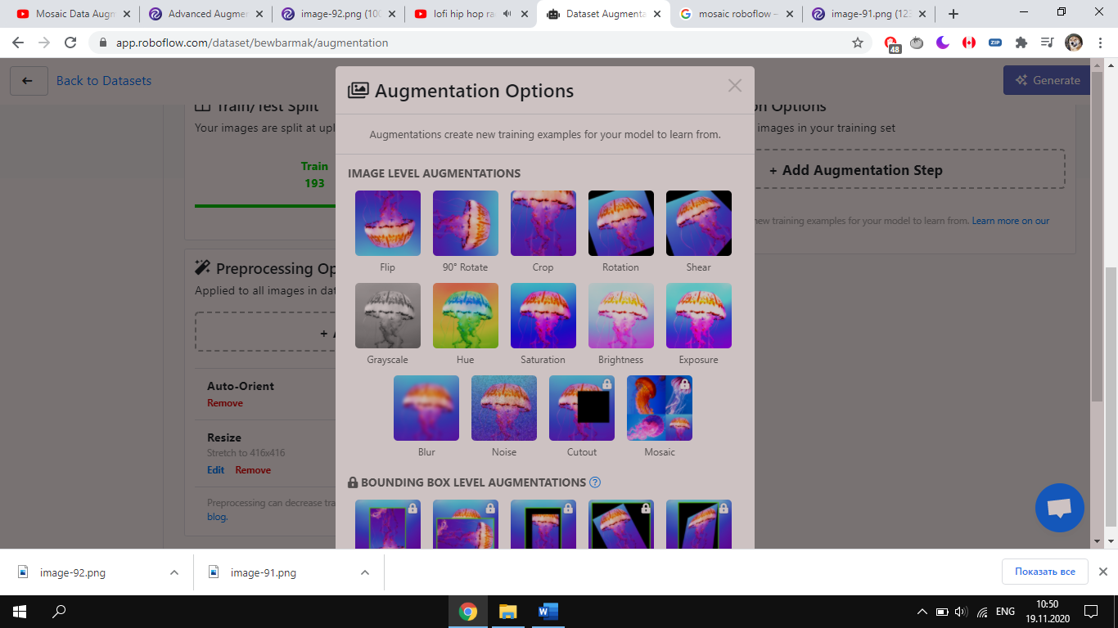

**I decided to choose Flip horizontal and 90* rotate clockwise, here is some examples.**

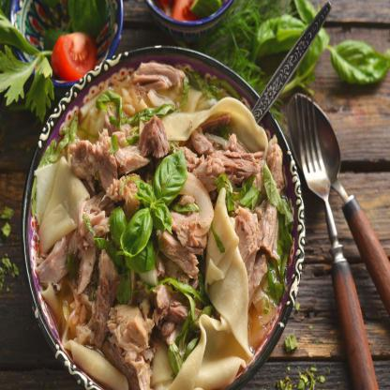 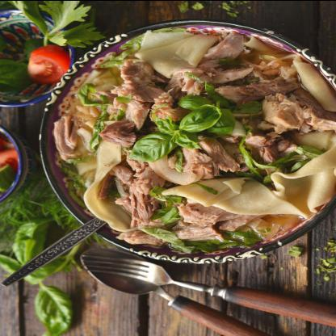

In total I got about 500 images for my beshbarmak dataset, whereas my previous amount was abount 200 images.

**Training the model**

I used Colab to train, and my training part you can see in **Lab10yolov3.ipynb** file.

My avg loss in 2 hour training section was 0.15, which is quite better than previous one, and thanks to this laboratory work, now I can easily augment my images for object detection.

