Laboratory work 4
- Retrieve all airline names in uppercase.
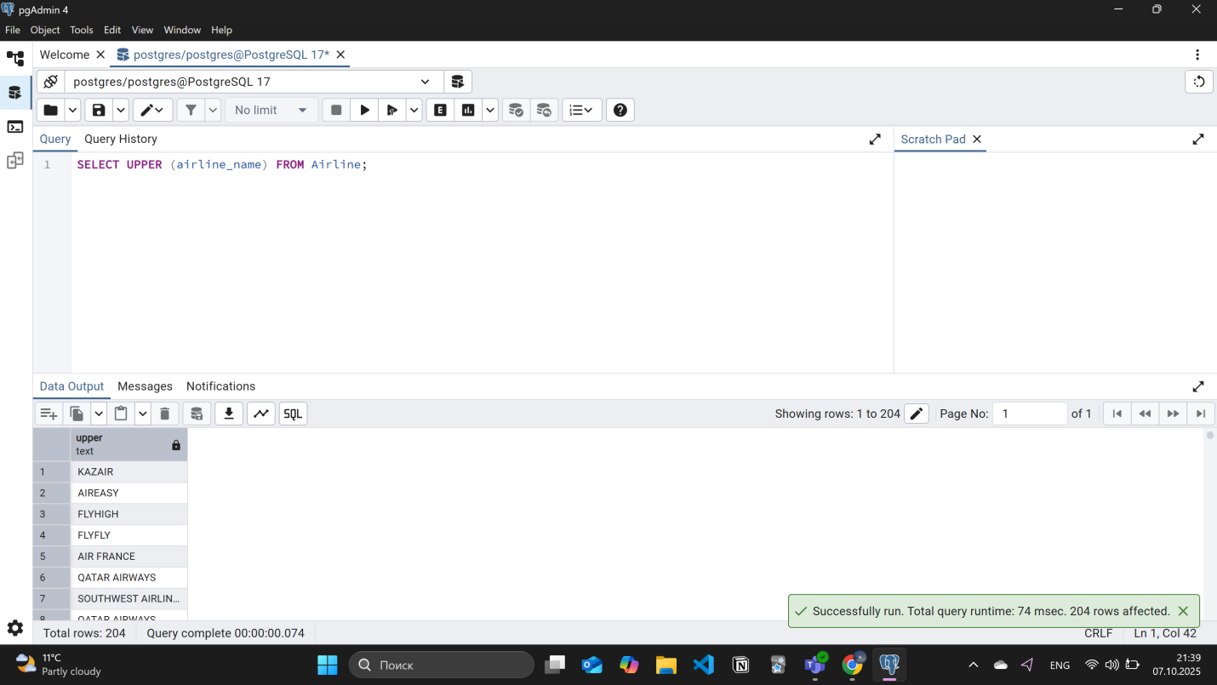
- Replace any occurrence of the word "Air" in airline names with "Aero".
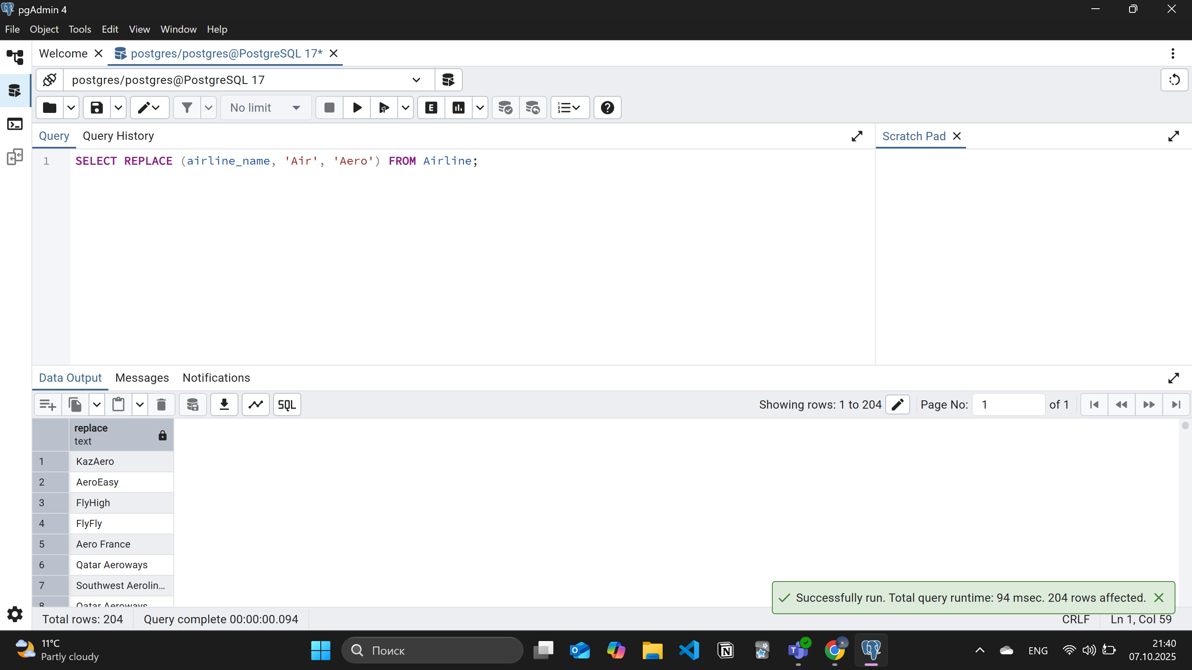
- Fing all flight numbers that coordinates with both airline 1 and airline 2.
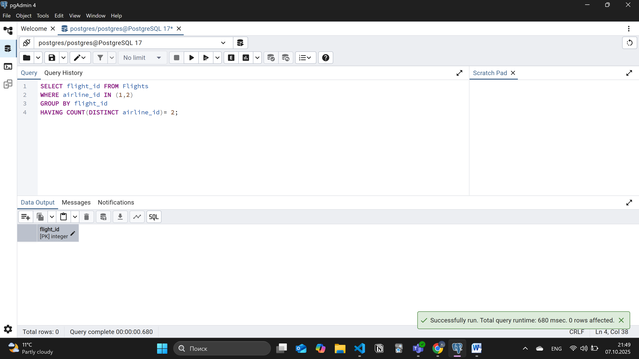
- Retrieve airports that contain the word "Reginal" and "Air" in their names.
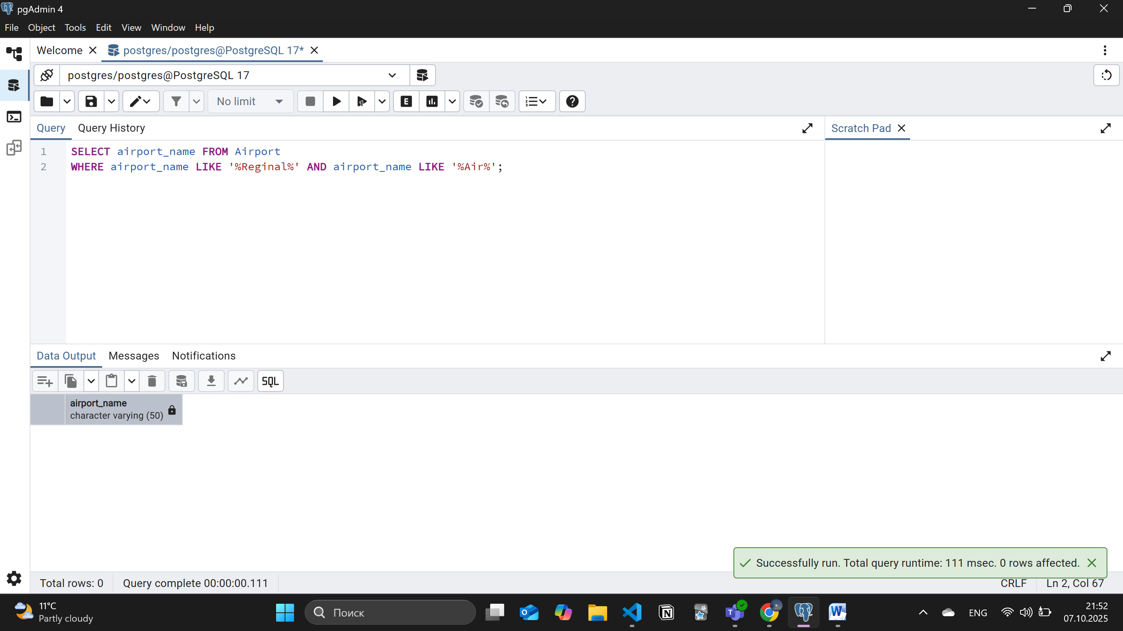
- Retrieve passenger names and format their birth dates as 'Month DD, YYYY'..o
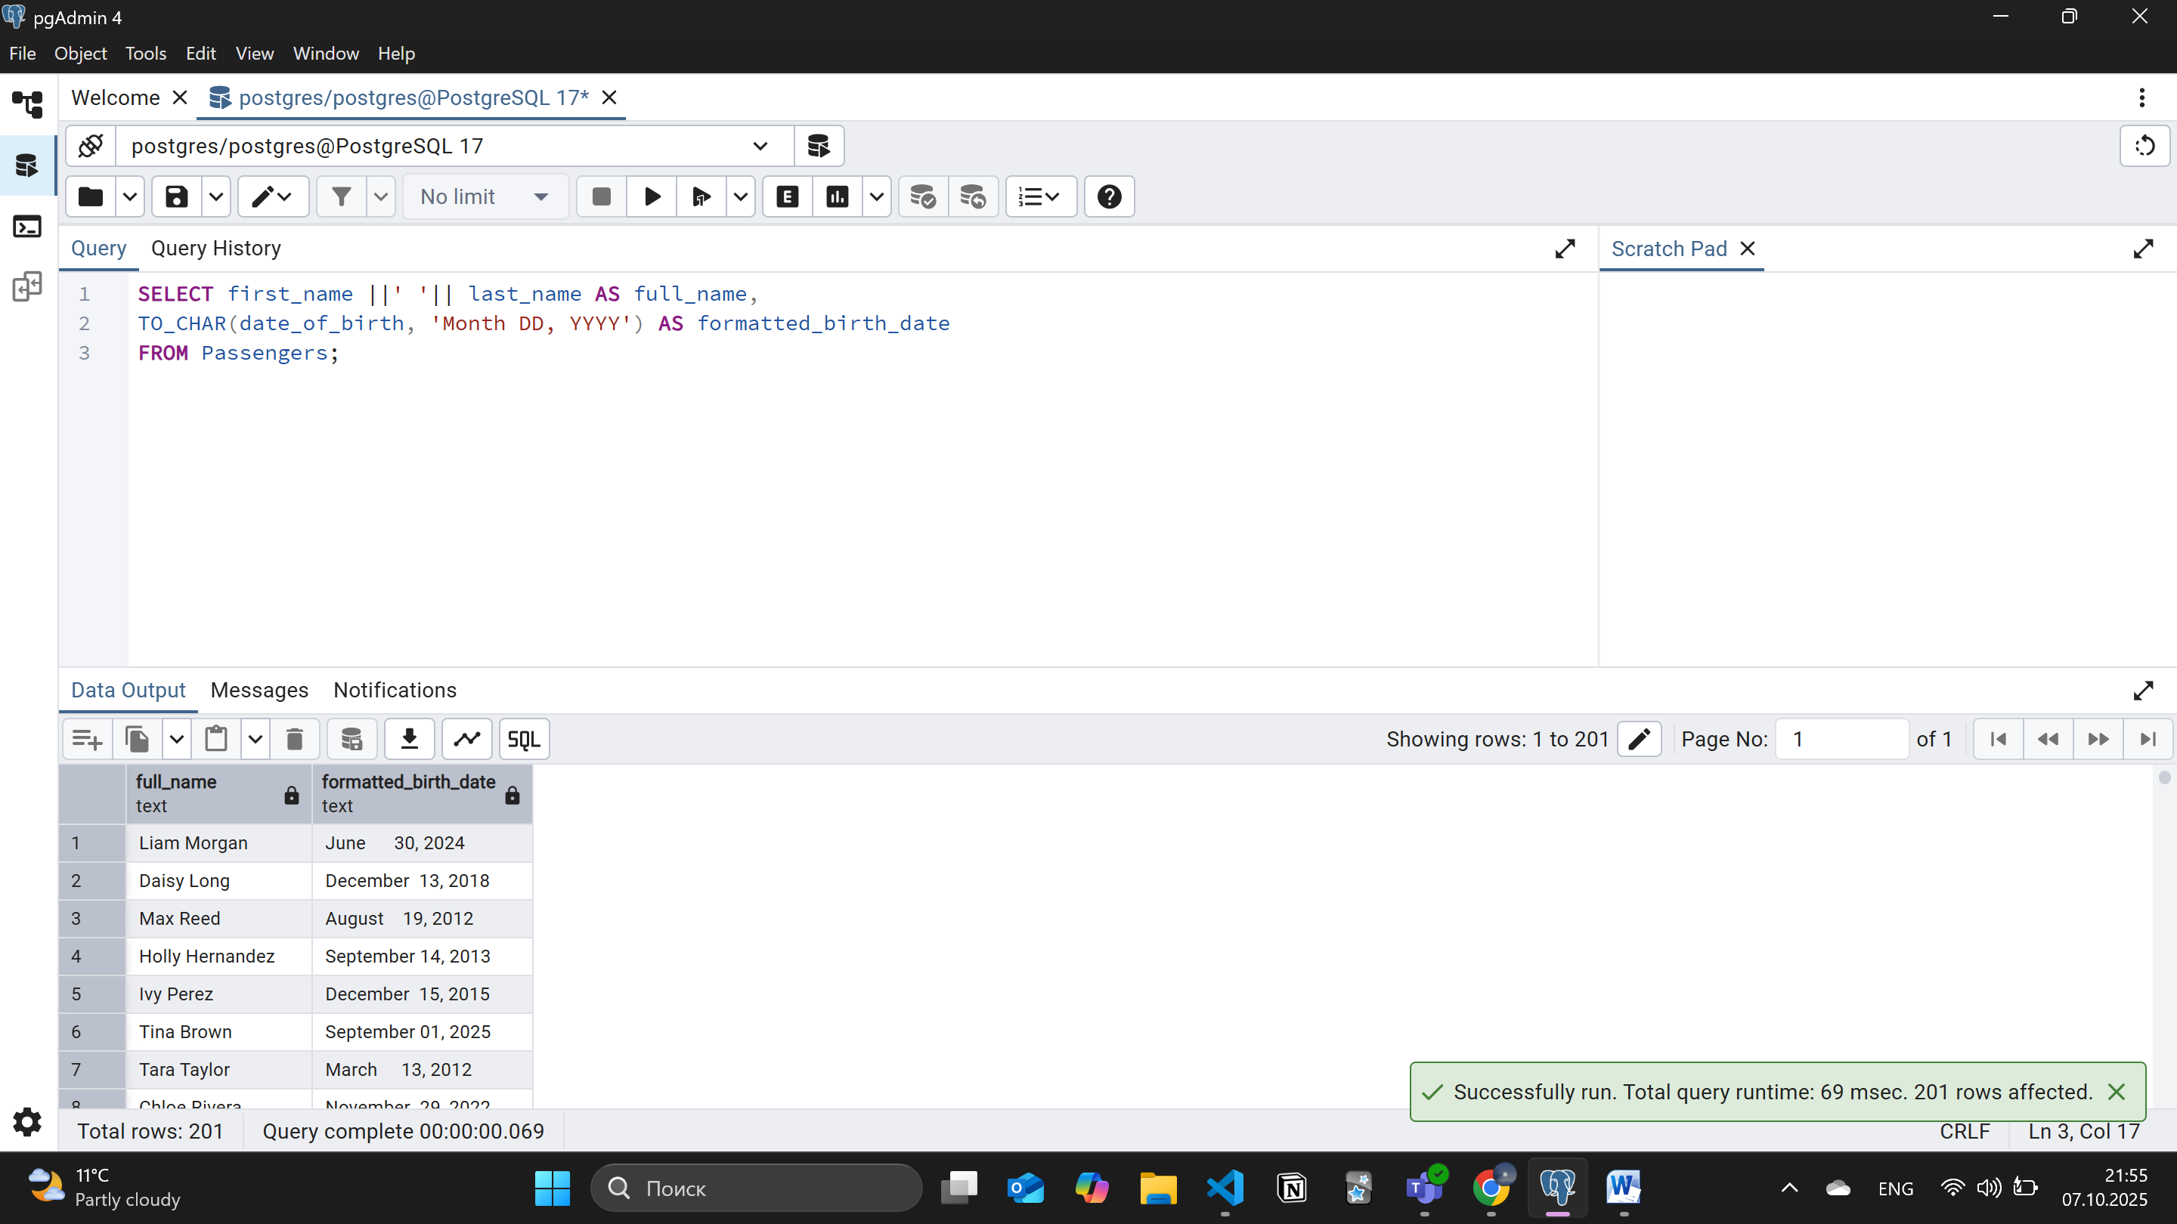
- Find flight numbers that have been delayed based on the actual arrival time.
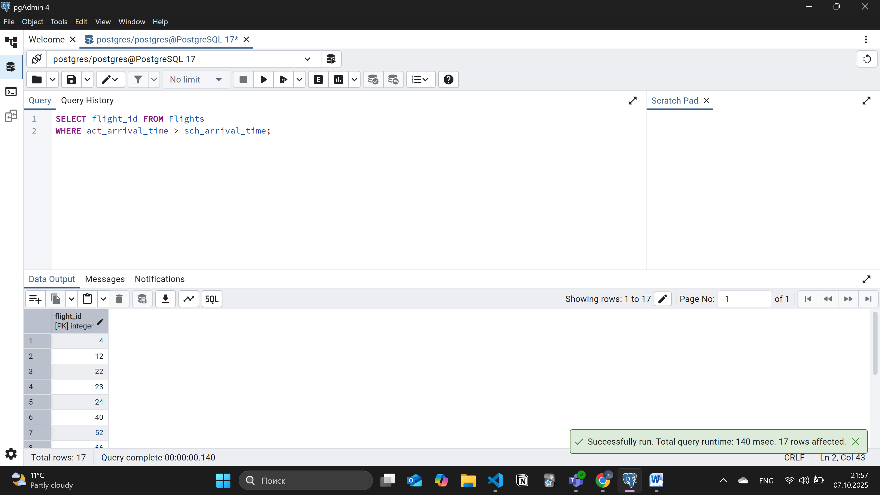
- Create a query that divides passengers into age groups like ‘Young’ and ‘Adult’ based on their birth date. Young passengers age between 18 and 35, Adult passengers age between 36 and 55.
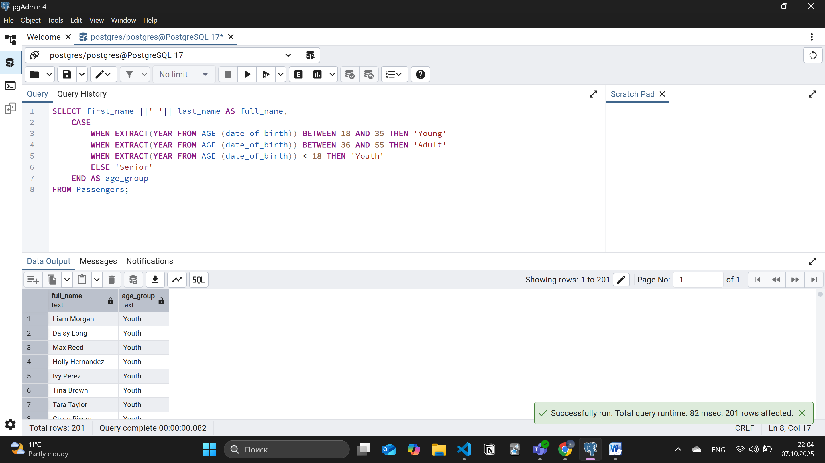
- Create a query that categorizes ticket prices based on their price as "Cheap," "Medium" or "Expensive."
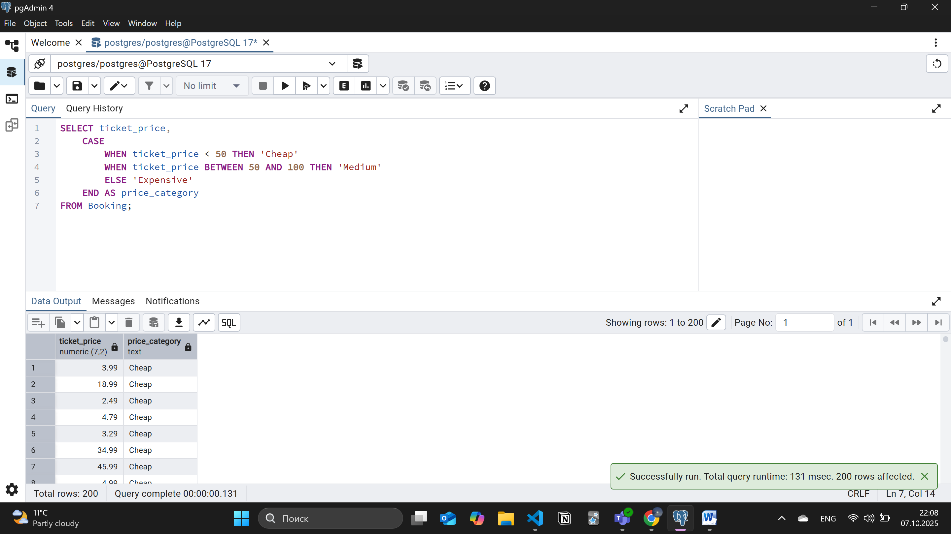
- Find number of airline names in each airline country.
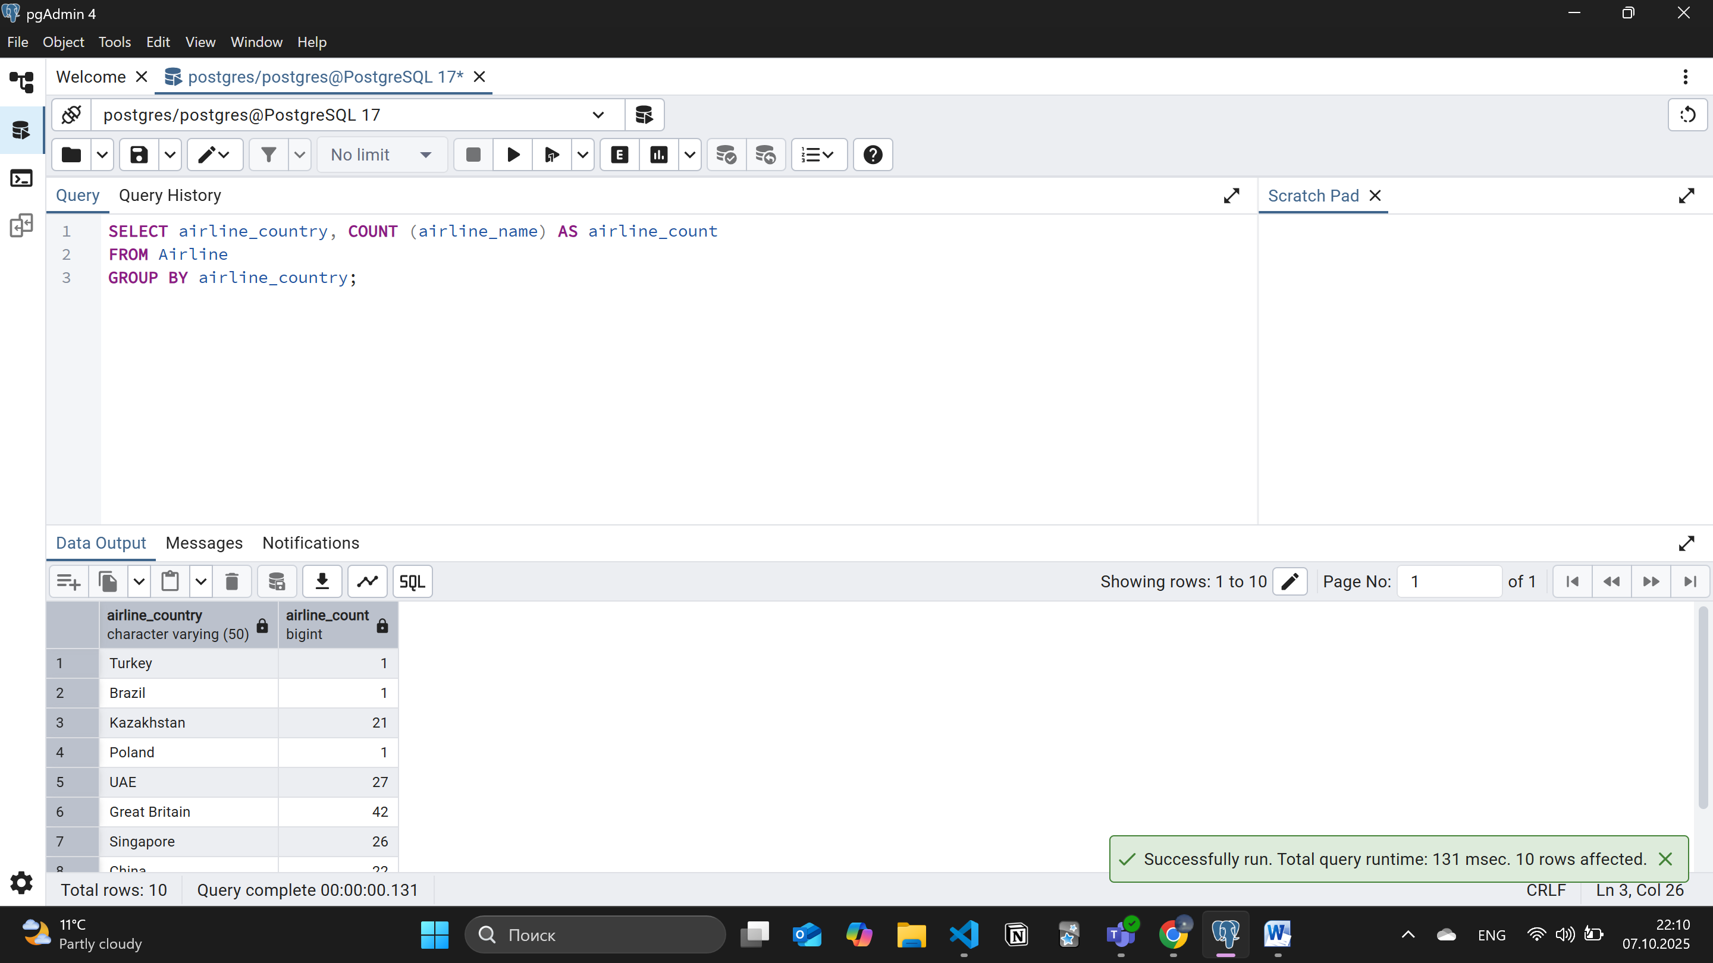
- Find flights that arrived late according to their actual arrival time compared to the scheduled arrival time.
