NAME OF STUDENT
AZAN WAHLA
(FA22-BSE-105)
SECTION
A
SUBMITTED TO:
Mam Yheela Mehroz
SUBMISSION DATE
Tuesday, 19 May 2026
Terminal Lab - Cypress E2E Testing
COURSE TITTLE:
Software Automated Testing
COMSATS UNIVERSITY ISLAMABAD
LAHORE CAMPUS

Table of Contents
1. Task Overview
2. Cypress Project Setup
3. Task 1 - UI Test Suite (Functional Testing)
4. Task 2 - Assertions, Aliases & Custom Commands
5. Test Execution Result
6. Difficulty Faced and Solution
7. Appendix - Real Cypress Screenshots

1. Task Overview
This report documents the completion of Part B of the terminal lab using the Cypress framework for end-to-end testing. The selected public web application was Sauce Demo, which provides login, shopping cart, checkout, and page navigation flows suitable for functional UI testing.
All required test cases from Task 1 and Task 2 were implemented, executed on the local PC, and verified with real Cypress test output and browser screenshots.

2. Cypress Project Setup
Item | Details
Website under test | https://www.saucedemo.com
Framework | Cypress 13.17.0
Browser used by run | Electron 118 (headless)
Node runtime | Node.js v20.11.1 local runtime
Run command | npm test / cypress run
Spec folder | cypress/e2e/task1 and cypress/e2e/task2

3. Task 1 - UI Test Suite (Functional Testing)
Task 1 required login, navigation, and form tests. Every implemented test used cy.visit(), cy.get(), and cy.should() as required.
Required Test | Spec File | Main Action | Assertion Result
Login Test 1 | task1/login-valid.cy.js | Entered valid username and password. | Products page displayed and URL included /inventory.html.
Login Test 2 | task1/login-invalid-password.cy.js | Entered valid username with incorrect password. | Error message was visible.
Login Test 3 | task1/login-empty-validation.cy.js | Submitted empty login fields. | Username required validation appeared.
Navigation Test 1 | task1/navigation.cy.js | Clicked shopping cart link after login. | Cart page title and URL were verified.
Navigation Test 2 | task1/navigation.cy.js | Visited the app, logged in, then moved from inventory to cart. | Products and Your Cart headings were verified in sequence.
Form Test 1 | task1/form.cy.js | Filled checkout first name, last name, and postal code. | Checkout overview and summary information were visible.

4. Task 2 - Assertions, Aliases & Custom Commands
Task 2 extended the suite with assertion practice, a negative assertion, alias usage, a reusable custom command, and beforeEach hooks.
Exercise | Implementation | Evidence
Assertion Practice | Used should('be.visible'), should('have.text', ...), and should('have.attr', ...) on different login page elements. | task2/assertions_aliases.cy.js passed.
Negative Assertion | Verified that the login error element does not exist before submission. | Negative assertion passed.
Alias Practice | Saved the username input with as('usernameInput') and reused it with get('@usernameInput'). | Alias test passed.
Custom Command | Created cy.login() in cypress/support/commands.js and used it in a test. | Custom command test passed and screenshot captured.
beforeEach Hook | Used beforeEach() to call cy.visit() before each Task 2 test. | Hook executed across Task 2 tests.

5. Test Execution Result
The complete Cypress suite was executed locally on the PC using the command below:
npm test
Specs | Tests | Passing | Failing
7 | 12 | 12 | 0
Final Cypress result: All specs passed in 00:16 with 12 passing tests, 0 failing tests, 0 pending tests, and 0 skipped tests.

6. Difficulty Faced and Solution
One difficulty was choosing stable selectors that would not break when the page layout changed. I solved this by using Sauce Demo data-test attributes wherever possible because they are intended for automated testing. Another challenge was keeping Task 1 and Task 2 separate while still avoiding repeated login code. I kept Task 1 explicit because the instructions required core Cypress commands in each test, and used a custom command only in Task 2. Sauce Demo also does not support direct deep-link visits to the cart route, so the navigation test opens the app and reaches the cart through the actual UI flow.

7. Appendix - Real Cypress Screenshots
The following screenshots were captured by Cypress during the real local test execution.

Screenshot 1: Checkout form test reached the overview page
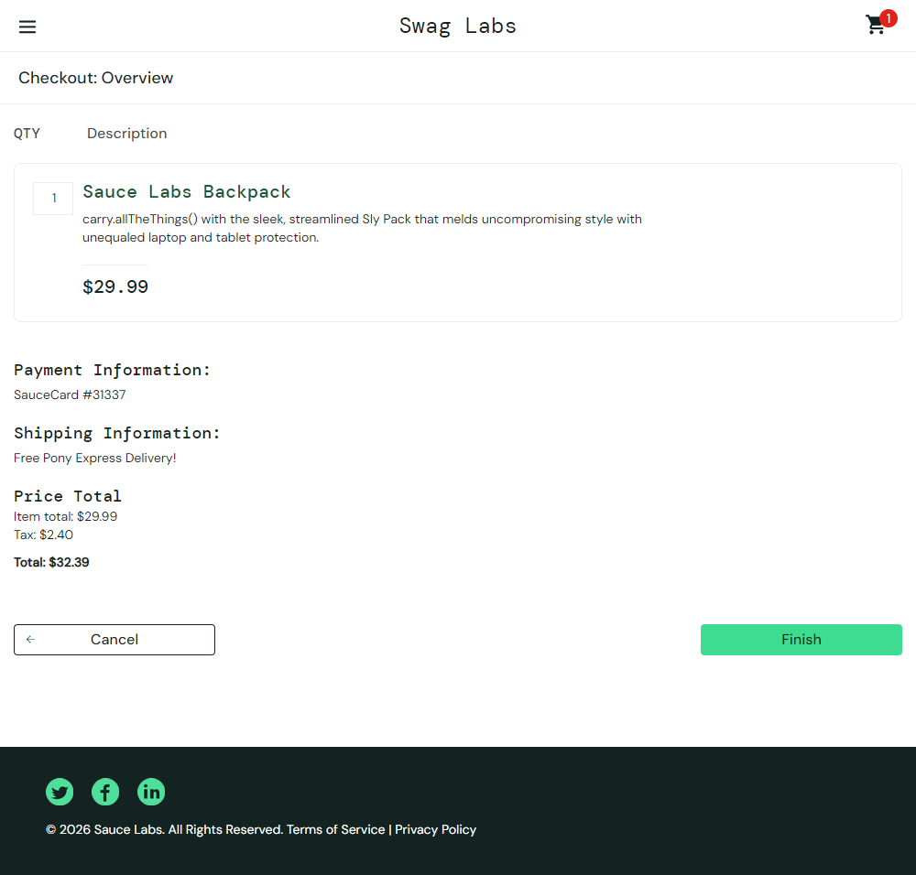

Screenshot 2: Valid login landed on Products page
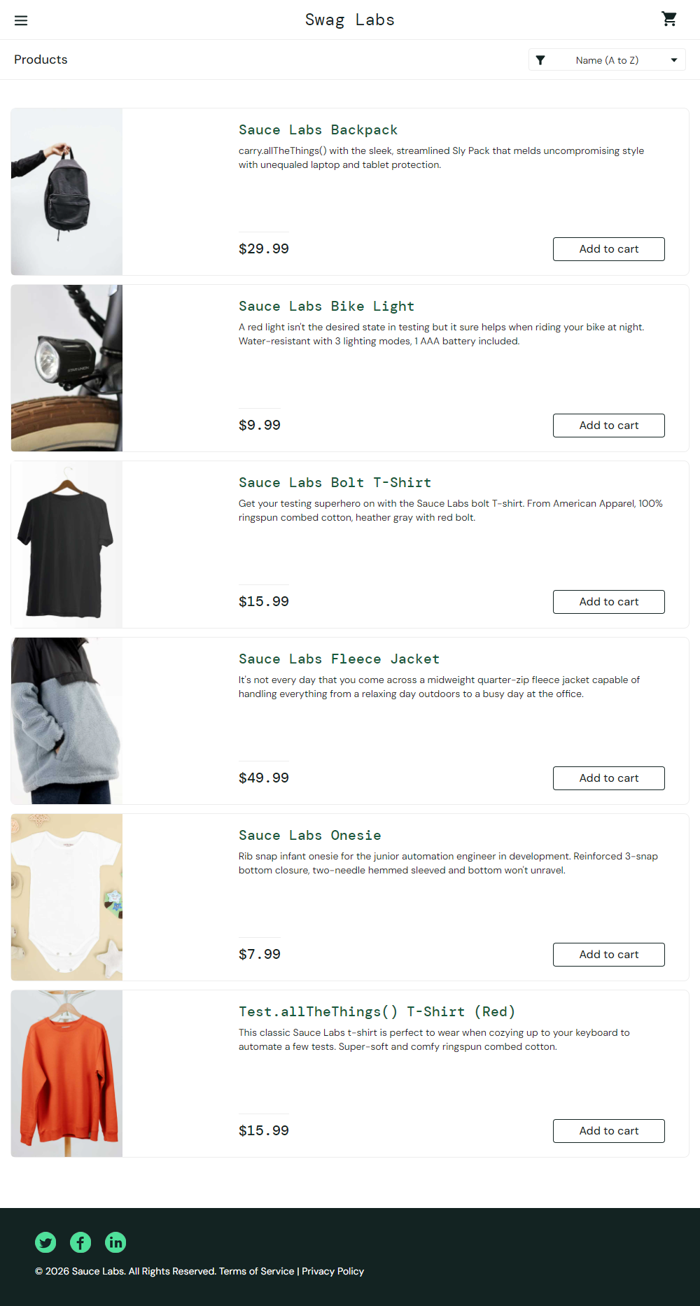

Screenshot 3: Navigation test opened the cart page
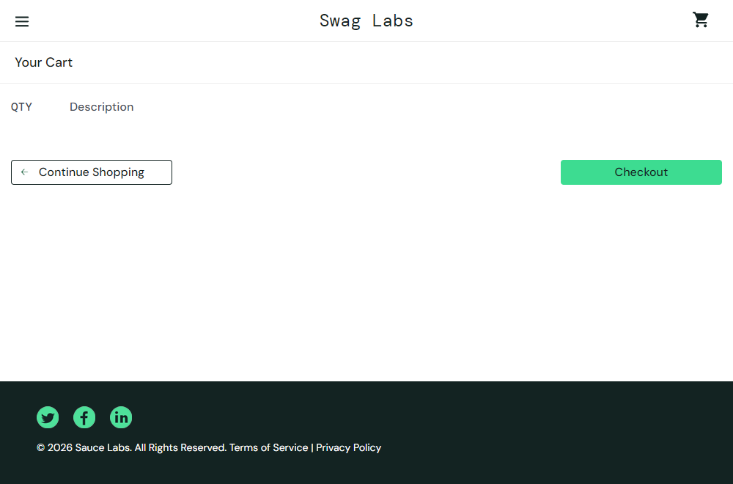

Screenshot 4: Navigation sequence reached the cart page


Screenshot 5: Custom cy.login() command reached Products page


