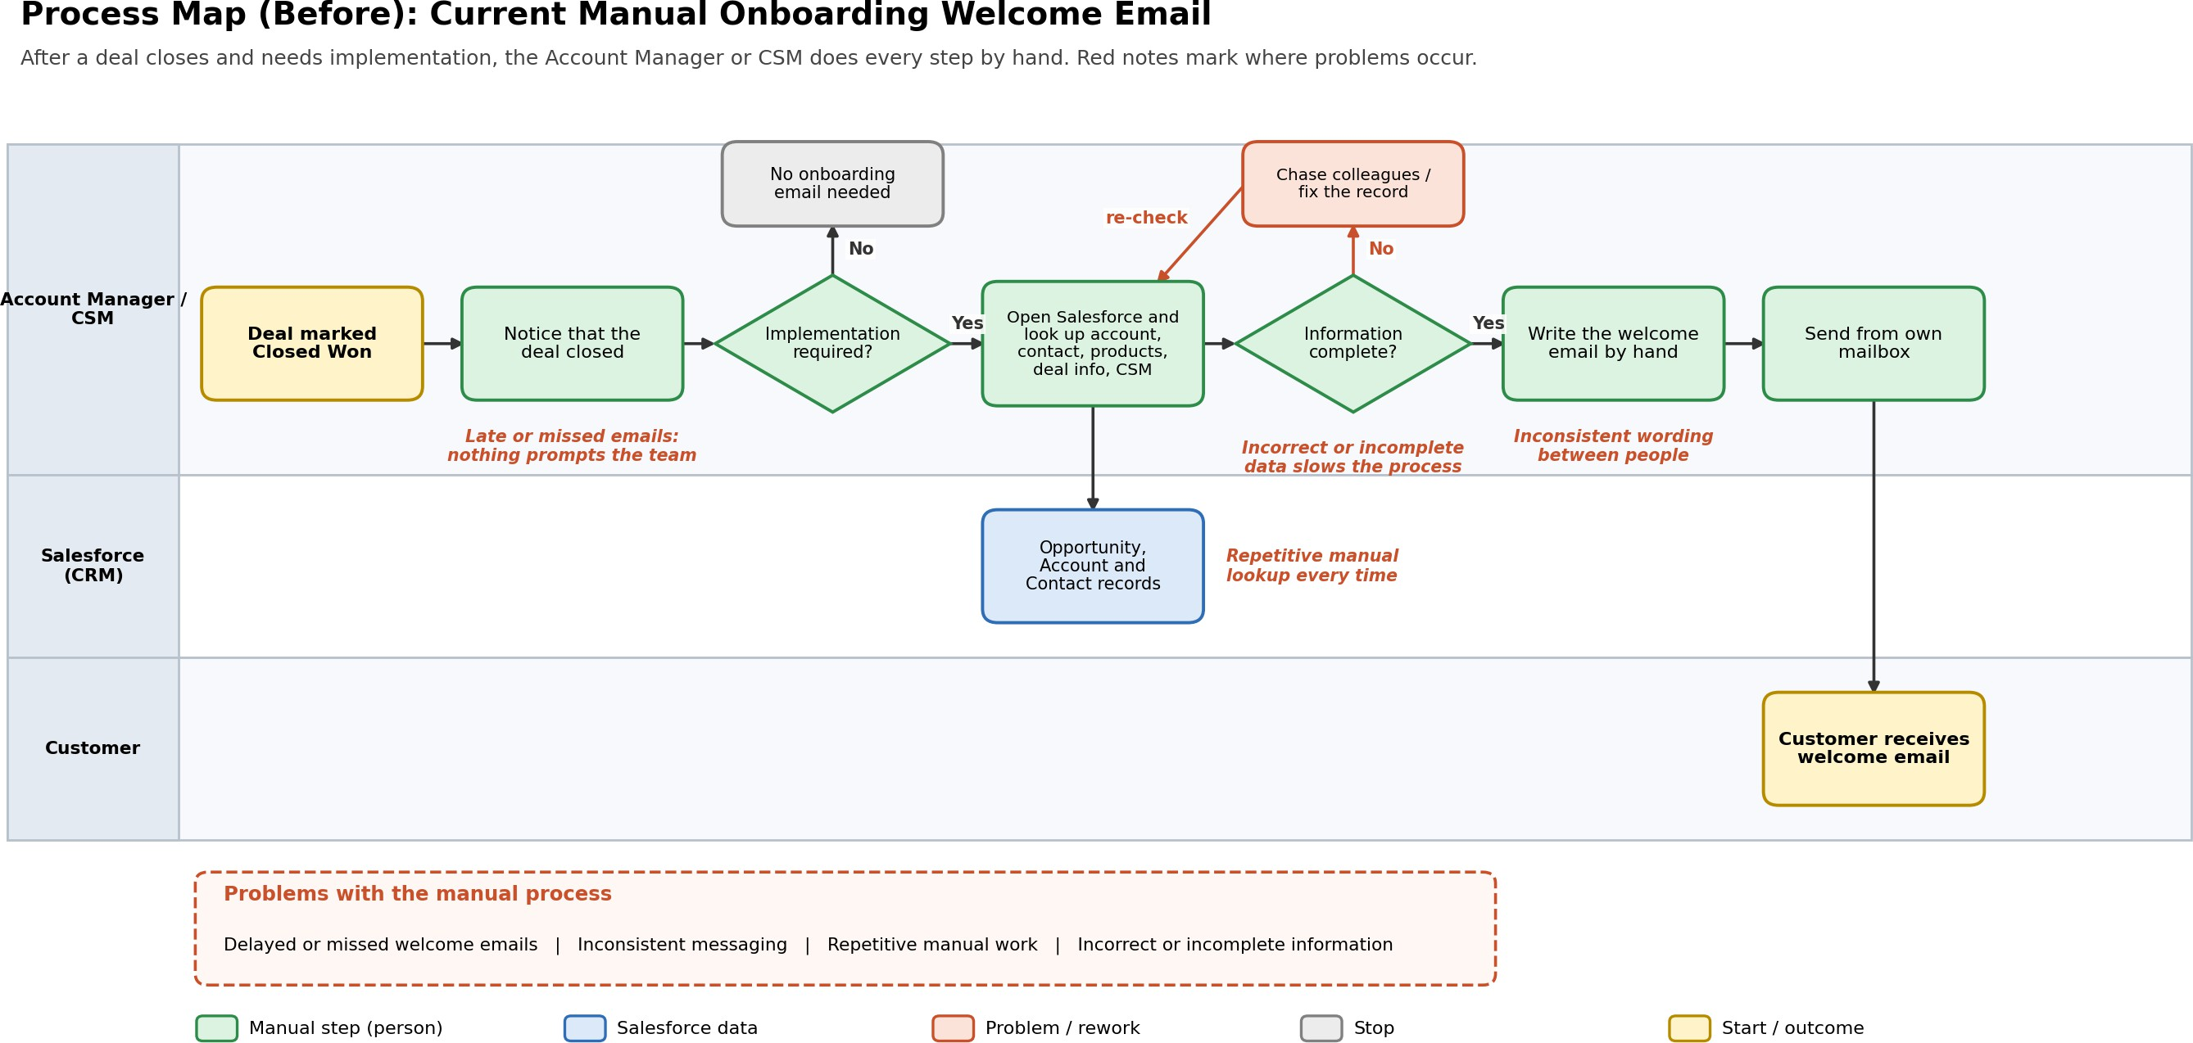

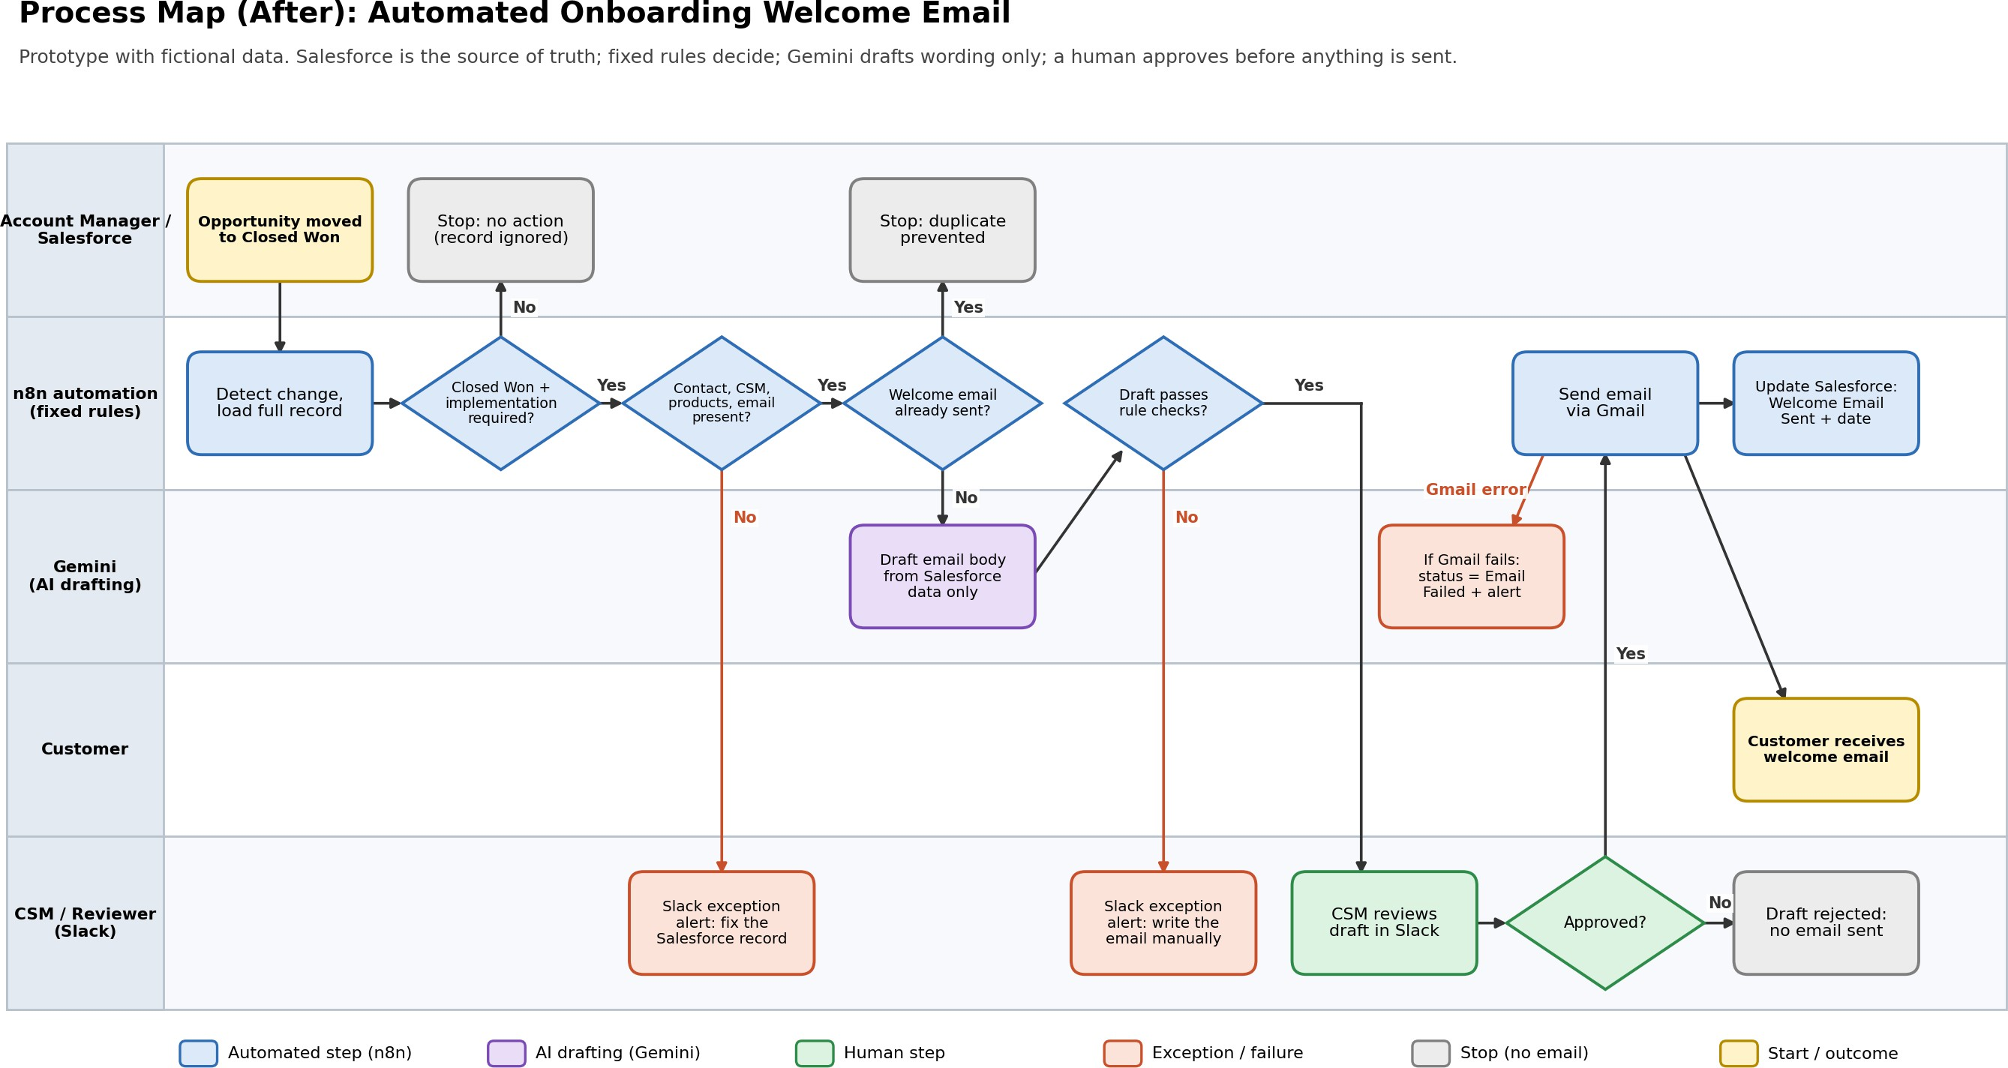

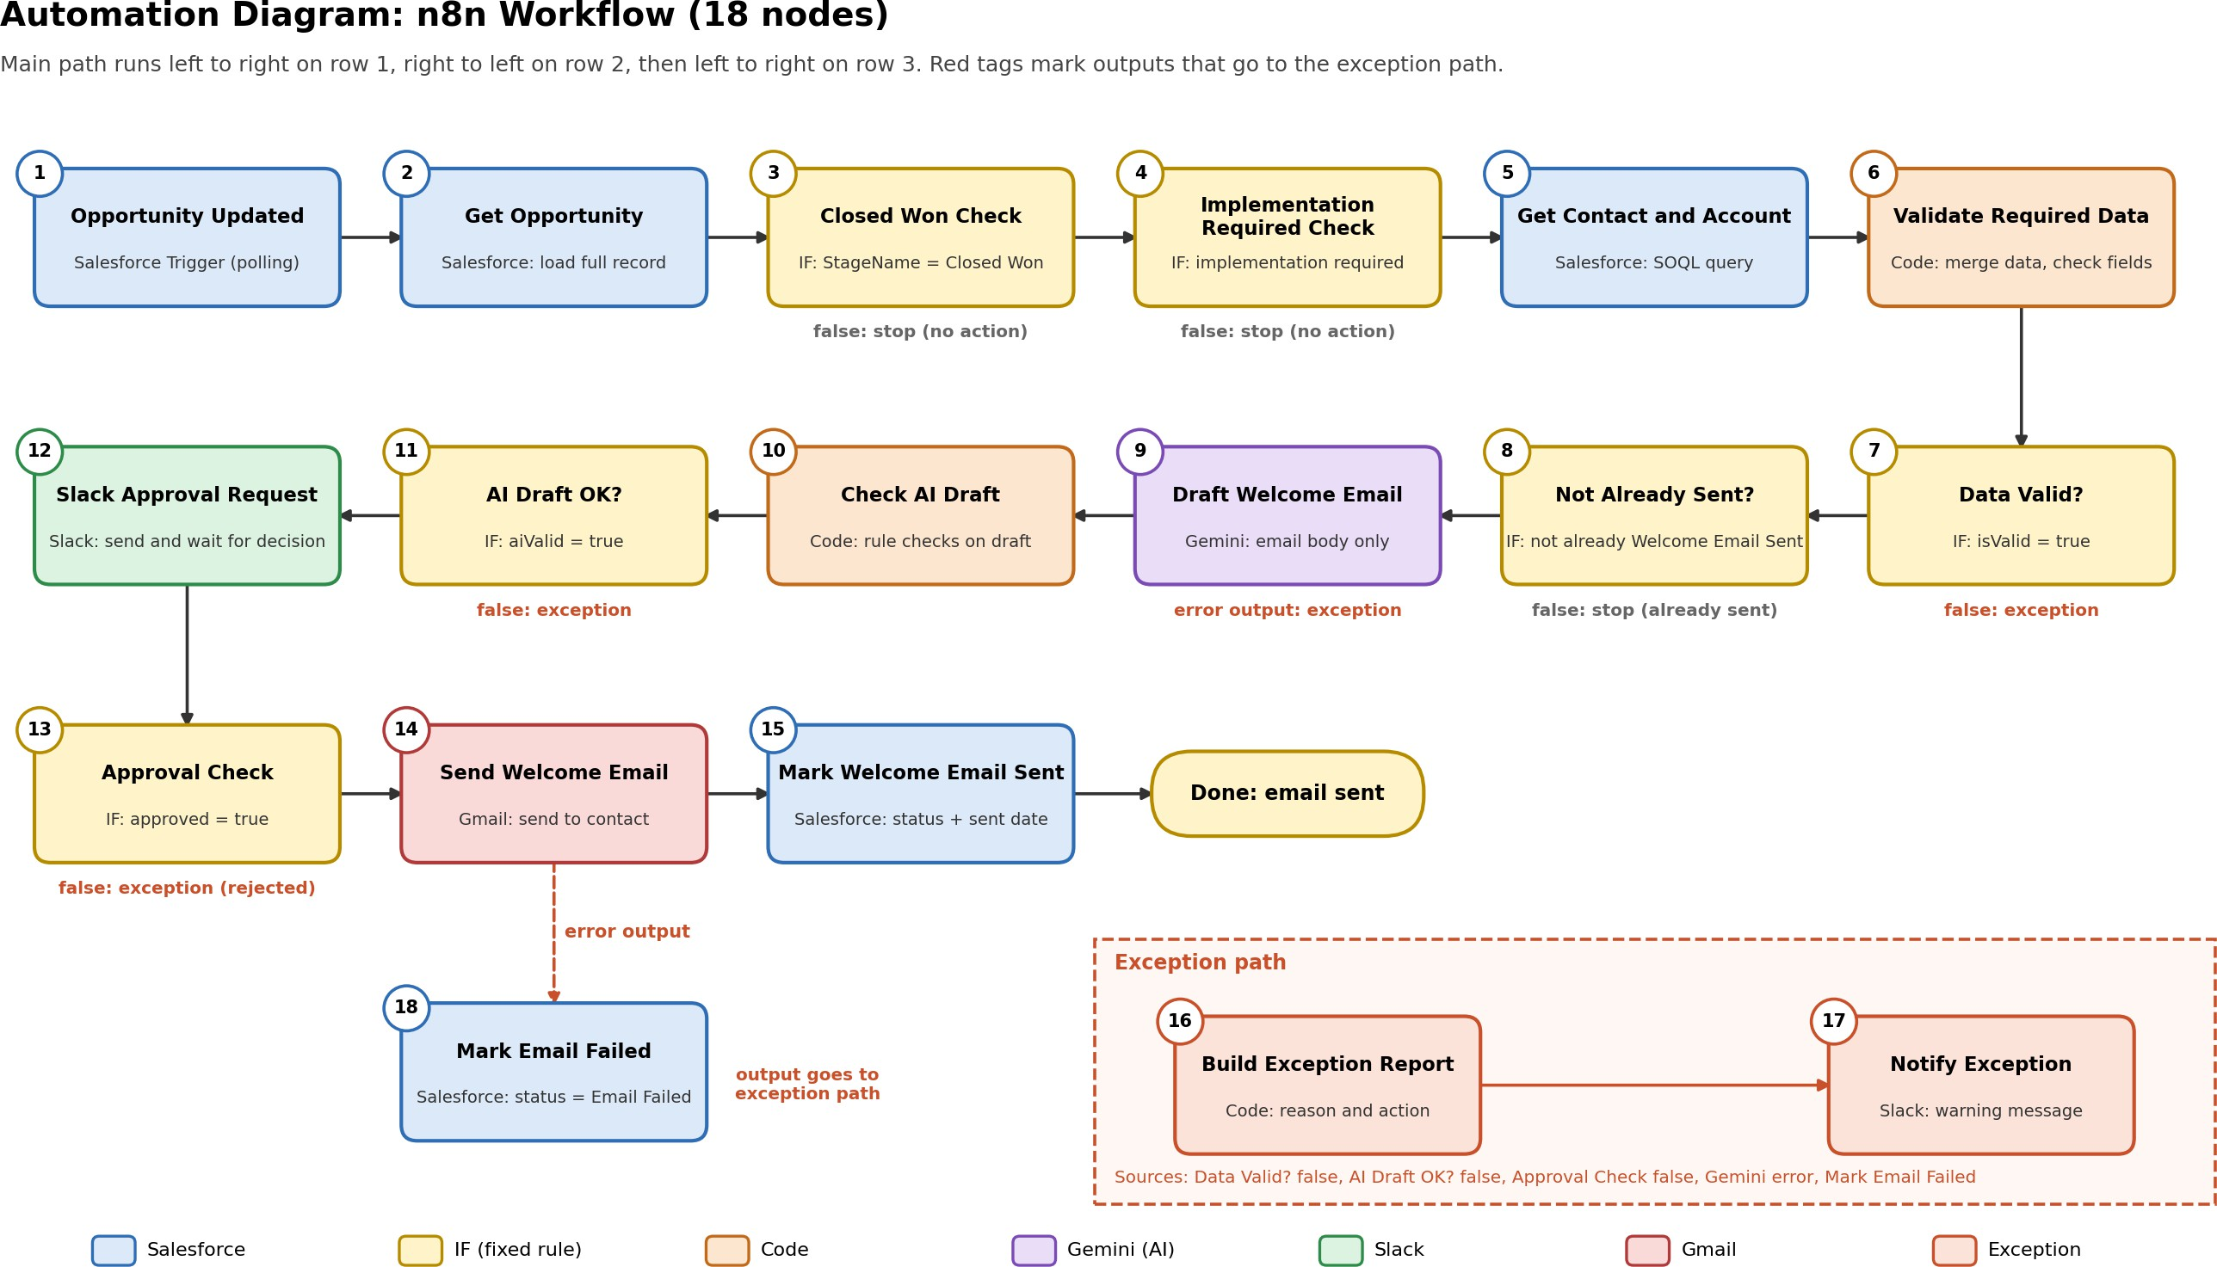

AI Customer Onboarding Welcome Automation: Written Summary
Prepared by John Gabriel L. Panopio. Project built with n8n, Salesforce Developer Edition, Google Gemini, Slack and Gmail, using fictional data.

The problem
When a deal closes and needs implementation, someone on the Account Manager or Customer Success team has to look up the customer, products, main contact and onboarding owner in Salesforce, then write and send a welcome email by hand. This can lead to late or missed emails, inconsistent messaging, repeated manual work, and mistakes from incomplete data.

The solution
An n8n workflow watches Salesforce for Opportunities that become Closed Won and need implementation. It gathers the customer data, validates it, asks Gemini to draft a personalized welcome email, and sends the draft to Slack for human approval. Only after approval does Gmail send the email, and Salesforce is then updated to Welcome Email Sent.

How the work is divided
Who | Responsible for
Salesforce | The trusted source of customer, contact, product, CSM and onboarding status data
n8n fixed rules | Is it Closed Won? Is implementation required? Is required data present? Was the email already sent? Does the draft pass checks?
Gemini | Wording of the email body only, using Salesforce data only
A human (Slack) | Final approval, plus all exceptions: missing data, rejected drafts, failed checks
AI is not used to decide whether an email should be sent, to determine contract terms, or to bypass approval. The subject line is built in code, and the draft is checked to ensure it mentions the contact, the CSM and every product, and contains no amounts, percentages or links.

Reliability and safety
- Duplicate prevention: the workflow stops if the Opportunity's Onboarding Status is already Welcome Email Sent.
- Missing information: a missing CSM, contact, email or product produces a Slack exception message and no customer email.
- Failures: a Gmail failure sets Email Failed in Salesforce and alerts Slack. A failed send is never marked as sent.
- Security: credentials are kept in n8n's credential store, Salesforce access uses OAuth2 with minimal scopes, and nothing is sent without approval.
- Multi-product deals: The workflow passes the complete Products value to the AI, and the draft validation checks that every listed product is mentioned before approval.

Testing
I tested four scenarios end to end: a normal onboarding (email sent and status updated), implementation not required (stopped), missing CSM (exception, no email), and duplicate processing (stopped). The rejected-draft and Gmail-failure paths are built into the workflow as well. I also hit and fixed two real issues: the Salesforce trigger returned only a partial record, which required an extra lookup step, and a Code node in the wrong mode silently dropped records when several arrived together.

Limitations and next steps
This is a prototype. The trigger polls about once a minute, two runs for the same Opportunity could both wait for approval at once, and some failures (Slack, Salesforce lookup and update) are not routed to the exception path. For a real deployment I would use a Salesforce event or Flow instead of polling, add a shared error workflow, write a Pending Review status, and link the CSM as a Salesforce user.

