- On login, it takes user to home page instead to the action that user was doing when tried login. I was marking a deal favorite without login and it took me to login page and afterwards to the home page not to the deal which I was marking favorite.
Comment : Working Properly on demo-v3.(Except Login with Facebook case.)

- Also, on the Quick view, there is no option to buy the deal, it says view details. I guess Buy Now option should be there.
Comment : In case of Hotel deals, we are not displaying the Buy Now button. User have to select Location and Date to purchase booking deals.

In case of normal deals and products, we are displaying Buy Now button in quick view.

- After login, when clicked on Quick View, pop up opens and screen freezes. PF secreen shot

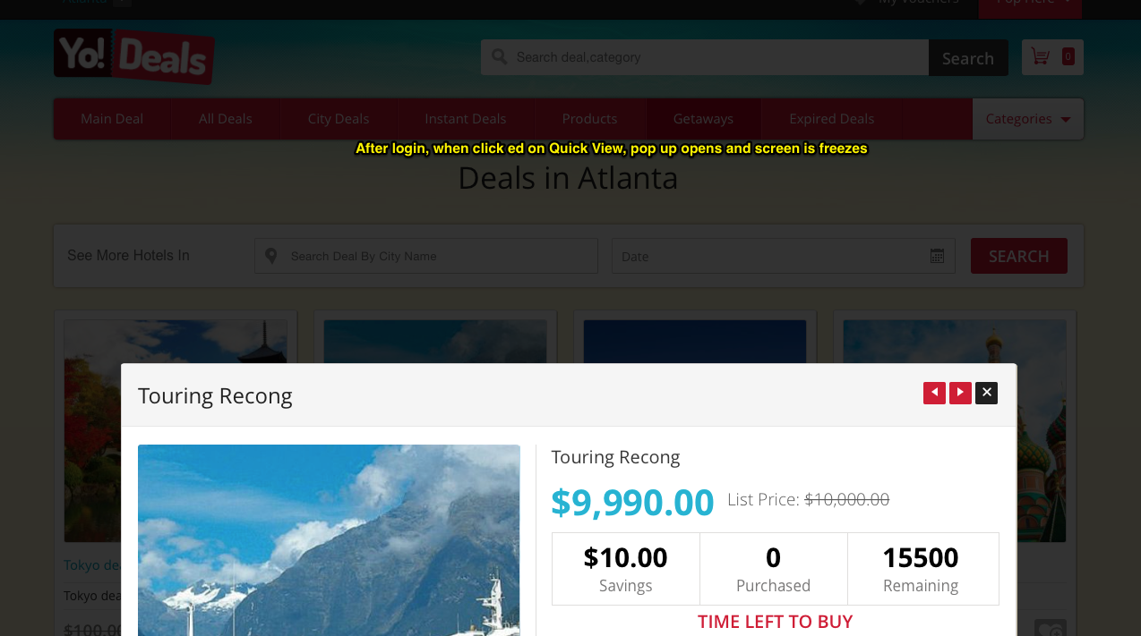

Comment: As per current system, in quick view users are not able to scroll down the page.

- Hidden buy button

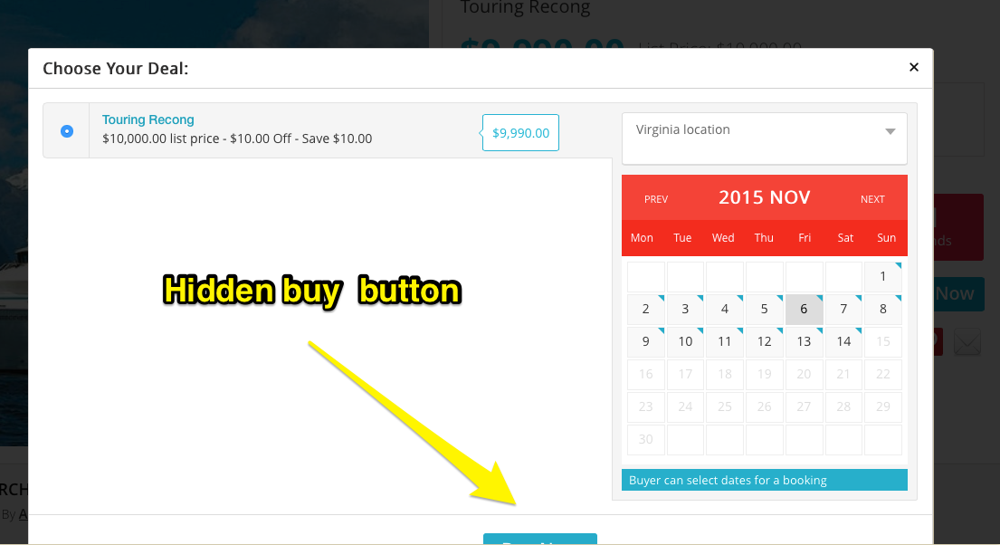

Comment: Solved on Local Server

- There is no way for user to understand that he has to select location and dates. I guess we can mention it somewhere if possible.

Comment: Can be considered

- Also, once user selects the check in date, All date prior to that date should be either crossed or disabled. For Example in above case dates available are from November 1 to November 14. I selected November 6 as check in date. Now all dates prior to November 6 should be disabled so that accidently user does not selects wrong check out date.
Comment : As per our current system, on first we are considering selected date as check in date and on second click we are considering selected as checkout date.

According to above request, if we will disable the prior date then user will not able to select prior date for check in if he/she changes his/her mind to selected different check-in date. Please advise if it is Ok or we can discuss about it.

- Do we have separate thank you text for thank you page – Deals, Products?
Comment : Solved On development Server.

- Products order and deals order should be separated. Please advise
Comment : I have discussed with Lakhvir Sir. We will make tabs for deal Order and Product Order.

- Side Deals should be commented while adding deal as it is no longer available in our system
Comment : Solved

- For Digital Products, address selection should not be mandatory. Please advise
Comment :We can consider this point in further update. Because it needs a good amount of time to implement the same.

- Unable to add digital products to the system. Its giving error select your address

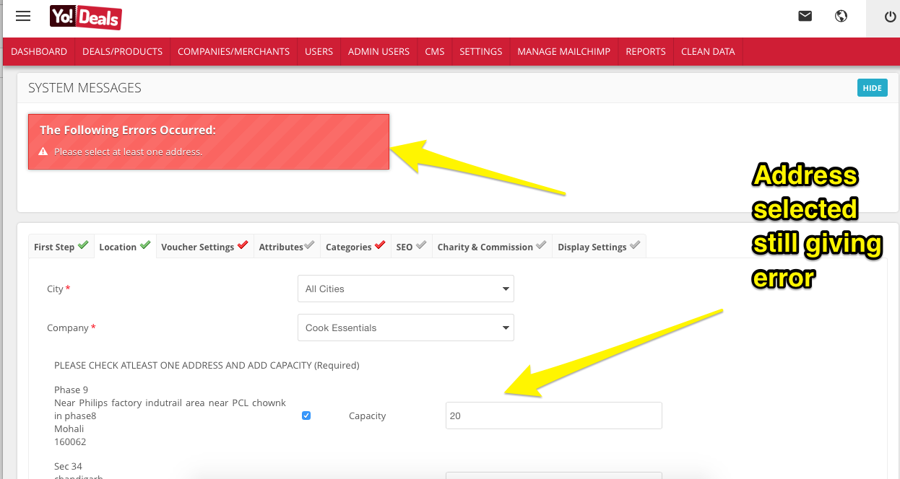

Comment : This error occurs when Admin has submitted the form without selecting any address. After select the address information admin has to again submit the form.

12. View Delivery Address show shipping status

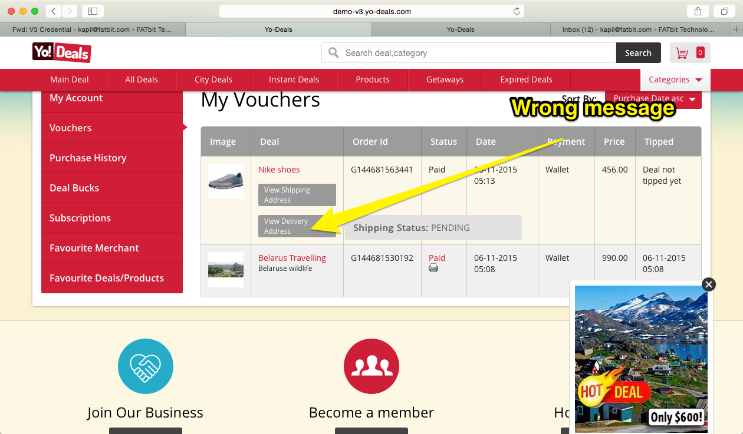

Comment : I have changed View Delivery Address to View Delivery Details.

13. Login Screen CSS isues



Comment : Solved

