King Abdulaziz University

Faculty of Computing and Information Technology

Computer Science Department

**CPCS405, 1st Term 2019**

**Program 2**: **CBMTCLD *(*GUI, JDBC, Threading, File IO and Localization***)*

**Due:**

## What is a learning disability?

Learning involves four stages of information processing:

* **Input**: the brain takes in and records information relayed by the senses
* **Integration:** the brain interprets the information
* **Memory:** the brain stores the information in a way that it can be retrieved later
* **Output:** the learner reproduces the information through language or motor activity.

People with learning disabilities have trouble with one or more of these steps; they have difficulty taking in, organizing, and/or acting on information their brains receive through the senses. That information can be nonverbal, but more commonly, the difficulty has to do with understanding or using written or spoken language. The problems are based on brain structure and function: a case of poor wiring in one or more areas of the brain.

Learning disabilities are not the same as low intelligence; when given IQ tests, people with learning disabilities generally show average or above-average intelligence. But there’s typically a big gap between how smart they are and what they’re able to achieve, because the brain sets up roadblocks that keep them from processing and reproducing information. Consequently, a hallmark of learning disabilities is that people who have them consistently learn and work below their intellectual capabilities.

Learning disabilities fall within the class of neurological issues called **developmental disabilities,** in that they are chronic, they limit success in one or more major life areas and they cannot be reversed by medication. This classification includes mental retardation, but most developmental disabilities, such as cerebral palsy and autism, don’t by definition encompass low intellectual function. One of the most painful aspects of having a learning disability is to have your brain’s inability to process information in certain ways mistaken for low intelligence.

## What are the types of learning disabilities?

The most common and best-known learning disorder is **dyslexia**, which causes problems with reading. However, learning disabilities can affect many areas involving language, calculation, reasoning, and motor skills. Keep in mind that a development lag isn’t an identifiable learning disability until the delay can be measured in **years**, not months.

|  |  |
| --- | --- |
| **Academic skills disorders:** | |
| **Developmental reading disorder       (dyslexia)** | Problems with reading, making sense out of written language. |
| **Developmental writing disorder    (dysgraphia)** | Problems with handwriting or with writing in a way that makes sense to others or yourself; you literally can’t read your own handwriting |
| **Developmental arithmetic disorder (dyscalculia)** | Problems with calculations or abstract mathematical concepts |
| **Speech and language disorders:** | |
| **Developmental articulation disorder** | Problems producing speech sounds, pronouncing certain letters or letter combinations |
| **Developmental expressive language disorder** | Problems using spoken language to communicate, expressing yourself verbally |
| **Developmental receptive language disorder (auditory processing disorder)** | Problems understanding what other people say; you hear the words but don’t process them as thoughts |
| **Other learning disabilities:** | |
| **Visual processing disorder** | Problems making sense of information taken in through the eyes; affects ability to recognize spatial relationships, identify distinctive shapes and objects, or differentiate part of an image from the whole. |
| **Developmental motor skill disorder (dyspraxia)** | Problems with fine motor skills, clumsiness with tools and your own fingers and hands |
| **Nonverbal learning disorder** | Problems understanding nonverbal communication; this person is highly adept with language but can have trouble with organizational, social, and motor skills |

**1.3 UNDESRANTDING THE PROBLEM:**

**Case 1:** Hameeda at age 14, Hameeda still tends to be quiet. Ever since she was a child, she was so withdrawn that people sometimes forgot she was there. She seemed to drift into a world of her own. When she did talk, she often called objects wrong names. She had few friends and mostly played with dolls or her little sister. In school, Hameeda hated reading and math because none of the letters, numbers or “+” and “-“signs made her any sense. She felt awful about herself. She’d been told and was convinced that she was retarded.

**Case 2:** Ather Ali has lived 46 years, and still has trouble understanding what people say. Even as a boy, many words sounded alike. His father patiently said things over and over often spanked him for not listening.

* 1. **OBJECTIVES**

Objectives of the Computer Based kit for Learning Disability:

1. To develop a computer based intervention multimedia kit for children with learning disability.
2. Pilot testing and evolution of kit in the laboratory setting.
3. To replicate the multimedia intervention kit for use in government sectors.

Computer based learning kits can alter speech sounds into phonemes. This would reinforce audio-visual learning and help develop critical language skills that are necessary for becoming a better reader.

**Following are the output of the Computer based multimedia toolkit for children with Learning Disability with is under development.**

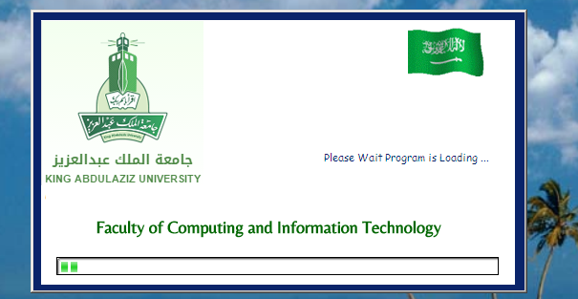

**Fig. 1**

**Fig. 1:**

This is the first screen which welcomes user to the system and loads the entire necessary file in the background to run the software.

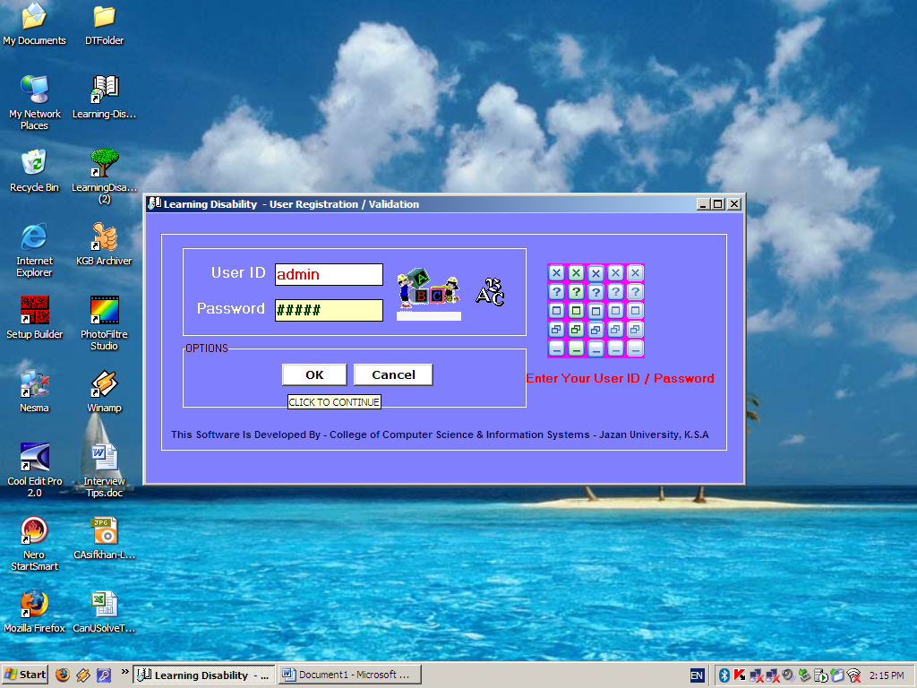

Fig. 2

**Fig. 2 Login form-** To access the system one must has login and password.

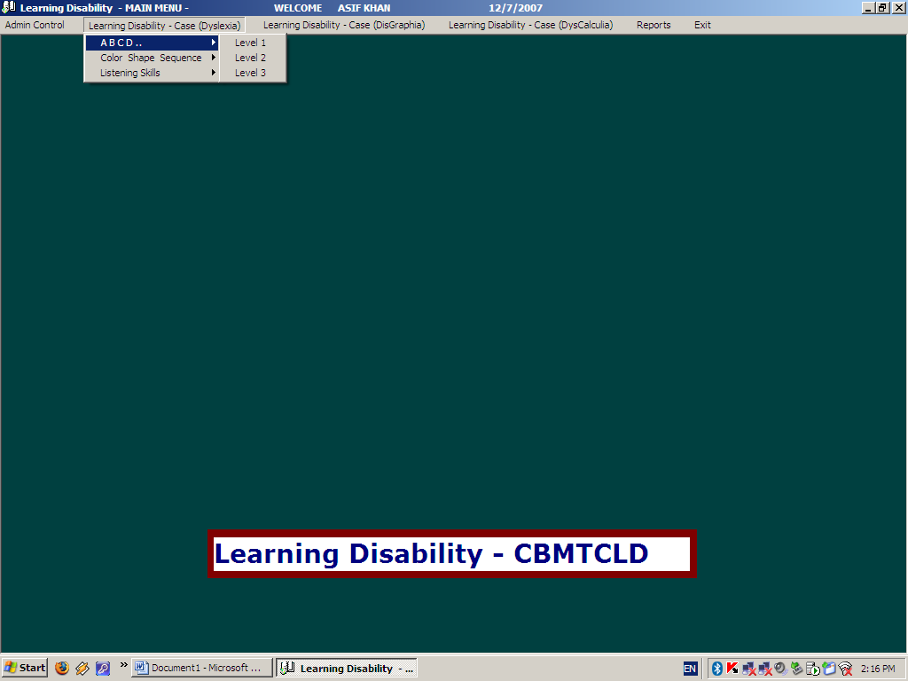

Fig. 3

Fig. 3: This is the main menu of the CBMTCLD. System covers Dyslexia, Dysgraphia, and Dyscalculia. It is a complete multimedia tool kit each exercise (game) has audio and graphics to attract the attention of child. Each exercise has three levels

Level 1 is Normal Level here voice play in the background of each exercise as per normal recording.

Level 2 is Medium Level here we slow down the pitch of normal voice.

Level 3 is Slow Level here we further slow down the pitch of normal voice.

Reason for the three levels is that a child who has learning disability will has problem in listing the normal voice. So if we can reduce the pitch of the voice it will helpful for child to understand and listen the voice.

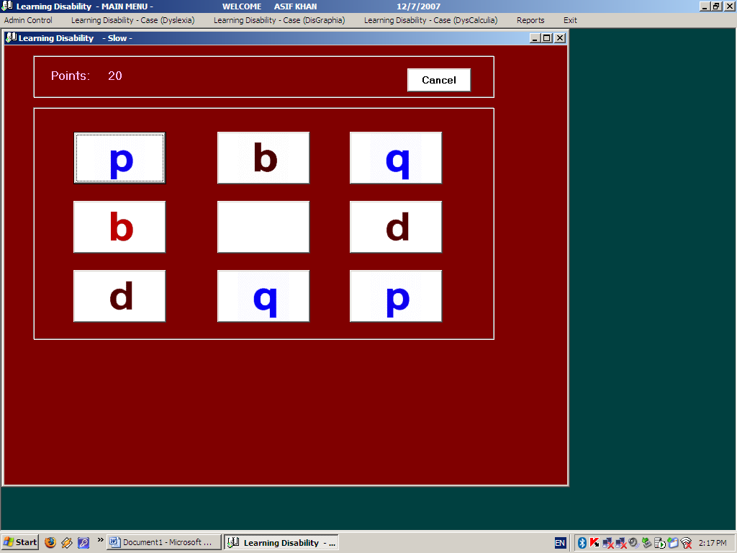

Fig. 4

Fig. 4, 5, 6 the aim of these exercises is to identify matching figure based on voice and picture to get the point.

When a child click button which has character **p** system generate sound for **p**, in the same way when he click button which has character **b** a sound for **b** also played in the background so a child knows character the aim is to match the similar button.

For example when a child clicks right combination **p & p** related buttons will disappeared and he will scored 5 marks.

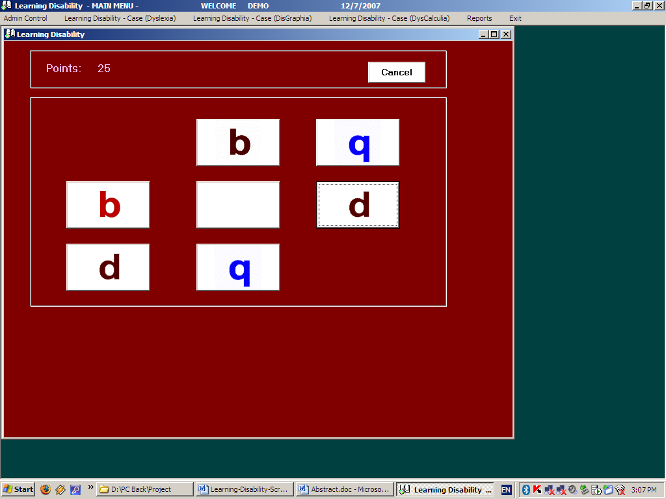

Fig. 5

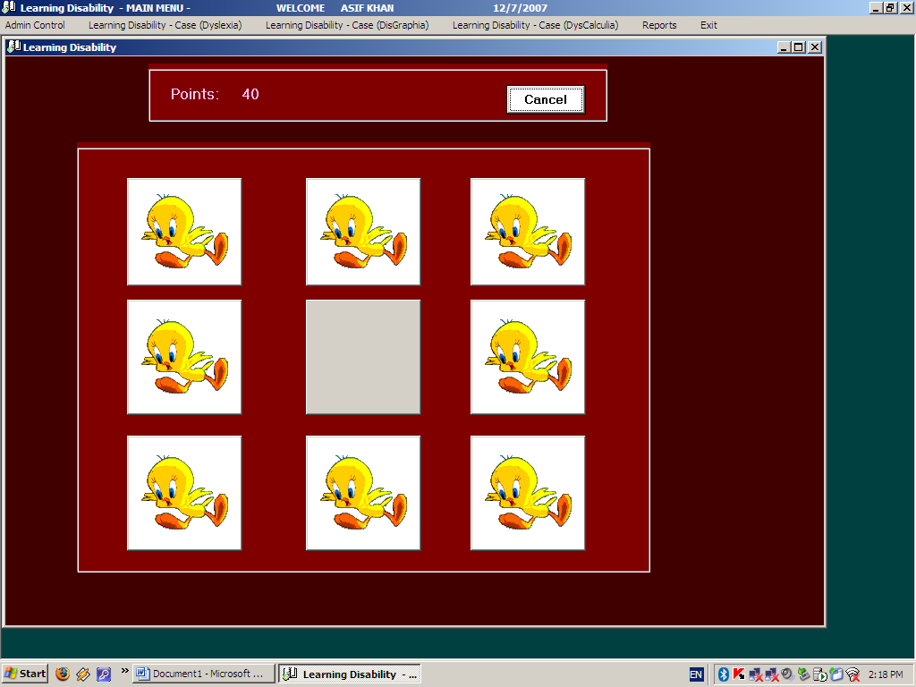

Fig. 6

This screen is the continuation of the above program here child has to remember matching button based on the audio sound played in background when he is clicking buttons to get the points.

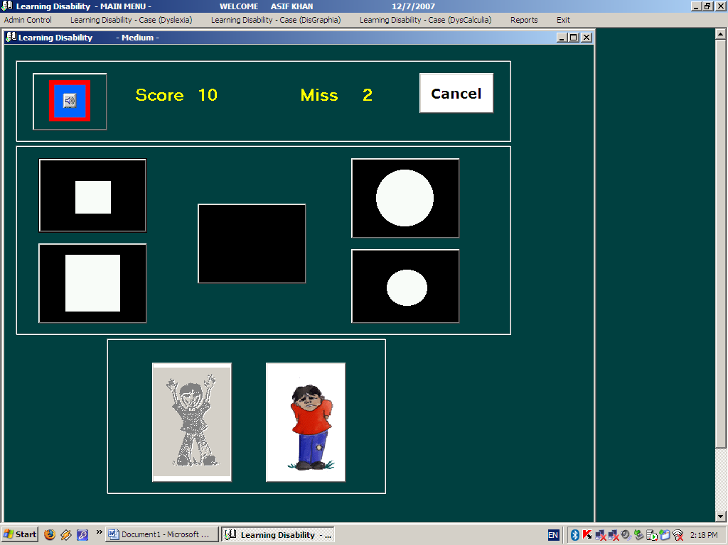

Fig. 7

Fig. 7: Aim of these exercises is to recognize different shapes and figures.

When a child click play button system will ask to pick one of the listed figures, child has to listen voice and based on voice he has to pick the matching figure to score 5 marks.

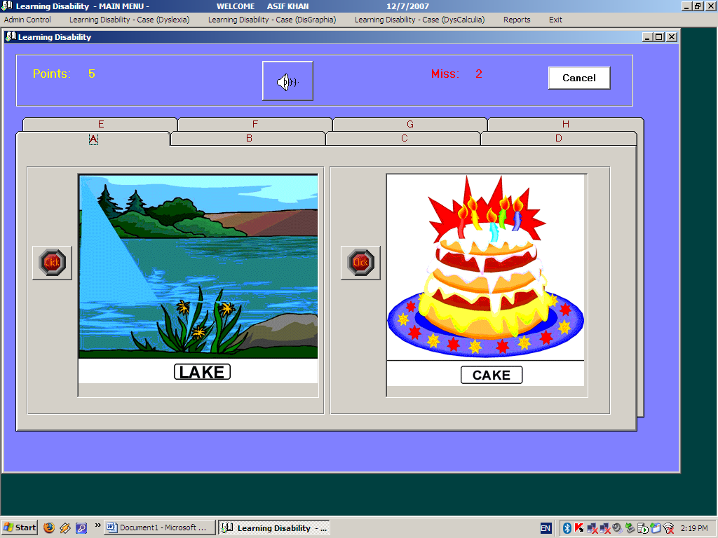

Phonemes Discrimination: In this exercise a child has to choose the correct word. Word like “LAKE” and “CAKE” or “ACT” “ANT” or “COCK” “COOK” has similar pronunciation.

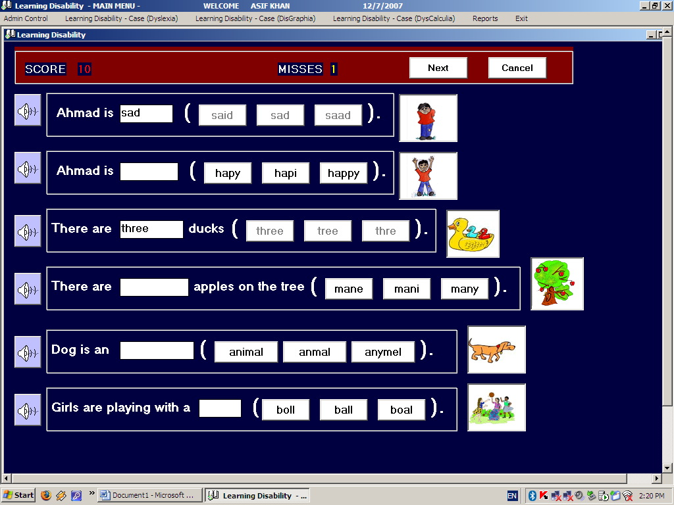

In the above exercise child has to choose the correct word to complete sentence.

Play button will play the complete sentence in background, child as to listen the sentence and choose the correct word from the given three words.

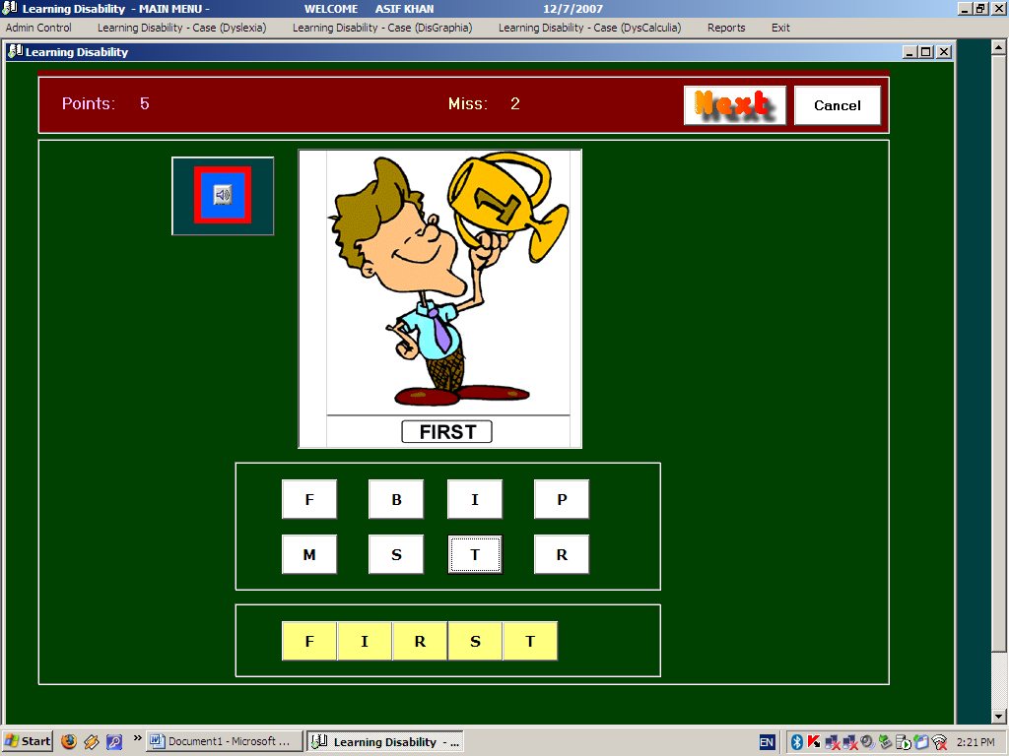

In the above exercise child has to make word with given sets of characters as the play button.

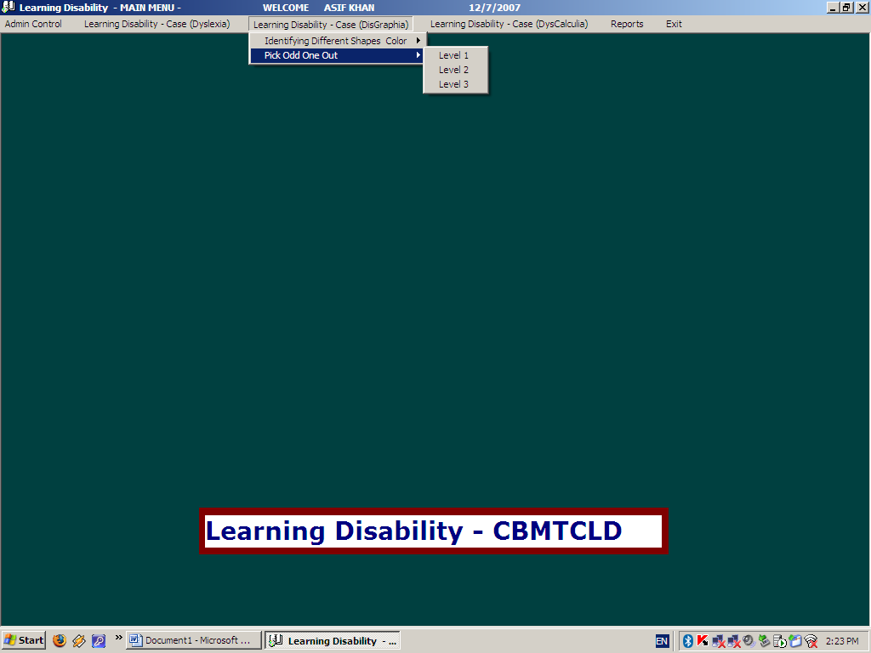

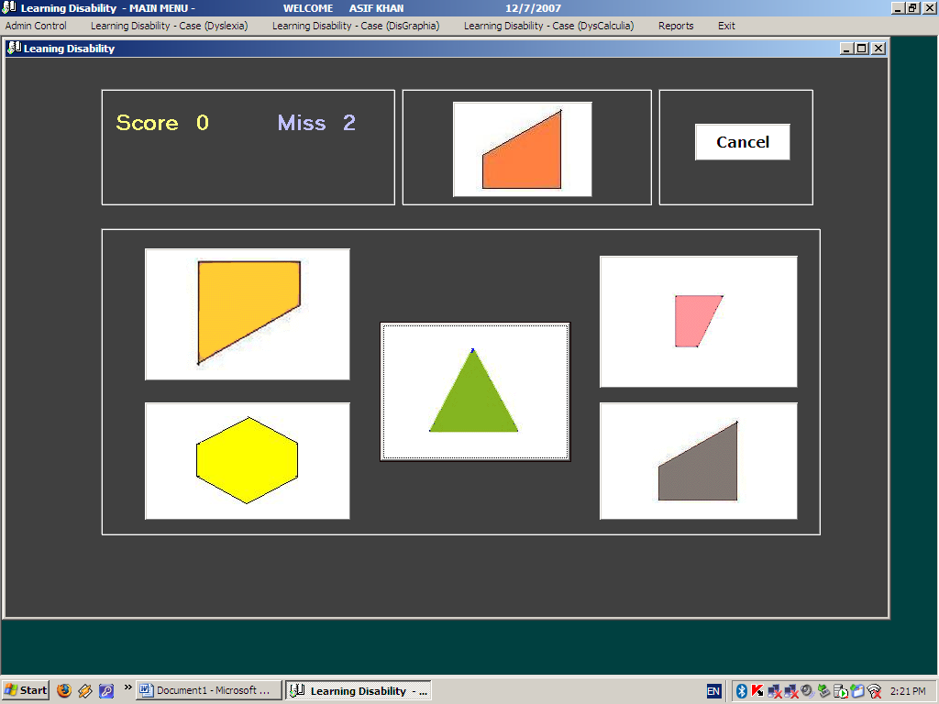

**Basic and Advanced figure /graph** The game starts with the display of various graphs or figures that will be used or seen in the game. The figures or graphs will keep changing automatically. To start playing the game the user has to click on CONTINUE button and the game starts. The top of the page displays a given figure or graph and the user has to click on the corresponding figure or graph in the boxes given below to score points. And continue the game till it finishes.

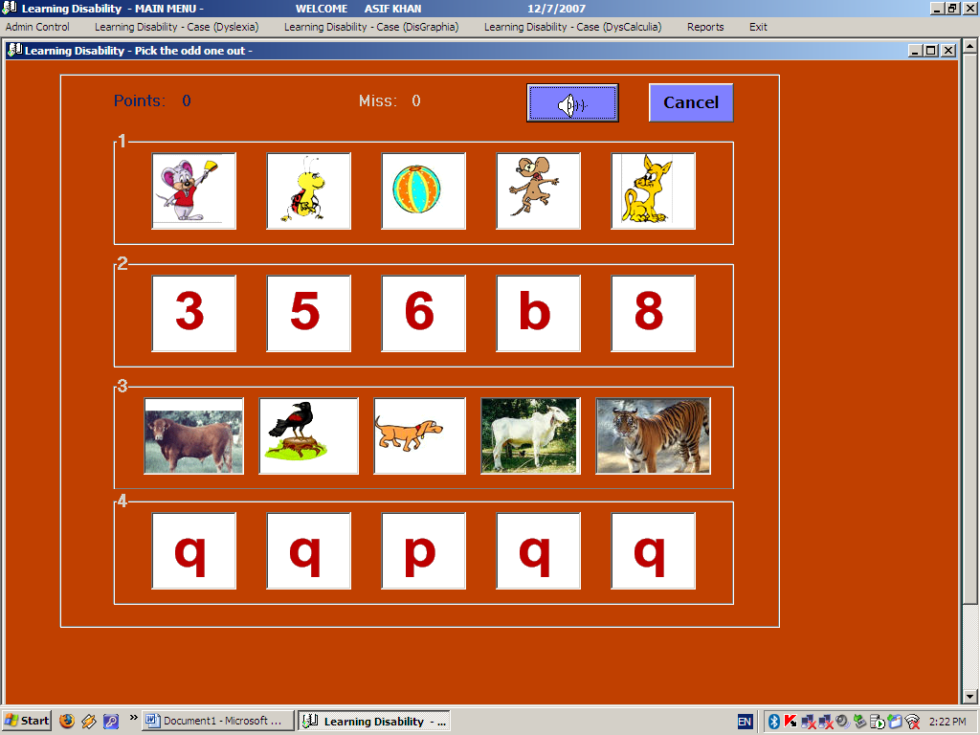

**Pick the odd one out**

This game will display 5 objects or figures in a row and the user has to click on the odd figure or object to get the right answer and score points. After having finished one row the user can then go to the next row. After finishing the four rows in any order the next four rows will appear automatically. And continue till the game finishes.

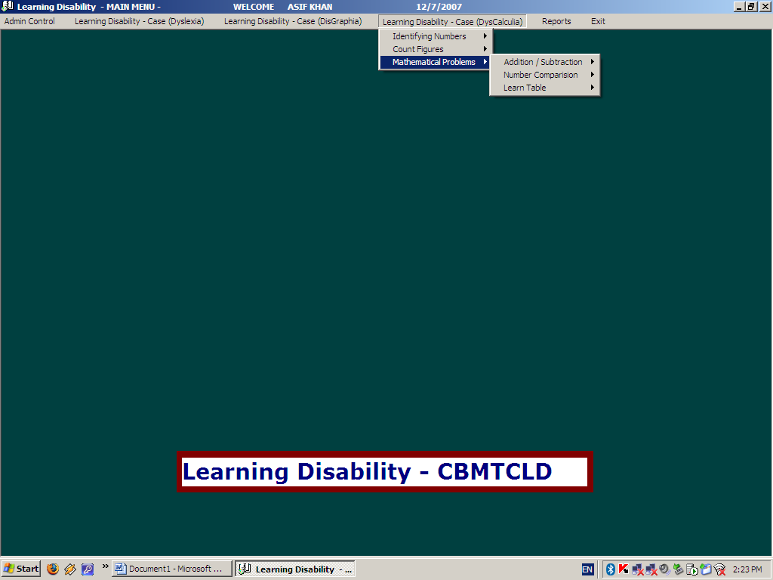

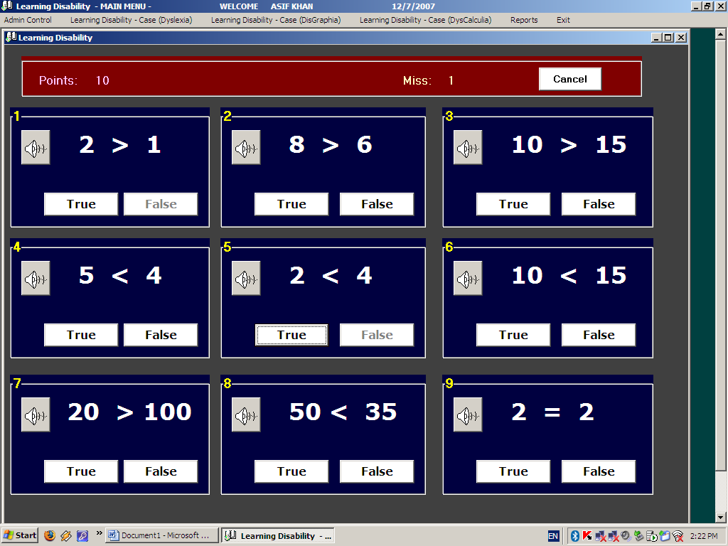

**Number comparison -** The child is given two sets of numbers on the screen. There is a symbol of greater than, less than, equal between the two and the child is asked whether the above statement is true or false and he has to click on the right option

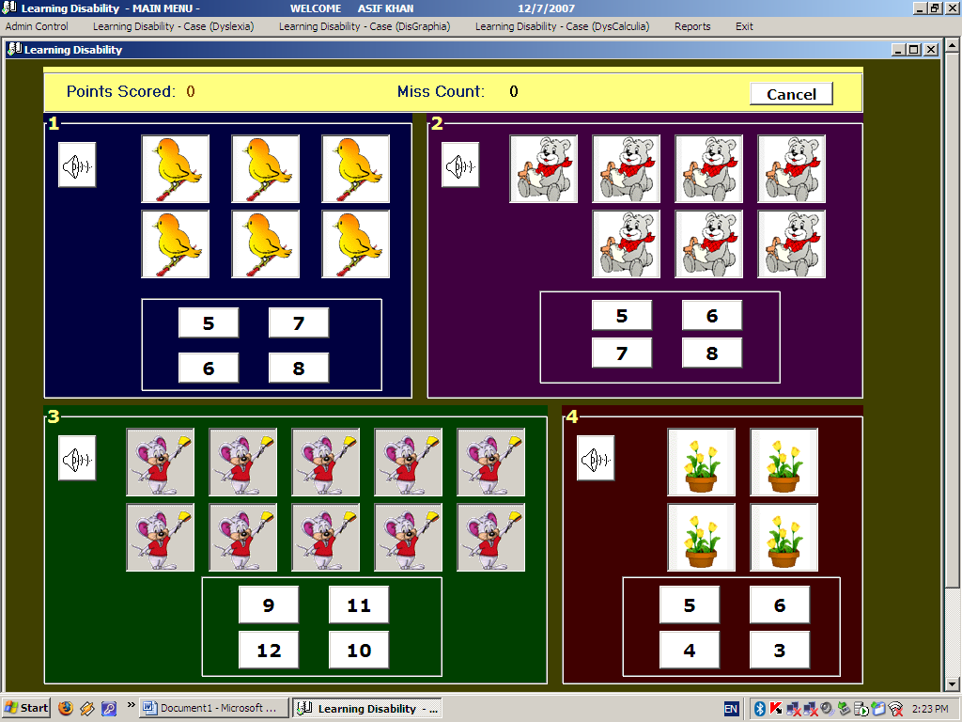

**Count the figures-**There are four boxes having different figures. The child will have to click the upper left button in each boxes, follow the instruction to score the points

