30 July, 2024

**PRESS RELEASE**

###### REVENUE FROM TOURISM: MAY 2024

**Revenue from Tourism -0,2%**

Based on the results of the Passengers Survey carried out by the Statistical Service, revenue from tourism reached €310,5 mn in May 2024, recording a minor decrease of 0,2% as compared to the corresponding month of the previous year (€311,0 mn).

For the period of January – May 2024, revenue from tourism is estimated at €751,2 mn compared to €728,6 mn in the corresponding period of 2023, recording an increase of 3,1%.

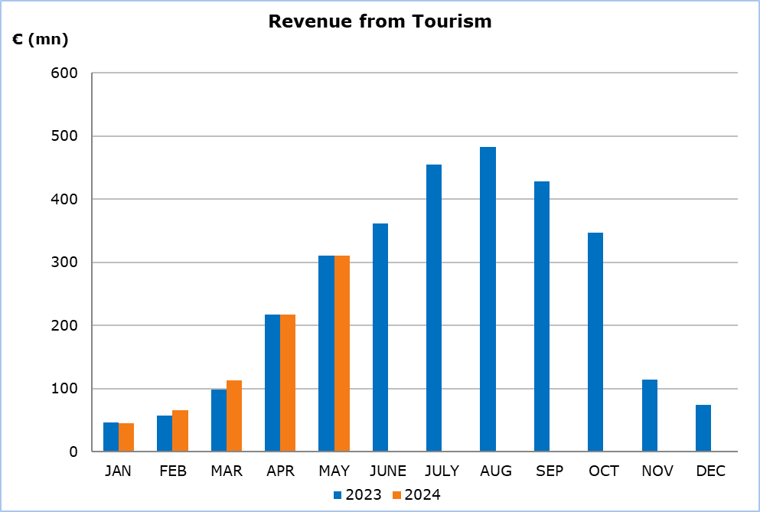

**Expenditure Analysis**

The average expenditure per person was €736,82 in May 2024 compared to €740,36 in May 2023, recording a decrease of 0,5%.

Tourists from the United Kingdom (the largest tourist market with 39,8% of the total tourists in May 2024) spent on average €83,18 per day, while tourists from Israel (the second largest market during the specific month with 7,9% of the total tourists) spent on average €161,66. Tourists from Poland (the third largest market with 7,6%), spent on average €86,40 per day.

Detailed statistics on the average expenditure of tourists per person and per day by country of usual residence are presented in the following table.

|  |  |  |  |  |  |  |  |  |
| --- | --- | --- | --- | --- | --- | --- | --- | --- |
| **Table** |  | | | |  | | | |
| **Country of Usual Residence** | **May 2023** | | | | **May 2024** | | | |
| **Arrivals** | **Average Length of Stay** | **Expenditure (€)** | | **Arrivals** | **Average Length of Stay** | **Expenditure (€)** | |
| **Per Person** | **Per Day** | **Per Person** | **Per Day** |
| **TOTAL** | **420.076** | **8,5** | **740,36** | **87,10** | **421.400** | **8,5** | **736,82** | **86,68** |
| Austria | 9.078 | 6,5 | 799,95 | 123,07 | 7.416 | 7,7 | 838,45 | 108,89 |
| Belgium | 3.047 | 9,1 | 1.016,94 | 111,75 | 2.879 | 7,1 | 870,67 | 122,63 |
| France | 10.027 | 6,7 | 647,35 | 96,62 | 9.214 | 6,4 | 666,15 | 104,09 |
| Germany | 25.916 | 9,1 | 955,32 | 104,98 | 27.081 | 8,4 | 944,32 | 112,42 |
| Denmark | 7.557 | 7,5 | 703,49 | 93,80 | 7.286 | u | u | u |
| Switzerland | 7.783 | 6,8 | 729,37 | 107,26 | 6.049 | 6,9 | 999,66 | 144,88 |
| Greece | 15.190 | 8,8 | 367,62 | 41,78 | 17.745 | 8,9 | 338,43 | 38,03 |
| United States | 5.437 | 9,8 | 1.175,71 | 119,97 | 3.936 | u | u | u |
| United Kingdom | 153.797 | 9,4 | 844,39 | 89,83 | 167.696 | 9,6 | 798,52 | 83,18 |
| Israel | 37.442 | 4,1 | 558,07 | 136,11 | 33.138 | 3,7 | 598,14 | 161,66 |
| Italy | 3.793 | 8,4 | 657,67 | 78,29 | 4.111 | u | u | u |
| Lebanon | 3.425 | 4,7 | 911,29 | 193,89 | 3.532 | u | u | u |
| Norway | 6.862 | 9,0 | 795,67 | 88,41 | 8.253 | 10,8 | 747,72 | 69,23 |
| Netherlands | 5.357 | 7,4 | 891,94 | 120,53 | 7.073 | 9,4 | 767,65 | 81,66 |
| Poland | 30.835 | 6,4 | 508,53 | 79,46 | 31.849 | 6,3 | 544,33 | 86,40 |
| Sweden | 21.837 | 10,2 | 737,77 | 72,33 | 20.103 | 7,6 | 689,10 | 90,67 |
| Finland | 4.794 | 7,1 | 680,84 | 95,89 | 6.200 | 6,5 | 670,92 | 103,22 |
| Other Countries | 67.899 | 7,7 | 645,25 | 83,80 | 57.839 | 8,7 | 766,08 | 88,06 |
|  |  |  |  |  |  |  |  |  |

u: Data with low reliability.

**METHODOLOGICAL INFORMATION**

**Definitions**

**Tourists** – Visitors who stay for at least one night in Cyprus.

**Tourist arrivals** – The term refers to the number of trips and not to the number of persons. This differs in the sense that one person can take more than one trips during the reference period.

**Revenue from Tourism -** It refers to the revenue from tourists during their visit in Cyprus.

**Source of Data and Coverage**

The data on the expenditure of tourists is obtained from the Passengers Survey which is carried out at the points of departure in Larnaka and Pafos airports. The data is collected through personal interviews with the use of an electronic questionnaire (CAPI method – Computer Assisted Personal Interviewing).

The data covers all persons in the Government controlled area of Cyprus. It does not include travelers who arrive and depart illegally via ports and airports in the occupied part of Cyprus.

***For more information:***

CYSTAT Portal, subtheme [Tourism](https://www.cystat.gov.cy/en/SubthemeStatistics?s=51)

[CYSTAT-DB](https://cystatdb.cystat.gov.cy/pxweb/en/8.CYSTAT-DB/8.CYSTAT-DB__Tourism__) (Online Database)

[Predefined Tables](https://www.cystat.gov.cy/en/KeyFiguresList?s=51) (Excel)

[Methodological Information](https://www.cystat.gov.cy/en/MethodologicalDetails?m=2172)

*Contact*

Lucy Panayidou: Tel.:+35722602152, E-mail: [lpanagidou@cystat.mof.gov.cy](mailto:lpanagidou@cystat.mof.gov.cy)