**GitHub URL:** <https://github.com/Azarianz/GIT_PA02>

**Gameplay Description**

Avoid the obstacles to get points and survive

**Left/Right Arrow keys: To move**

**Spacebar: To Jump**

**Enter: To Start/Restart Game**

|  |  |  |  |  |  |  |
| --- | --- | --- | --- | --- | --- | --- |
| **Test Case ID** | **Description** | **Input** | **Expected Result** | **Actual Result** | **Pass/Fail** | **Remarks** |
| 1 | Tire Prefab is able to move | Script | Tire prefab is moving like the other obstacles prefab | As expected | Pass | Nil |
| 2 | Obstacles collision works with player | Collider | Player Health decreases by 1 | As expected | Pass | Nil |
| 3 | Add scores when obstacles go off screen | Script | Game Manager Score increases by 1 | As expected | Pass | Nil |
| 4 | Player can jump over low obstacles | Spacebar | Will not collide | As expected | Pass | Nil |
| 5 | Player animations are working | Animator | Player animation keeps playing when game starts | As expected | Pass | Nil |
| 6 | Explosion spawns when obstacles are destroyed | Script | Explosion where player collides with obstacle | As expected | Pass | Nil |
| 7 | Obstacles spawn every 1 second interval | Script | Objects spawn every 1 second | As expected | Pass | Nil |
| 8 | Obstacles will spawn on a random x axis between (-2 to 3) each time | Script | Object on a random x point within the set range | As expected | Pass | Nil |
| 9 | Game Over Screen shows player at his current score | Script | Final Score Shown | As expected | Pass | Nil |
| 10 | Gamestate properly changes when losing and starting game | Script | Gamestate is correctly set | As expected | Pass | Nil |

Summary: Test Cases All Passed (10)

**Git Client Full History**

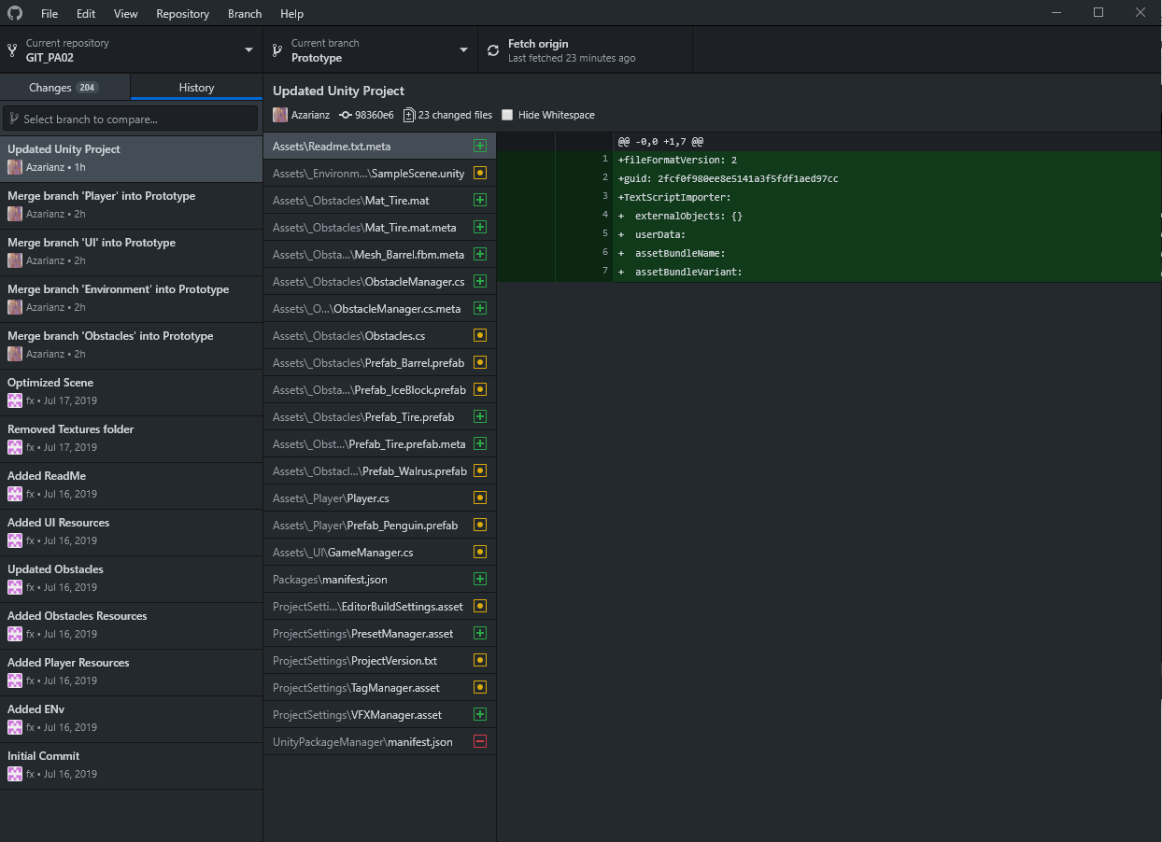

**GitHubCloud Prototype Screenshot**

