《数值分析》实验报告

学号：20003068 姓名:何彦劭 班级：信计200 成绩：

实验名称：三次样条插值 | 实验地点：奉贤数学系机房
所使用的工具软件及环境：Matlab
一、实验目的：
1. 利用Matlab 实现三次样条插值；
2. 利用Matlab绘制函数图像。
二、实验内容：
1. 给定插值节点及对应的函数值，以及在边界节点处的导数值，求出三次样条插值函数；
2. 把区间[-1,1]用等距节点分成n个小区间，对龙格函数f(x)=1/(1+25x^2)作多项式插值及三次样条插值，取n=10和20，分别画出插值函数及f(x)的图形。

三、操作步骤：
1.程序：function s = cubic_spline_interpolation(x,y,b)
% x,y are (n+1) dimensional column vectors where n is the number of intervals
% b=[s'(x(1)) s'(x(end))]
% s is a matrix with n rows and 4 columns
% The j-th row s(j,:) are coefficients of the cubic polynomial on [x(j),x(j+1)] in decending degrees

2.程序：
function P = cubic_spline_interpolation(x,y,b)
n = length(x) - 1;
h = x(2:n+1) - x(1:n);
mu_p = h(1:n-1)./(h(1:n-1) + h(2:n));
mu = [mu_p 1];
lambda_p = h(2:n)./(h(1:n-1) + h(2:n));
lambda = [1 lambda_p];
delta = (y(2:n+1) - y(1:n))./h(1:n);
d_p = 6*(delta(2:n) - delta(1:n-1))./(h(1:n-1) + h(2:n));
d = [6*(delta(1) - b(1))/h(1) d_p 6*(b(end) - delta(end))/h(n)];

A = eye(n+1).*2;

for i = 1:n
A(i,i+1) = lambda(i);
A(i+1,i) = mu(i);
end

M = A\(d');
P = zeros(n,4);

for i = 1:n
c1 = M(i)/(6*h(i));
c2 = M(i+1)/(6*h(i));
c3 = (y(i)-M(i)*(h(i)^2)/6)/h(i);
c4 = (y(i+1) - M(i+1)*(h(i)^2)/6)/h(i);
P(i,1) = -c1 + c2;
P(i,2) = 3*(x(i+1)*c1 - x(i)*c2);
P(i,3) = 3*(-(x(i+1)^2)*c1 + (x(i)^2)*c2) - c3 + c4;
P(i,4) = c1*(x(i+1)^3) - c2*(x(i)^3) + x(i+1)*c3 - x(i)*c4;
end

n = 10;
%n = 20;
x = -1:2/n:1;
y = 1./(1 + 25*(x.^2));
b = [-50*(-1)/((1 + 25*(-1)^2)^2) -50*(1)/((1 + 25*(1)^2)^2)];
L = lagrange(x,y);
s = cubic_spline_interpolation(x,y,b);
t = linspace(-1,1,n+1);
u = 1./(1 + 25*(t.^2));
v = polyval(L,t);
k = 1000;
w = zeros(n,k);
t_n = zeros(k*n,1);
w_n = zeros(k*n,1);
for i = 1:n
t_ = linspace(x(i),x(i+1),k);
w(i,:) = polyval(s(i,:),t_);
for j = 1:k
t_n(k*(i-1)+j) = t_(j);
w_n(k*(i-1)+j) = w(i,j);
end
end
figure
plot(t,u,'r--');
hold on,
plot(t,v,'b:');
plot(t_n,w_n,'o-.');
%plot(t,w,'o^');
plot(x,y,'g+');
legend('f(x)','L','Three','t');

四、实验结果：

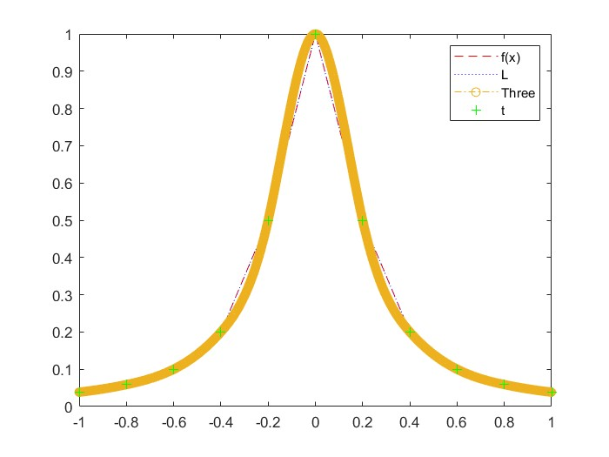

任课教师： 20 年 月 日

