Magenic Masters – Angular 4 : Exercise 1

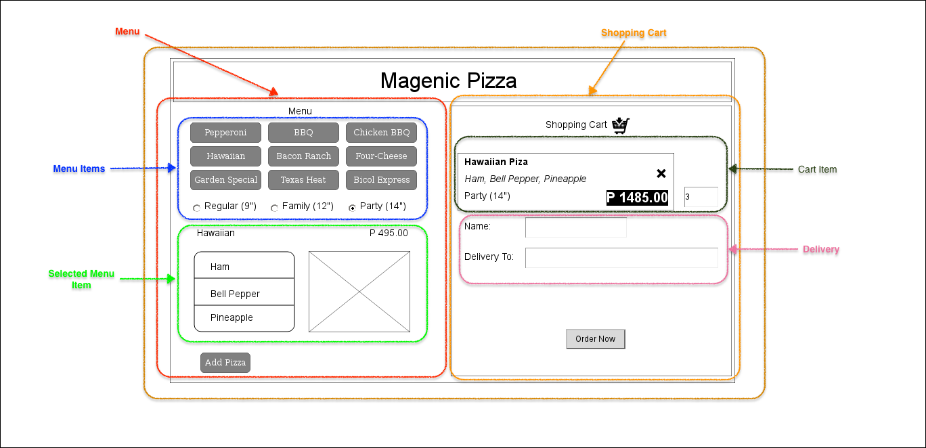

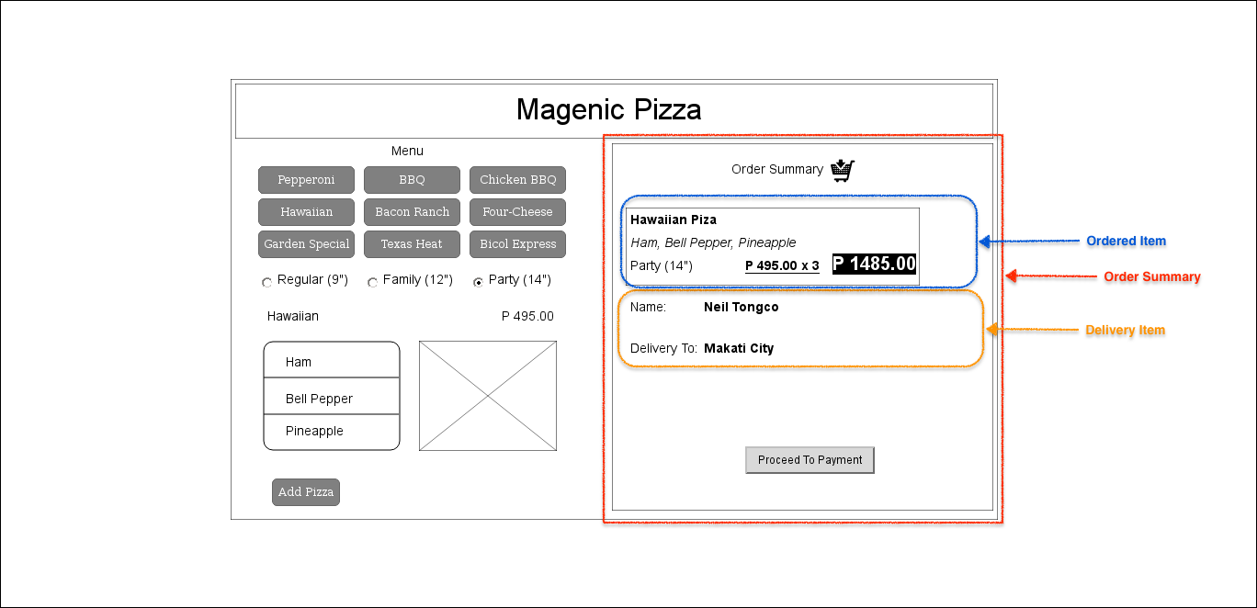

Criteria:

1. Create a parent component.
2. The parent component must contain the following sub-components:
   1. Menu Component
   2. Shopping cart component
3. The Menu Component must contain the following sub components:
   1. Menu Items Component
      1. List of clickable menu items – clicking any of the menu items enables the selected menu item component
      2. List of Pizza sizes as option boxes
   2. Selected Menu Item Component
      1. Selected menu item name and price
      2. Ingredient List
      3. Item photo
   3. Add Pizza button – Clicking this button adds the selected item to the Shopping Cart component
4. Shopping Cart Component:
   1. Cart Item component should contain the menu item details (Name, Ingredients and Size, Qty and Computed Price). Qty must be editable.
   2. Delivery component should contain the Name and Deliver To editable fields.
   3. Order Now button – Clicking this button hides the shopping cart and displays the Order Summary component
5. Order Summary Component:
   1. Ordered Item including details (Name, Ingredients and Size, Qty and Computed Price)
   2. Delivery component should contain the Name and Deliver To fields.

BONUS POINTS:

1. User should be able to add more than one item in the shopping cart