**ASSIGNMENT 1**

**Submitted by:**

**Azaybee Rai**

**Student ID: 23003615**

**Submitted to:**

**Professor: Nawaz Chowdhury**

**Subject: Web Development 2**

**Course code: CSD213**

Honesty Statement: “I declare that this submission is my own work in compliance with Sault College Academic Policies.”

**Due date: 21 May 2024**

**Table of Content**

**Assignment Steps** 3

**Assignment Steps-1** 3

**Assignment Step-2** 4

**Assignment Step-3** 4

# 

# **Assignment Steps**

## **Assignment Steps-1**

The JavaScript code is used for making web page for jokes

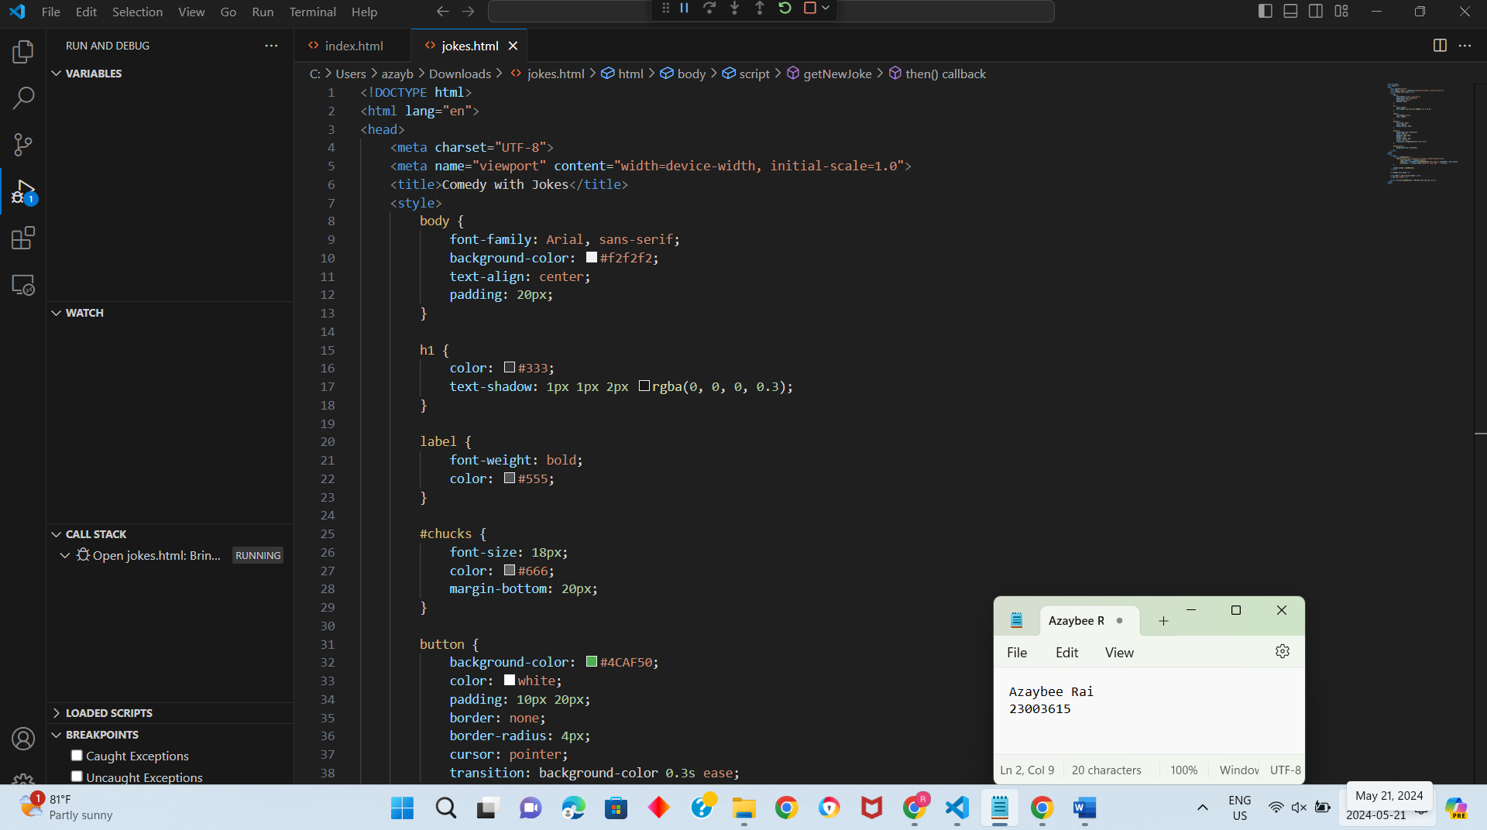

## **Assignment Step-2**

## **Assignment Step-3**

This is my output results:

