

**UNIVERSITY OF ENGINEERING AND TECHNOLOGY PESHWAR JALOZAI CAMPUS**

**DIGITAL SIGNAL PROCESSING PROJECT**

Name: - Azaz Hassan Khan

Registration #: - 18JZELE0262

Department: - Electrical Engr (Comm.)

Semester: - 7th Semester

Submitted To: Dr. ZAKA ULLAH ZAHID

**Design Analog Filter Using Arduino**

**Block Diagram of Circuit**

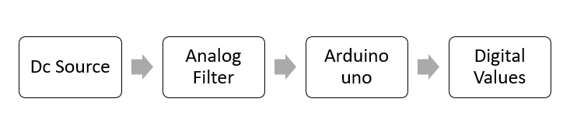

**Analog Filter**

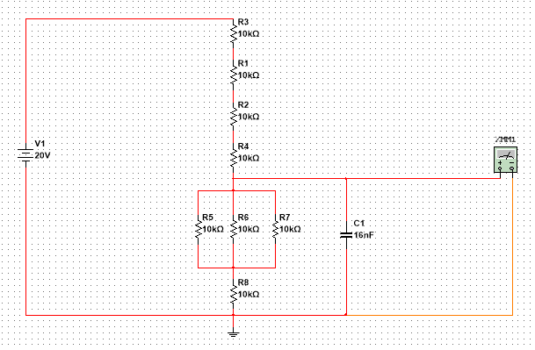

**Arduino uno**

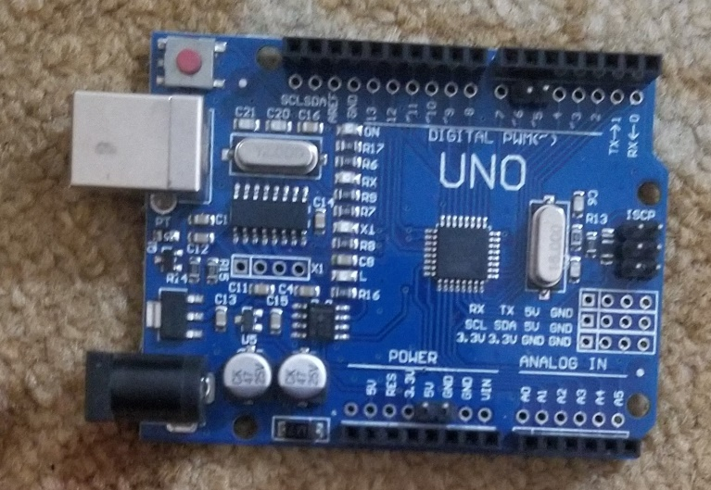

**Hardware Connections**

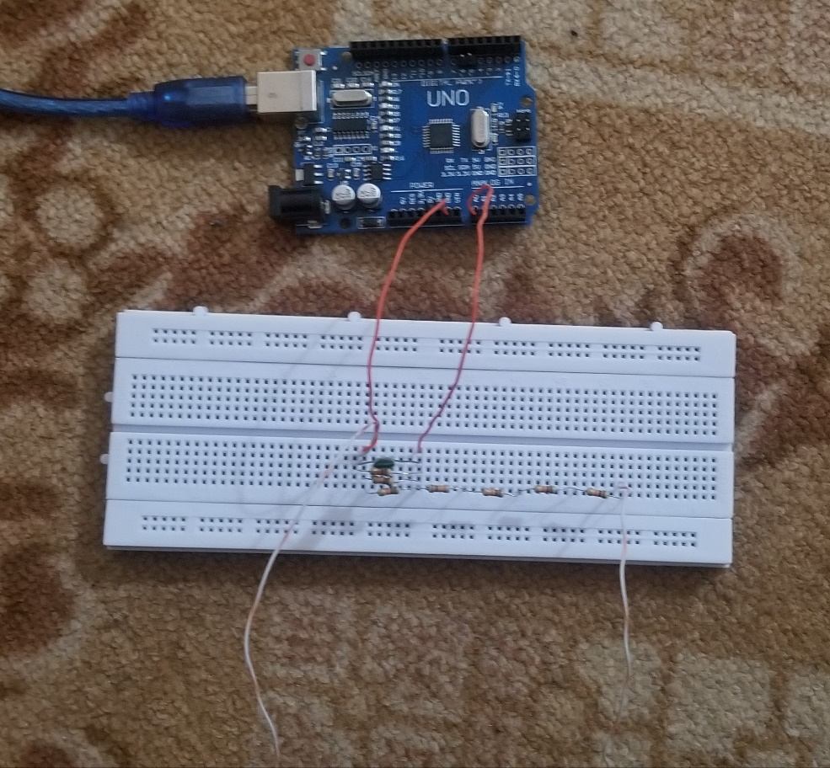

**Multimeter and Dc source**

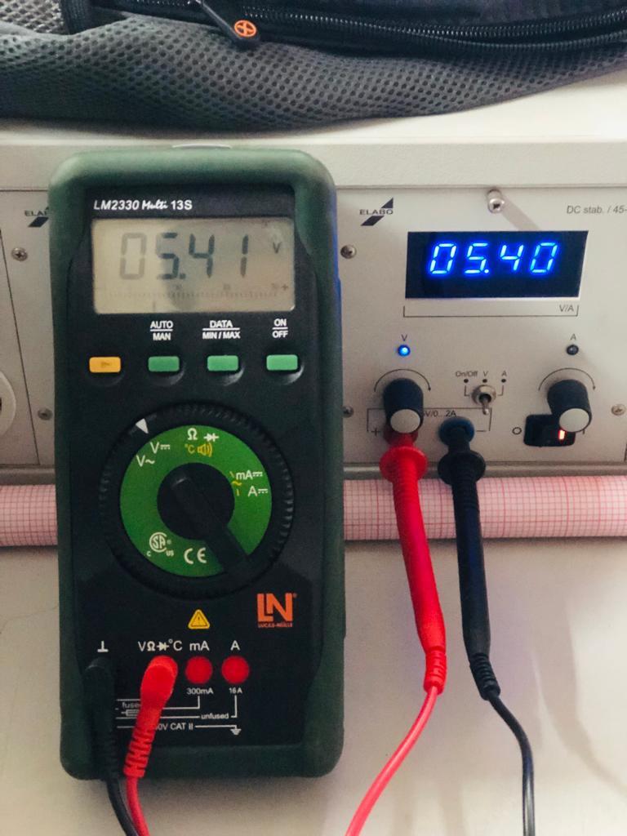

**Tables and Observations**

**Analog Input v/s Analog Output**

|  |  |
| --- | --- |
| **VIN** | **VOUT** |
| 1 | 0.256 |
| 2 | 0.514 |
| 3 | 0.78 |
| 4 | 1.04 |
| 5 | 1.3 |
| 6 | 1.55 |
| 7 | 1.87 |
| 8 | 2.07 |
| 9 | 2.32 |
| 10 | 2.6 |
| 11 | 2.86 |
| 12 | 3.11 |
| 13 | 3.33 |
| 14 | 3.6 |
| 15 | 3.96 |

**Analog Input v/s V_ADC (Digital values)**

|  |  |
| --- | --- |
| **VIN** | **VADC** |
| 1 | 50 |
| 2 | 102 |
| 3 | 154 |
| 4 | 206 |
| 5 | 258 |
| 6 | 312 |
| 7 | 366 |
| 8 | 418 |
| 9 | 472 |
| 10 | 523 |
| 11 | 576 |
| 12 | 630 |
| 13 | 685 |
| 14 | 732 |
| 15 | 810 |

**Analog output v/s V_ADC (Digital values)**

|  |  |
| --- | --- |
| **VOUT** | **VADC** |
| 0.256 | 50 |
| 0.514 | 102 |
| 0.78 | 154 |
| 1.04 | 206 |
| 1.3 | 258 |
| 1.55 | 312 |
| 1.87 | 366 |
| 2.07 | 418 |
| 2.32 | 472 |
| 2.6 | 523 |
| 2.86 | 576 |
| 3.11 | 630 |
| 3.33 | 685 |
| 3.6 | 732 |
| 3.96 | 810 |

**ARDUINO UNO CODE**

**Arduino CODE**

void setup() {

// put your setup code here, to run once:

Serial.begin(9600);

pinMode(A0,INPUT);

}

void loop() {

// put your main code here, to run repeatedly:

int ADC;

ADC=analogRead(A0);

Serial.println(ADC);

}

**MATLAB CODE**

% Azaz Hassan Khan |18jzele0262

% Input Applied from the Station

V_in =1:1:15;

%%Output Calculated from the Breadboard

V_out=[0.256,0.514,0.78,1.04, 1.3, 1.55,1.81, 2.07, 2.32, 2.66, 2.86, 3.11, 3.33, 3.66, 3.91]; %% From capacitor

V_out_ADC=[50,102,154,206,288,312,366,418, 472,523,575, 630,685,732,810]; %% Vout from Arduino IDE

% Plotting Figure for Analog input vs Analog output

figure

plot(V_in, V_out)

xlabel('Vin')

ylabel('V_out')

title('Analog Input v/s Analog Output')

grid on %% X -axis Vin and Y-axis Vout from Capacitor

% Plotting Figure for Analog input vs ADC

figure

plot (V_in,V_out_ADC);

xlabel('Vin')

ylabel('V_ADC')

title('Analog Output v/s Arduino ADC ')

grid on;

% Plotting Figure for Analog output vs ADC

figure

plot(V_out, V_out_ADC)

xlabel('V_out')

ylabel('V_out_ADC')

title('Output Comparison')

grid on

**RESULTS:**

**Analog Input to Analog Output**

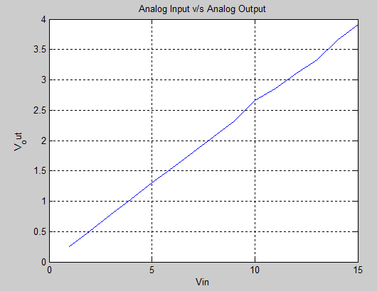

**(Figure a)**

**Analog Input to V_ADC**

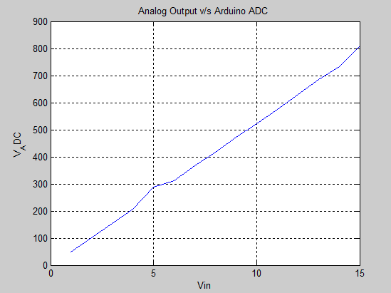

**(Figure b)**

**Analog Output to V_ADC**

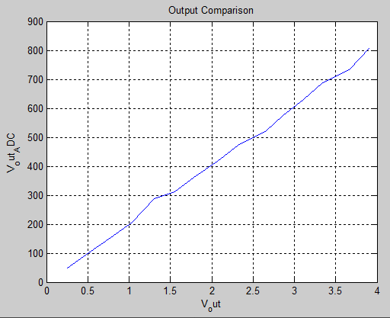

**(Figure c)**

**SERIAL MONITOR IN ARDUINO UNO:**

