

**UNIVERSITY OF ENGINEERING AND TECHNOLOGY PESHWAR JALOZAI CAMPUS**

**Communication Systems**

Name: - Azaz Hassan Khan

Registration #: - 18JZELE0262

Department: - Electrical Engr (Comm.)

Semester: - 6th Semester

Submitted To: Dr. Sadiq Ali

**Quadrature Amplitude Modulation System**

**OBJECTIVE**

Implementation and analysis of Quadrature- Amplitude Modulation System in Gaussian Channel using Simulink

**Theory:**

* Quadrature Amplitude Modulation transmits two double side band suppressed signals in the bandwidth of single double side band suppressed carrier signal, therefore saves the bandwidth problem.
* Quadrature Amplitude Modulation allows for the transmission of two message signal on the same carrier frequency.
* Quadrature Amplitude Modulation has two components, in phase component and quadrature component.
* One message signal is modulated with the help of in phase component of carrier signal whereas the other message signal is modulated with the help of quadrature component of carrier signal.
* In communication theory, it is often assumed that the transmitted signals are distorted by some noise. The most common noise to assume is additive Gaussian noise, the so‐called additive white **Gaussian noise channel** (AWGN). ... Often in communication systems, the signaling is allowed to occupy a certain bandwidth

**APPARATUS REQUIRED**

1. Hardware Tools: Computer system
2. Software Tool: MATLAB 7.0 and above version

**Mathematical Derivation:**

**Modulation**

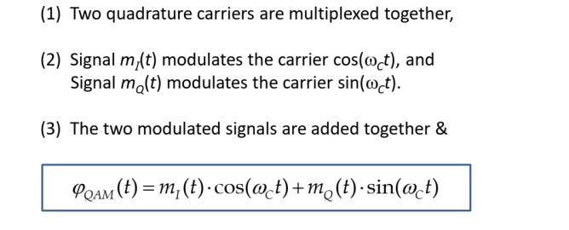

**Demodulation**

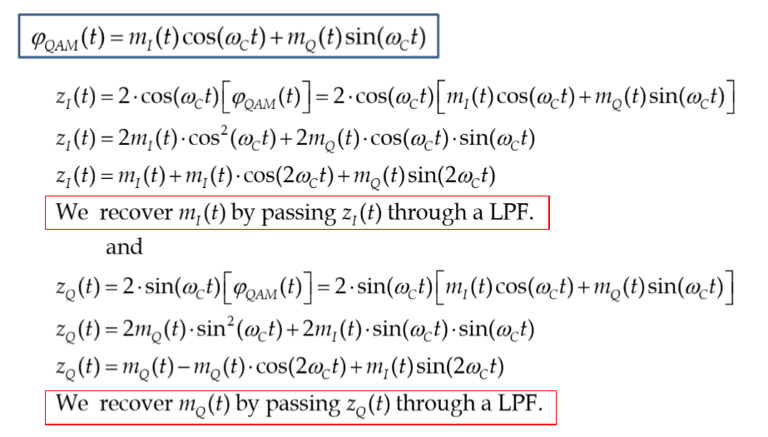

**Procedure:**

1. In Simulink library we choose virtual instruments like Sine wave for message and carrier signal, product for modulation of two message signals with their respective carrier signals, adder for summing (multiplexing) two modulated signals, AWGN Channel, low pass filter to get demultiplexed signal, scope to analyze the signals at each stage.
2. Now setting up the block diagram as shown above and setting each virtual instrument as settings are given in Table 1.
3. We have two message signals (Sine wave & Sine wave 2) initially to be modulated and then multiplexed, first one is modulated with a carrier signal with 0 as phase and 2nd with carrier of phase 90.
4. Once these two signals are modulated using product, then the modulated signals are multiplexed using adder.
5. The multiplexed signal is then passed through AWGN Channel.
6. The multiplexed signal may lose some of its power due to the value of gaussian noisy channel.
7. The signal from AWGN channel is then modulated with the Sync Carrier for 0 & 90 phase.
8. This modulated signal is then passed through low pass filter which gives us original message signal with some loss in its power.

**Simulink Model / block diagram:**

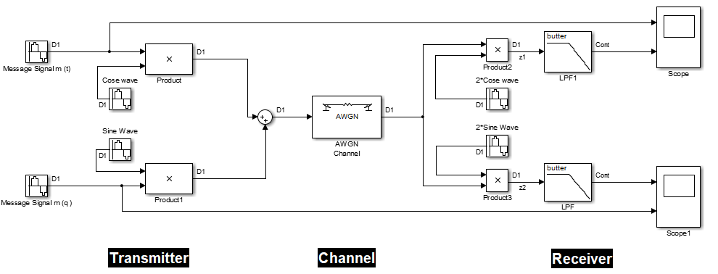

**Output:**

**Case 1:**

**Gaussian Channel at SNRs Infinity**

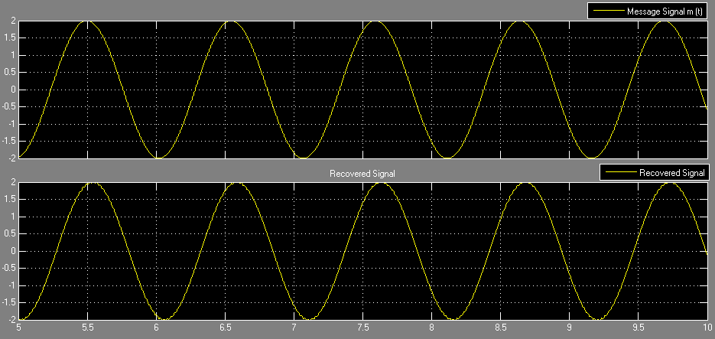

**Figure From Scope**

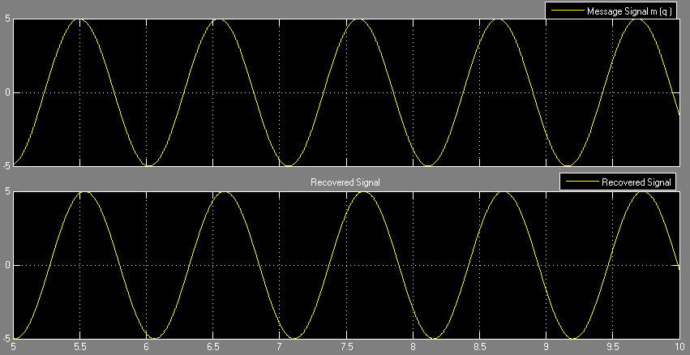

**Figure From Scope1**

**Case 2:**

**Gaussian Channel at SNRs = 0 dB.**

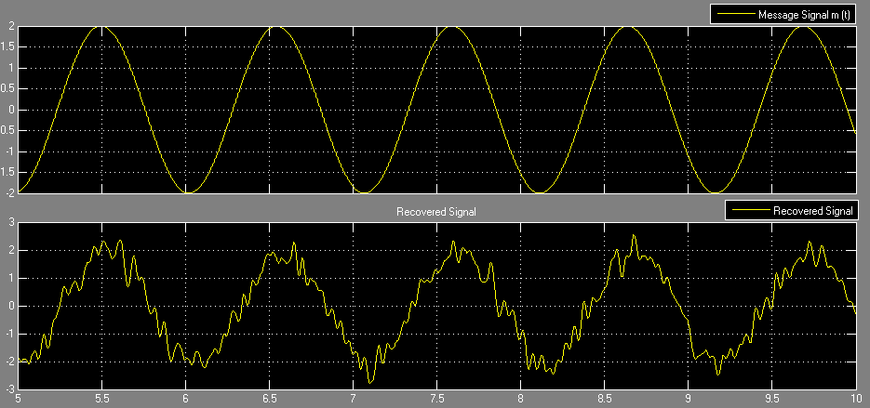

**Figure From Scope**

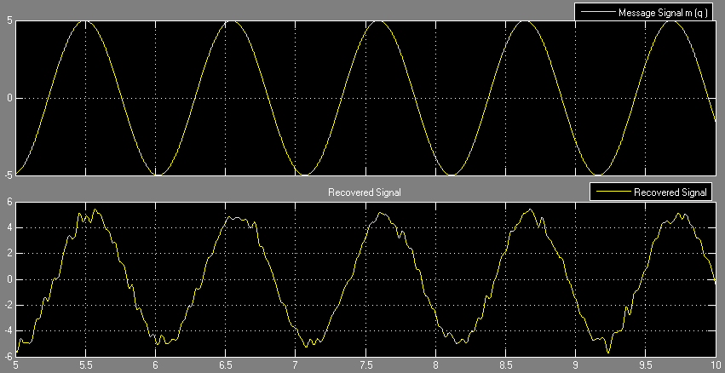

**Figure From Scope1**

**Case 3:**

**Gaussian Channel at SNRs = 4 db.**

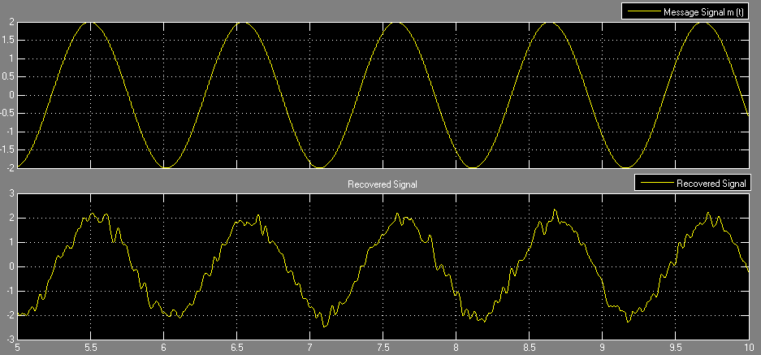

**Figure From Scope**

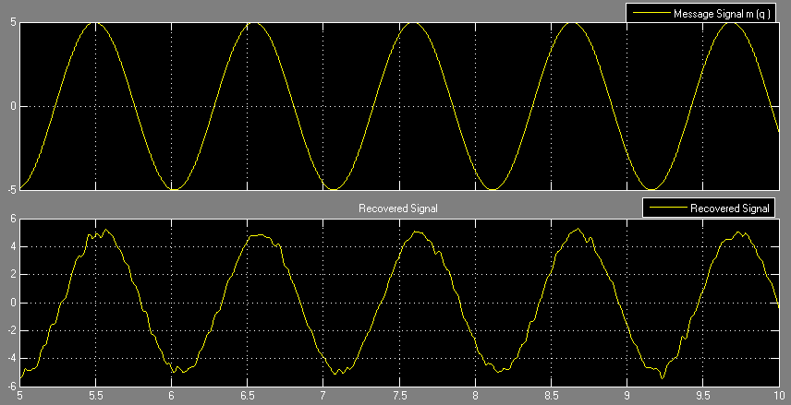

**Figure From Scope1**

**Case 4:**

**Gaussian Channel at SNRs = -4 db.**

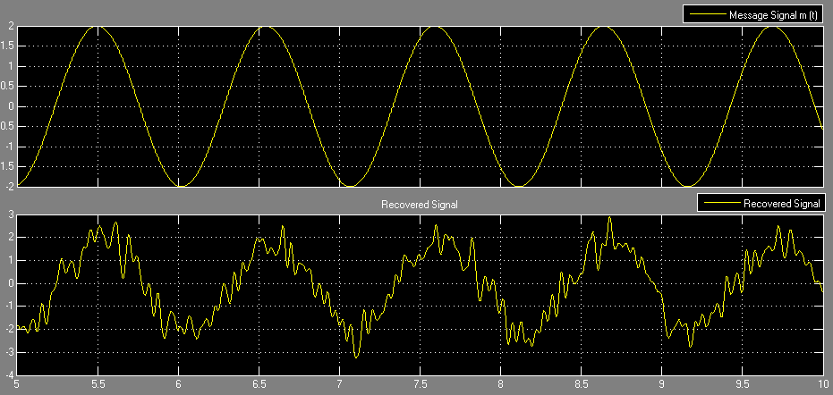

**Figure From Scope**

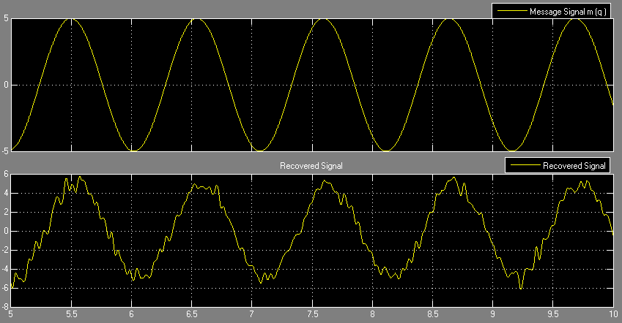

**Figure From Scope1**

**Conclusion:**

* We have two Massage Signals with Different Frequency Phase and Amplitude We Modulated Them with Carrier Signal of Different Phase in phase and quadrature phase.
* Them We add Them Together to send them through gaussian Channel So Here We got the Advantage Quadrature Amplitude Modulation transmits two double side band suppressed signals in the bandwidth of single double side band suppressed carrier signal, therefore saves the bandwidth problem.
* Then At the Receiver Side we Again Multiplied them by Synchronous carrier And Then Pass through the low pass filter so the message gets recovered.
* Gaussian noise channel is only for adding noise so the noise can occupy the bandwidth and signal is being distorted.
* As SNR Decreases signal distortion will be increasing.

**Precautions:**

* Both Carrier Signals must have the same frequency.
* Carrier frequency must be greater than message frequency.
* Frequency of filter must be the same as carrier frequency.
* Phase difference between both carrier signals must be 90 degree apart.