**Variable Power Supply**

**Project Title**

Variable Voltage Supplier Of 5V,9V and 12V

**Apparatus: -**

1. Voltmeter (Multimeter)
2. 4 Diode (1N4007GP)
3. Resistor (1k ohm)
4. Capacitor (50uf)
5. Ground
6. Ac Voltage Source
7. Oscilloscope
8. Stepdown Transformer (10:1)
9. Connecting wires
10. Regulator (LM7805, LM7809, LM7812)

**Theory:-**

**Full Wave Rectification: -** Full-wave rectification rectifies the negative component of the input voltage to a positive voltage, then converts it into DC (pulse current) utilizing a diode bridge configuration. The power diode in a **Full wave rectifier** circuit passes complete sine wave of the AC supply in order to convert it into a DC supply.

**Use of Filter: -**The Dc output in from Full wave rectifieris fluctuating so we use **filter** in order to make it stable the filter The main function of this filter is to allow the ac components and blocks the dc components of the load. The filter circuit output will be a stable dc voltage. The Filter we use is capacitor in parallel with circuit.

**Use of Regulator: -** A voltage regulator is a component of the power supply unit that ensures a steady constant voltage supply through all operational conditions. It regulates voltage during power fluctuations and variations in loads. It can regulate AC as well as DC voltages

**Procedure: -**

1. First of all, Open the Multisim
2. Now we have to Drag or Pick the Equipment’s which we have Required in the Apparatus in Order to Study, Observe and Draw the Full wave rectifier With or without the filter and regulator.
3. In the **Place source** click on the **Power sources** and select **ground** and similarly Click on the **Signal Voltage Sources** to pick **AC Voltage Source**.
4. Now in the **Top Left Corner** click on **Place Basics** and in Basics Select **Resister** Of 1k Ohm, and for picking Diode click on the **Diode** on the **Top Left Corner** and select the required **diode** of 1N4007GP.Now for selecting **Transformer** Select **Basics** And click on Transformer
5. Now pick Multimeter as a Voltmeter and Oscilloscope from the **right-side bar** of Multisim.
6. Now connect all the required equipment as shown in the **figure (a)** for without Filter and regulator circuit.
7. Observe the Graph By using Oscilloscope and from graph calculate **Peak to Peak value** and use voltmeter as AC and for **RMS Value** and as Dc for **Average Value**.
8. Same Process Will Be repeated Again but Now Also Connect the Filter And Regulator as shown in the **figure (b)**.

**Note: -**

* For calculating **Peak to Peak** **value** **Vm** Use Oscilloscope.
* For calculating **RMS Value Vrms** use voltmeter as AC.
* For calculating **Average Value Vdc** use voltmeter as DC.
* For Properly use of transformer use formula **N1/N2=V1/V2**
* If You connect the Vrms Ac Voltage source instead of Vpk Then You have to divide every voltage value by Under root of 2.

**Circuit Diagram: -**

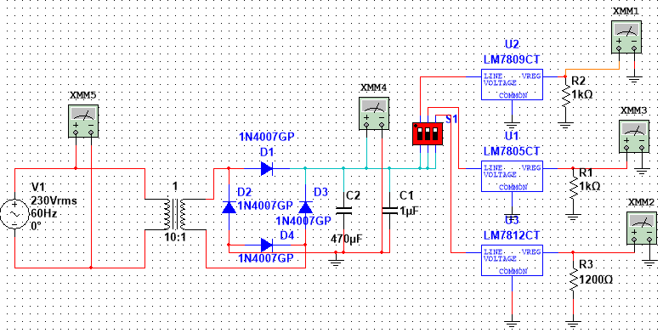**Figure (a)**

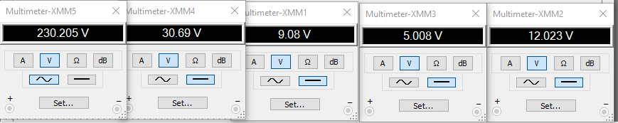

**Figure (B)**

**Observations and Calculations: -**

**RMS Voltage**

|  |  |  |  |  |
| --- | --- | --- | --- | --- |
|  | **Input XMM5** | **Output XMM1** | **Output XMM2** | **Output XMM3** |
| **Amplitude Vm** | **230v** | **9.008V** | **5.008V** | **12.02V** |
| **Time Period (T)** | **16ms** | **infinite** | **infinite** | **infinite** |
| **Frequency (f)** | **60Hz** | **0Hz** | **0Hz** | **0Hz** |

**Graph: -**

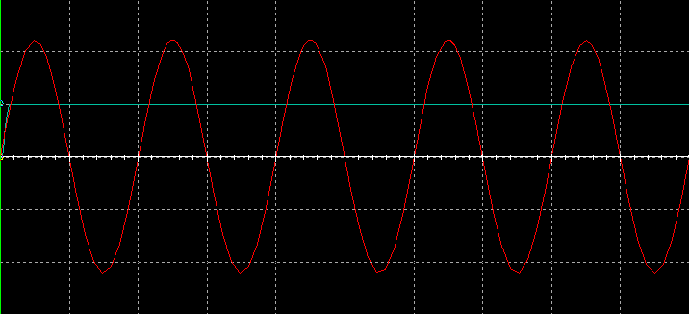

**Blue line shows the output and red line shows the input**

**Precautions: -**

* While doing the experiment do not exceed the Maximum ratings of the diode and regulator. This may lead to damage the diode and regulator.
* Connect voltmeter and Oscilloscope in correct polarities as shown in the circuit diagram.
* Do not switch ON the power supply unless you have checked the circuit connections as per the circuit diagram.