**INXOL TECHNOLOGIES**

**GENDER CLASSIFICATION USING DEEP NEURAL NETWORK(Task 2)**

**Name: Azba Shahid**

**Roll No: C1-19**

**Abstract**

This project focuses on using a deep neural network for gender classification based on facial images. By employing convolutional neural networks, the study aims to automatically learn gender-related features from diverse facial data. The model's architecture is designed to extract and discern intricate facial attributes, enabling accurate gender prediction. The project's outcomes contribute to advancing computer vision applications and highlighting the efficacy of deep neural networks in addressing gender classification tasks.

**Preprocessing Steps**

1. **Resizing:**

The first step in preprocessing involves resizing the input images to a consistent size. This is crucial to ensure that all images have the same dimensions.Resizing also helps to reduce the computational complexity during training.

1. **Normalization:**

Normalization is performed to scale the pixel values of the images to a common range, typically between 0 and 1. This step improves the convergence of training algorithms and makes the model less sensitive to variations in pixel intensity.

1. **Label Encoding:**

Label encoding is used to convert categorical labels into numerical values.

1. **Randomized the target:**

It is important to introduce randomness and prevent any potential bias that might arise from the ordering of data samples. It helps to ensure that the training and testing sets are representative of the entire dataset.

**Model performace**

i have use sequential model from keras and apply 3 dense layers to it. The epochs are set to 20 and batch size to 25. at these values model perform bet with accuracy of 82% approximately. On other values of epochs and batch size model performance become poor. However it gives actual result while deploying.

**Model Evaluation**

The graph show the trend of accuracy and val-accuracy of model.

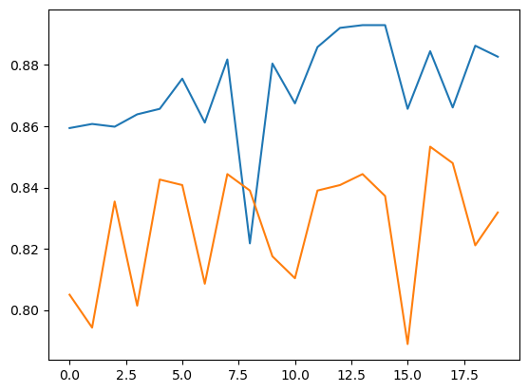

**Conclusion**

Model performs best on 20 epochs and 25 batch size with accuracy of 82%. it also deploy accurately.