**Homework 4**

Chapter 7: Graph Coverage Criteria

**Name: Antonio Zea Jr**

**What to do?**

Consider the following method, and submit your answers for the questions below.

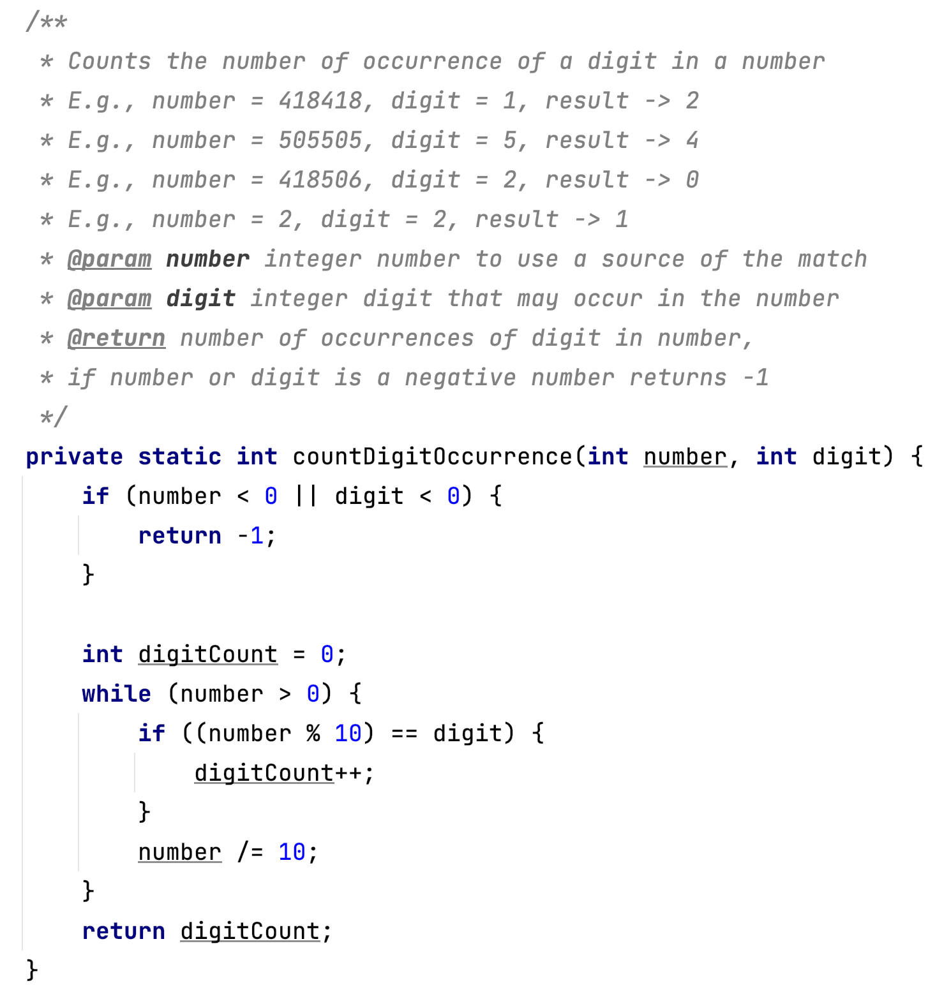

Using the code above, answer the following questions.,

* 1. Draw the control flow graph that represents abstraction of its execution. Label edges and nodes in the graph with the corresponding code fragments. **(15 points)**
     + **Hint-1:** Do not forget to indicate initial and end node(s).
     + **Hint-2**: You do not need to create a node for the method declaration part in the first line (i.e., private static int countDigitOccurrence(int number, int digit))

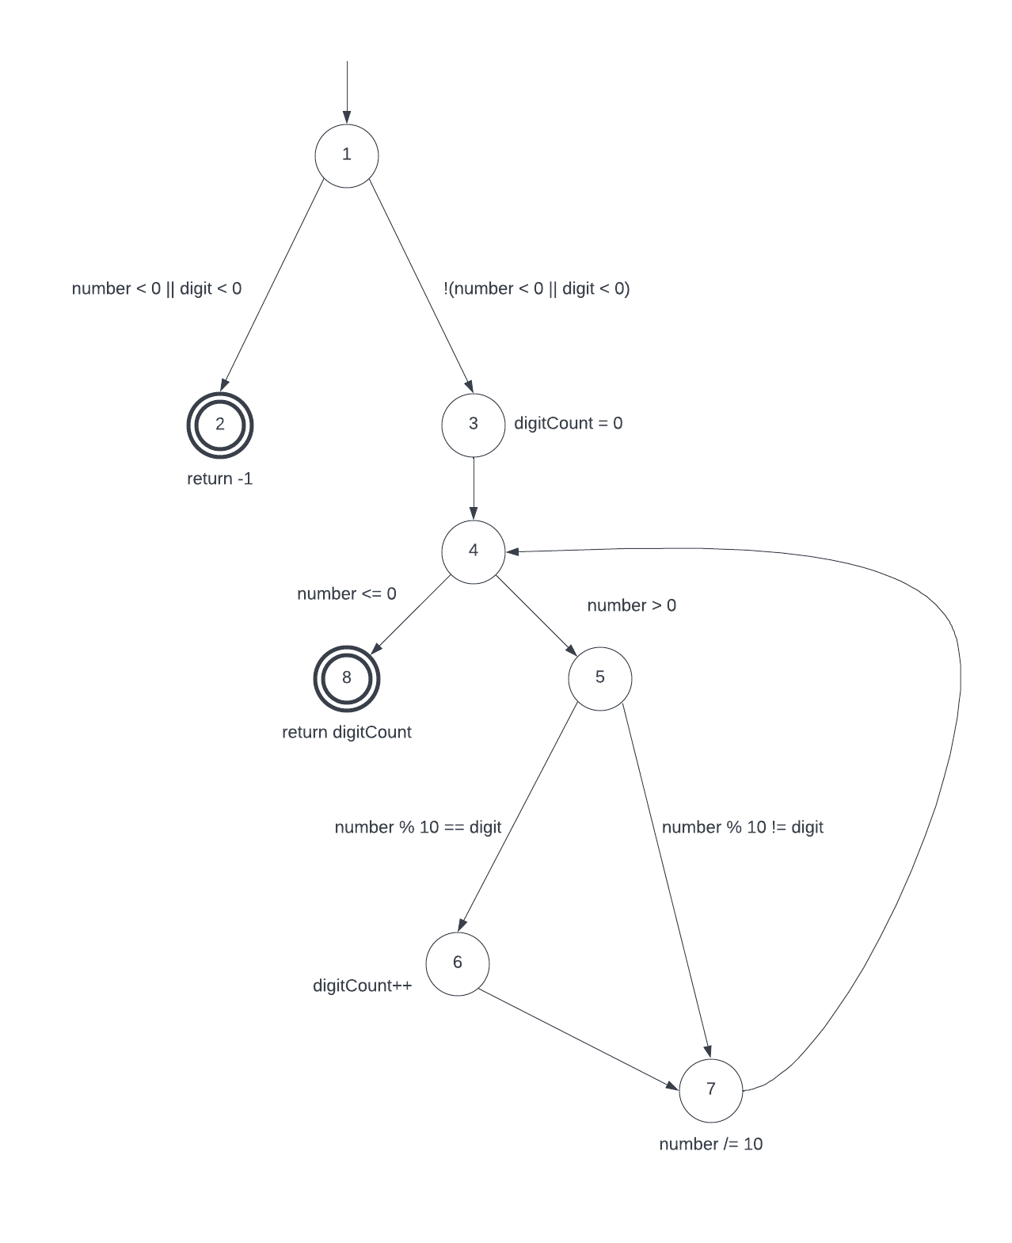

* 1. List the test requirements for **Node Coverage** **(3 points)**

TR={1,2,3,4,5,6,7,8}

* 1. Identify test paths that achieve the test requirements for **Node Coverage (3 points)**

T1={1,2}

T2={1,3,4,5,6,7,4,8}

* 1. Give a set of test cases for the test paths in c. Make sure to include test input values and expected outputs. If it is impossible to design a test case for any test requirements, briefly discuss why. **(5 points)**

T1 countDigitOccurrence(-5,1) returns -1

T2 countDigitOccurrence(1,1) returns 1

* 1. List the test requirements for Edge Coverage **(3 points)**

TR={(1,2), (1,3), (3,4), (4,8), (4,5), (5,6), (5,7), (6,7), (7,4)}

* 1. Identify test paths that achieve the test requirements for **Edge Coverage (3 points)**

T1={1,2}

T2={1,3,4,5,6,7,4,8}

T3={1,3,4,5,7,4,8}

* 1. Give a set of test cases for the test paths in f. Make sure to include test input values and expected outputs. If it is impossible to design a test case for any test requirements, briefly discuss why. **(5 points)**

T1 countDigitOccurrence(-5,1) returns -1

T2 countDigitOccurrence(1,1) returns 1

T3 countDigitOccurrence(2,1) returns 0

* 1. List the test requirements for **Edge-Pair Coverage** **(6 points)**

TR={(1,2), (1,3,4), (3,4,8), (3,4,5), (4,5,6), (4,5,7), (5,6,7), (5,7,4), (6,7,4), (7,4,5), (7,4,8)}

* 1. Identify test paths that achieve the test requirements for **Edge-Pair Coverage (6 points)**

T1={1,2}

T2={1,3,4,8}

T3={1,3,4,5,7,4,5,6,7,4,8}

* 1. Give a set of test cases for the test paths in i. Make sure to include test input values and expected outputs. If it is impossible to design a test case for any test requirements, briefly discuss why. **(9 points)**

T1 countDigitOccurrence(-5,1) returns -1

T2 countDigitOccurrence(0,1) returns 0

T3 countDigitOccurrence(21,1) returns 1

* 1. List all simple paths **(12 points)**

|  |  |  |  |  |  |
| --- | --- | --- | --- | --- | --- |
| Len-0 | Len-1 | Len-2 | Len-3 | Len-4 | Len-5 |
| 1 | 1,2! | 1,3,4 | 1,3,4,5 | 1,3,4,5,6 | 1,3,4,5,6,7!! |
| 2! | 1,3 | 3,4,5 | 1,3,4,8! | 1,3,4,5,7!! |  |
| 3 | 3,4 | 3,4,8! | 3,4,5,6 | 3,4,5,6,7!! |  |
| 4 | 4,5 | 4,5,6 | 3,4,5,7!! | 4,5,6,7,4* |  |
| 5 | 4,8! | 4,5,7 | 4,5,6,7 | 5,6,7,4,5* |  |
| 6 | 5,6 | 5,6,7 | 4,5,7,4* | 5,6,7,4,8! |  |
| 7 | 5,7 | 5,7,4 | 5,6,7,4 | 6,7,4,5,6* |  |
| 8! | 6,7 | 6,7,4 | 5,7,4,5* | ~~6,7,4,5,7~~ |  |
|  |  | 7,4,5 | 5,7,4,8! | 7,4,5,6,7* |  |
|  |  | 7,4,8! | 6,7,4,5 |  |  |
|  |  |  | 6,7,4,8! |  |  |
|  |  |  | 7,4,5,6 |  |  |
|  |  |  | 7,4,5,7* |  |  |

* 1. List the prime paths **(9 points)**

{1,3,4,5,6,7}

{1,3,4,5,7}

{4,5,6,7,4}

{5,6,7,4,5}

{5,6,7,4,8}

{6,7,4,5,6}

{7,4,5,6,7}

{1,3,4,8}

{4,5,7,4}

{5,7,4,5}

{5,7,4,8}

{7,4,5,7}

{1,2}

* 1. Extend the prime paths to create a set of test paths TR that provide **Prime Path Coverage** (PPC) **(9 points)**

T1={1,3,4,5,6,7,4,5,6,7,4,8}

T2={1,3,4,5,7,4,5,7,4,8}

T3={1,3,4,8}

T4={1,2}

* 1. Give a set of test cases for the requirements in questions m. Make sure to include test input values and expected outputs. If it is impossible to design a test case for any test requirements, briefly discuss why. **(12 points**)

T1 countDigitOccurrence(11,1) returns 2

T2 countDigitOccurrence(25,1) returns 0

T3 countDigitOccurrence(0,1) returns 0

T4 countDigitOccurrence(-5,1) returns -1

**What to submit?**

Submit the following file to Blackboard:

* A word document describing your answers to the question above.

**Note:** I have attached a Power Point file where you can use the nodes and edges listed there to create a new graph. You can copy and paste, and use connectors to connect the nodes together. Once you are done with drawing your graph, make sure to copy paste it under the corresponding answer. **All of your answers must be in the same word document and typed electronically.**