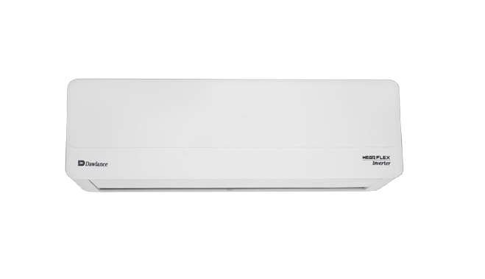
Dawlance Hyper T3 1.5 Ton Inverter AC (White)

Product Overview
The Dawlance Hyper T3 1.5 Ton Inverter AC is designed for extreme
hot climate conditions. It uses advanced T3 inverter technology to deliver powerful
cooling with reduced electricity consumption.

Key Features
• T3 Twin Rotary Compressor
• Inverter Technology
• Low Voltage Operation
• Heat & Cool Function
• R32 Eco‑Friendly Refrigerant
• 4D Airflow
• Gold Fin Condenser
• Auto Restart & Sleep Mode

Technical Specifications
Capacity: 1.5 Ton (18000 BTU)
Compressor Type: T3 Twin Rotary
Refrigerant: R32
Voltage Range: 150 – 260 V
Frequency: 50 Hz
Cooling Mode: Yes
Heating Mode: Yes

Dimensions & Color
Color: White
Indoor Unit: Wall Mounted
Outdoor Unit: Weather Resistant

Package Contents
• Indoor Unit
• Outdoor Unit
• Remote Control
• User Manual
• Installation Kit

Warranty
• Compressor: 10 Years
• PCB: 4 Years
• Parts: 1 Year

Installation & Safety Notes
• Installation by authorized technician recommended
• Use proper MCB and wiring
• Maintain airflow clearance

