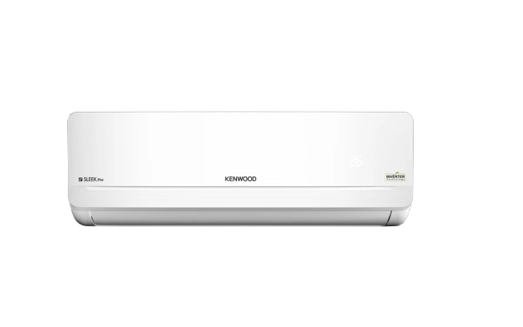
Kenwood E‑Sleek Pro Inverter Air Conditioner

Product Overview
Kenwood E‑Sleek Pro Inverter Air Conditioners are designed to deliver powerful cooling with high energy efficiency and modern aesthetics. Equipped with advanced inverter technology, this series ensures stable performance, low noise operation, and long‑lasting durability, making it ideal for homes and offices in Pakistan.

Key Features
- DC Inverter Technology
- Up to 60% Energy Saving
- 4D Air Flow for Uniform Cooling
- Eco‑Friendly R32 Refrigerant
- Ultra‑Silent Operation
- I‑Feel Temperature Control
- Golden Fin Condenser (Anti‑Corrosion)
- Sleep Mode
- Self‑Cleaning Function
- Fault Code Indication

Technical Specifications
Feature | Details
AC Type | Split DC Inverter
Available Capacities | 1 Ton (KES‑1263S), 1.5 Ton (KES‑1863S)
Refrigerant | R32 Eco‑Friendly
Air Flow | 4D Air Flow
Noise Level | Low / Silent Operation
Energy Efficiency | Up to 60% Energy Saving
Voltage Range | Wide Voltage Operation
Usage | Residential & Commercial

Design & Build
- Sleek and modern indoor unit design
- High‑quality plastic body with premium finish
- Golden fin coating for enhanced durability
- Strong copper tubing for efficient heat transfer
- Designed for long‑term performance in hot climates

Package Contents
- Indoor Unit
- Outdoor Unit
- Remote Control
- User Manual
- Installation Accessories

Warranty
Warranty may vary by dealer. Common market warranty includes:
• Compressor Warranty: Up to 10 Years
• PCB Warranty: Up to 4 Years
• Parts Warranty: 1 Year

Installation & Safety Notes
- Installation should be carried out by authorized technicians only
- Use appropriate wiring, MCB, and earthing
- Ensure proper ventilation around the outdoor unit
- Follow all electrical and safety standards during installation

