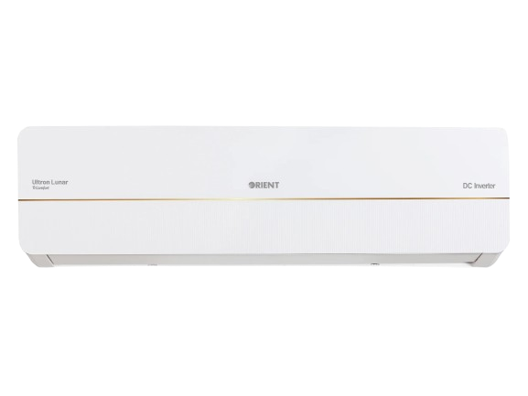
Orient Ultron King E-Comfort Silk Inverter Air Conditioner

Product Overview
Orient Ultron King E-Comfort Silk Inverter Air Conditioner is engineered to provide powerful cooling, high energy efficiency, and reliable performance even in extreme summer conditions. With advanced DC inverter technology and a premium silk-finish design, this AC is ideal for modern homes and offices.

Key Features
- Japanese DC Inverter Technology
- Up to 60% Energy Saving
- T3 Tropicalized Compressor for Extreme Heat
- E-Comfort Technology for Stable Cooling
- Low Voltage Startup Capability
- Turbo Cooling Mode
- Ultra-Silent Operation
- Eco-Friendly R32 Refrigerant
- Self-Cleaning Function
- Auto Restart Function
- Sleep Mode

Technical Specifications
Feature | Details
AC Type | Split DC Inverter
Series | Ultron King E-Comfort Silk
Available Capacities | 1 Ton, 1.5 Ton
Compressor Type | T3 Inverter Compressor
Refrigerant | R32 Eco-Friendly
Cooling Performance | High Performance Cooling
Voltage Range | Wide Voltage Operation
Noise Level | Low Noise Operation
Usage | Residential & Commercial

Design & Build
- Premium silk-finish indoor unit design
- Corrosion-resistant outdoor unit body
- Golden fin condenser coating for durability
- High-quality copper tubing
- Built for long-term reliable performance

Package Contents
- Indoor Unit
- Outdoor Unit
- Remote Control
- User Manual
- Installation Kit

Warranty
Warranty may vary by dealer. Common market warranty includes:
• Compressor Warranty: Up to 10 Years
• PCB Warranty: 4 Years
• Parts Warranty: 1 Year

Installation & Safety Notes
- Installation should be carried out by authorized Orient technicians only
- Ensure proper wiring, earthing, and MCB protection
- Maintain adequate ventilation around the outdoor unit
- Follow all electrical and safety standards during installation

