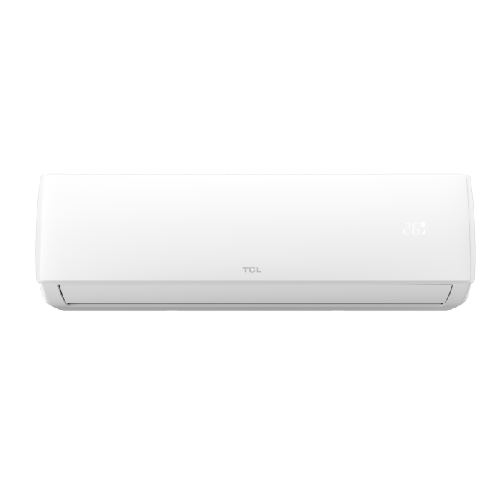
TCL Extreme Series Inverter Air Conditioner

Product Overview
TCL Extreme Series Inverter Air Conditioners are designed for
powerful cooling performance in extreme weather conditions. Equipped with modern
inverter technology, this series ensures energy efficiency, durability, and stable
operation even at high ambient temperatures.

Key Features
• Inverter Technology
• Extreme Cooling Performance
• T3 Compressor for Hot Climate
• Low Voltage Startup
• Energy Efficient Operation
• Turbo Cooling Mode
• Auto Restart Function
• Sleep Mode

Technical Specifications
Compressor Type: T3 Inverter
Refrigerant: R32 Eco‑Friendly
Voltage Range: 150 – 260 V
Frequency: 50 Hz
Cooling Mode: Yes
Heating Mode: Yes
Air Flow: High Volume

Design & Build
• Elegant indoor unit design
• Corrosion‑resistant outdoor unit
• Strong copper tubing
• Long‑lasting performance

Package Contents
• Indoor Unit
• Outdoor Unit
• Remote Control
• User Manual
• Installation Kit

Warranty
• Compressor Warranty: Up to 10 Years
• PCB Warranty: 4 Years
• Parts Warranty: 1 Year

Installation & Safety Notes
• Installation should be carried out by authorized technicians
• Use appropriate wiring and MCB
• Ensure proper ventilation around outdoor unit
• Follow electrical safety standards

