**Data Pre-processing for credit card approval dataset**

**General Information about csv files.**

* There were two csv files .
* **Credit_card.csv** had all the information about the customers like   
  **Features name:** (Credit_Card.csv)

**Ind_ID:** Client ID

**Gender:** Gender information

**Car_owner**: Having car or not

**Propert_owner**: Having property or not

**Children:** Count of children

**Annual_income**: Annual income

**Type_Income**: Income type

**Education:** Education level

**Marital_status**: Marital_status

**Housing_type**: Living style

**Birthday_count**: Use backward count from current day (0), -1 means yesterday.

**Employed_days**: Start date of employment. Use backward count from current day (0)Positive value means, individual is currently unemployed.

**Mobile_phone**: Any mobile phone

**Work_phone**: Any work phone

**Phone:** Any phone number

**EMAIL_ID**: Any email ID

**Type_Occupation**: Occupation

**Family_Members**: Family size

* Another data set **(Credit_card_label.csv**) contains two key pieces of information
* **ID:** The joining key between application data and credit status data, same is Ind_ID
* **Label:** 0 is application approved and 1 is application rejected.

**Steps followed in data preprocessing**

* The two datasets have a column that is Id of the customers. We have merged the datasets on the basis of this column.
* We replaced all the positive values in Employed days column with zero
* The Birthday_count and Employed_days columns are in days so we added two new columns representing age and employment years .
* We filled the missing values in age column with mean and converted it into integer type.
* The missing values in Type_occupation column were around 30% so we removed the whole column.
* We filled the missing values in Gender column with mode i.e ‘female’.
* We dropped the id column,Employed_days,Birthday_count columns since we have added two new columns age and EmploymentYears.
* Mobile-phone column has all values as 1 so we dropped that column also.

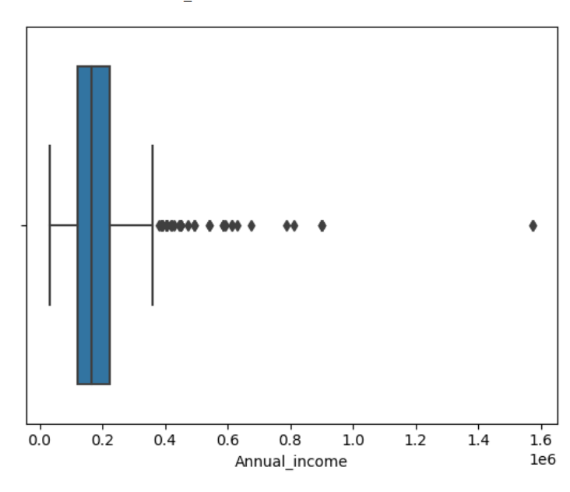

* The Annual income has 4 percent data as outliers so we removed those data points.

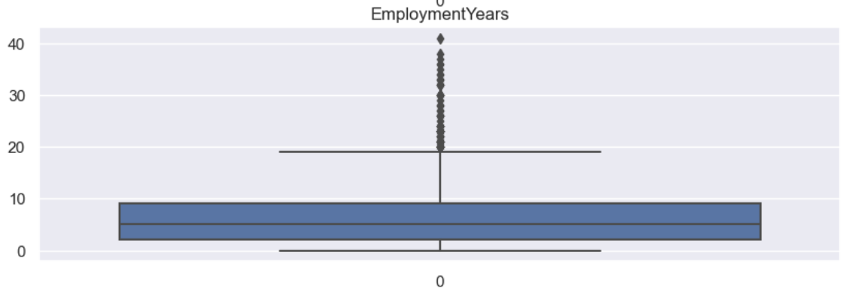

* The employment years column has 5% data as outliers so we removed those data points.
* The final data that we got from cleaning has 1367 rows and 16 column.

**Data Transformation Techniques used**

* First we split the data into train and test .
* We applied Standard scaler (fit and transform) to numerical train features and one hot encoding (fit and transform) to categorical train features.
* Similarly we applied Standard scaler (only transform) to numerical test features and one hot encoding(only transform ) to categorical features.
* Since our target feature was heavily imbalanced so we applied SMOTE() to balance the data.