**Exploratory Data analysis on credit card approval dataset**

This dataset contains the information of the bank customers related to their income, age, family members, number of children they have ,their education level, whether they own a property or they live in a rented apartment and various other features.

**General Information about the data**

* This dataset contains information about 1548 customers represented by 19 columns/features.
* Ind_ID: Client ID
* Gender: Gender information
* Car_owner: Having car or not
* Propert_owner: Having property or not
* Children: Count of children
* Annual_income: Annual income
* Type_Income: Income type
* Education: Education level
* Marital_status: Marital_status
* Housing_type: Living style
* Birthday_count: Use backward count from current day (0), -1 means yesterday.
* Employed_days: Start date of employment. Use backward count from current day (0). Positive value means, individual is currently unemployed.
* Mobile_phone: Any mobile phone
* Work_phone: Any work phone
* Phone: Any phone number.
* EMAIL_ID: Any email ID
* Type_Occupation: Occupation
* Family_Members: Family size
* Label: 0 is application approved and 1 is application rejected.

**Distribution Patterns of Individual Features**

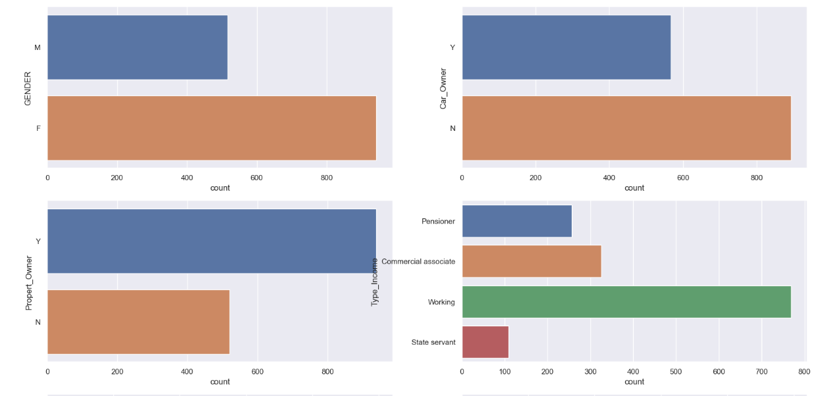

* Gender: 517 are Males and 942 are Females.
* Car_owner: Out of 1548 892 are not having cars and 567 are owning cars.
* Proper_Owner : 939 are having property while 520 are not having property.
* Type_income : Working are the highest in number i.e 768 while state servant are 109 in numbers which is least.

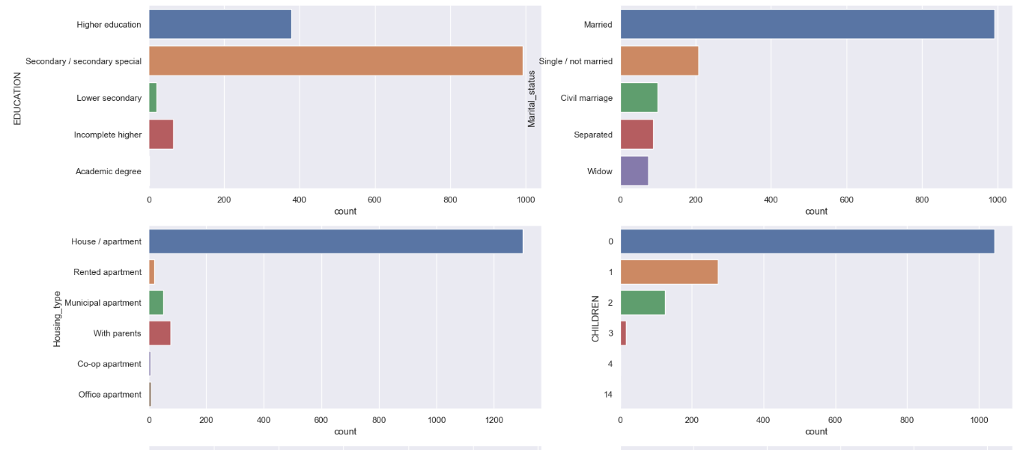

* Education: Those who have completed Seconadry/Secondary Special are highest in numbers followed by individuals having higher education.Customers having academic degree are least.
* Marital_Status: Maximum number of people are married,207 are single.
* Housing_Type:Around 1300 people live in House/apartment while very few people live in office and co-op apartment.
* Children: Maximum number of applicants are not having children followed by one child.

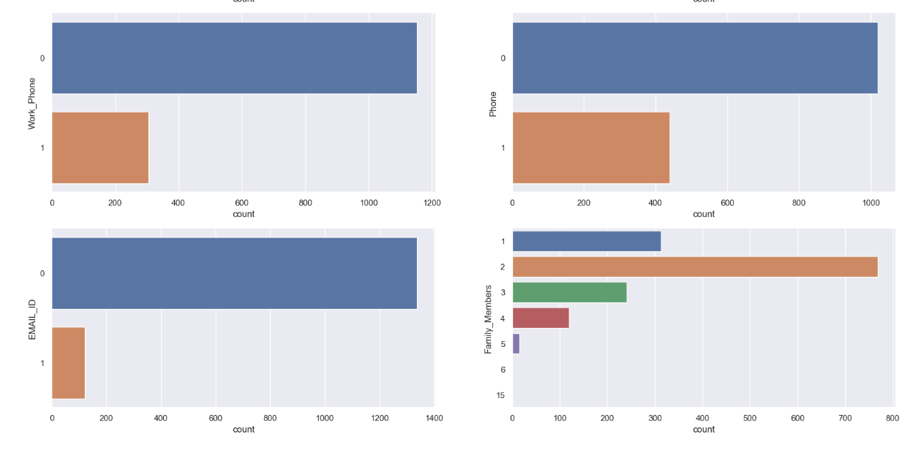

* Work_phone: More than 1000 people are not having work phone ,only 300 of them are having work phone.
* Phone:Around 1000 people are not having phone while around 400 of them are having phone.
* Email_ID: Around 1300 people are not having email_id
* Family_Members: Maximum number of people are having two family members followed by one and three family members.

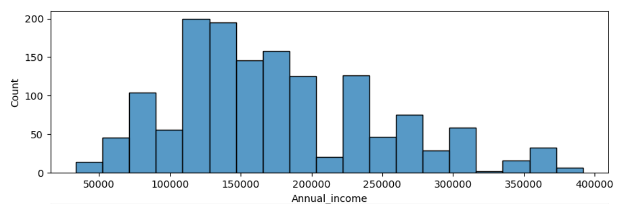

* Income range is from 50,000 to 400000.
* Most of the people have income in between 100000 to 200000.

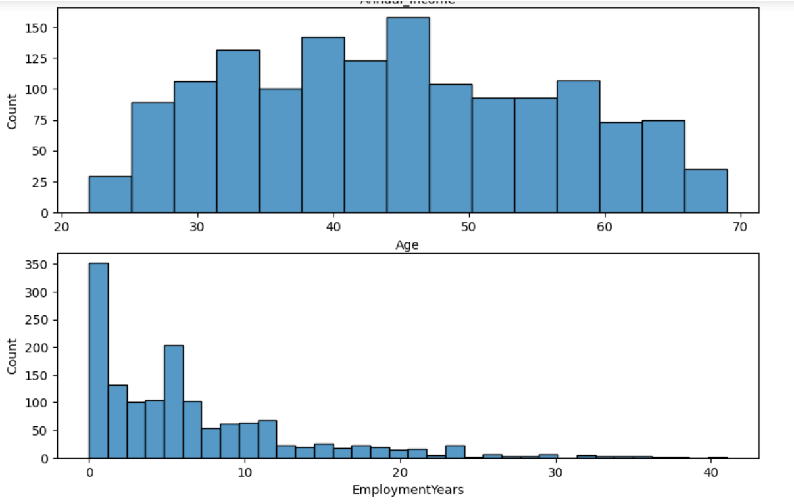

* Applicants age lies between 21 to 68 years.
* Maximum number of applicants are in their mid thirties to late forties.
* Most of the people have been employed since two years while 261 are not employed. Maximum employment is from 1 to 20 years.

**Target Feature distribution**

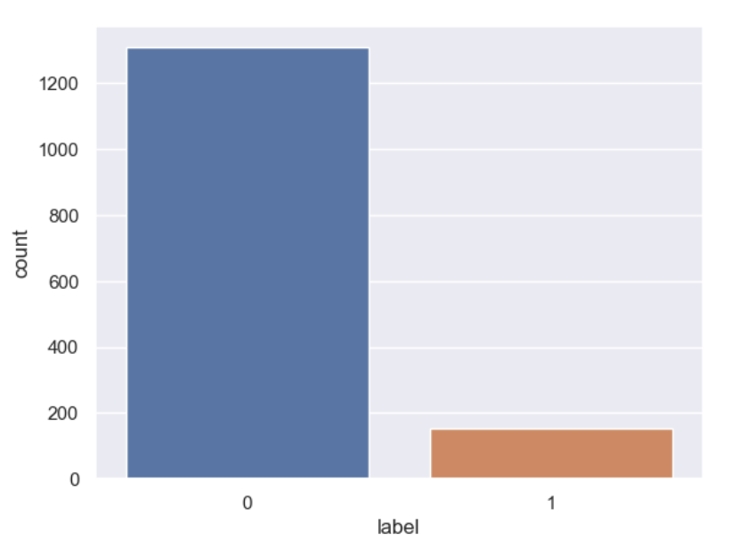

* Label feature shows that more than 1200 applicants are having credit card approved while less than 200 people are having credit card application rejected.

**Relationship of other features with label features**

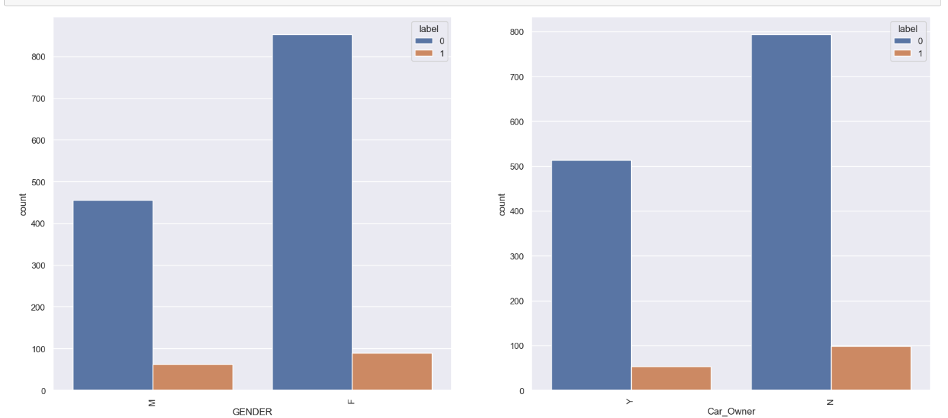

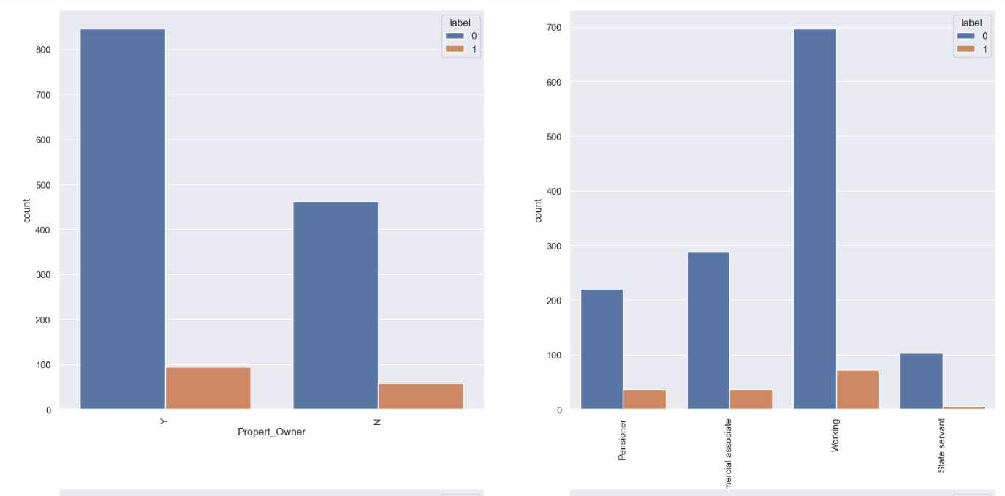

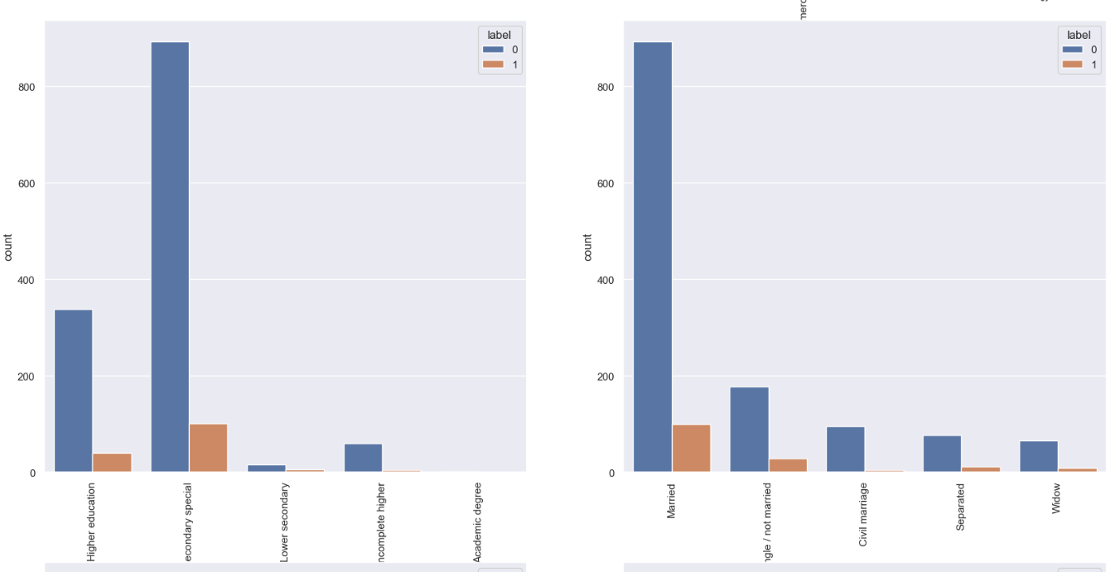

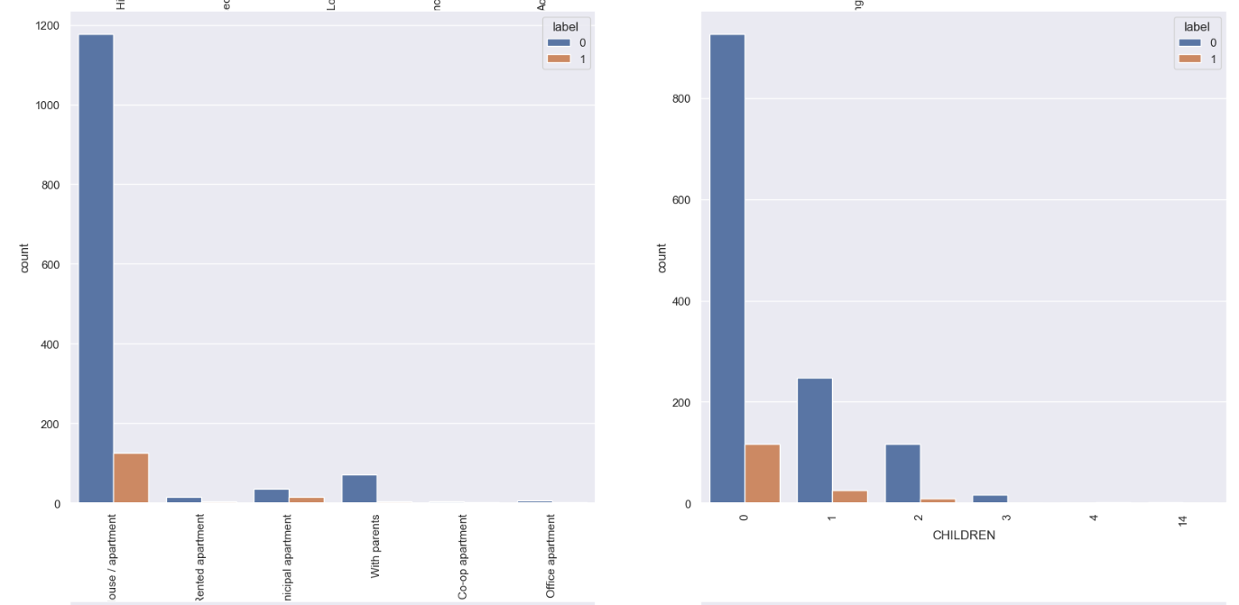

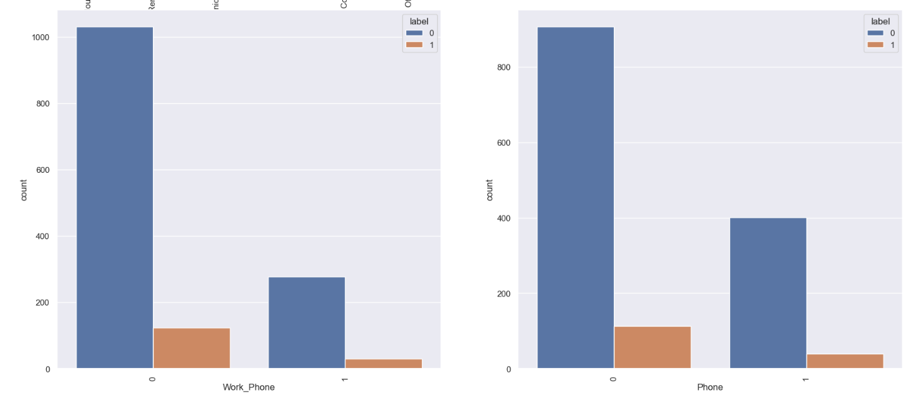

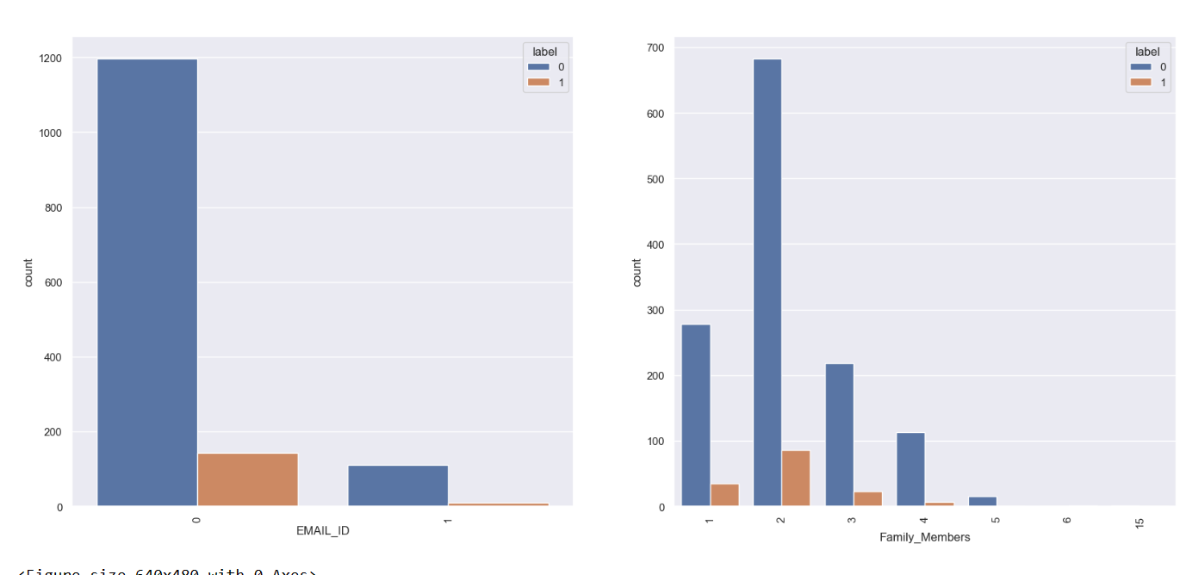

* Females and Males seems to have equal chances of getting credit card approved.
* Property owner have also similar chances of getting approved.
* People not having car are getting their applications rejected more.
* In Type Income the working class are maximum in number so they are higher in number for getting credit card approved and rejected as well. For state servant card rejected is almost negligible.
* People having secondary education are highest in getting credit card approved and rejected while Incomplete Higher education has lowest rejection.
* Customers having civil marriage status has negligible credit card disapproval .
* Customers living with parents have least rejected count.
* People having two children are less likely to have credit card application rejected.
* Work_phone and Phone features does not show any significant impact on credit card approval.
* Customers having email_id are more likely to have credit card approved.
* Customers having 4 family members have least rejection.

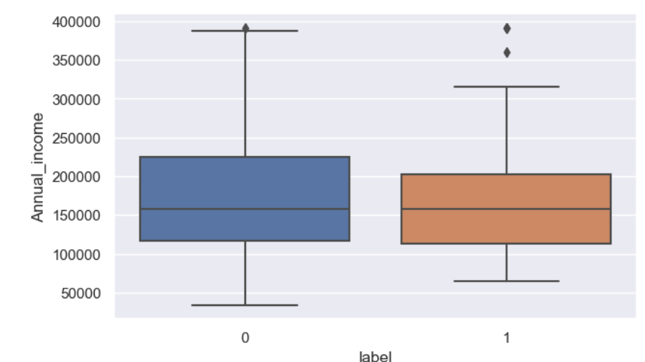

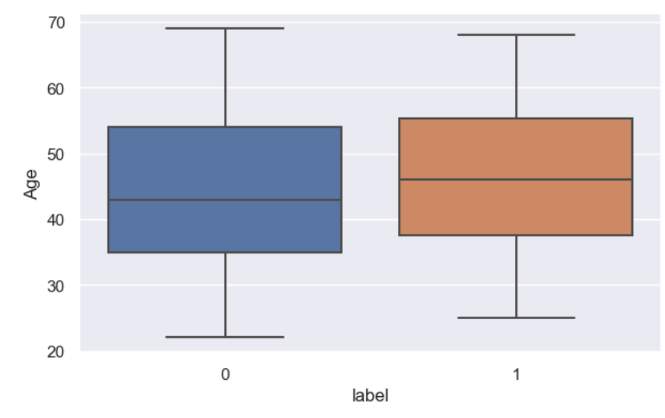

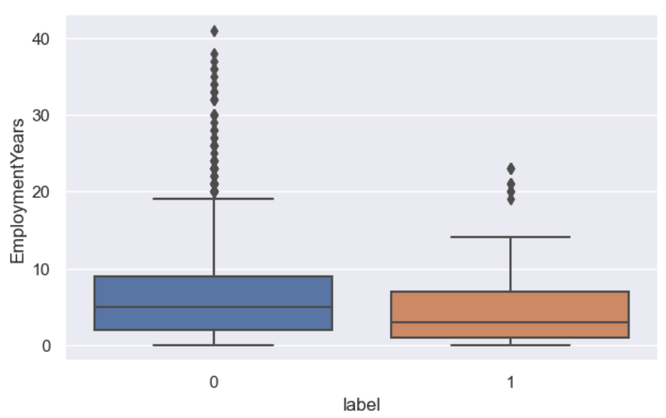

* Customers having higher level of income are more likely to have credit card approved.
* People having credit card rejected are most in their late thirties and late fifties.
* People who have been employed for longer period are having less chance of getting rejected.