Diabetes Prediction Using Machine Learning and Explainable AI
Comparative Analysis of Machine Learning Models for Diabetes Prediction Using the Pima Indians Diabetes Dataset

Abstract
This project presents a comparative analysis of multiple Machine Learning and Deep Learning models for predicting diabetes using the Pima Indians Diabetes Dataset. The models implemented include Logistic Regression, Decision Tree, Random Forest, Support Vector Machine (SVM), K-Nearest Neighbors (KNN), and Artificial Neural Network (ANN). The system evaluates model performance using Accuracy, Precision, Recall, F1-Score, and ROC-AUC metrics. Furthermore, SHAP (SHapley Additive exPlanations) was integrated to provide explainability and interpretability for the prediction system. The experimental results demonstrate that the ANN model achieved the highest ROC-AUC score, while Random Forest provided highly interpretable and competitive results.

1. Introduction
Diabetes is one of the most widespread chronic diseases globally and can lead to severe health complications if not detected early. Predictive healthcare systems powered by Machine Learning can assist healthcare professionals in identifying high-risk patients through data-driven analysis.
The objective of this project is to build an intelligent diabetes prediction system using multiple Machine Learning algorithms and compare their performance. Additionally, Explainable AI techniques were used to improve transparency and trust in the predictions.

2. Objectives
- To preprocess and analyze the diabetes dataset.
- To train multiple Machine Learning and Deep Learning models.
- To evaluate model performance using standard evaluation metrics.
- To compare the effectiveness of different algorithms.
- To integrate SHAP explainability for transparent AI predictions.

3. Dataset Description
The project uses the Pima Indians Diabetes Dataset, which contains medical diagnostic measurements of female patients. The dataset includes 768 samples and 9 attributes.
- Pregnancies
- Glucose
- Blood Pressure
- Skin Thickness
- Insulin
- BMI
- Diabetes Pedigree Function
- Age
- Outcome (Target Variable)

4. Methodology
- Data preprocessing and handling missing values.
- Exploratory Data Analysis (EDA).
- Feature scaling using StandardScaler.
- Train-test split (80% training, 20% testing).
- Training six different Machine Learning models.
- Hyperparameter tuning using GridSearchCV.
- Performance evaluation using multiple metrics.
- SHAP-based explainability analysis.

5. Implemented Models
- Logistic Regression
- Decision Tree
- Random Forest
- Support Vector Machine (SVM)
- K-Nearest Neighbors (KNN)
- Artificial Neural Network (ANN)

6. Evaluation Metrics
- Accuracy
- Precision
- Recall
- F1-Score
- ROC-AUC

7. Experimental Results
Model | Accuracy | Precision | Recall | F1-Score | ROC-AUC | CV_Avg_Accuracy
Logistic Regression | 0.7013 | 0.587 | 0.5 | 0.54 | 0.8128 | 0.7722
Decision Tree | 0.6818 | 0.5532 | 0.4815 | 0.5149 | 0.6357 | 0.7098
Random Forest | 0.7792 | 0.7273 | 0.5926 | 0.6531 | 0.8191 | 0.7644
SVM | 0.7078 | 0.6047 | 0.4815 | 0.5361 | 0.813 | 0.7656
KNN | 0.7338 | 0.6327 | 0.5741 | 0.6019 | 0.7919 | 0.7579
ANN | 0.7403 | 0.6458 | 0.5741 | 0.6078 | 0.8204 | nan
The results indicate that the ANN model achieved the highest ROC-AUC score of 0.8204, while Random Forest also demonstrated strong predictive performance.

8. Visualizations and Analysis

Class Distribution
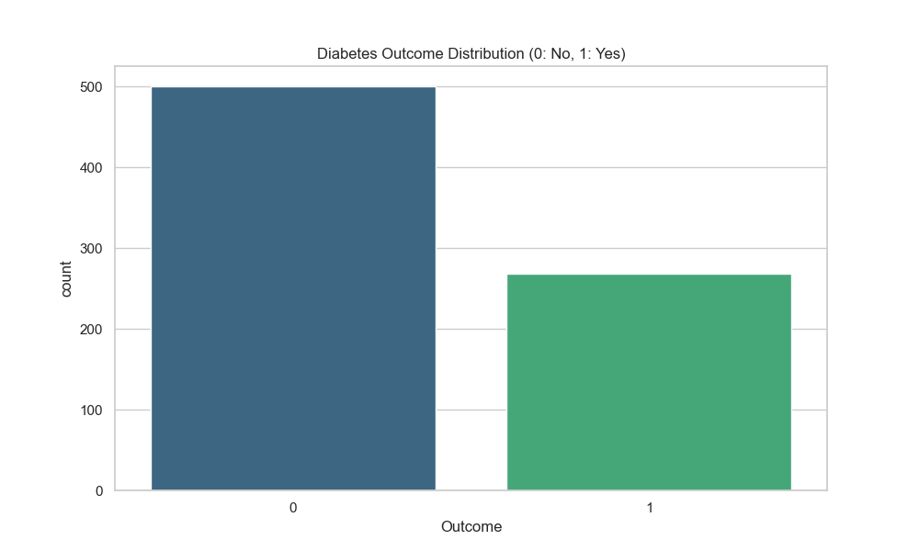
Figure: Class Distribution

Correlation Heatmap
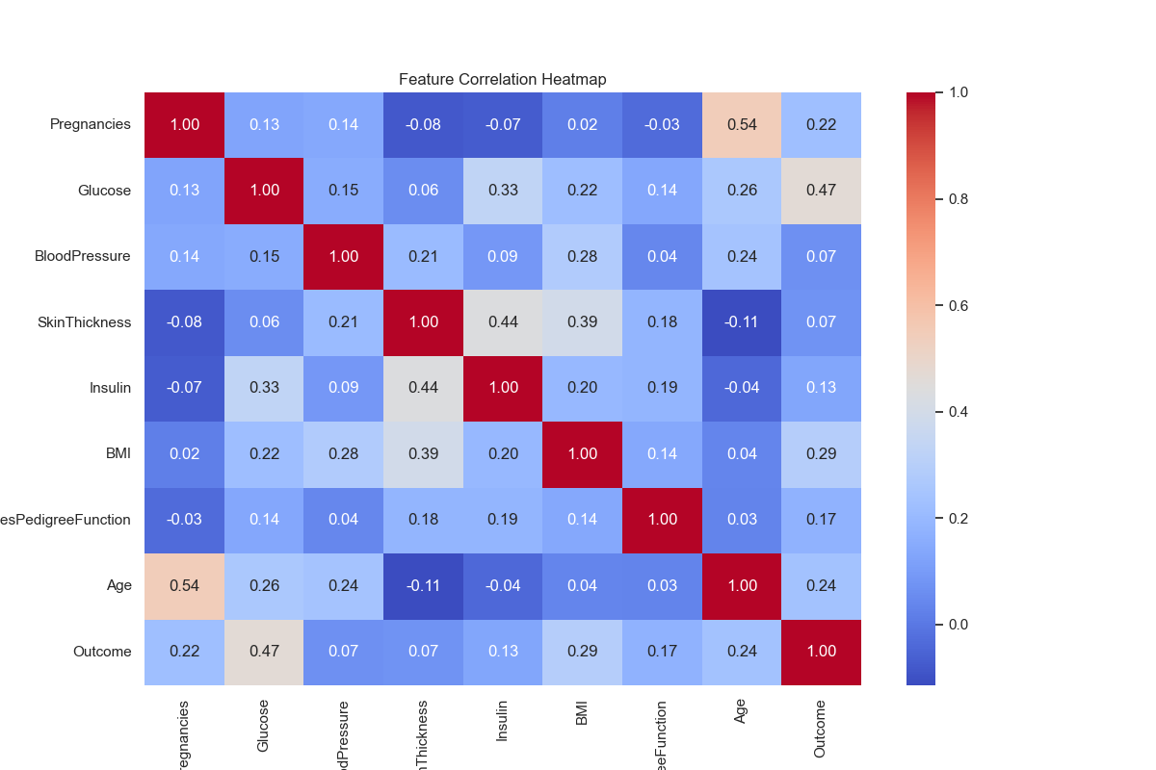
Figure: Correlation Heatmap

Feature Histograms
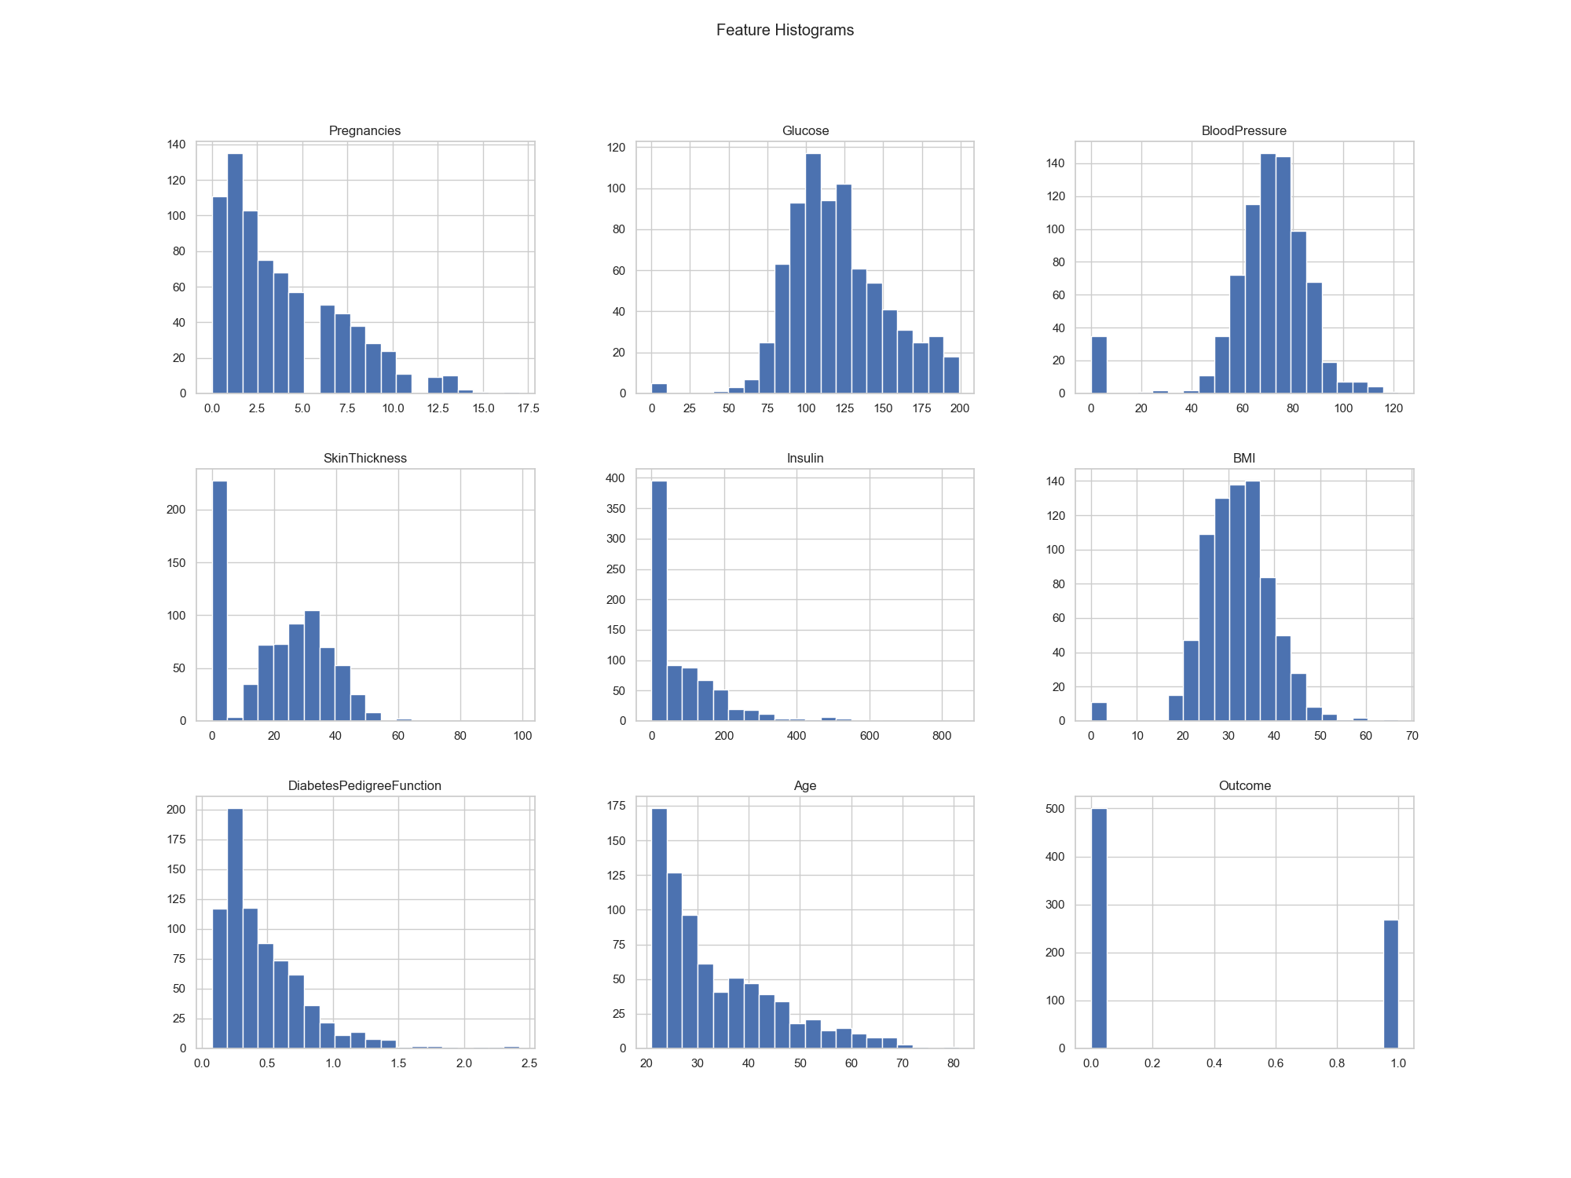
Figure: Feature Histograms

Feature Boxplots
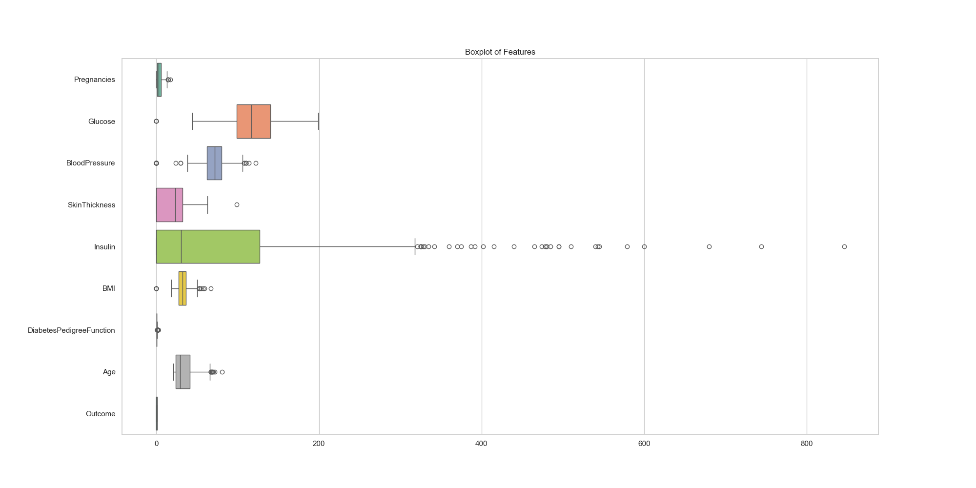
Figure: Feature Boxplots

ROC Curve Comparison
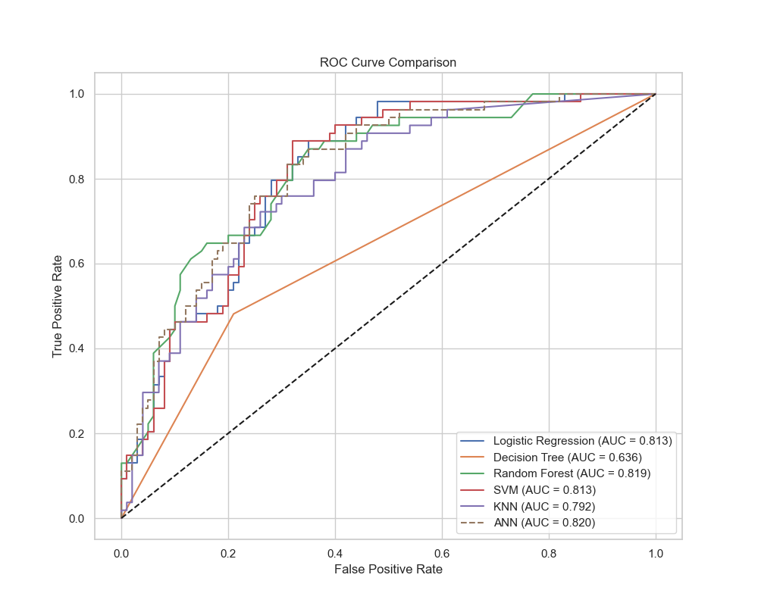
Figure: ROC Curve Comparison

Random Forest Feature Importance
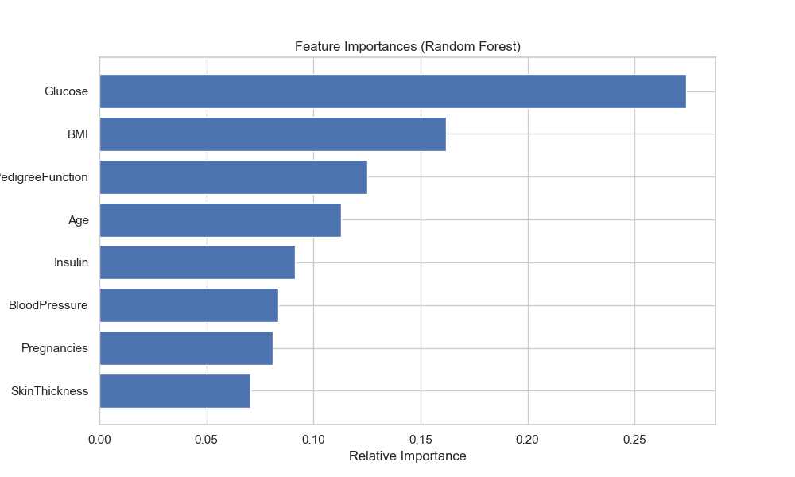
Figure: Random Forest Feature Importance

SHAP Summary Bar Plot
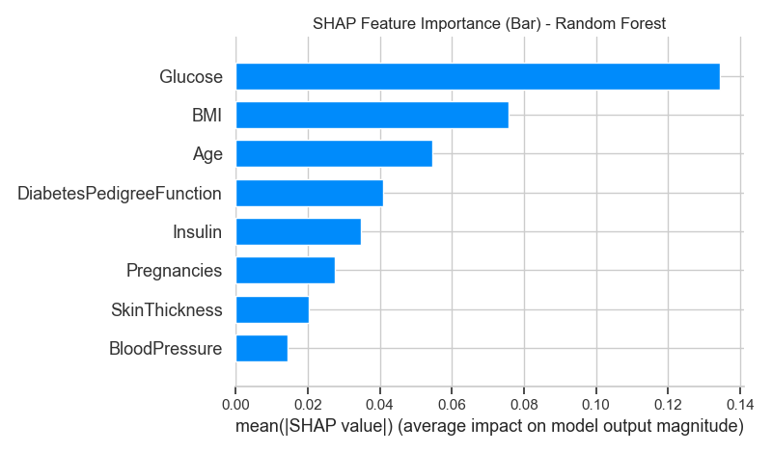
Figure: SHAP Summary Bar Plot

SHAP Beeswarm Plot
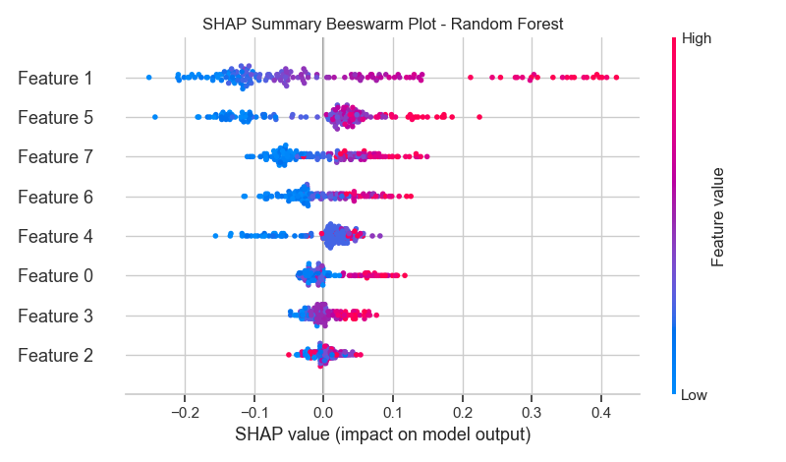
Figure: SHAP Beeswarm Plot

SHAP Dependence Plot - Glucose
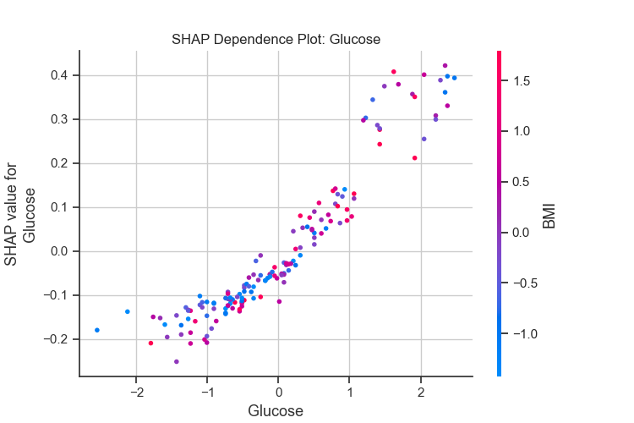
Figure: SHAP Dependence Plot - Glucose

SHAP Dependence Plot - BMI
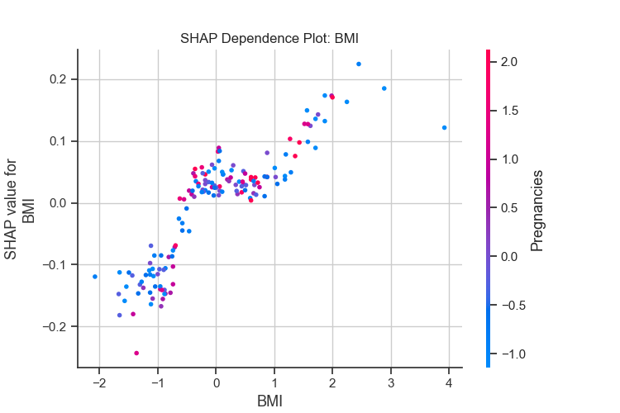
Figure: SHAP Dependence Plot - BMI

SHAP Dependence Plot - Age
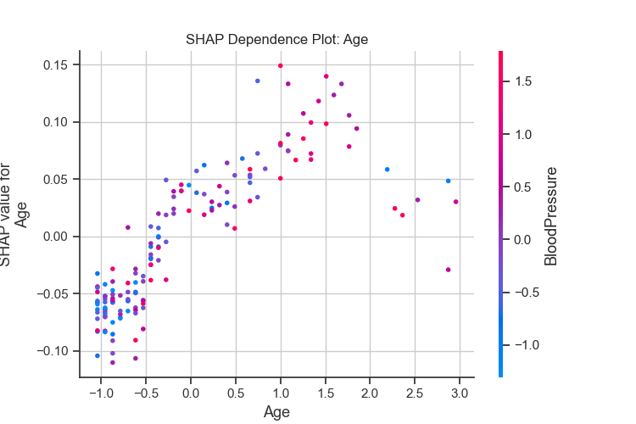
Figure: SHAP Dependence Plot - Age

SHAP Waterfall Plot
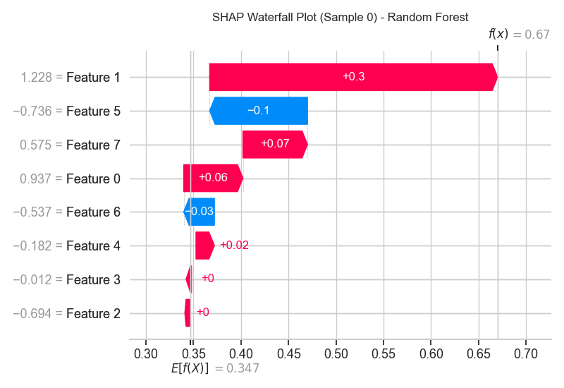
Figure: SHAP Waterfall Plot

9. Confusion Matrices

Logistic Regression
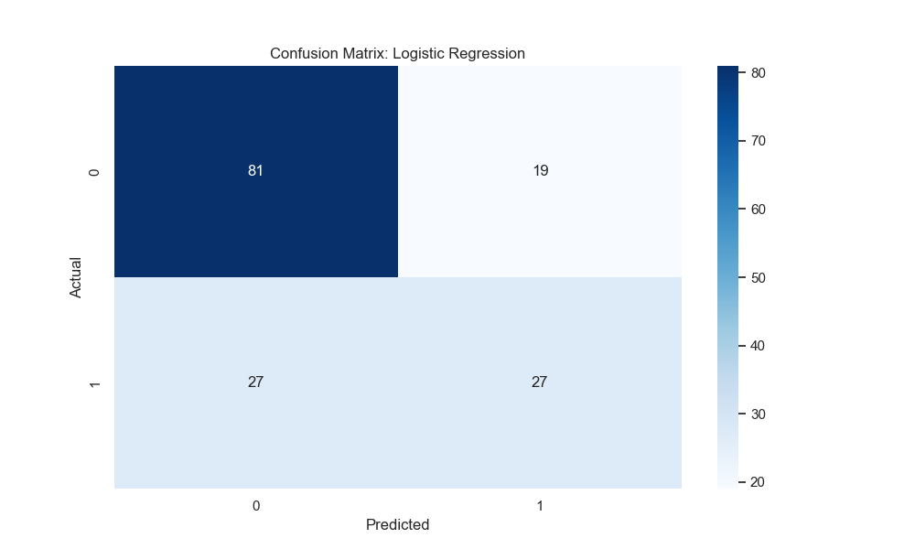
Figure: Confusion Matrix for Logistic Regression

Decision Tree
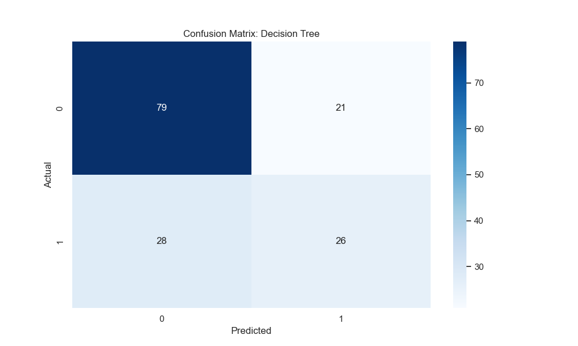
Figure: Confusion Matrix for Decision Tree

Random Forest
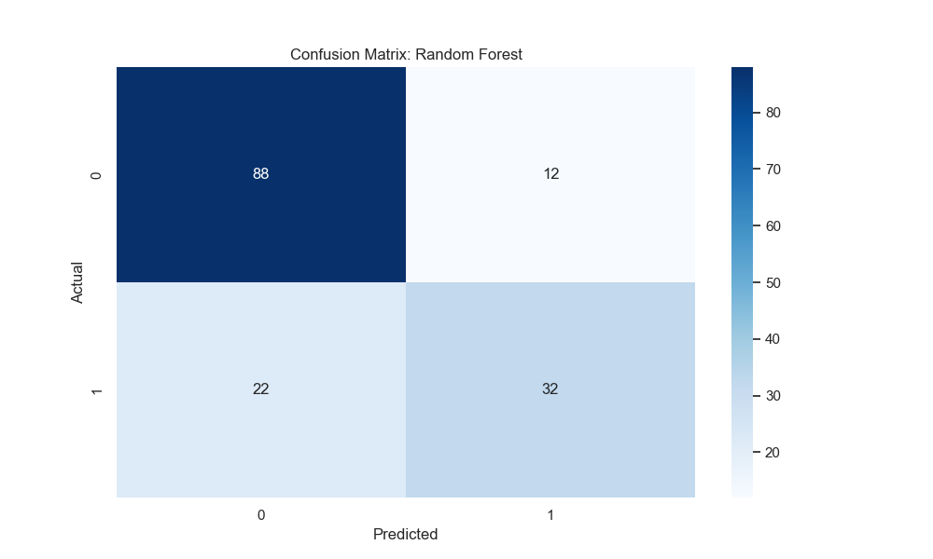
Figure: Confusion Matrix for Random Forest

SVM
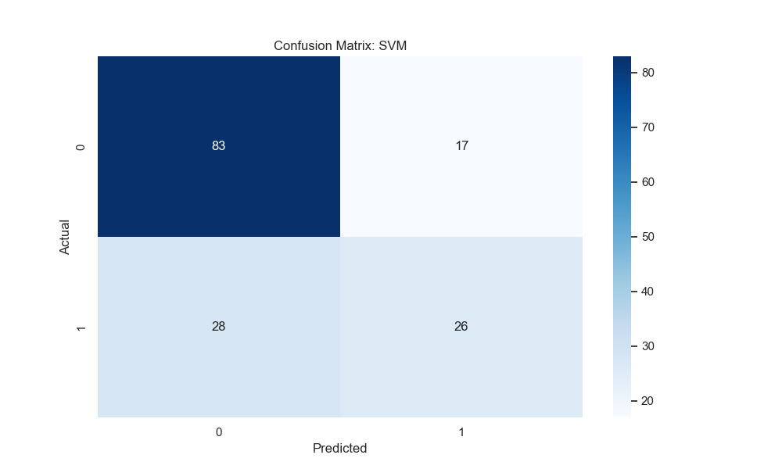
Figure: Confusion Matrix for SVM

KNN
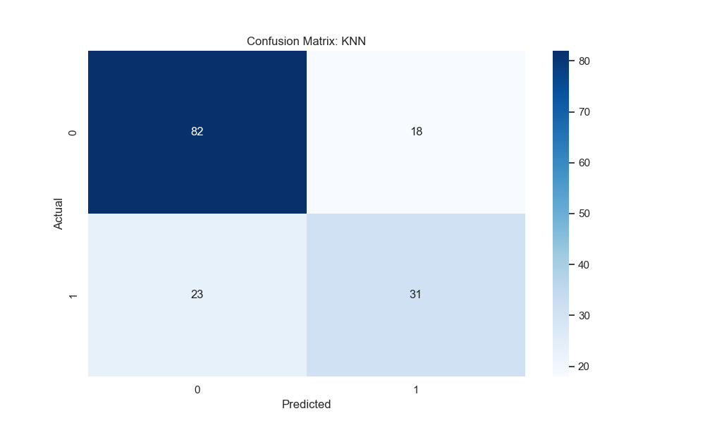
Figure: Confusion Matrix for KNN

ANN
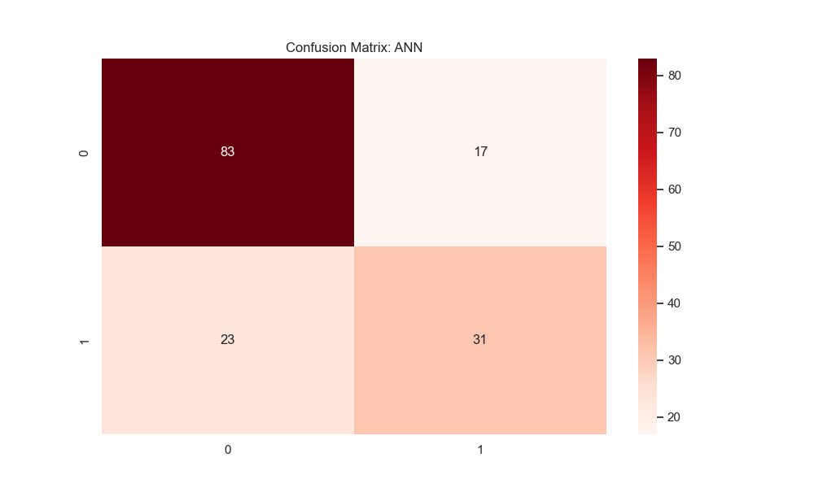
Figure: Confusion Matrix for ANN

10. Explainable AI using SHAP
SHAP (SHapley Additive exPlanations) was used to explain the predictions generated by the Random Forest model. SHAP values measure the contribution of each feature toward the final prediction.
- Glucose was identified as the most influential feature.
- BMI and Age also contributed significantly to diabetes prediction.
- SHAP summary plots helped visualize feature importance globally.
- Dependence plots illustrated how feature values impacted predictions.

11. Conclusion
This project successfully implemented multiple Machine Learning and Deep Learning models for diabetes prediction. Comparative analysis revealed that the ANN model achieved the best ROC-AUC score, while Random Forest provided strong interpretability through SHAP explainability.
The integration of Explainable AI techniques improved transparency and made the system more suitable for healthcare applications where interpretability is essential.

12. Future Work
- Deploy the model using Streamlit or Flask.
- Use larger healthcare datasets for improved generalization.
- Integrate real-time patient data.
- Apply advanced deep learning architectures.
- Enhance explainability using additional XAI techniques.

13. References
- Pima Indians Diabetes Dataset - Kaggle
- Scikit-learn Documentation
- TensorFlow/Keras Documentation
- SHAP Documentation

