SALES PERFORMANCE REPORT
FY 2023 – 2024 | Regional & Product Sales Analysis
Prepared: July 27, 2026

Executive Summary
This report presents a comprehensive analysis of company sales performance across four regions (East, North, South, and West) and five product categories (Laptop, Monitor, Printer, Keyboard, and Mouse) over the period 2023–2024. The data is drawn from 100 transaction records and consolidated into an interactive Excel dashboard supported by Pivot Tables and Slicers.
Overall, total sales stood at ₹27,23,000 across 100 orders, with an average order value of ₹27,230. Laptops emerged as the dominant revenue driver, while the North region led in regional performance. Sales activity was notably stronger in the first eight months of the year, with a marked decline from September onward.

Key Performance Indicators
Total Sales  ₹27,23,000 | Total Orders  100 | Avg Sales  ₹27,230 | Max Sales  ₹88,700 | Min Sales  ₹5,700

Regional Sales Performance
The North region generated the highest sales contribution, followed by East, West, and South. The distribution below shows each region's share of total revenue and order volume.
Region | Sales (₹) | Share (%) | Orders
North | 9,34,600 | 34% | 27
East | 7,64,400 | 28% | 29
West | 5,49,000 | 20% | 24
South | 4,75,000 | 18% | 20
Insight: North and East together account for 62% of total revenue, indicating a concentration of demand in these two regions. South, despite having the second-highest order count relative to its region, generated the lowest sales value — suggesting a lower average order size that may warrant targeted upselling.

Product Sales Contribution
Laptops are by far the top-performing product category, contributing more than 60% of total sales value despite likely being a lower-volume, higher-ticket item.
Product | Sales (₹) | Share (%)
Laptop | 16,86,700 | 61.9%
Printer | 4,07,500 | 15.0%
Monitor | 3,38,200 | 12.4%
Keyboard | 1,67,800 | 6.2%
Mouse | 1,22,800 | 4.5%
Insight: Laptop sales significantly outweigh all other categories combined would be close, but individually each accessory (Mouse, Keyboard) contributes under 7%. This highlights an opportunity to bundle accessories with laptop purchases to grow average order value.

Monthly Sales Trend
Monthly sales remained strong and stable from January to August, consistently in the ₹2,64,000–₹2,80,000 range. From September onward, sales dropped sharply to roughly ₹1,34,000–₹1,41,000 per month and stayed flat through December.
Month | Sales (₹)
Jan | 2,68,700
Feb | 2,65,700
Mar | 2,72,300
Apr | 2,79,600
May | 2,72,600
Jun | 2,64,200
Jul | 2,75,200
Aug | 2,75,200
Sep | 1,34,600
Oct | 1,34,000
Nov | 1,39,900
Dec | 1,41,000
Insight: The Sep–Dec decline represents roughly a 49% drop from the Jan–Aug average, a pattern significant enough to investigate — possible causes include seasonal demand shifts, inventory or supply constraints, or reduced sales activity that should be validated against operational records.

Year-over-Year Comparison
Year | Sales (₹) | Share (%)
2023 | 16,25,800 | 59.7%
2024 | 10,97,200 | 40.3%
2023 outperformed 2024 by roughly ₹5,28,600 (a ~32% decline year-over-year), consistent with the sharp drop observed in the last four months of the data period.

Top Performing Salespersons
Salesperson | Total Sales (₹)
Rajesh Sharma | 6,02,800
Karan Singh | 5,82,700
Aditi Shah | 5,01,200
Deepak Joshi | 1,47,000
Arif Khan | 1,40,200
Insight: Rajesh Sharma, Karan Singh, and Aditi Shah together contribute over 61% of total sales, indicating high dependency on a small group of top performers. Structured mentoring or process replication from these performers could help lift mid-tier sales contributors.

Dashboard Snapshot
The full interactive dashboard — including KPI cards, regional donut chart, product bar chart, and monthly trend line — is shown below and available as a filterable Excel workbook.
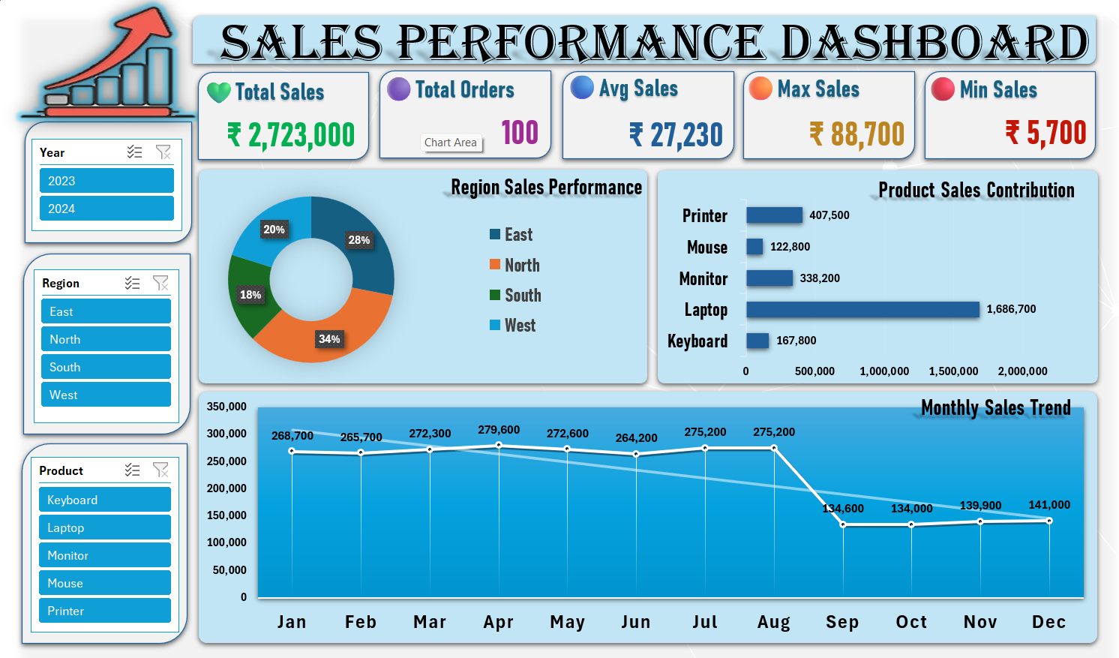

Recommendations
- Investigate the Sep–Dec sales decline against inventory, marketing, and staffing records to identify root cause.
- Increase focus on the South region through targeted promotions or account outreach to lift its low share of revenue.
- Bundle high-margin accessories (Mouse, Keyboard) with Laptop purchases to raise average order value.
- Document and replicate the sales approach of top performers (Rajesh Sharma, Karan Singh, Aditi Shah) across the wider sales team.
- Set a recovery target for Q4 2024/Q1 2025 to bring monthly sales back toward the ₹2,70,000+ range observed in H1.

Conclusion
The business delivered strong, consistent performance through the first eight months of the analysis period, anchored by the North and East regions and driven heavily by Laptop sales. The sharp decline beginning in September is the single most important finding in this dataset and should be prioritized for root-cause investigation, as reversing it represents the largest available opportunity for revenue recovery.

