1. Below information looks like dynamic content and search functionality also there. Please confirm on this.

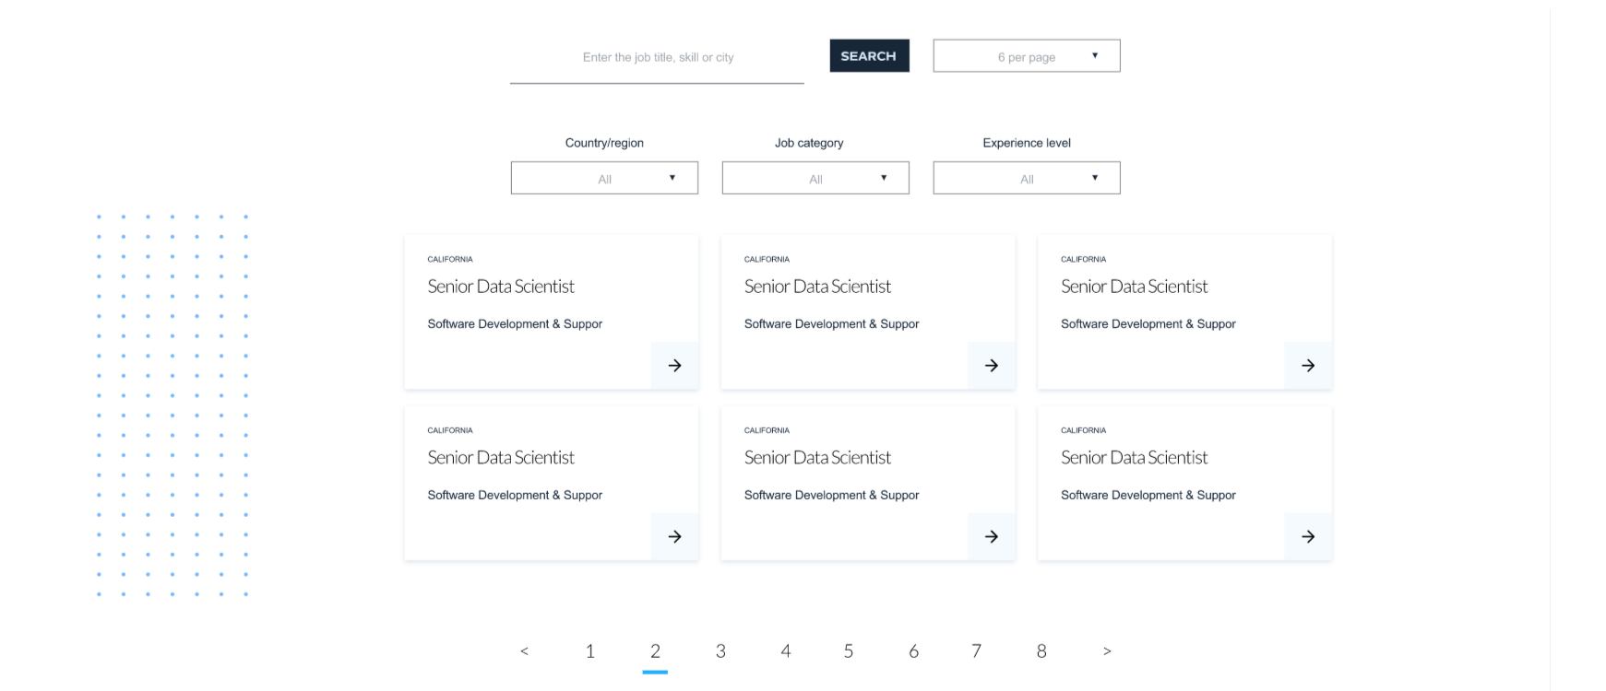

1. Submit option is there on Get in touch and solution screens. What needs to be done on click of submit.

Azeem: Send email to an email address with attachment.

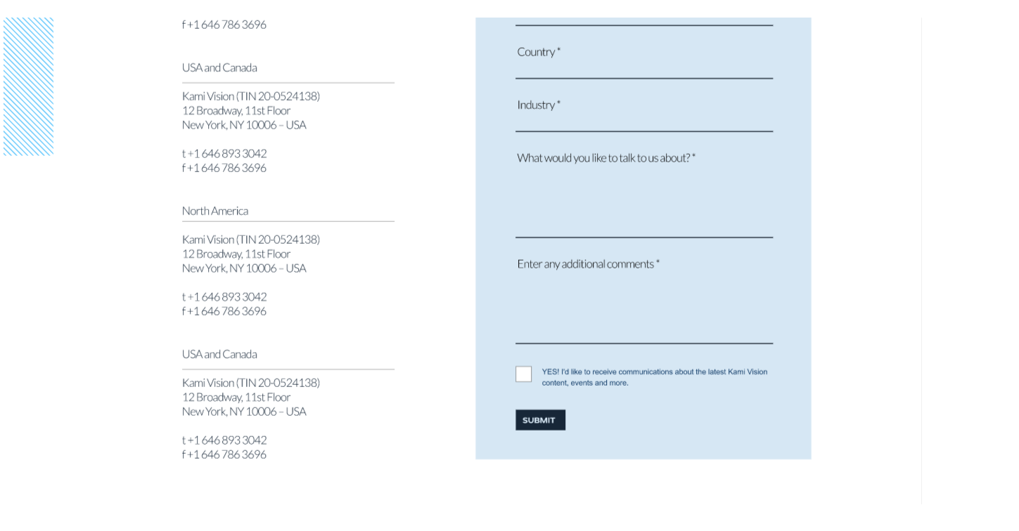

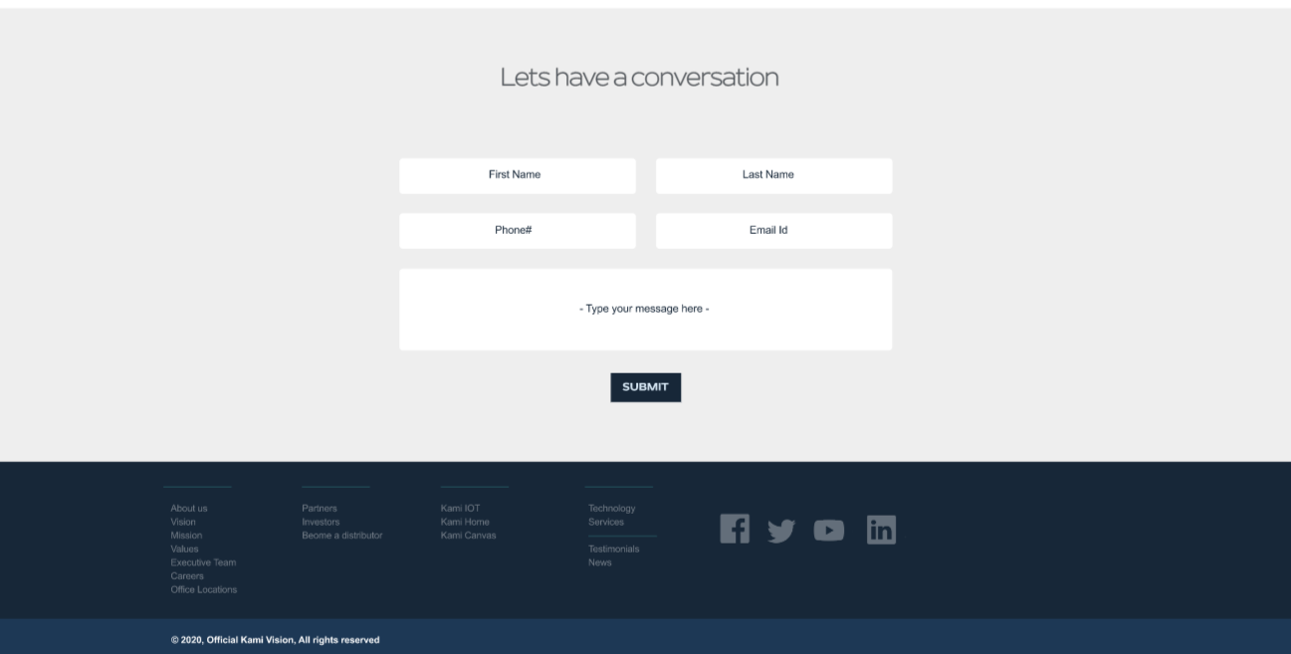

1. There are some blue lines on most of the screen design. Is this represents some effect?

Azeem: They are patterns which we discussed during our meeting. They are part of design.

