1. Please share Strip image ( about us). pattern is different from available strip images.

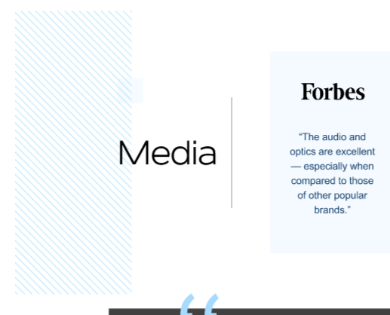

1. Banner image
2. Strip image  
   