OPEN LANE PROJECT REPORT

Azeem.R.Gadkari and Manish.Patla

PES2UG20EC124 and PES2UG20EC129

DESIGN NAME: 8 bit priority encoder

1. Final Optimization
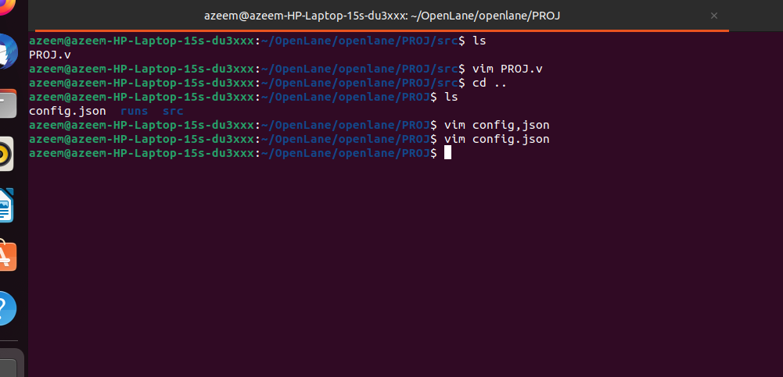

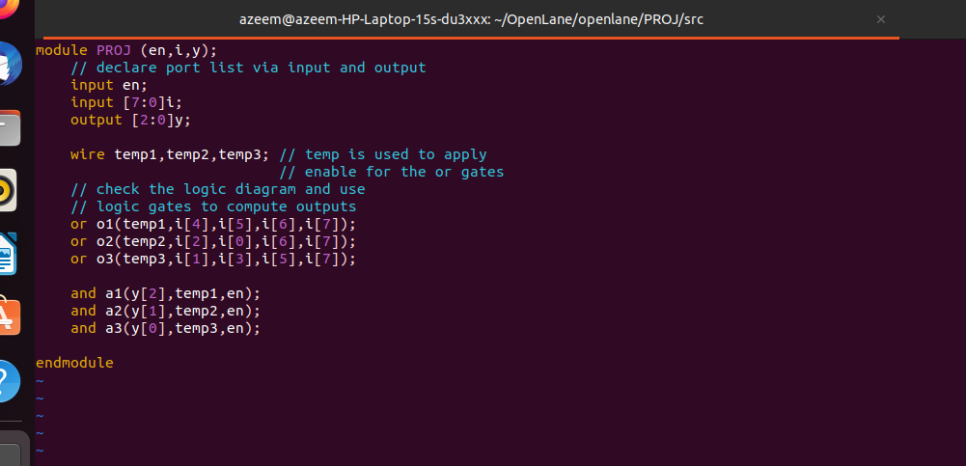
Verilog file structural style (optmized)
Config.json file with optimization
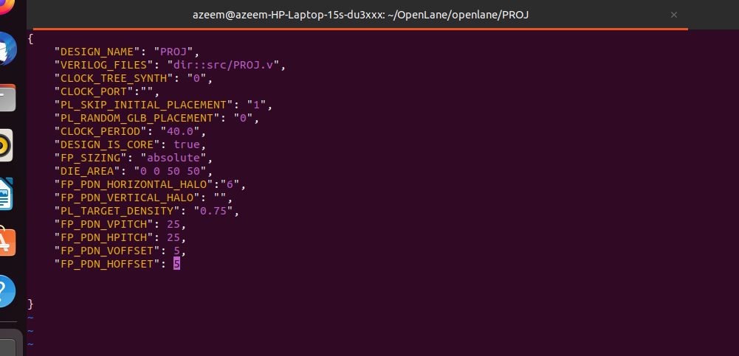
Generating Layout using Klayout
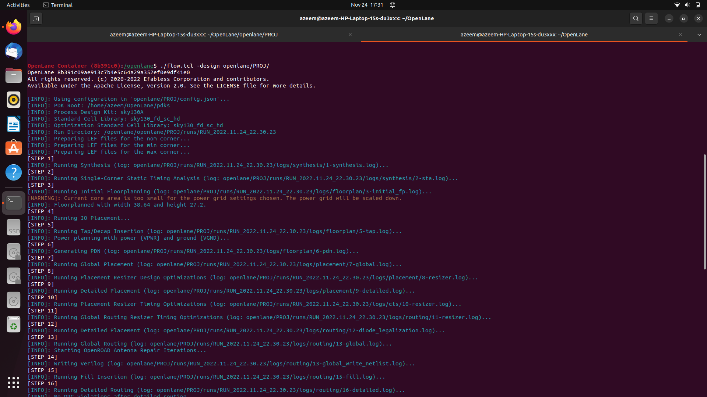

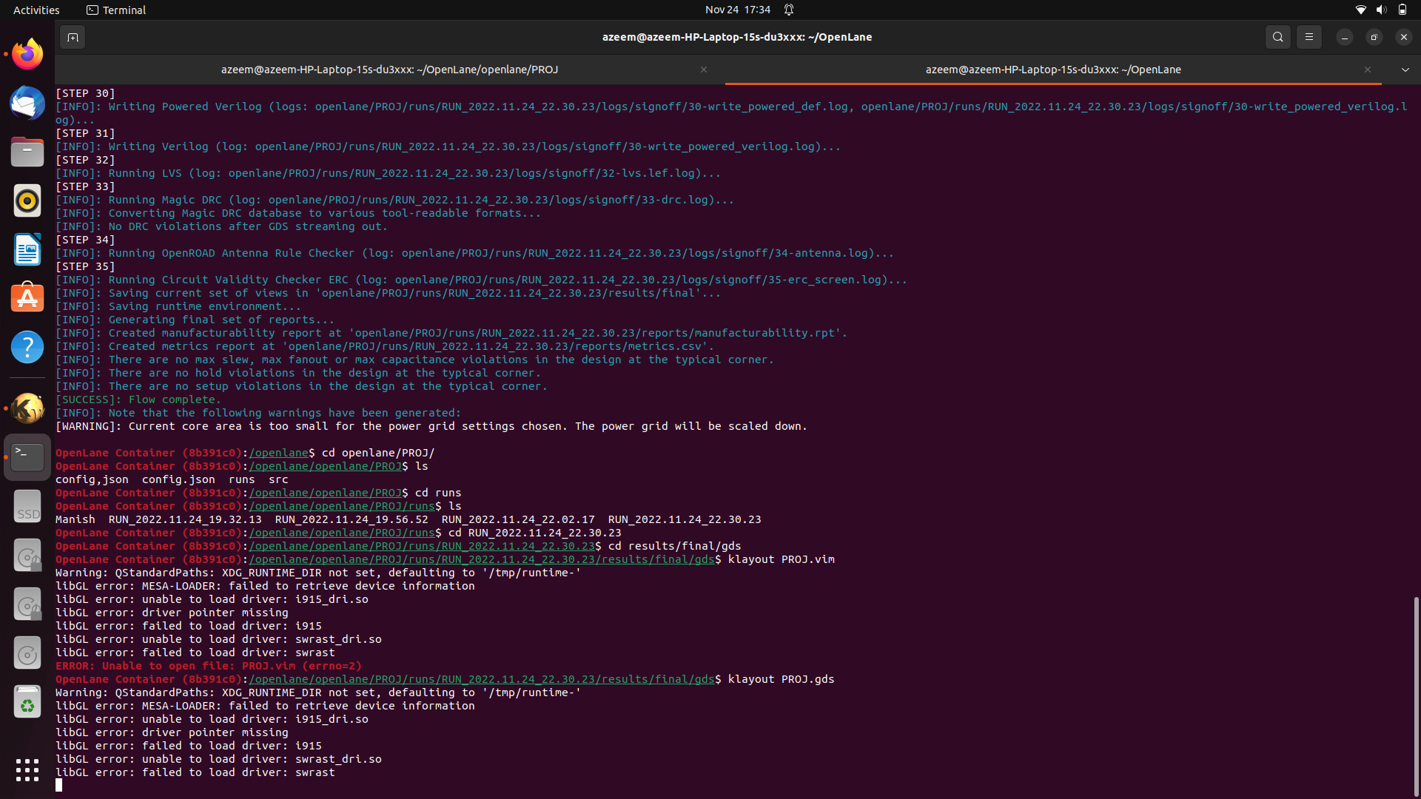
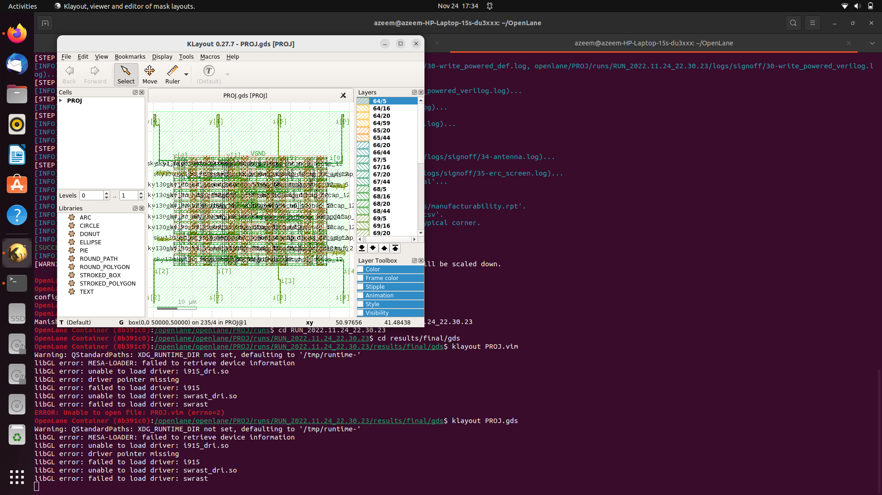

Layout Optimized

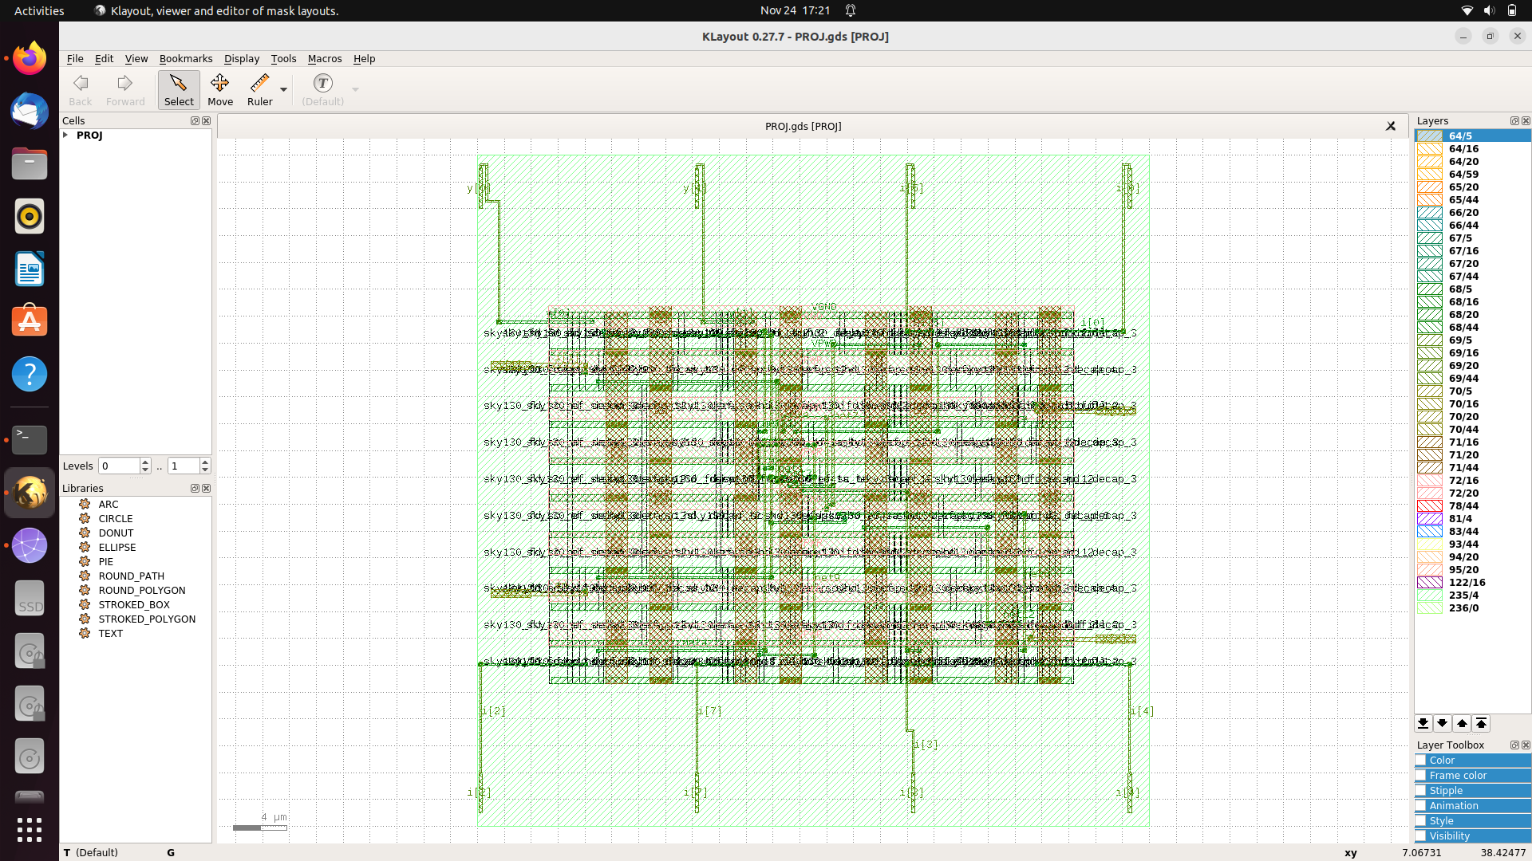
Results:

Units: 1000
Number of layers: 13
Number of macros: 441
Number of vias: 25
Number of viarulegen: 25

[INFO DRT-0150] Reading design.

Design: PROJ
Die area: ( 0 0 ) ( 50000 50000 )
Number of track patterns: 12
Number of DEF vias: 4
Number of components: 137
Number of terminals: 14
Number of snets: 2
Number of nets: 24
After synthsis of design
=== PROJ ===

Number of wires: 3
Number of wire bits: 12
Number of public wires: 3
Number of public wire bits: 12
Number of memories: 0
Number of memory bits: 0
Number of processes: 0
Number of cells: 3
sky130_fd_sc_hd__o41a_2 3

Chip area for module '\PROJ': 37.536000
Clock period : 40 Clock frequency 25

After FP Placement and Routing
===========================================================================
report_design_area
============================================================================
Design area 98 u^2 9% utilization.

------------------------------------------------------------------------------------------------------------------------------------------------------------------------------------------------------

2. 1st Optimization
Verilog file (not optimized)
Config,json file (optimized)

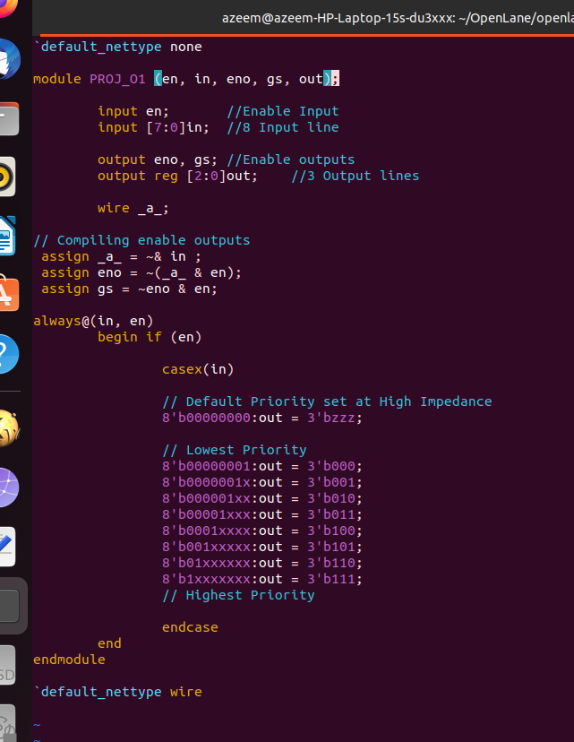

Config file

Klayout
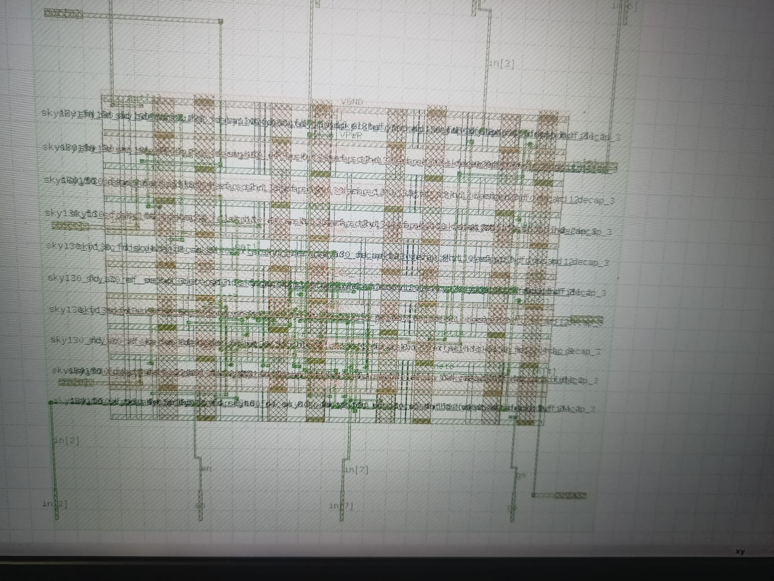
Results:
Units: 1000
Number of layers: 13
Number of macros: 441
Number of vias: 25
Number of viarulegen: 25

[INFO DRT-0150] Reading design.

Design: PROJ
Die area: ( 0 0 ) ( 50000 50000 )
Number of track patterns: 12
Number of DEF vias: 4
Number of components: 156
Number of terminals: 16
Number of snets: 2
Number of nets: 39

After synthesis
=== PROJ ===

Number of wires: 16
Number of wire bits: 25
Number of public wires: 5
Number of public wire bits: 14
Number of memories: 0
Number of memory bits: 0
Number of processes: 0
Number of cells: 16
sky130_fd_sc_hd__a211o_2 1
sky130_fd_sc_hd__a21boi_2 1
sky130_fd_sc_hd__a21oi_2 1
sky130_fd_sc_hd__and4_2 2
sky130_fd_sc_hd__buf_1 1
sky130_fd_sc_hd__dlxtp_1 3
sky130_fd_sc_hd__inv_2 4
sky130_fd_sc_hd__o21ba_2 1
sky130_fd_sc_hd__o221ai_2 1
sky130_fd_sc_hd__or4_2 1
Clock Period : 40 Frequency: 25
Chip area for module '\PROJ': 147.641600

After FP , Placement and Route

===========================================================================
report_design_area
============================================================================
Design area 203 u^2 19% utilization.

------------------------------------------------------------------------------------------------------------------------------------------------------------------------------------------------------

3. Without Optimization

Verilogfile (not optimized)
Config file (not optimized)

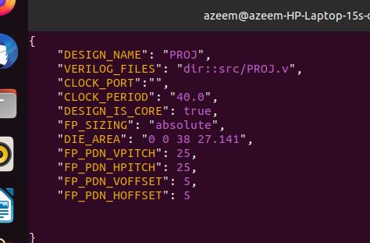

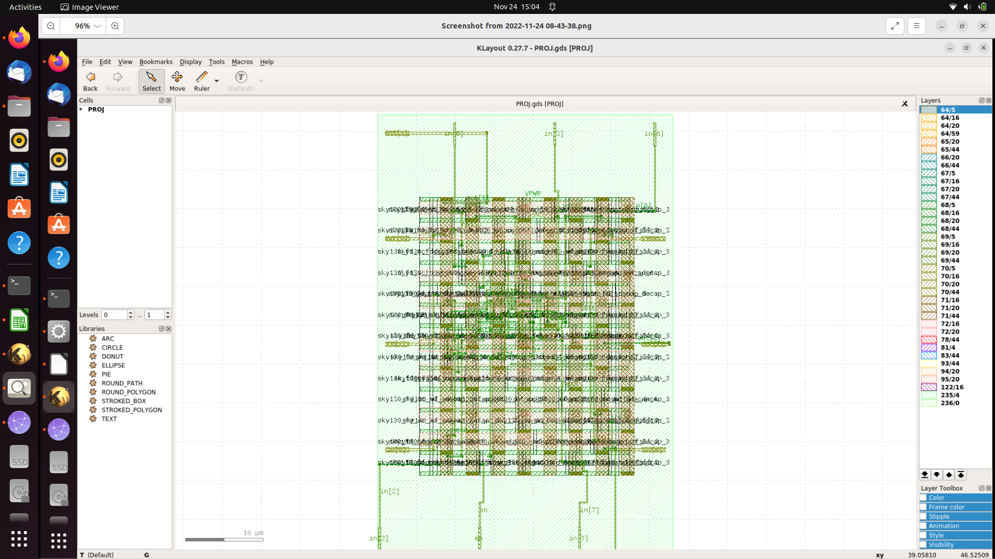
Klayout

Result

Units: 1000
Number of layers: 13
Number of macros: 441
Number of vias: 25
Number of viarulegen: 25

[INFO DRT-0150] Reading design.

Design: PROJ
Die area: ( 0 0 ) ( 38000 57120 )
Number of track patterns: 12
Number of DEF vias: 4
Number of components: 145
Number of terminals: 16
Number of snets: 2
Number of nets: 39

After Synthesis

=== PROJ ===

Number of wires: 16
Number of wire bits: 25
Number of public wires: 5
Number of public wire bits: 14
Number of memories: 0
Number of memory bits: 0
Number of processes: 0
Number of cells: 16
sky130_fd_sc_hd__a211o_2 1
sky130_fd_sc_hd__a21boi_2 1
sky130_fd_sc_hd__a21oi_2 1
sky130_fd_sc_hd__and4_2 2
sky130_fd_sc_hd__buf_1 1
sky130_fd_sc_hd__dlxtp_1 3
sky130_fd_sc_hd__inv_2 4
sky130_fd_sc_hd__o21ba_2 1
sky130_fd_sc_hd__o221ai_2 1
sky130_fd_sc_hd__or4_2 1

Chip area for module '\PROJ': 147.641600
Clock Period : 10 Frequency : 100

After FP , Placement and Routing

===========================================================================
report_design_area
============================================================================
Design area 196 u^2 21% utilization.

Thank You

