Organization not able to perform any action after this , he should be able to accept it and project will go in progress status for both in their order management table , futher developer will be able to deliver order and send files.

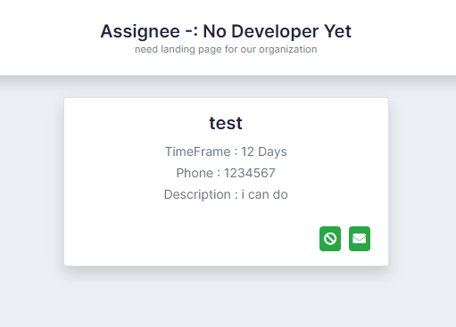

While posting project organization will be able to post files , documents

Make a proper landing page of projects

Add Site menu in both

Make different pages for post a project and manage a project

Make a about page and form for both

For non profit

List of developers

Filter developers by skills

Show developer profile

Post project

For developer

Create profile

Edit profile

List for projects for developer interface

Put quote option for developer

Create profile option for developer