Week 2 Journal: Security Planning and Testing Methodology
Module: Operating Systems
Assessment: Week 2 Phase 2: Security Planning and Testing Methodology

1. Performance Testing Plan
For this week’s task, my aim was to see how my Ubuntu system performs when it’s under different types of loads like CPU, memory, disk, and network. I also wanted to set up remote monitoring from my Linux Mint machine so I could control and test Ubuntu from there. Both systems were connected through a Host-only adapter in VirtualBox, which made them communicate directly without internet.
Tools Installed
On both Ubuntu and Linux Mint, I used the command below to install all the tools I needed:
sudo apt update && sudo apt install -y htop sysstat iotop iperf3 stress-ng ufw fail2ban unattended-upgrades
These tools helped me with monitoring system performance, running stress tests, and setting up security features.
Remote Monitoring Setup
After checking that both machines had IP addresses on the same network (Ubuntu: 192.168.56.101, Mint: 192.168.56.102), I connected from Mint to Ubuntu using SSH. The connection worked successfully, which confirmed that remote access and monitoring were properly set up.
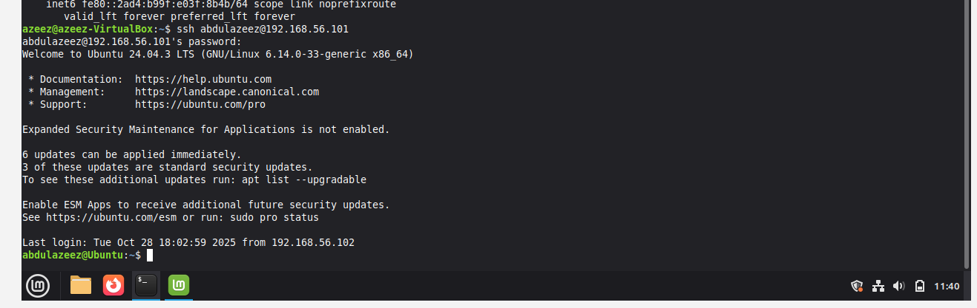

2. Baseline Performance Test (Idle)
Before stressing the system, I recorded the idle performance to see how the machine behaves normally. I used vmstat, iostat, and htop. The CPU usage stayed below 10%, memory was mostly free, and the system was stable. This gave me a clean baseline for comparing later tests.
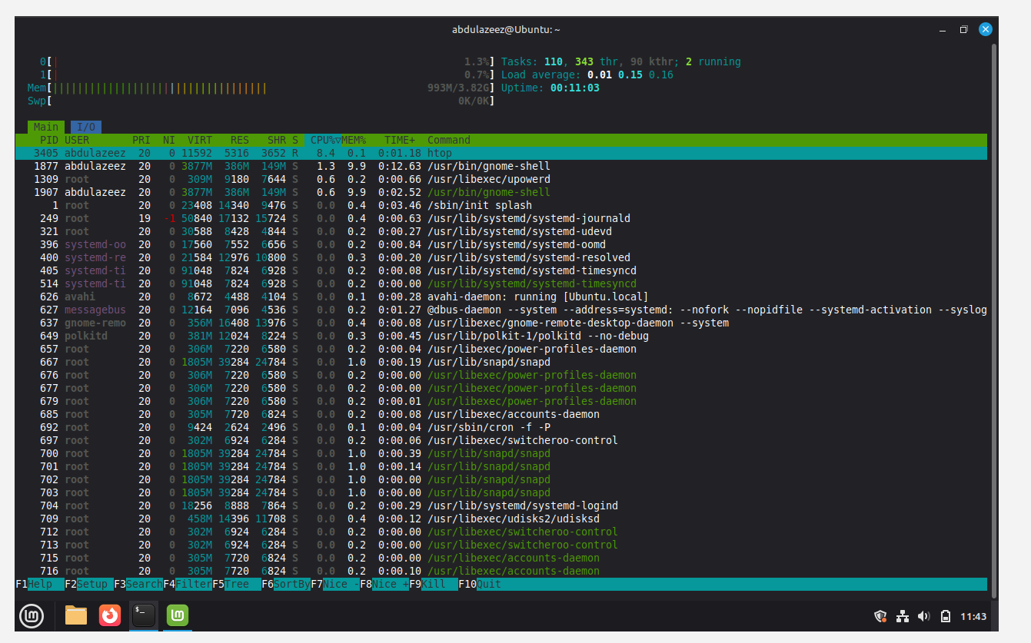

3. CPU and Memory Stress Test
Next, I tested how the system reacts when CPU and memory are under pressure. I ran the stress-ng command, which pushed CPU to 100% and used about 50% of memory. The SSH connection stayed stable and after the test ended, everything went back to normal.
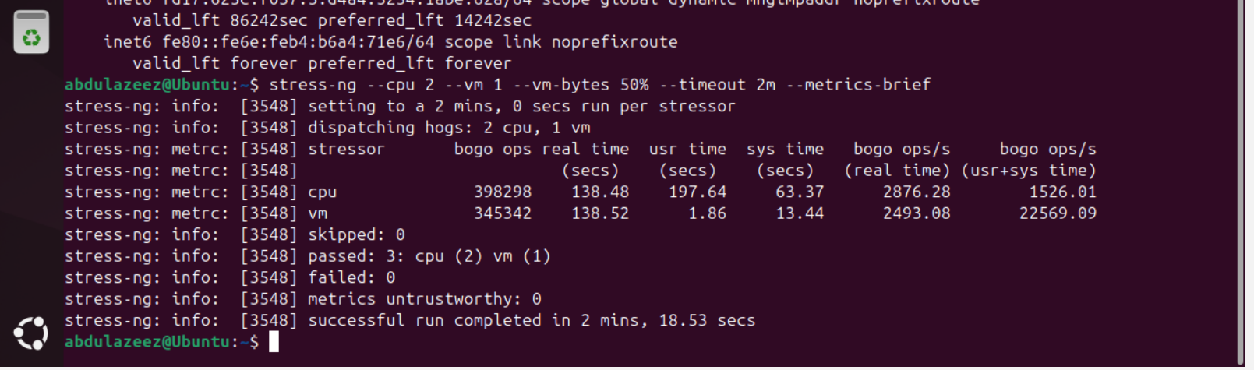

4. Disk I/O Stress Test
Then I tested how the disk handles heavy writing operations using stress-ng and monitored it with iotop. I saw stress-ng writing heavily to disk but the system stayed responsive. 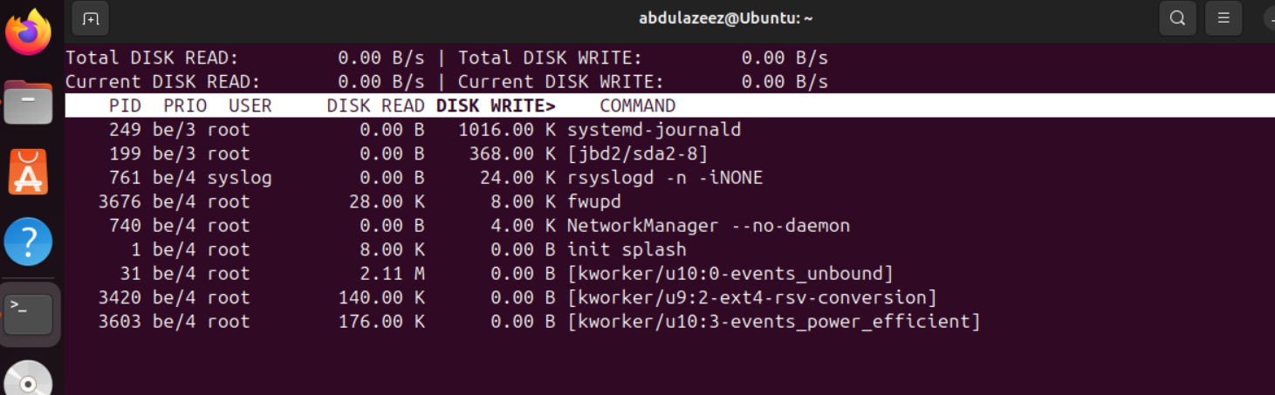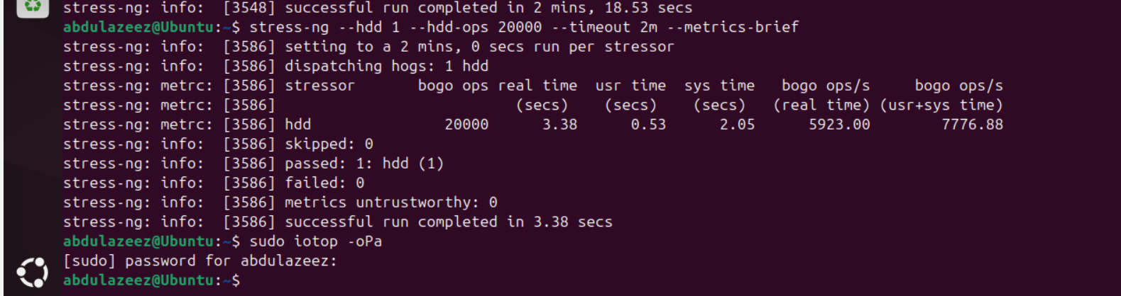

5. Network Throughput Test (Host-only Connection)
The last part of the performance test was checking network speed between Mint and Ubuntu using iperf3. Due to some connection errors, the test wasn’t fully complete at first, but the setup and commands were correctly configured.

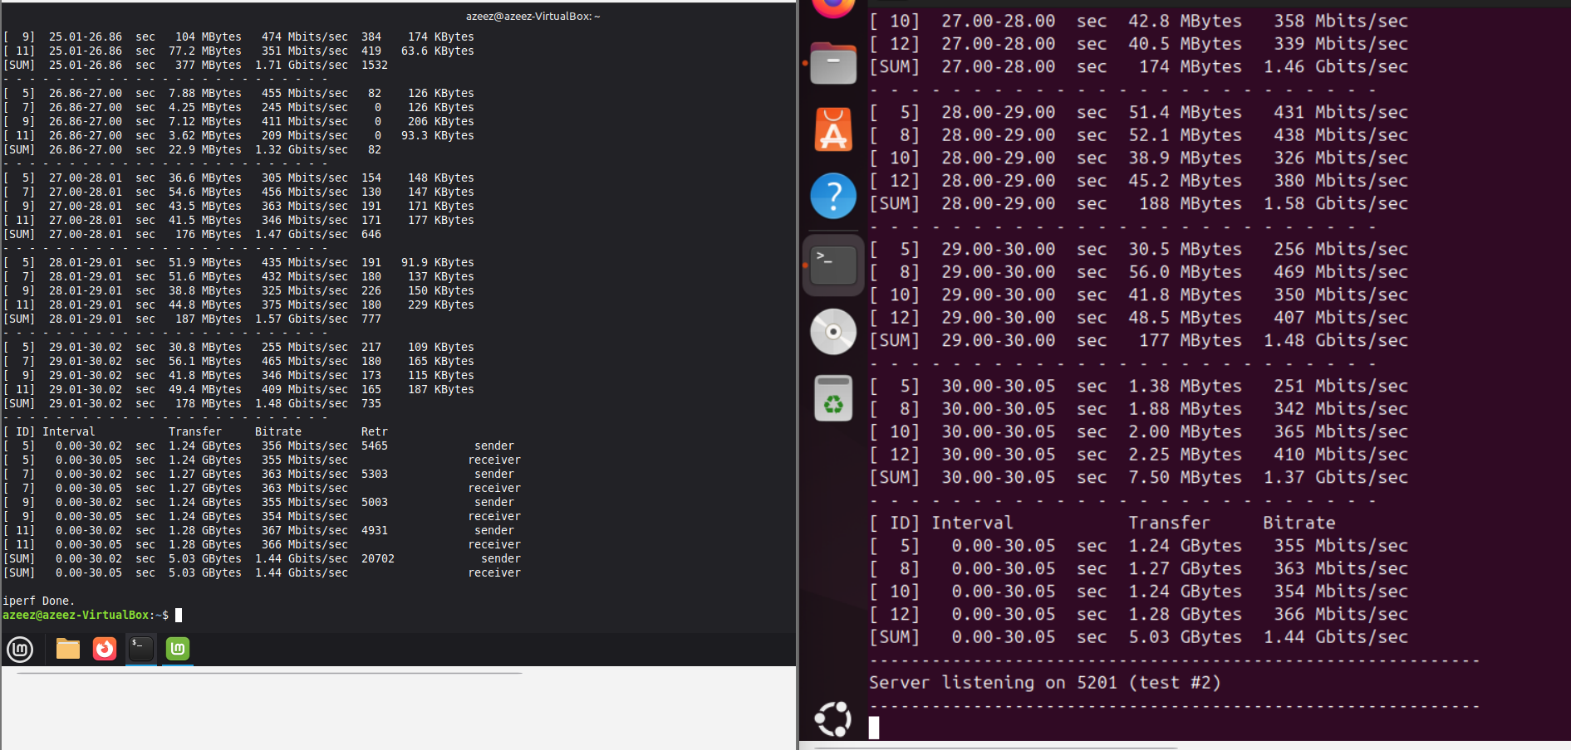

6. Security Configuration Checklist

After performance testing, I moved on to security setup on my Ubuntu (target) system.
Security Task | Command / Action | Description
SSH Hardening | Edit /etc/ssh/sshd_config | Disabled root login, set password auth to no, limited tries
Firewall Setup | sudo ufw default deny incoming  sudo ufw allow OpenSSH  sudo ufw enable | Allowed only SSH traffic, blocked all others
Fail2ban | sudo apt install -y fail2ban  sudo systemctl enable --now fail2ban | Blocked repeated failed login attempts
Automatic Updates | sudo apt install -y unattended-upgrades | Keeps security patches up-to-date
AppArmor | sudo aa-status | Verified AppArmor profiles were active
Least Privilege | sudo -l | Checked minimal sudo privileges

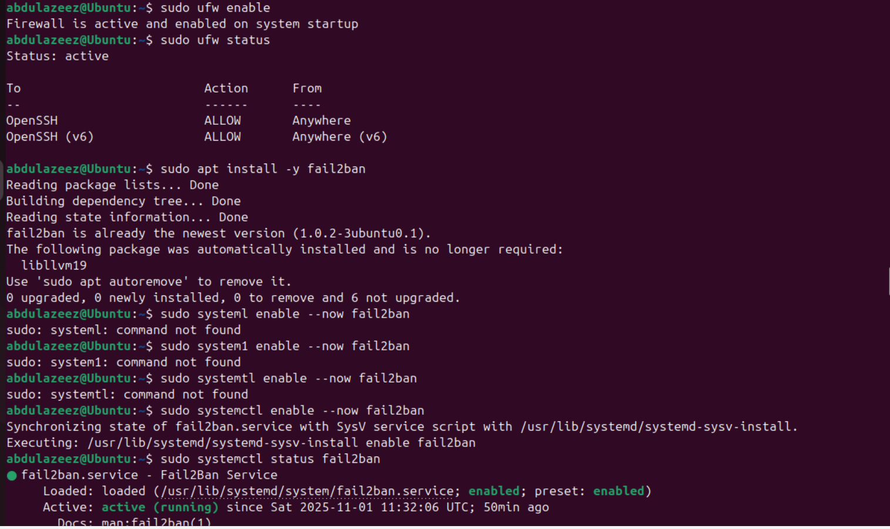

7. Threat Model and Mitigation

I created a simple table showing common threats and how I mitigated them.
Threat | Description | Mitigation
Brute-force SSH attacks | Attackers try random passwords to log in | Disabled password login, enabled Fail2ban
Unpatched vulnerabilities | Hackers exploit outdated packages | Enabled automatic updates
Privilege escalation | Normal user gains root access | Applied least privilege and limited sudo
Open ports exposure | Attackers scan for open services | Configured UFW to allow only SSH
Configuration tampering | Unauthorized system changes | Restricted config access and backups

8. Conclusion
In this week’s task, I learned how to monitor system performance, apply stress tests, and set up a basic security plan for a Linux system. The hardest part was getting the network connection to work for the iperf3 test, but I understood the full setup process and command usage. This gave me a better idea of how real admins test performance and secure their systems.

